**X Base Farm house table**

Modify to be extendable. Either one section in the middle or a section at each end.

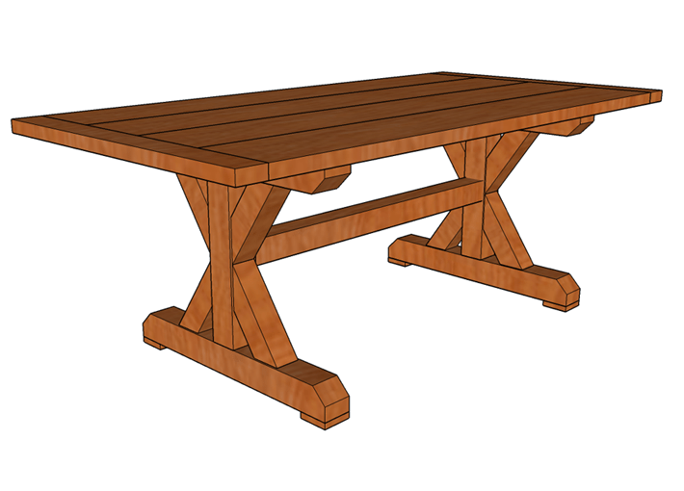

Materials

* 4 – 2″ × 10″ @ 6’
* 4 – 4″ × 4″ @ 8′
* 1 – 2″ × 4″ @ 8’
* #20 biscuits
* Dowel pins

Step 1: Cut the leg posts and angle supports

Start your x-base dining table by cutting the two posts from 4x4s at 19 3/4” in length. Once you have your two leg posts you’ll need to cut the 1 1/2” x 1 1/2” x 1 1/2” mortises in the center of each leg. These mortises will be used to accept the tenons of the stretcher later in Step 4. Use the plunge router and straight bit to clean out the majority of the mortise, then use the chisel to clean up the corners. Alternatively you can skip the mortise and tenon connections and simply use just the two structural screws on each end to hold the stretcher in place. Of course, if you’re not comfortable cutting mortise and tenons, you can just use two 5″ structural screws for attaching the stretching to the leg posts when the time comes.

After finishing the mortises, it’s time to cut the x-braces. You’ll be cutting eight of these identical pieces. Each x-brace is 12 1/16″ inches in length on the longer side with a 55° angle on the inside of one cut, and a 35° angle on the side of the other (refer to the diagram below). After cutting all 8 pieces, drill three holes in each that match the diameter of your dowel pins (typically 3/8″ or 1/2″). Insert the dowel pin centers into one of the legs and push against the post to mark where to drill the corresponding holes on the post, then drill out the holes in the center support.

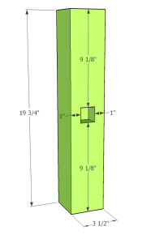[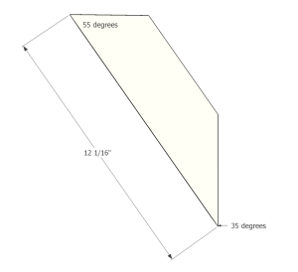](https://famousartisan.com/?attachment_id=4933)[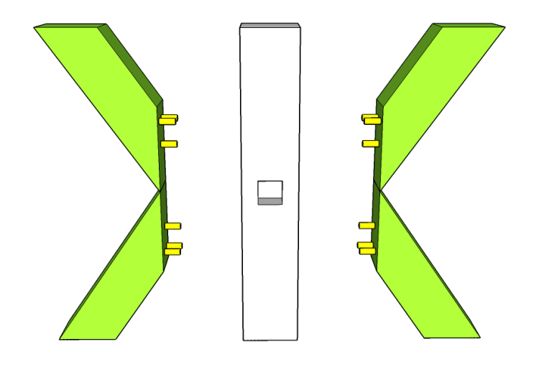](https://famousartisan.com/x-base-dining-table-xs-dowels/)

Step 2: Assemble the x-base

Now that you have the pieces cut for your leg assemblies, it is time to actually assemble them. Start by cutting four 4×4 boards at 32″ for the top and bottom horizontal supports. Also notch out 45° cuts from the end of each to give a tapered affect. Then use three 5″ structural screws to attach the top support, and three more for the bottom support of each of the leg assemblies. Be sure to countersink the heads of the structural screws so they don’t create problems with the table top laying flat.

To attach the X braces, use wood glue and to secure the dowels and drive two 5″ structural screws through the top and bottom supports into the upper and lower ends, respectively, of the x-braces.

[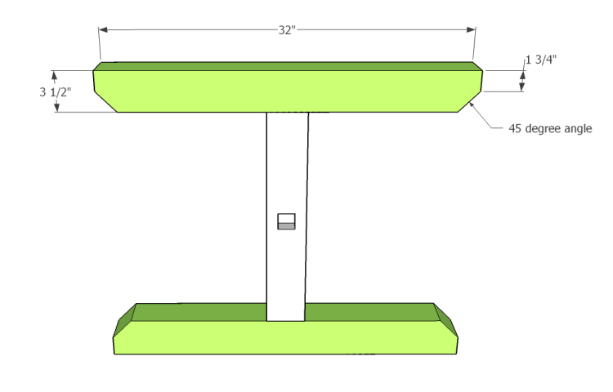](https://famousartisan.com/x-base-dining-table-x-top-and-bottom/)[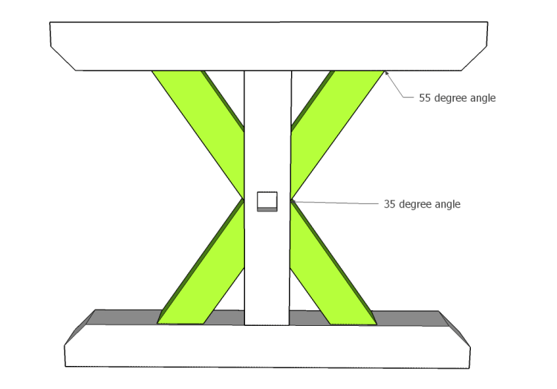](https://famousartisan.com/x-base-dining-table-xs/)

Step 3: Add feet to x-base

To add a little bit of refined design to your x-base table, cut four 1 1/2″ pieces of 4×4, cut or route a 45° taper on all of the edges, and attach to the bottoms of your leg assemblies using wood glue and finish nails.

[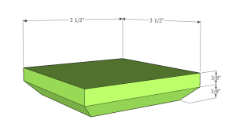](https://famousartisan.com/x-base-dining-table-feet-dimensions/)[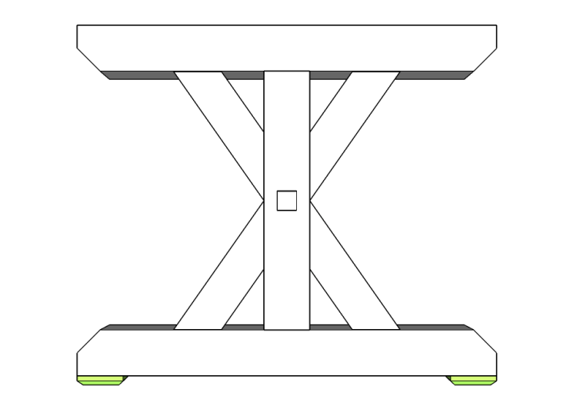](https://famousartisan.com/x-base-dining-table-feet/)

Step 4: Cut the tenons on the stretcher and install

Now that your leg assemblies are complete, let’s cut the stretcher. If you are doing the tenons, cut this 4×4 board at 46″. Then cut a 1 1/2″ x 1 1/2″ tenon, 1 1/2″ deep in the center of each end. Use wood glue to secure it in between the leg assemblies, ensuring the assemblies are square and plum to the stretcher. Then give the glue a good 24 hours to dry.

If you are not doing the tenons, cut this at 43″ and use two 5″ structural screws on each end from the outside of the leg assemblies to install.

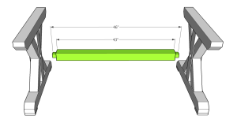[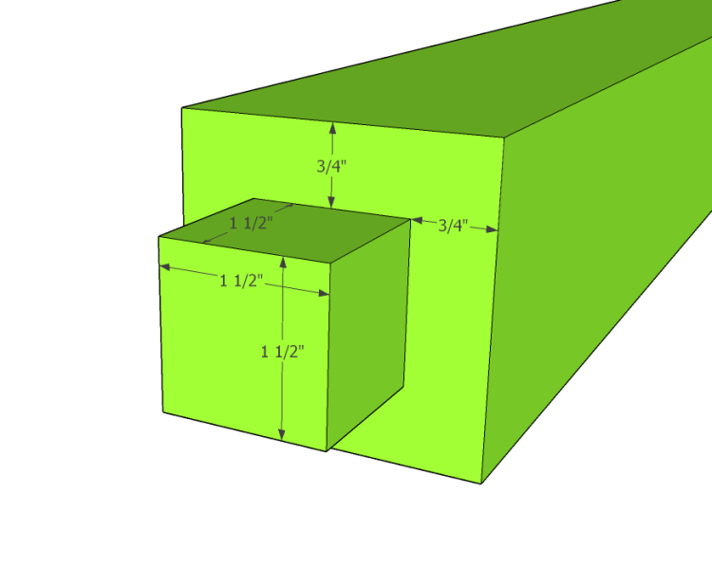](https://famousartisan.com/x-base-dining-table-stretcher-tenon/)

Step 5: Join and attach the top boards

It’s time to put the top on this table. Well, almost time. Start by cutting your 4×10’s down to 72″. That will allow us to cut two 1 1/2″ deep x 1/2″ high x 1 1/2″ wide tenons on each end of these boards. These tenons go into the breadboard ends we’ll add in the next step to hide the end grains. Of course, if you don’t want to add the breadboard ends, you could just cut the top boards to 75″ and call it a day.

Once your top boards are cut, lay them out next to each other and make a series of lines across them every 12 to 16″. This is where you’ll make the cuts for biscuits with the biscuit joiner. Adding the biscuits between the top boards will help keep the tops of the boards aligned.

After you’ve glued the top up, lay it out on the base ensuring it is centered and square to the leg assemblies, using the 4″ outdoor wood screws from underneath.

[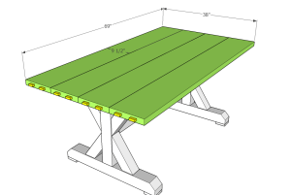](https://famousartisan.com/x-base-dining-table-top/)[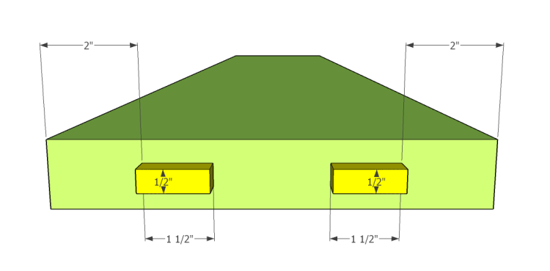](https://famousartisan.com/x-base-dining-table-top-tenons/)

Step 6: Add the breadboard ends

The last step in these x-base dining table plans is to add the breadboard ends. These are cut from the 2×4 stock at 38″ in length. The important cut of these pieces is the 1 1/2″ deep x 1/2″ wide dado that needs to be cut down the center to accept the tenons on the ends of your top boards. Using the tenons and a long dado will allow for the wood’s natural movement. The simplest way to cut the dado is with a straight bit attached to your router on a router table. Make the cut in several passes, each one getting progressively deeper. Don’t try to cut it all in one pass.

After cutting your dado, it’s time to slide the breadboard ends onto the tenons. Do not use wood glue here, as that will prevent the natural movement of the wood over time. Instead, just use two finish nails – one going through each of the center most tenons. These two finish nails, plus a snug fit of the tenons into the dado should be enough to hold the breadboard ends in place.

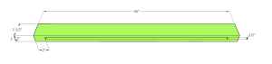[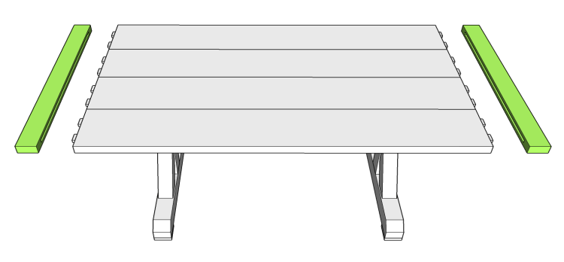](https://famousartisan.com/x-base-dining-table-breadboard-ends/)

There you have it, you have a completed DIY Restoration Hardware table.  The last step is just to finish as you prefer. If you used wood from the big box store, I’d recommend staining with outdoor wood stain and sealant in a similar fashion as you would stain your deck.  I prefer using an oil such as [Teak Oil](https://amzn.to/2LcLKRW) on my tables built from cedar.  The oil provides a rich look, and allows water to bead and run off easily.

https://famousartisan.com/diy-xbase-dining-table-plans/