Blast Gate
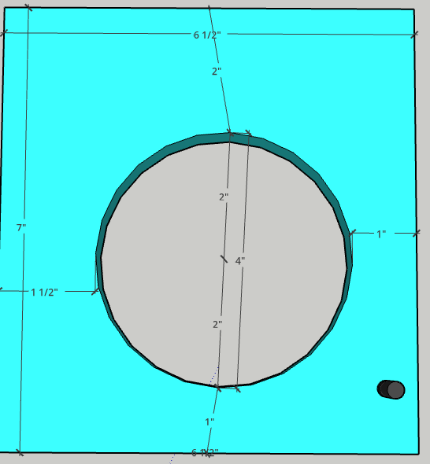 2 outside plates
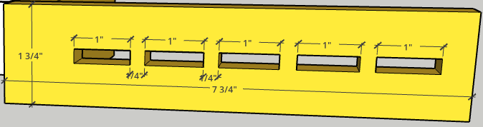 7” Side
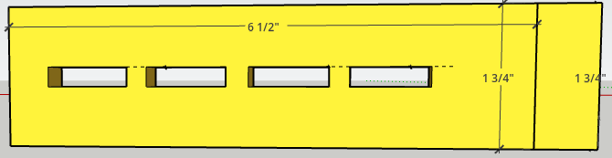 6 ½” Side
Rotating Gate
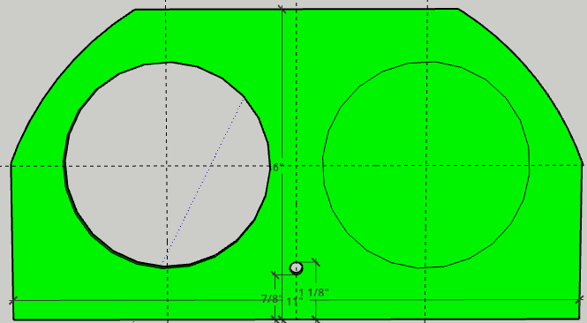
11” wide; 5” tall; ¼” hole centered 1” from edge; 4” holes 3” from sides, 3” inces from bottom
