Boom Arm
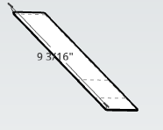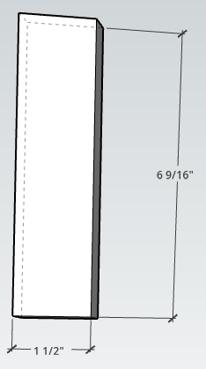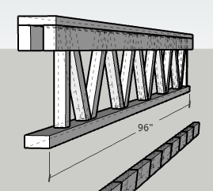
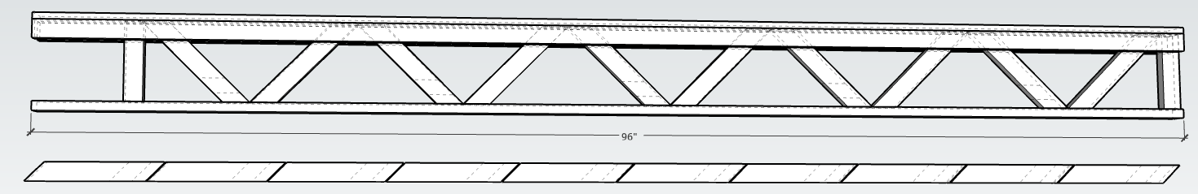
2 @ 6 9/16” x 1 ½” (from scrap)
10 @ 9 3/16” x 1 ½” (from one 8’ 1.5”; 94.5” + 1 1/8” = 95 5/8”)
3@ 8’ x 1 ½”
1 @ 8’ x 2 ¼” top cap (may not need; from plywood or a 1 x 3))
Materials
4 @ 8’ 1x2 + 1.5” scrap + plywood from chop
1@ 8’ 1x3 (top)

Style 2 Boom Arm
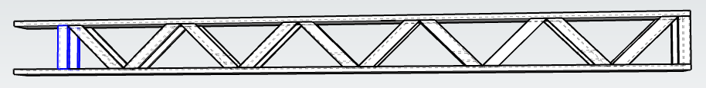
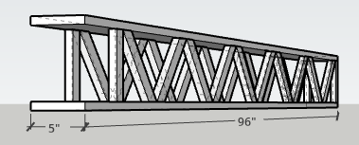

Materials:
3@ 8’ x 1 x 2
2@ 8’ x 1 x 6 or 1@ 8’ x 1 x 12

