Panel Layout
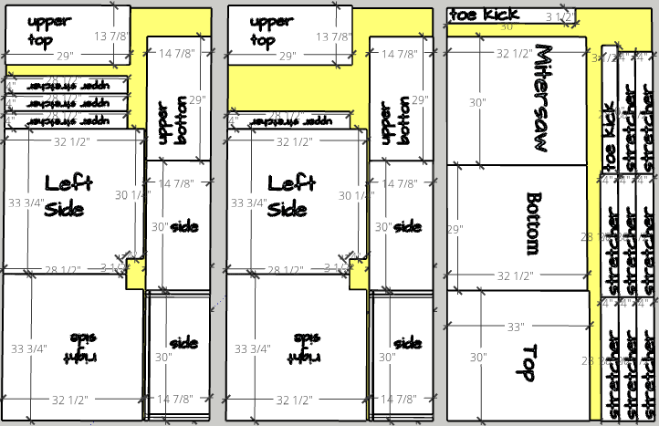
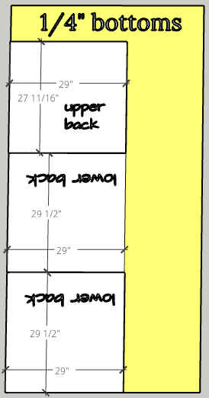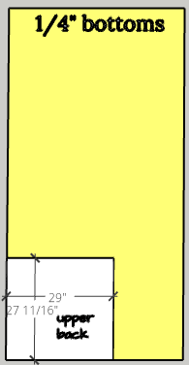
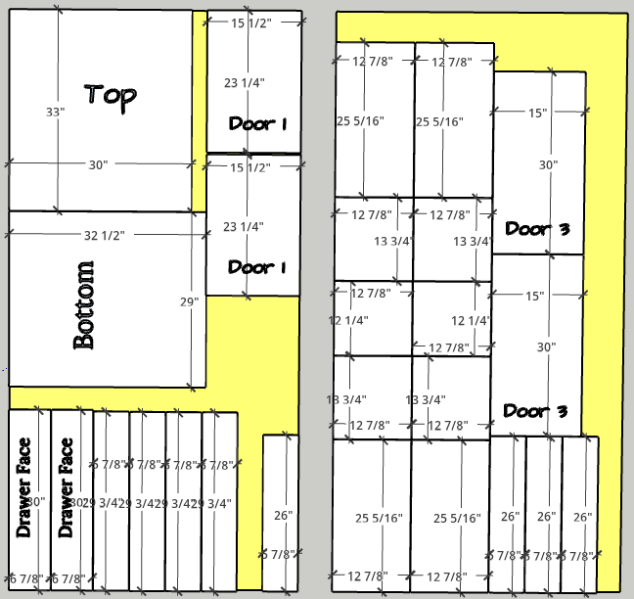
Materials
5 sheets ¾” plywood
2 sheets ¼” plywood
1 ½” screws
1 ½” pocket hole screws

Lower Cabinets
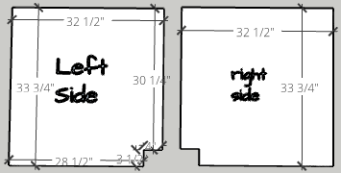 2 Left side; 2 Right side 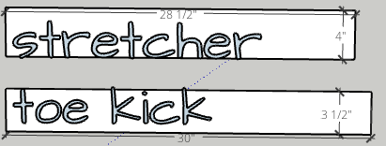 2 toe kicks; 8 stretchers
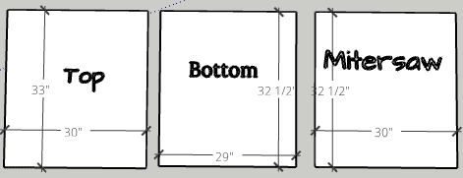
2 Tops; 2 Bottoms; 1 Miter saw (between cabinets)
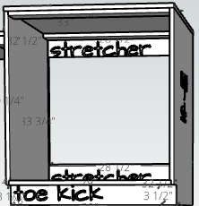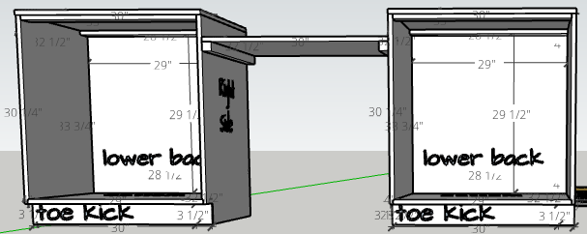
Wall Cabinets
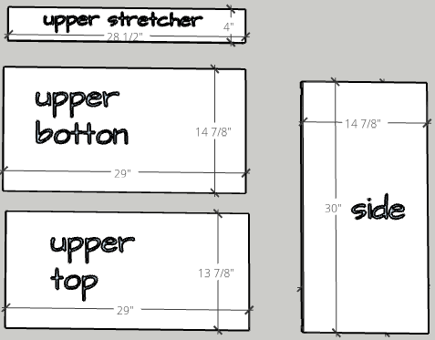
2 upper bottom; 2 upper top; 4 sides; 4 stretchers
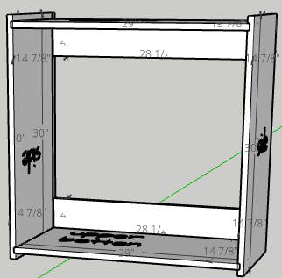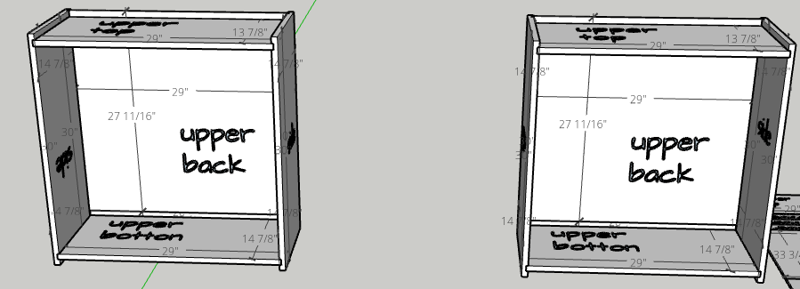

Full Layout
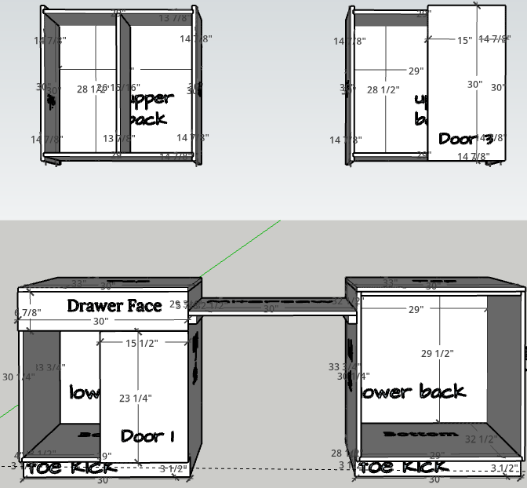
Consider making the upper cabinets drawbinets (see video) or shelves with doors.
Consider making the lower cabinets with doors and shelves or 1 drawer with doors and shelf.
Unit is 90” wide;
Lower 34 ½” tall; lower 32 ½” deep (consider making tops another ¼” deep or ½” shorter with backsplash.
Leave 30” on each side to add additional cabinets.
Upper: 30” tall x 14 7/8” deep

Door & Drawer Lower
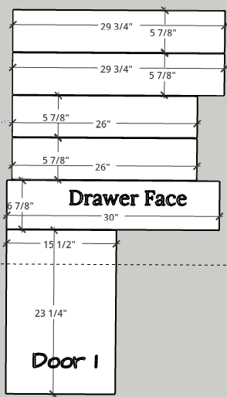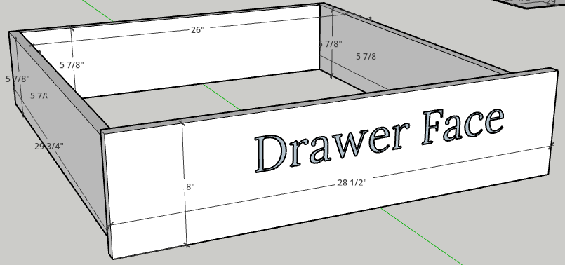
Back & Front 26 x 5 7/8; Side 29 ¾ x 5 7/8; face 6 7/8 x 28 ½
Upper pull-out insert
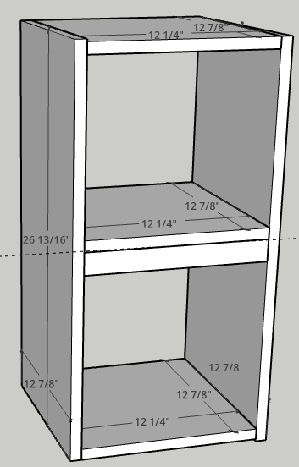
Top & Bottom 12 7/8 x 13 ¾
Front & Back 12 7/8 x 25 5/16
Middle 12 7/8 x 12 ¼
Middle Support 1 ½ x 12 ¼

