**WHITE HOUSE SITUATION ROOM: PORTFOLIO BRIEF**

CONTENTS

NATIONAL SECURITY ADVISOR, UNITED STATES OF AMERICA 2

DEPUTY NATIONAL SECURITY ADVISOR, UNITED STATES OF AMERICA 3

SECRETARY OF STATE, UNITED STATES OF AMERICA 4

SECRETARY OF DEFENSE, UNITED STATES OF AMERICA 5

SECRETARY OF ENERGY, UNITED STATES OF AMERICA 6

CHAIRMAN OF THE JOINT CHIEFS OF STAFF, UNITED STATES OF AMERICA 7

DIRECTOR OF NATIONAL INTELLIGENCE, UNITED STATES OF AMERICA 8

ATTORNEY GENERAL, UNITED STATES OF AMERICA 9

SECRETARY OF THE TREASURY, UNITED STATES OF AMERICA 10

SECRETARY OF HOMELAND SECURITY, UNITED STATES OF AMERICA 11

WHITE HOUSE COUNSEL, UNITED STATES OF AMERICA 12

AMBASSADOR TO THE UNITED NATIONS, UNITED STATES OF AMERICA 13

DIRECTOR OF OFFICE OF MANAGEMENT AND BUDGET, UNITED STATES OF AMERICA 14

HOMELAND SECURITY ADVISOR, UNITED STATES OF AMERICA 15

WHITE HOUSE CHIEF OF STAFF, UNITED STATES OF AMERICA 15

ASSISTANT TO THE PRESIDENT FOR ECONOMIC POLICY, UNITED STATES OF AMERICA 17

SPEAKER OF THE HOUSE, UNITED STATES OF AMERICA 18

PRESIDENT PRO TEMPORE OF THE SENATE, UNITED STATES OF AMERICA 19

# NATIONAL SECURITY ADVISOR, UNITED STATES OF AMERICA

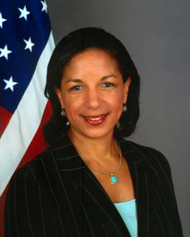

**Susan Rice**

**July 1, 2013 to Present**

The National Security Advisor of the United States of America has to perform the following duties and has the following powers:

● The National Security Advisor is also known as the Assistant to the President for National Security Affairs.

● The National Security Advisor is directly appointed by the President without confirmation by the Senate and thus can provide direct advice to the President independent of the large bureaucracies of the Department of State or Defense.

● At the time of a crisis, the National Security Advisor has the duty to provide the President with updates of the crisis.

● The National Security Advisor usually functions from the White House Situation Room.1

# DEPUTY NATIONAL SECURITY ADVISOR, UNITED STATES OF AMERICA



**Avril Dannica Haines**

**January 11, 2015 to Present**

The Deputy National Security Advisor of the United States of America has to perform the following duties and has the following powers:

● The Deputy National Security Advisor is a Deputy to the National Security Advisor as the name suggests.

● The Deputy National Security Advisor is the Executive Secretary to National Security Council Principals Committee.

● The Deputy National Security Advisor is the Chairman of the National Security Council Deputies Committee.

# SECRETARY OF STATE, UNITED STATES OF AMERICA

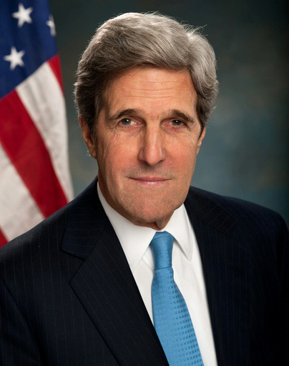

**John Kerry**

**February 1, 2013 to Present**

The Secretary of State of the United States of America has to perform the following duties and has the following powers:

● The Secretary of State organizes and supervises the entire United States Department of State and the United States Foreign Service

● The Secretary of State advises the President on matters relating to U.S. foreign policy, including the appointment of diplomatic representatives to other nations, and on the acceptance or dismissal of representatives from other nations.

● The Secretary of State participates in high-level negotiations with other countries, either bilaterally or as part of an international conference or organization, or appoints representatives to do so. This includes the negotiation of international treaties and other agreements.

● The Secretary of State is responsible for overall direction, coordination, and supervision of interdepartmental activities of the U.S. Government overseas.

● The Secretary of state provides information and services to U.S. citizens living or traveling abroad, including providing credentials in the form of passports and visas. 3

# SECRETARY OF DEFENSE, UNITED STATES OF AMERICA

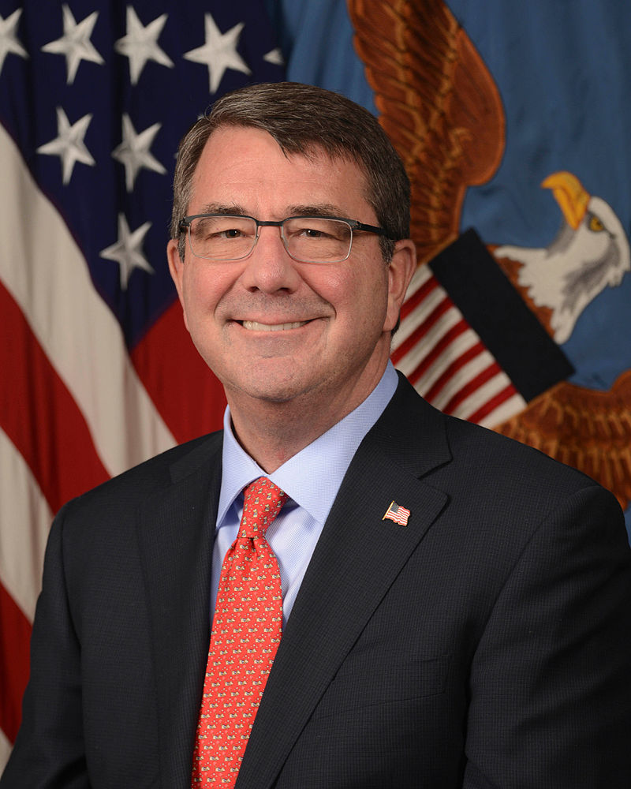

**Ashton Carter**

**February 17, 2015 to Present**

The Secretary of Defense of the United States of America has to perform the following duties and has the following powers:

● The Secretary of Defense is second in power after the President for the military.

● The Secretary of Defense is the head of the Department of Defense.

● The Secretary of Defense presides over Secretary of Army, Secretary of Navy, Chief of Staff and the Chief of the National Guard Bureau.

● The Secretary of Defense is the chief witness for the congressional committees with oversight responsibilities over the Department of Defense.

● The Secretary of Defense is a statutory member of the National Security Council.

# SECRETARY OF ENERGY, UNITED STATES OF AMERICA

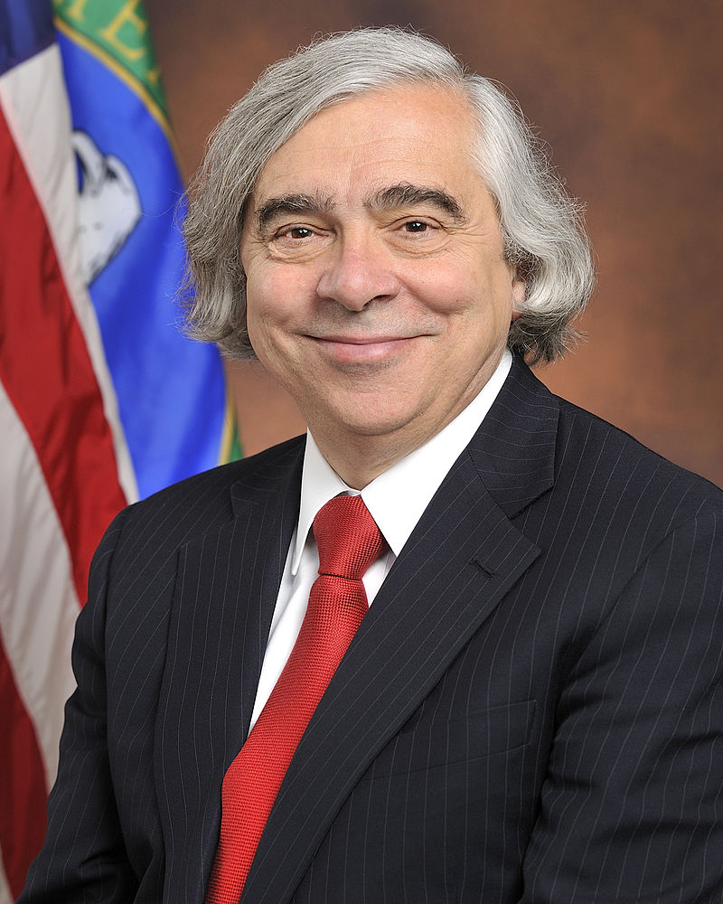

**Ernst Moniz**

**May 21, 2013 to Present**

The Secretary of Energy of the United States of America has to perform the following duties and has the following powers:

● The Secretary of Energy is the head of the United States Department of energy and is 14th in the President’s line of succession.

● The Secretary of Energy has to ensure the United States’ nuclear security.

# CHAIRMAN OF THE JOINT CHIEFS OF STAFF, UNITED STATES OF AMERICA

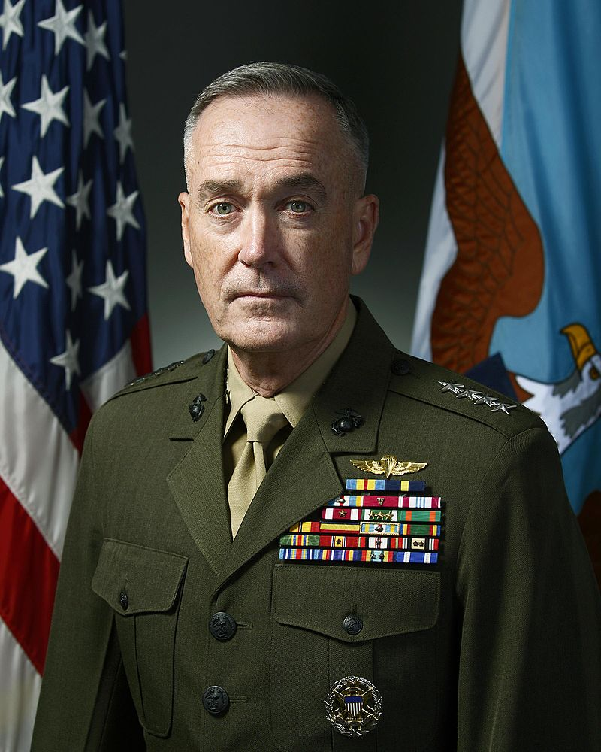

**General Joseph Dunford**

**October 1, 2015 to Present**

The Chairman of the Joint Chiefs of Staff of the United States of America has to perform the following duties and has the following powers:

● The Chairman of the Joint Chiefs of Staff is the highest ranking officer in the United States Armed Forces.

● The Chairman of the Joint Chiefs of Staff serves as the Principal military advisor to the President, the National Security Council and the Homeland Security Council.

● The Chairman of the Joint Chiefs of Staff convenes the meetings and coordinates the efforts of the Joint Chiefs of Staff.

# DIRECTOR OF NATIONAL INTELLIGENCE, UNITED STATES OF AMERICA

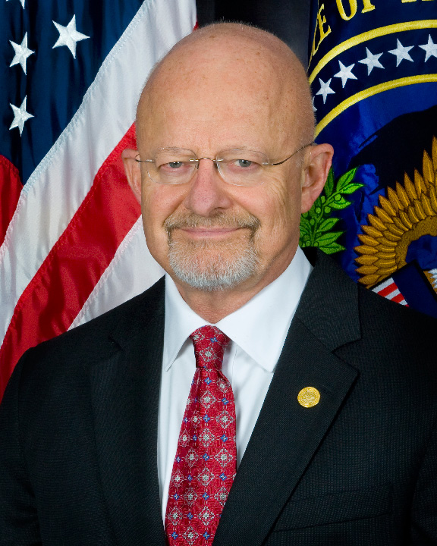

**Lt. General James R. Clapper**

**August 5, 2010 to Present**

The Director of National Intelligence of the United States of America has to perform the following duties and has the following powers:

● The Director of National Intelligence serves as principal advisor to the President, the National Security Council, and the Homeland Security Council about intelligence matters related to national security.

● The Director of National Intelligence serves as head of the sixteen-member Intelligence Community.

● The Director of National Intelligence directs and oversees the National Intelligence Program.

# ATTORNEY GENERAL, UNITED STATES OF AMERICA

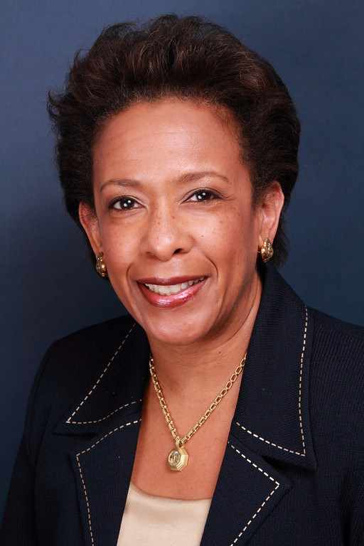

**Lorreta Lynch**

**April 27, 2015 to Present**

The Attorney General of the United States of America has to perform the following duties and has the following powers:

● The Attorney General is the head of the Department of Justice.

● The Attorney General is the Chief Law Enforcement officer of the United States of America.

● The Attorney 8General is responsible for all suits in the Supreme Court that involve the United States of America.

● The Attorney General is also the Chief Legal Advisor to the President and other heads of departments of the United States government.

# SECRETARY OF THE TREASURY, UNITED STATES OF AMERICA

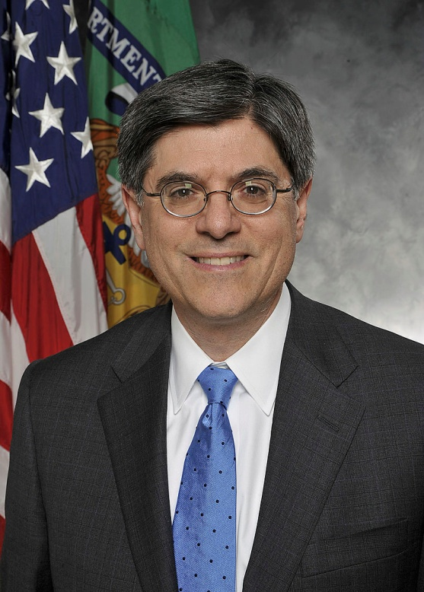

**Jack Lew**

**February 27, 2013 to Present**

The Secretary of the Treasury of the United States of America has to perform the following duties and has the following powers:

● The Secretary of the Treasury is the head of the Department of Treasury.

● The Secretary of the Treasury is the principal economic advisor to the President and plays a critical role in policy-making by bringing an economic and government financial policy perspective to issues facing the 9government.

● The Secretary of the Treasury is responsible for formulating and recommending domestic and international financial, economic, and tax policy, participating in the formulation of broad fiscal policies that have general significance for the economy, and managing the public debt.

● The Secretary of the Treasury oversees the activities of the Department in carrying out its major law enforcement responsibilities; in serving as the financial agent for the United States Government; and in manufacturing coins and currency.

# SECRETARY OF HOMELAND SECURITY, UNITED STATES OF AMERICA

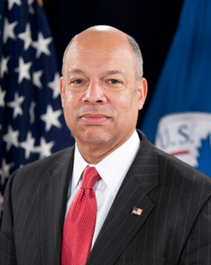

**Jeh Johnson**

**December 6, 2013 to Present**

The Secretary of Homeland Security of the United States of America has to perform the following duties and has the following powers:

● The Secretary of Homeland Security is the head of the Department of Homeland Security.

● The Secretary of Homeland Security is responsible for border security at both the north and south borders, as well as for securing ports and airspace. This responsibility ties in with efforts to secure against terrorism and deter illegal immigration.

● The Secretary of Homeland Security is responsible for overseeing the application of laws regarding immigration and foreign travelers to the United States. This includes tracking and people who are in the U.S. illegally and ensuring that they are prosecuted in conjunction with the U.S. Department of Justice.

# WHITE HOUSE COUNSEL, UNITED STATES OF AMERICA

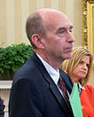

**W. Neil Eggleston**

**June 1, 2014 to Present**

The White House Counsel of the United States of America has to perform the following duties and has the following powers:

● The White House Counsel is responsible for advising on all legal aspects of policy questions, legal issues arising in connection with the President's decision to sign or veto legislation, ethical questions, financial disclosures, and conflicts of interest during employment and post employment.

● The White House Counsel also helps define the line between official and political activities, oversees executive appointments and judicial selection, handles Presidential pardons, reviews legislation and Presidential statements, and handles lawsuits against the President in his role as President, as well as serving as the White House contact for the Department of Justice.

● The White House Counsel serves as the President’s legal representative only in his official capacity and does not function as their personal legal representative11.

# AMBASSADOR TO THE UNITED NATIONS, UNITED STATES OF AMERICA

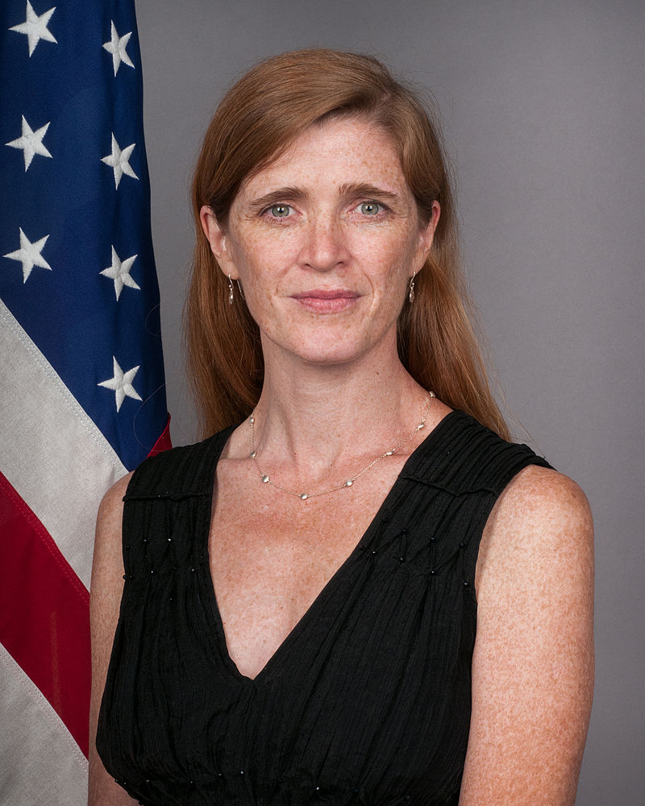

[**Samantha Power**](https://en.wikipedia.org/wiki/Samantha_Power) **August 2, 2013 to Present**

The Ambassador to the United Nations of the United States of America has to perform the following duties and has the following powers:

● The Ambassador to the United Nations serves as the head of the United States’Delegation.

● The Ambassador to the United Nations is not a member of the Cabinet but is accorded with a profile of a similar rank.

● The Ambassador to the United Nations is the representative of the United States of America in the United Nations Security Council.

# DIRECTOR OF OFFICE OF MANAGEMENT AND BUDGET, UNITED STATES OF AMERICA

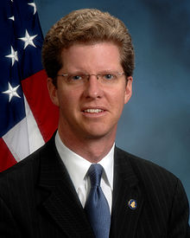

**Shaun Donovan**

**August 5, 2014 to Present**

The Director of Office of Management and Budget of the United States of America has to perform the following duties and has the following powers:

● The Director of Office of Management and Budget provides the President and the Cabinet with an estimate for each and every policy and program that concerns the United States of America.

● The Director of Office of Management and Budget has the chief responsibility of providing the President with the annual budget, assisting the President in managing the Executive Branch and developing the administration's official position on legislation pending before Congress

# HOMELAND SECURITY ADVISOR, UNITED STATES OF AMERICA

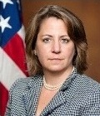

**Lisa Monaco**

**March 8, 2013 to Present**

The Homeland Security Advisor of the United States of America has to perform the following duties and has the following powers:

● The Homeland Security Advisor is responsible for assessing the objectives, commitments, and risks of the United States, and for making recommendations to the president with respect to homeland security policy.

● The Homeland Security Advisor is the Chief Advisor to the President for Homeland Security Issues. 14

# WHITE HOUSE CHIEF OF STAFF, UNITED STATES OF AMERICA

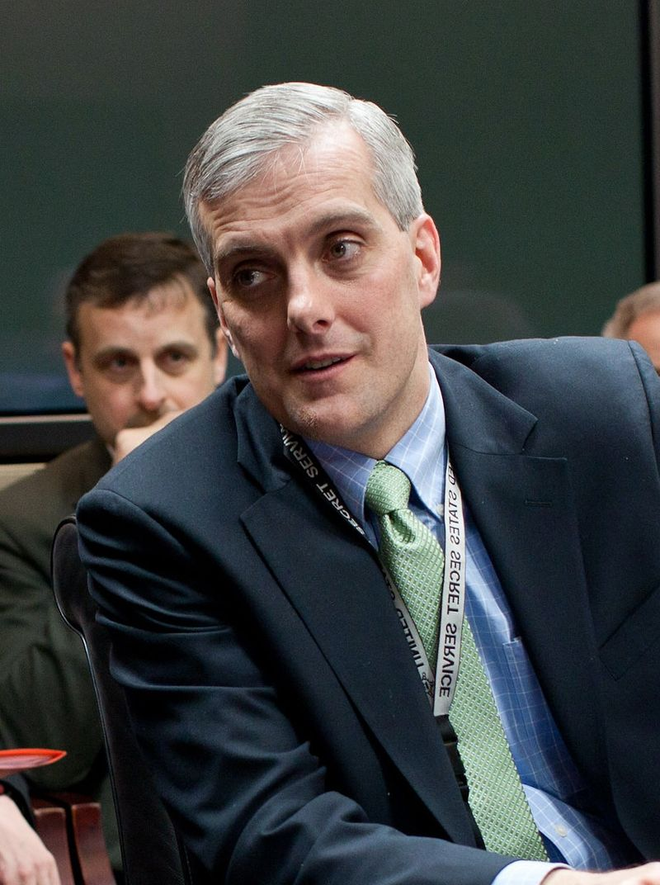

**Denis McDonough  
since January 25, 2013**

The White House Chief of Staff of the United States of America has to perform the following duties and has the following powers:

● The White House Chief of Staff selects key White House staff and supervises them.

● The White House Chief of Staff structures the White House staff system.

● The White House Chief of Staff controls the flow of people into the Oval Office.

● The White House Chief of Staff manages the flow of information.

● The White House Chief of Staff protects the interests of the President

● The White House Chief of Staff negotiates with the Congress, other members of the executive branch, and extra-governmental political groups to implement the President's agenda.

● The White House Chief of staff advises the President on various issues.

# ASSISTANT TO THE PRESIDENT FOR ECONOMIC POLICY, UNITED STATES OF AMERICA

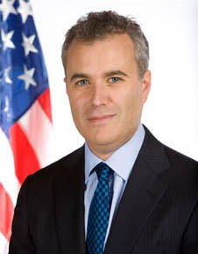

**Jeffrey Zients**

**March 5, 2014 to Present**

The National Economic Council (NEC) was established in 1993 to advise the President on U.S. and global economic policy. It resides within the Office of Policy Development and is part of the Executive Office of the President.

By Executive Order, the NEC has four principal functions: to coordinate policy-making for domestic and international economic issues, to coordinate economic policy advice for the President, to ensure that policy decisions and programs are consistent with the President's economic goals, and to monitor implementation of the President's economic policy agenda.

The NEC is comprised of numerous department and agency heads within the administration, whose policy jurisdictions impact the nation's economy. The NEC Director works in conjunction with these officials to coordinate and implement the President's economic policy objectives. The Director is supported by a staff of policy specialists in various fields including: agriculture, commerce, energy, financial markets, fiscal policy, healthcare, labor, and Social Security.

# SPEAKER OF THE HOUSE, UNITED STATES OF AMERICA

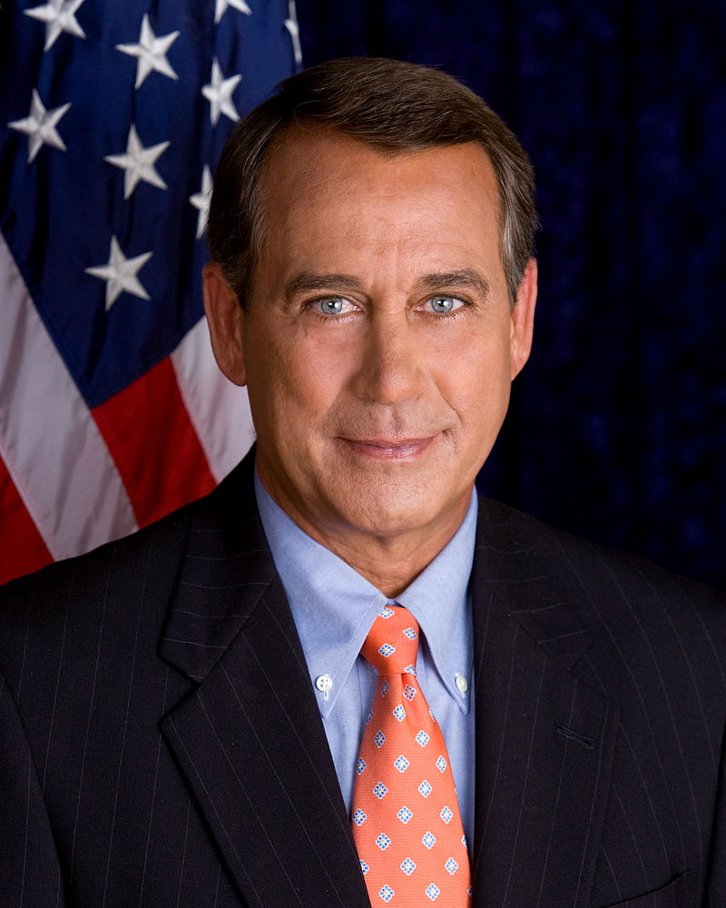

[**John Boehner**](https://en.wikipedia.org/wiki/John_Boehner) **January 5, 2011 to Present**

The Speaker in the United States is the head of the majority party in the House of Representatives, outranking the Majority Leader. However, despite having the right to vote, the Speaker usually does not participate in debate and rarely votes.

The Speaker is responsible for ensuring that the House passes legislation supported by the majority party. In pursuing this goal, the Speaker may use his or her power to determine when each bill reaches the floor. They also chair the majority party's steering committee in the House. While the Speaker is the functioning head of the House majority party, the same is not true of the President *pro tempore* of the Senate, whose office is primarily ceremonial and honorary.

# PRESIDENT PRO TEMPORE OF THE SENATE, UNITED STATES OF AMERICA

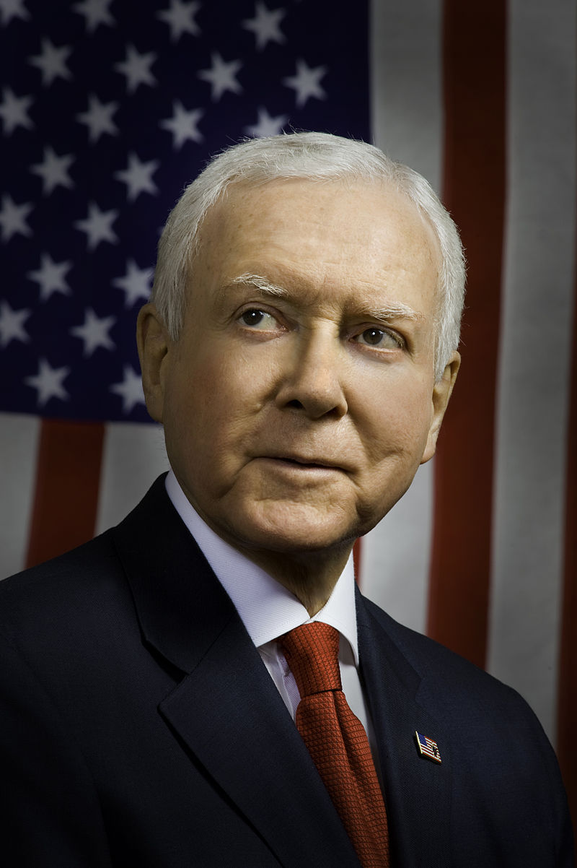

[**Orrin Hatch**](https://en.wikipedia.org/wiki/Orrin_Hatch) **January 6, 2015 to Present**

The President Pro Tempore of the State of the United States of America has to perform the following duties and has the following powers:

● The President Pro Tempore and the Speaker are the two authorities to whom declarations must be transmitted that the president is unable to perform the duties of the office.

● The President Pro Tempore is third in the President’s line of succession.

● The President Pro Tempore is the designated legal recipient of various reports to the Senate, including War Powers Act reports under which he or she, jointly with the speaker, may have the president call Congress back into session.