2nd

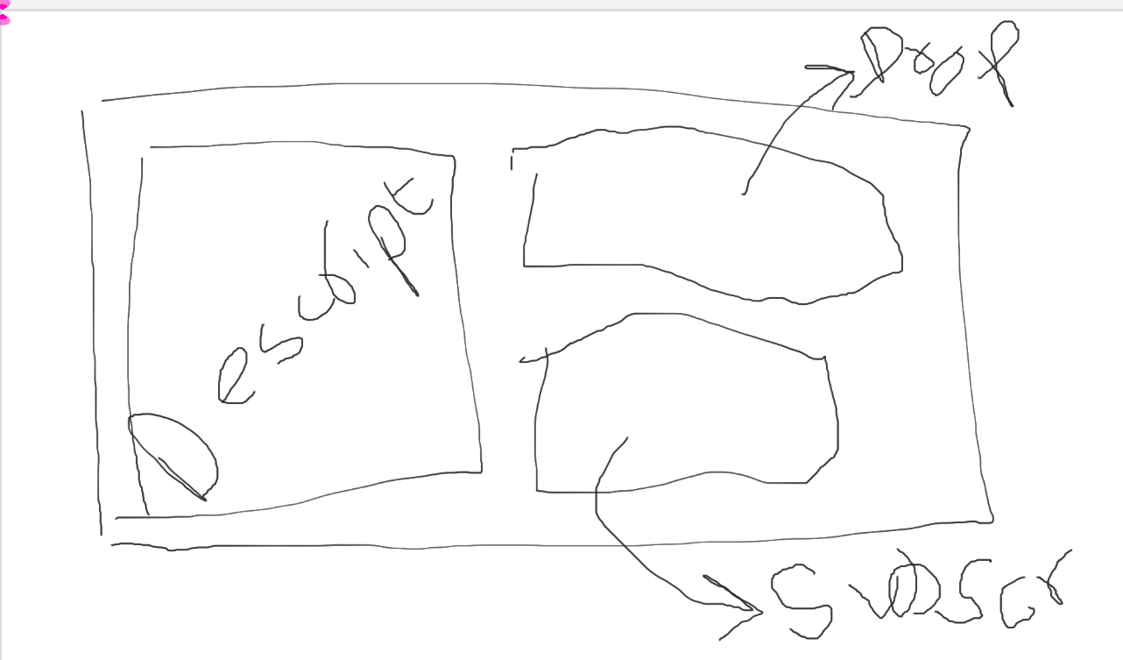

3rd



4th



Last

* Loader
* Reviews through database
* Drop file captured (like upload file)
* authentication