BLACK FRIDAY DATASET ANALYSIS

About Dataset

The dataset here is a sample of the transactions made in a retail store. The store wants to know better the customer purchase behaviour against different products. Specifically, here the problem is a regression problem where we are trying to predict the dependent variable (the amount of purchase) with the help of the information contained in the other variables.

This is a dataset of 550 000 observations about the black Friday in a retail store, it contains different kinds of variables either numerical or categorical. It contains missing values.

Dataset Source : https://www.kaggle.com/mehdidag/black-friday

About Dataset Columns :

- User_ID
- Product_ID
- Gender
- Age
- Occupation
- City_Category
- Stay_In_Current_City_Years
- Marital_Status
- Product_Category_1
- Product_Category_2
- Product_Category_3
- Purchase

About Files Attached :

black_friday.ipynb : Contains analysis codes
black_friday_model.ipynb : Contains model for future prediction

Analysis
On the basis of Gender :

On the basis of gender it can clearly be seen that Males are more dominant . There is a ratio of 3:1 male female ratio .

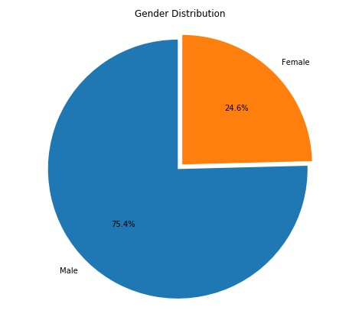

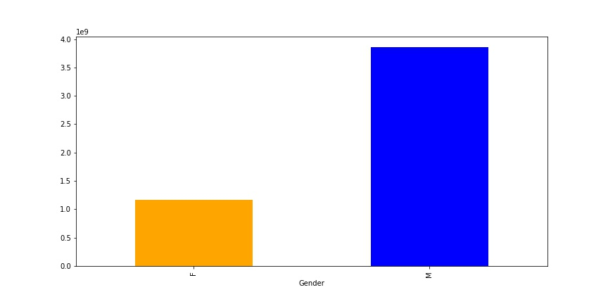

On the basis of Age :
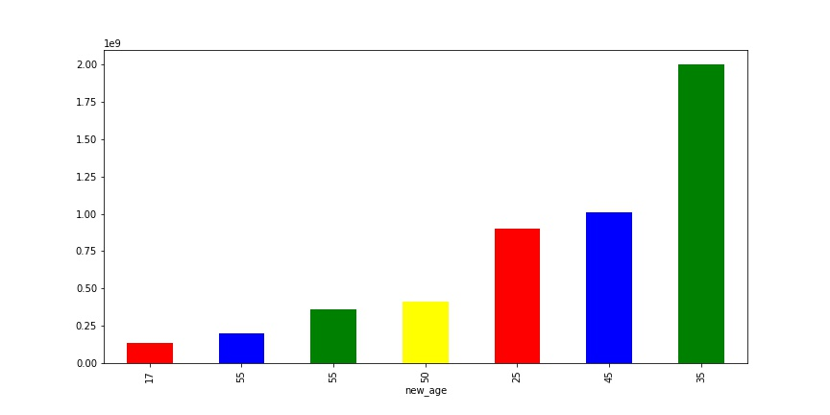

On the basis of Occupation :
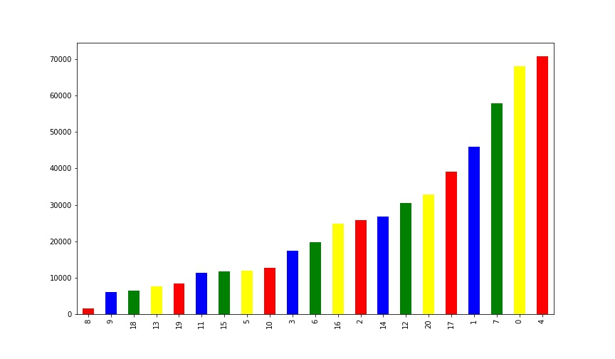

On the basis of City Category :

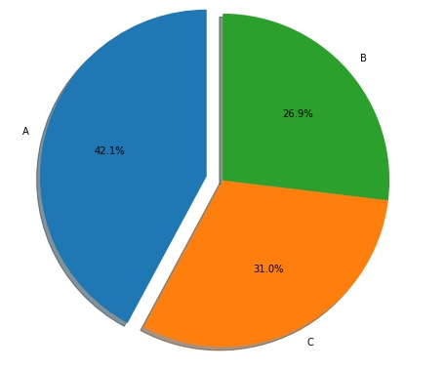

On the basis of Age & Gender :

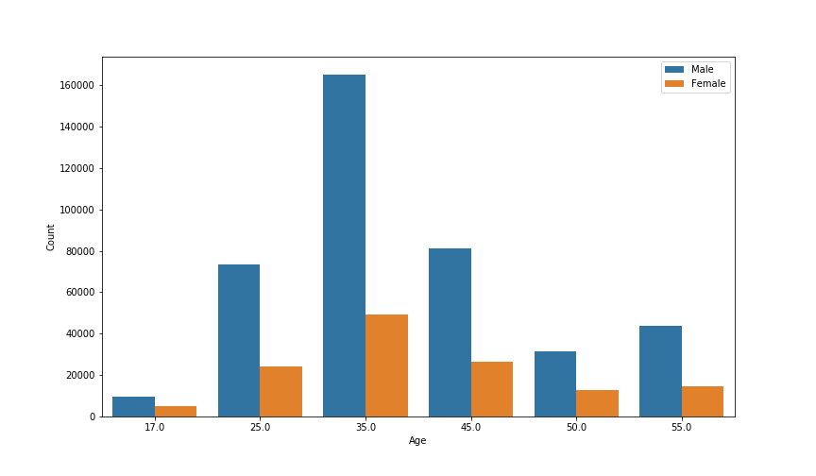

On the basis of Age & City :

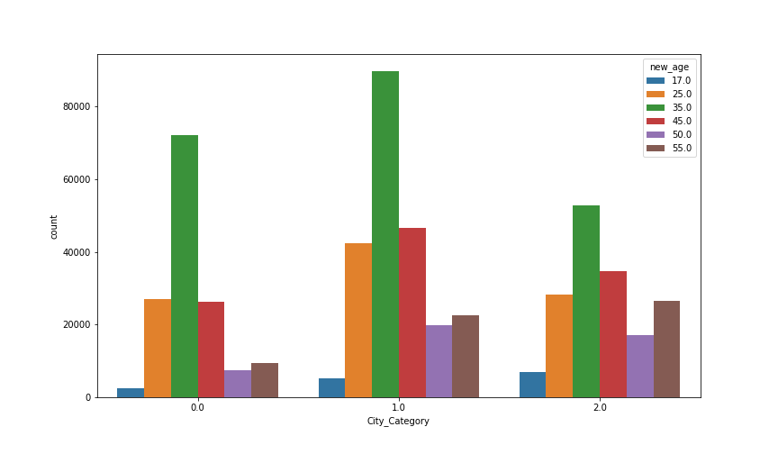

On the basis of Product :

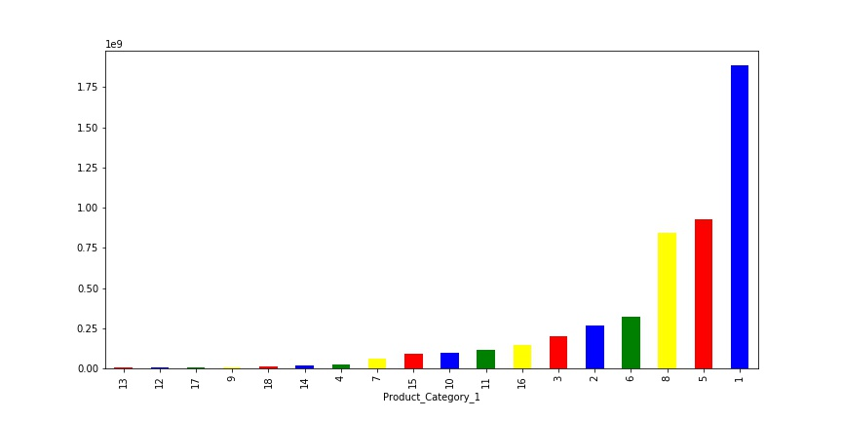

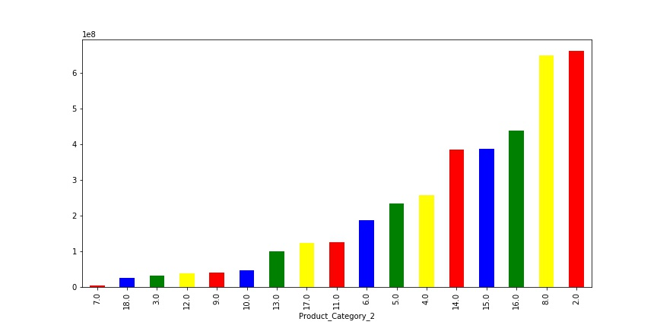

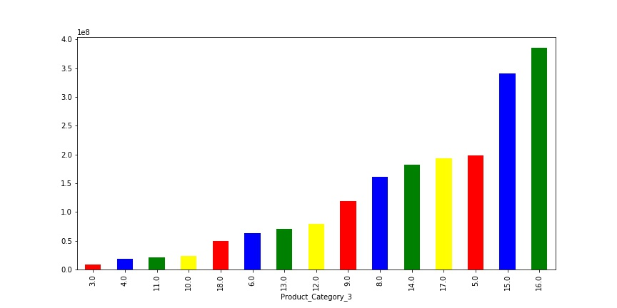

On the basis of Stay( in years ) :

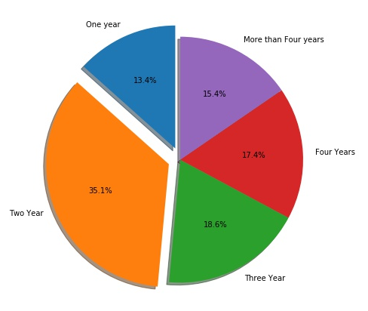

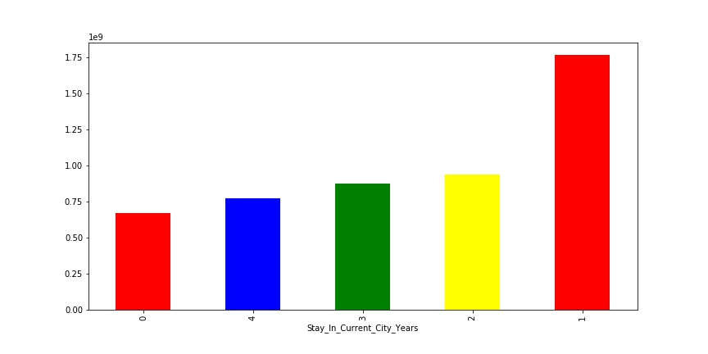

Future Planning :

Here in this dataset we need to improve the sales . To do so we need to focus on the dominating categories . We can also create a prediction model to predict the future sales .

In this project we tried linear regression model , Ridge regression model and DecisionTree Regressor model and DecisionTree Regressor model was stood up as best model for future prediction with minimum Root Mean Squared Error.

Code Snippets

