Step 1 Copy Folder AS-Webkeywords from location below to c:\users\ntni5

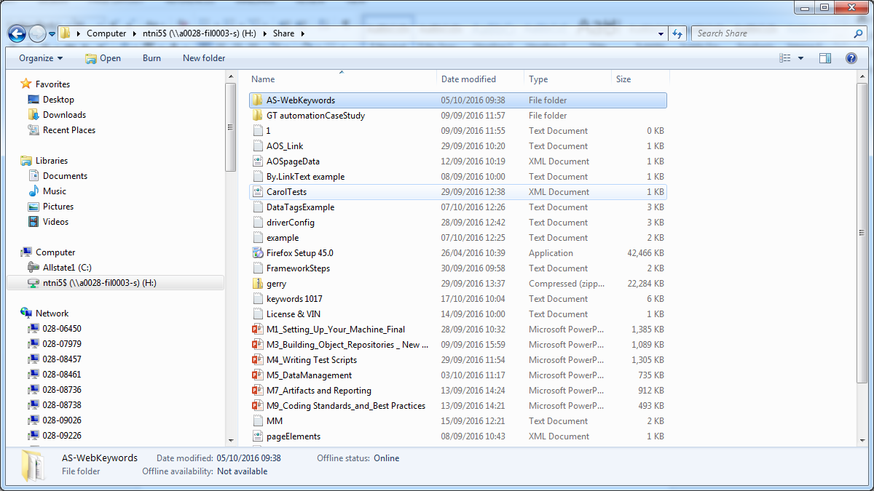

c:\users\ntni5

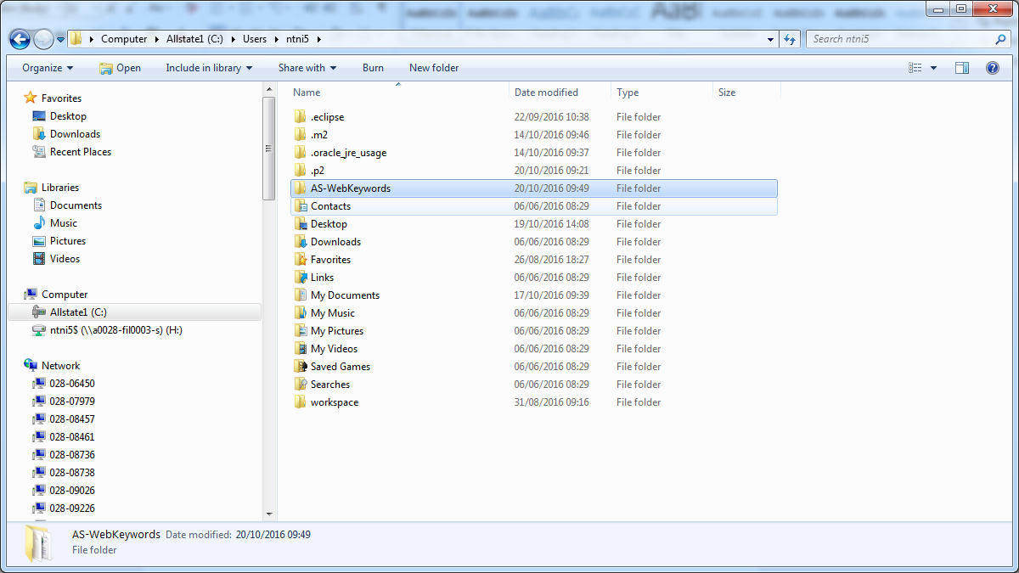

Step2 In Eclipse select file🡪import and you will see the screen below

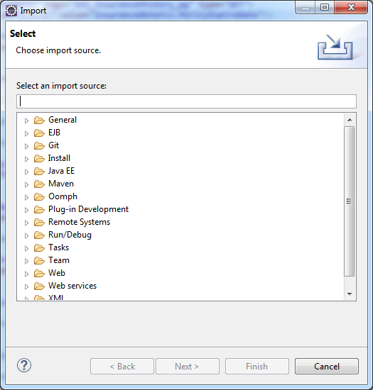

Step 3 Select General and Existing Projects into Workspace

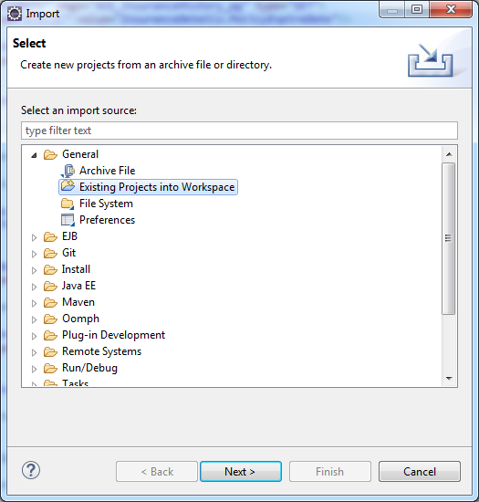

Step 4 Browse to the location where you copied the folder c:\users\ntni5 and click ok and click finish. When you click finish allow the project to build

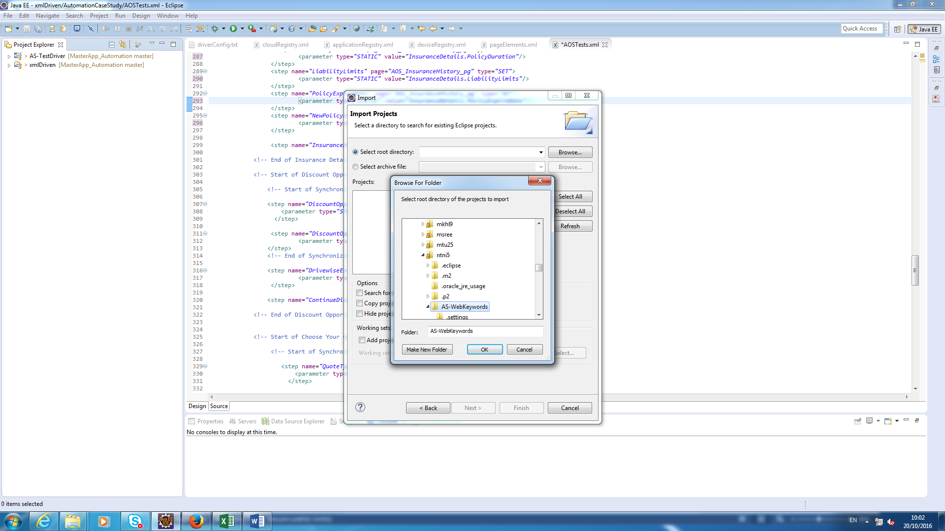

Step 5 Right Click on AS-TestDriver folder and select Build Path🡪Configure Build Path

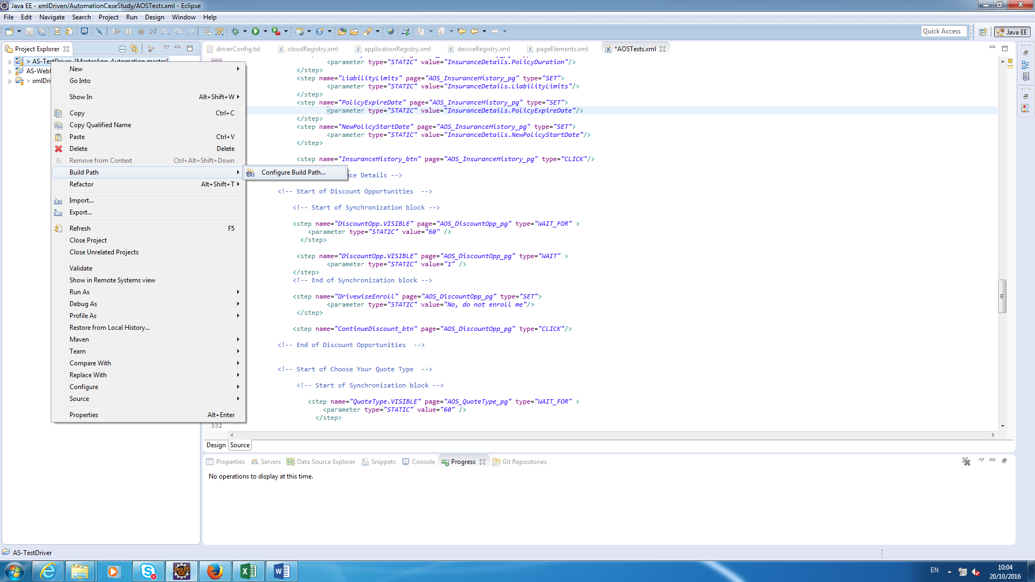

Step 6 Click on projects tab and click Add. Select the AS-WebKeywords project and click ok. On the next screen click OK

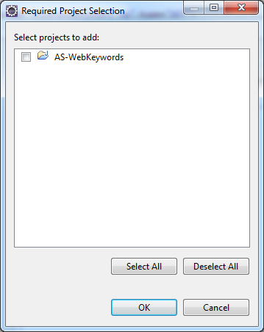

Step 7 Open your driver config file and uncomment the last 2 lines

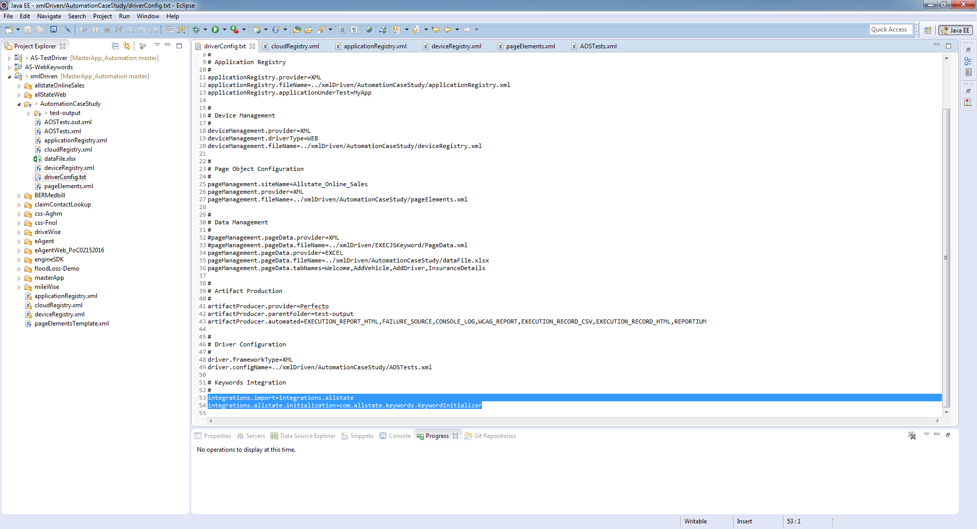

Step 8 To test this is working add the step below to your test at the start

<step name="ELEMENTNAME" page="PAGE_NAME" type="MAXIMIZE"/>

REMEMBER TO USE YOUR OWN ELEMENT NAME AND PAGE NAME