**GitHub Initialization**

This document is to guide you through the initial upload of your automation project into the allstate github server. This is an important step for each team to carry out as this allows your team to implement version control and manage the automation code correctly.

More importantly though is that whenever the code has been correctly uploaded to github, it is being backed up and can be accessed by any team member at any time providing that they have access to the repository in github. Teams who are managing their code on individuals laptops and sharing via email are running the risk that their entire project could be lost due to hardware failure, team members may be running out of date code or team members may not have access to the latest version of the code if the person managing the code is out of the office ill or on leave.

Steps to upload code to Github

1. Create Github Repository.
   1. Launch github.allstate.com, and login.
   2. Click New Reposity button. Green button see below. (For practice purposes create the repository under your own id)

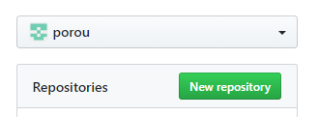

* 1. Enter a meaningful repository name and make the repository public. When finished click the create repository button.

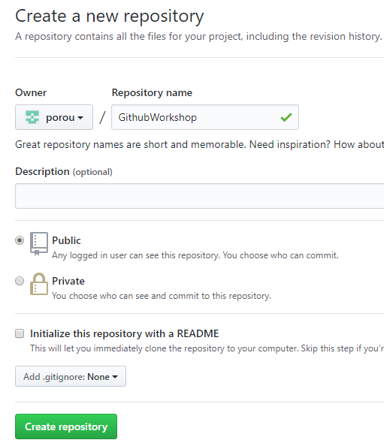

* 1. The repository should be displayed and also be empty. See below

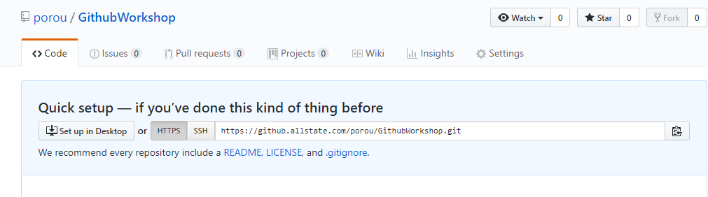

Click on the clipboard icon to copy the github url. We will use this later.

1. Open team project in Eclipse

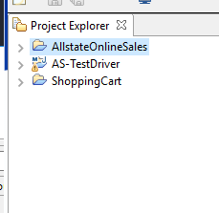

1. The next step is it create a local github repository. To do this right click on one of your projects and select Team 🡪Share Project.

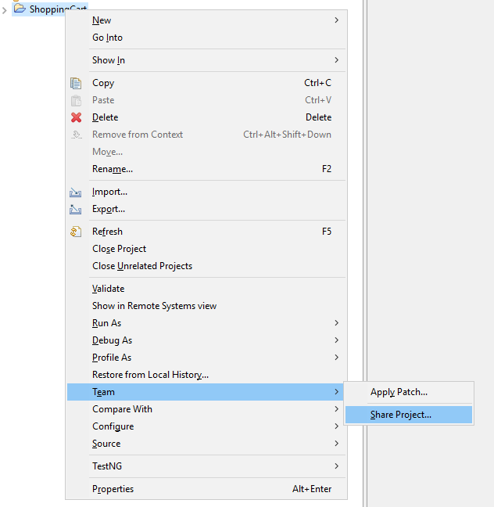

1. The panel below will be displayed. Check the Use or create repository in parent folder of project.

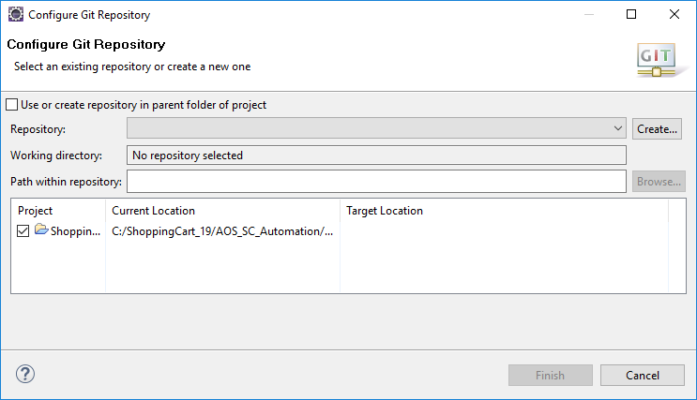

Select the project

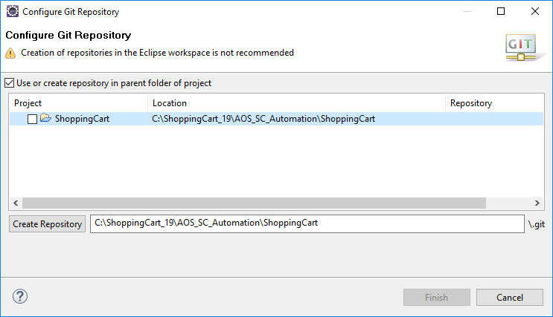

Remove the project folder leaving the path to the parent folder. See below.

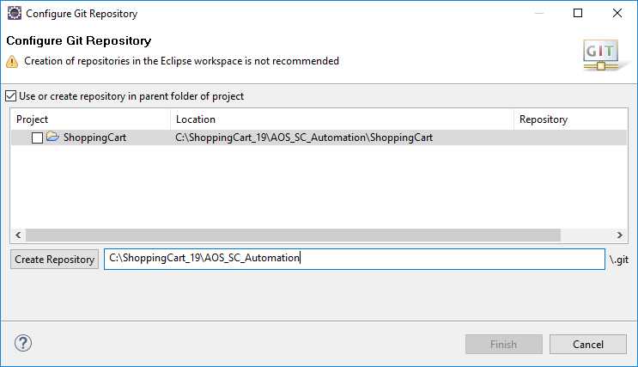

Click the Create Repository button. The checkbox beside the project should now be checked.

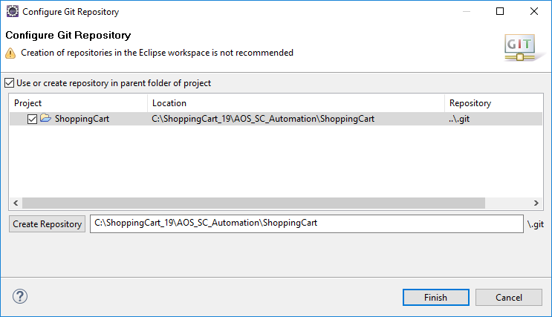

Click finish

The project in eclipse should now be linked to a github repo but with no head.

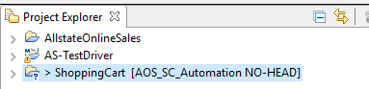

The new repository will also be displayed in the Git Repositories tab.

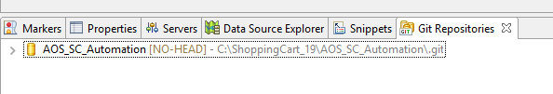

1. The next step is to add our project files to this new github repository. Right click on the project and select Team 🡪Commit

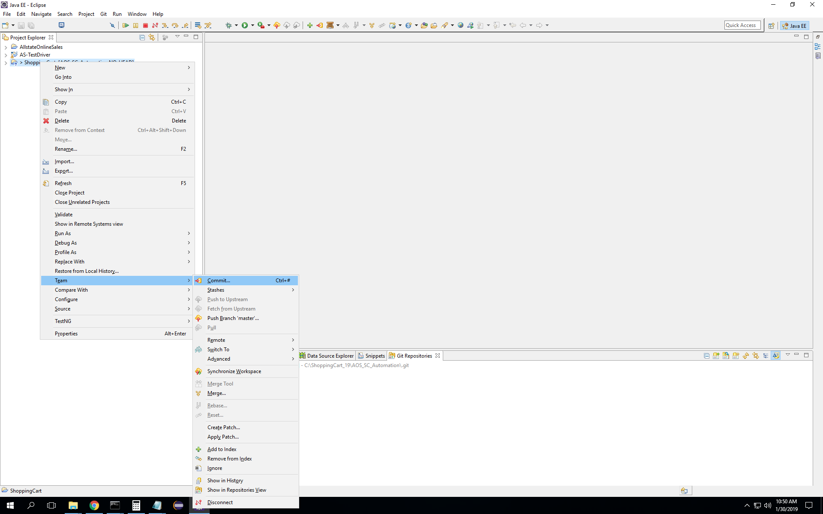

Enter a comment First Commit or github initialization.

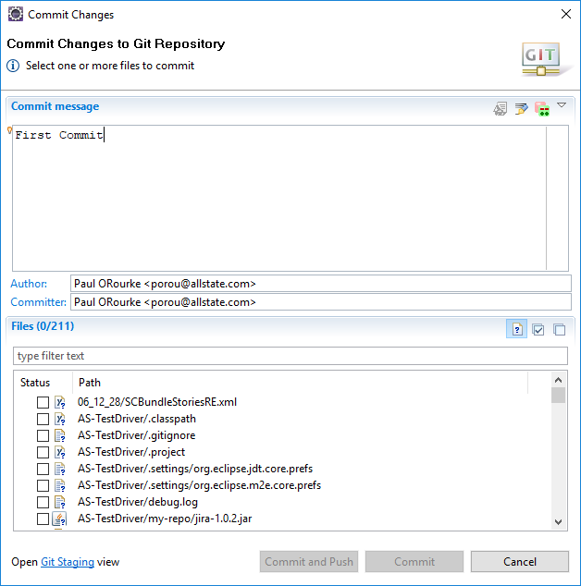

Then click the box with the tick in it to select all the files to add to github.

All the files should be selected. See below. Then click the commit button

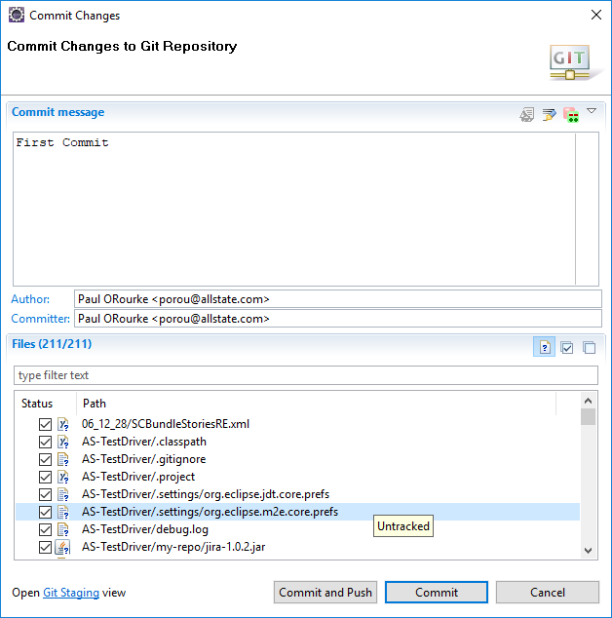

The project is now associated with a master branch no longer [NO-HEAD]

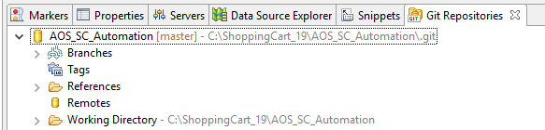

These changes have only been committed and tracked in your local repository. We need to get them pushed back into the remote repository that you created at the start of this process.

To get the github buttons added to the tool bar if they are missing. Select Window🡪Perspective🡪Customise Perspective

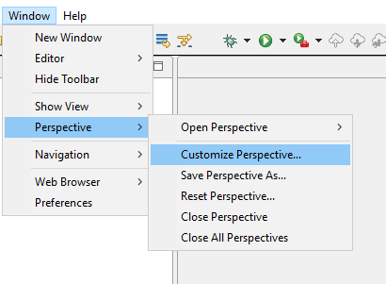

Select the action set availability tab and click the git checkbox.

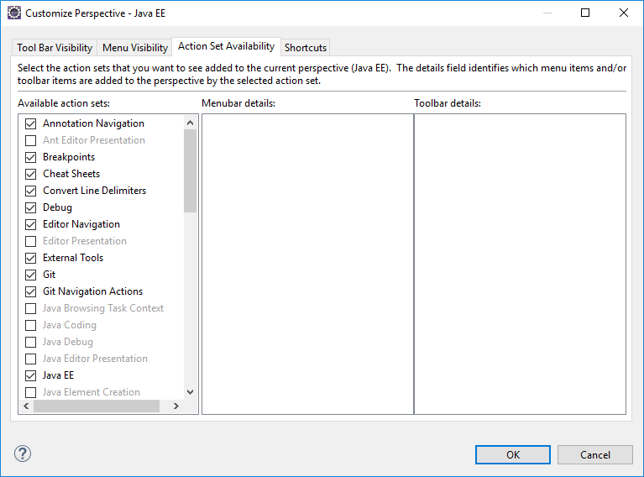

Click ok. The git buttons should be displayed in your tool bar.



Click the yellow cloud with the red arrow point up.

In the panel that displays enter the url of the github repo that you created earlier, into the URL field.

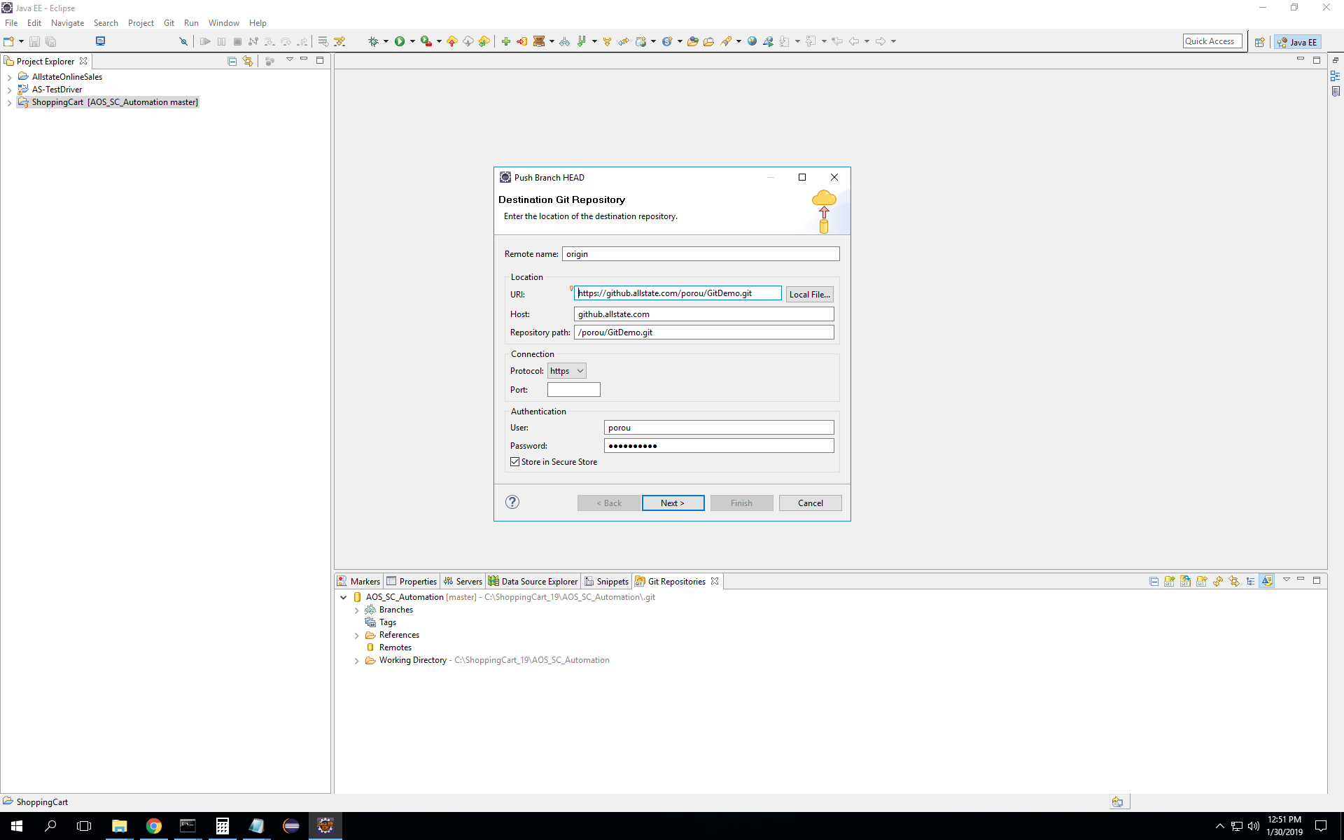

You may need to enter your windows credentials. Click Next

Rename the branch master and click next

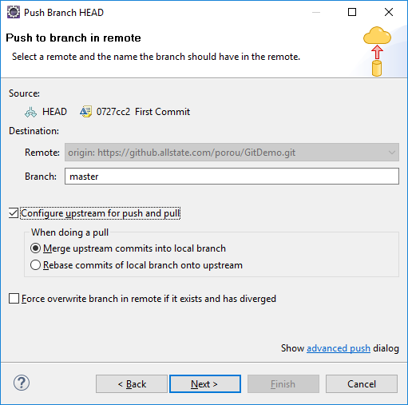

Confirmation that a new branch has been created should be displayed

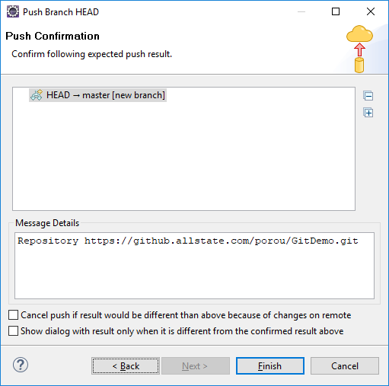

Click Finish

Finally refresh your github.allstate.com. Your project should be visible now in the remote repository.

