 DEPAUL University Library

Web Services Team

**ContentDM 6.1 Development Guide**

**Date:** 8/1/2012

**Prepared By:** Jim LeFager

Table of Contents

1. Revision History 3

2. Introduction 4

3. Upgrade 4

4. Development 5

5. Procedure 8

5.1. Creation of Navbar 8

5.2. Portal Landing Page 12

5.2.1. Upload Process 12

5.2.2. Search Box 13

5.2.3. Links to Collections 15

5.2.3.1. Containers 15

5.2.3.2. CSS 16

5.3. Images Carousel 18

5.4. Accordions 24

5.5. Custom Landing Pages 26

5.6. Google Analytics 28

# Revision History

|  |  |  |  |
| --- | --- | --- | --- |
| Date | Description | Revised by | Version No. |
| 12/02/2011 | Draft started – Original functions created for 6.0 | JL | 1 |
| 12/19/2011 | Updated to include Google Analytics | JL | 2 |
| 7/23/2012 | Updated following Usability study performed in the Fall of 2012 | JL | 3 |
|  |  |  |  |

# Introduction

The digitization platform ContentDM is a hosted product that the library uses for display of digitized, non-curricular based images. The hosted platform was upgraded on July 17th, 2011, and included a new customizable display for the landing page, and each collection page, as well as several other new features. Our instance had a test environment that allowed us to develop the site before the official launch on September 1st to the production site.

**Note:**

A usability study was conducted in the Fall of 2011 that showed that students usage of the CONTENTdm digital collections platform was focused on searching, the tabbed interface was generally ignored, and students were unaware of the scope of the collections. A redesigned interface was developed that placed the search box more prominently on the page, included a jquery carousel, and information about the collections was included on the landing page.

# Upgrade

The upgrade to CONTENTDM included the ability to upload CSS, JavaScript files, and custom landing pages both at a global level and at a collection level to the server. There is no native ability to edit the source code on the CONTENTDM server, but CONTENTDM also includes Jquery, and multiple Jquery libraries that when combined with the ability to upload custom CSS, JavaScript and custom pages allow for robust customizations.

Documentation on customizations and use of the API is available at <http://www.contentdm.com/help6/server-admin/index.asp>

Access to the admin area of the CONTENTDM servers: <https://server16106.contentdm.oclc.org>

* After logging in, choose website and then login in again using the same credentials to access the website configuration tool

Note: CONTENTdm was upgraded to 6.1 in January of 2012. These updates included several bug fixes and new social features including:

* Use Generated Content including tags, comments, and ratings
* Download of files and images
* Print menu
* Share option to social sites

# Development

A wireframe mockup was created following the usability testing showing the updated design featuring an image carousel, prominent search features, text about the collections and the mega drop down. Each published collection, eleven at the time of this report, would also need custom landing pages. Five of the published collections had several pages created in the older system that would need to be moved into the upgraded CONTENTDM site. At the time of the upgrade to 6.0, only one page was available for each collection so in order to migrate all of the content from the previous CONTENTDM site to the current site, content was placed in Jquery accordions.

Using the Website configuration tool, included in the web client for CONTENTDM, we are able to upload JavaScript, css files and custom landing pages to customize our instance.

**CSS Files**

Our uploaded CSS files include the following:

* Dpucdm8.css – Custom CSS file that controls global styles
* Collections.css – Custom CSS file that is applied to each collection page, containing the default styles for each collection
* Menu.css – Custom CSS file that contains styling for the dropdown mega menu

**JavaScript Files**

Top Includes

* jquery.easing.1.3.js – Used as part of the dropdown megamenu
* navbar.js – Core JS file that powers the megamenu
* carousel.jquery.js – Core JS file that is necessary for the image carousel on the landing page

Bottom Includes

* googleanalytics.js – Used to include the tracking code for the DePaul Google Analytics Account
* menu.js – jQuery file used to replace default CONTENTdm navigation with mega drop down

**Image Files**

Image files can be stored on the CONTENTdm servers using the Website Configuration tool. In order to maintain a consistent file structure, images are uploaded using the WYSIWIG editor located under Page Types – Home Page, under the Global Settings tab. Image files are created and uploaded, using the collection identifier so as to allow for consistent paths to images that can be edited and distributed for all collections.

**Steps to upload images**

1. Select the Image Icon from the WYSIWIG, and ignore the rest of the editor 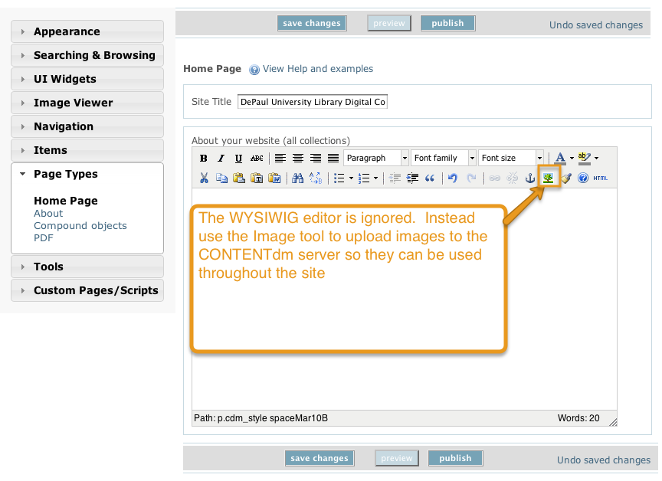
2. Select the icon in the upper right corner to access the upload menu

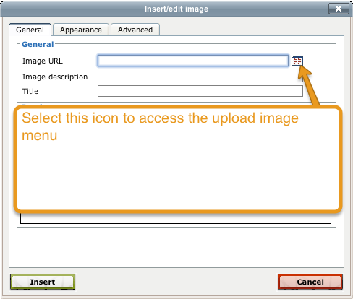

1. You may edit or upload new images using the tabbed interface

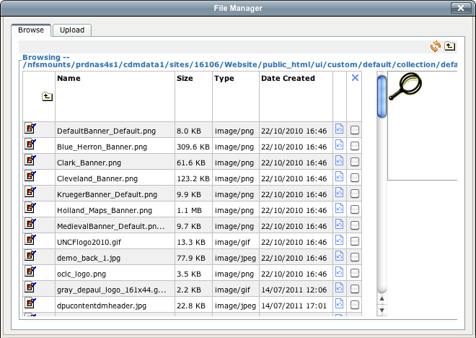

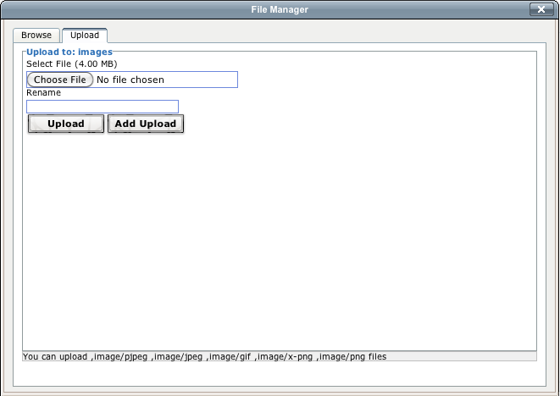

All images uploaded using this process can be accessed using the following path:

http://digicol.lib.depaul.edu/ui/custom/default/collection/default/images/filename.png

**Development Scenario**

* Place image carousel with media controls on global landing page using Jquery Carousel
* Replace current navigation menu with mega drop down menu using jquery tabs
* Create custom collection level pages for each published collection

# Procedure

## Creation of Navbar

In order to replace the native navbar in CONTENTDM with our upgraded Mega drop down, we use the jquery empty function to remove the original menu and .html to write our new menu. CSS styles for the dropdown menu are included in the dpucdm8.css file that has been uploaded to the CONTENTDM server on a global level. The navbar utilizes the following jquery libraries:

* core jquery library file jquery-1.4.2.min.js
* jquery.hoverintent.minifies.js
* jquery.ui.tabs.js.

All of these files are already included in CONTENTDM. Two additional files are also necessary and must be added to CONTENTDM via the custom scripts tool in ContentDM:

* navbar.js -which controls the functions of the MEGA drop down, and
* menu.js- which includes our replace function.

There is no need to link to any of the javascript files in the custom pages that are uploaded as the website configuration tool includes these files in the header, or in the footer.

### Upload menu.js to ContentDM using

Using Custom Scripts Menu, upload the menu.js file in the ‘Upload Bottom Includes’ option at the global level. Spaces usually used for displaying a hierarchical view are removed from this script since spaces cause an error in the execution

// JavaScript Document

//Removes original CONTENTDM MENU and replaces it with new dropdown menu   
$("div#nav_top_left").empty().html('<div id="nav_top_left"><ul class="nav" id="mega"><li class="nav_li"><a tabindex="1001" id="nav_top_left_first_link" href="/cdm/" class="selected" ><div class="nav_top_left_text_container">Home</div></a></li><li class="nav_li"><a href="/cdm/#tab-collections"><div class="nav_top_left_text_container">Collections&nbsp;&nbsp;<div style="float:right"><img src="http://cdm16106.contentdm.oclc.org/ui/custom/default/collection/default/images/down_arrow.png" border="none" /></div></div></a><div class="sub"> <div class="row"><ul><li><h2>DePaul Digital Collections</h2></li><li><a href="/cdm/landingpage/collection/dpubuilding" title="" class="first">DePaul University Buildings Collection</a></li><li><a href="/cdm/landingpage/collection/p15448coll1" title="DePaul University Yearbooks">DePaul University Yearbooks</a></li><li><a href="/cdm/landingpage/collection/gic" title="">Geographic Image Collection</a></li><li><a href="/cdm/landingpage/collection/lpnc1" title="Lincoln Park Architectural Photographs">Lincoln Park Architectural Photographs</a></li><li><a href="/cdm/landingpage/collection/lpnc6" title="Via Sapientiae">Lincoln Park Neighborhood Collection</a></li><li><a href="/cdm/landingpage/collection/iic" title=""> Photograph Souvenir Cards and Tarot Decks</a></li><li><a href="/cdm/landingpage/collection/p16106coll1" title="Selected Maps from Special Collections and Archives">Selected Maps from Special Collections and Archives</a></li><li><a href="/cdm/landingpage/collection/younglords" title="Young Lords">Young Lords Newspaper Collection</a></li></ul><ul><li><h2>Vincentian Collections</h2></li><li><a href="/cdm/landingpage/collection/p15448coll3" title="Vincentian Historical Texts">Vincentian Historical Texts</a></li><li><a href="/cdm/landingpage/collection/cm1" title="Vincentian Postcards">Vincentian Postcards</a></li><li><a href="/cdm/landingpage/collection/p15448coll2" title="Vincentiana - Historical Maps">Vincentiana - Historical Maps</a></li></ul></div></div> </li><li class="nav_li"><a tabindex="1002" href="/cdm/search"><div class="nav_top_left_text_container">Browse All</div></a></li><li class="nav_li"><a tabindex="1003" href="HTTP://library.depaul.edu"><div class="nav_top_left_text_container">DPU Libraries</div></a></li></ul></div>'); //Removes original CONTENTDM Footer and replaces it with updated DePaul footer $("div#nav_footer_left").empty().html('<div id="nav_footer_left"><ul class="nav"><li class="nav_footer_li"><a href="/cdm/">Home</a></li><li class="nav_footer_left_divider">|</li><li class="nav_footer_li"><a href="/cdm/#tab-about">About</a></li><li class="nav_footer_left_divider">|</li><li class="nav_footer_li"><a href="mailto:LibraryWeb@depaul.edu">Contact Us</a></li><li class="nav_footer_left_divider">|</li><li class="nav_footer_li"><a href="http://library.depaul.edu">DPU Libraries</a></li></ul><p class="dpuFooter"><span class="class="nav_footer_li">&copy;2011 DePaul University Libraries</span>&nbsp;&nbsp;&nbsp;&nbsp;<span class="nav_footer_left_divider">|</span>&nbsp;&nbsp;&nbsp;&nbsp;<span class="class="nav_footer_li"><a href="http://www.depaul.edu/disclaimer.asp" title="Disclaimer" target="_self">Disclaimer</a></span>&nbsp;&nbsp;&nbsp;&nbsp;<span class="nav_footer_left_divider">|</span>&nbsp;&nbsp;&nbsp;&nbsp;<span class="class="nav_footer_li">Administrative Offices, 2350 N Kenmore Avenue Chicago, IL 60614</span>&nbsp;&nbsp;&nbsp;&nbsp;<span class="nav_footer_left_divider">|</span>&nbsp;&nbsp;&nbsp;&nbsp;<span class="class="nav_footer_li">(773) 325-7862</span>&nbsp;&nbsp;&nbsp;&nbsp;</p></div>');

### Upload navbar.js file to ContentDM

This navbar.js javascript file controls the behaviors of the dropdown menu. Using the custom scripts menu, upload the navbar.js file in the ‘Upload top Includes’ option

function wrapLogout() { var expires = " expires=Thu, 01-Jan-1970 00:00:01 GMT;"; document.cookie = "WRAP16=;"+expires+" path=/;domain=ncsu.edu"; document.cookie = "WRAP_REFERER=;"+expires+" path=/;domain=ncsu.edu"; document.cookie = "WRAP_REFERER_P=;"+expires+" path=/;domain=ncsu.edu"; document.cookie = "LIBFUNCTION=;"+expires+" path=/;domain=ncsu.edu"; } function findWrap(){ var sindex = document.cookie.indexOf("WRAP16"); if (sindex != -1){ return 1; } return 0; } /* * jQuery In-field Labels Plugin v1.0 * http://richardscarrott.co.uk/posts/view/jquery-in-field-labels * * Copyright (c) 2010 Richard Scarrott * * Dual licensed under the MIT and GPL licenses: * http://www.opensource.org/licenses/mit-license.php * http://www.gnu.org/licenses/gpl.html * * Requires jQuery v1.3+ * */ (function($) { $.fn.inFieldLabels = function(filter) { var removeLabel = function($input) { // remove label if in 'label' state if ($input.hasClass('dummy')) { $input.hide().prev('input').show().focus(); } else if ($input.hasClass('label')) { $input.removeClass('label').val(''); } }; var addLabel = function($input) { var label = $input.data('label'), val = $input.val(); // add label if val is empty if ($input.is('input:password') && (val === '')) { $input.hide().next('input').val(label).show(); } else if (val === '') { $input.addClass('label').val(label); } }; return this.each(function() { var $form = $(this), $inputs = $form.find('input[type=text], input[type=password], textarea'); if (filter) {$inputs = $inputs.filter(filter);} $inputs.each(function() { var $input = $(this), label = $form.find('label[for=' + $input.attr('id') + ']').hide().text(); $input.data('label', label) .focus(function() { removeLabel($input); }).blur(function() { addLabel($input); }); if ($input.is('input:password')) { var $dummy = $('<input type="text" class="dummy label" />').insertAfter($input).focus(function() { removeLabel($dummy); }); if ($input.val() !== '') {$dummy.hide();} } addLabel($input); }); $form.submit(function() { $inputs.each(function() { removeLabel($(this)); }); }); }); }; })(jQuery); // console.log(gaID); //var _gaq = _gaq || []; // _gaq.push(['_setAccount', gaID]); // _gaq.push(['_setLocalRemoteServerMode']); // _gaq.push(['_trackPageview']); // // (function() { // var ga = document.createElement('script'); ga.type = 'text/javascript'; ga.async = true; // ga.src = ('https:' == document.location.protocol ? 'https://ssl' : 'http://www') + '.google-analytics.com/ga.js'; // var s = document.getElementsByTagName('script')[0]; s.parentNode.insertBefore(ga, s); // })(); $(document).ready(function() {

$('#search-header form').inFieldLabels(); // display logout link in utility navigation if(findWrap()) {

$('#libraries_title_menu li.last').before('<li><a href="http://www.lib.ncsu.edu/" onclick="wrapLogout();">Logout</a></li>'); } //Mega menus //On Hover Over function megaHoverOver(){

$(this).find(".sub").stop().fadeTo('fast', 1).show(); //Find sub and fade it in (function($) { //Function to calculate total width of all ul's jQuery.fn.calcSubWidth = function() { rowWidth = 0; //Calculate row

$(this).find("ul").each(function() { //for each ul... rowWidth += $(this).width(); //Add each ul's width together }); }; })(jQuery); if ( $(this).find(".row").length > 0 ) { //If row exists... var biggestRow = 0; $(this).find(".row").each(function() { //for each row... $(this).calcSubWidth(); //Call function to calculate width of all ul's //Find biggest row if(rowWidth > biggestRow) { biggestRow = rowWidth; } });

$(this).find(".sub").css({'width' :biggestRow}); //Set width $(this).find(".row:last").css({'margin':'0'}); //Kill last row's margin } else { //If row does not exist...

$(this).calcSubWidth(); //Call function to calculate width of all ul's $(this).find(".sub").css({'width' : rowWidth}); //Set Width } } //On Hover Out function megaHoverOut(){

$(this).find(".sub").stop().fadeTo('fast', 0, function() { //Fade to 0 opactiy

$(this).hide(); //after fading, hide it }); } //Set custom configurations var config = { sensitivity: 2, // number = sensitivity threshold (must be 1 or higher) interval: 10, // number = milliseconds for onMouseOver polling interval over: megaHoverOver, // function = onMouseOver callback (REQUIRED) timeout: 10, // number = milliseconds delay before onMouseOut out: megaHoverOut // function = onMouseOut callback (REQUIRED) };

$("ul#mega li .sub").css({'opacity':'0'}); //Fade sub nav to 0 opacity on default $("ul#mega li").hoverIntent(config); //Trigger Hover intent with custom configurations });

## Portal Landing Page

## Upload Process

The Portal landing page contains the image carousel, the updated search box, links to each collection, and descriptive text about the scope of the collections. The current template is portal12.html and is uploaded to CONTENTdm using the following method:

1. Log in to the CONTENTdm Website Configuration Tool.
2. Under the **Global Settings Tab,** choose **Page Types** and then **Home Page**
3. On the new page that appears, select “More homepage configurations” and select “Custom (replace with my own HTML page)”
4. Click **Browse** under upload your custom page and navigate to the updated template and choose upload.
5. When you have uploaded the document, Click **Save Changes,** and then **publish** in order for your changes to appear on the site.

## Search Box

The customizations to the search box done via CSS, and are included as inline style changes in the template file, currently portal12.html. This is done so that the changes are only available on the CONTENTdm portal landing page, and not throughout the entire CONTENTdm site since we only want these changes to appear on the landing page.

/*Inline Styling to override and position Search Bar in Center of Page*/

a:link, a:active, a:visited, a:hover {

color:#006FD1;

text-decoration:none;

}

#search {

height: 44px !important;

background-color: white !important;

margin: 50px -74px !important;

overflow: visible;

border-bottom: none !important;

}

#search_content {

font-family: Verdana, Arial, Helvetica, sans-serif;

margin: 7px 0 0 100px !important;

clear: both;

}

.search_content_box_noresults {

border: 1px solid #7F9DB9;

width: 450px !important;

margin: 0 15px 0 0;

height: 30px !important;

font-size: 18px !important;

}

.search_content_button {

height: 32px !important;

font-family: Verdana, Arial, Helvetica;

font-weight: bold;

font-size: 18px !important;

text-align: center;

color: white;

background-color: steelBlue;

border: 1px solid;

padding: 5px 6px 3px 5px !important;

margin: 0 5px 0 0 !important;

cursor: pointer;

border-color: midnightBlue;

}

/*Search Button*/

#search_content_text {

/*color: black;

font-family: Arial;

font-size: 18px !important;

font-weight: bold;

margin: 10px 5px 0 0 !important;*/

display:none;

}

/*Advanced Search*/

.action_link_10 {

font-family: Verdana;

font-size: 18px !important;

font-weight: normal;

color: #006FD1;

font-style: normal;

text-decoration: none;

padding: 10px 15px !important;

}

#adv_search {

font-family: Verdana, Arial, Helvetica, sans-serif;

background-color: #f6f6f6;

display: none;

border: solid #333333 2px;

padding-bottom: 20px;

margin-top: -40px !important;

width: 910px;

margin-left: 30px;

margin-bottom: 10px;

}

/*#top_content {

margin: 0 30px 0 30px;

min-width: 960px;

display: none !important;

}*/

#breadcrumb_top {

padding: 14px 0 24px 0;

vertical-align: middle;

overflow: hidden;

min-width: 811px;

text-overflow: ellipsis;

display: none;

}

#backToTopLink {

display: none !important;

}

## Links to Collections

Links to collection are contained within nested divs, located below the searchbar. The CSS styles for the div containers are stored within the dpucdm8.css file.

## Containers

<div class="dpu_portalbox_inner">

<div class="dpu_portalbox_inner_left">

<!--Collection Container-->

<div class="dpu_portalcontainer">

<div class="dpu_portalcontainertitle"><h3 class="dpu_portalcontainertitle">DePaul Digital Collections</h3></div>

<div class="dpu_portalcontainerleft"><img class="img.dpu_portalcontainerleft" src="http://digicol.lib.depaul.edu/ui/custom/default/collection/default/images/depaul_portal_leftbox.jpg" />

</div>

<div class="dpu_portalcontainerright"><ul>

<li><a href="/cdm/landingpage/collection/dpubuilding" title="" class="first">DePaul University Buildings Collection</a></li>

<li><a href="/cdm/landingpage/collection/p15448coll1" title="DePaul University Yearbooks">DePaul University Yearbooks</a></li>

<li><a href="/cdm/landingpage/collection/scimages" title="Exhibits from the DePaul University Libraries and Partners">Exhibits from DePaul University Libraries & Partners</a></li>

<li><a href="/cdm/landingpage/collection/gic" title="">Geographic Image Collection</a></li>

<li><a href="/cdm/landingpage/collection/lpnc1" title="Lincoln Park Architectural Photographs">Lincoln Park Architectural Photographs</a></li>

<li><a href="/cdm/landingpage/collection/lpnc6" title="Lincoln Park Neighborhood Collection">Lincoln Park Neighborhood Collection</a></li>

<li><a href="/cdm/landingpage/collection/iic" title=""> Photograph Souvenir Cards and Tarot Decks</a></li>

<li><a href="/cdm/landingpage/collection/p16106coll1" title="Selected Maps from Special Collections and Archives">Selected Maps from Special Collections and Archives</a></li>

<li><a href="/cdm/landingpage/collection/younglords" title="Young Lords">Young Lords Newspaper Collection</a></li>

</ul></div>

</div>

<div style="clear:both"></div>

<!--Collection Container-->

<div class="dpu_portalcontainer" id="dpu_vincentian">

<div class="dpu_portalcontainertitle">

<h3 class="dpu_portalcontainertitle">Vincentian Collections</h3></div>

<div class="dpu_portalcontainerleft"><img class="img.dpu_portalcontainerleft" src="http://digicol.lib.depaul.edu/ui/custom/default/collection/default/images/vincentian_portal_leftbox.jpg" />

</div>

<div class="dpu_portalcontainerright">

<ul>

<li><a href="/cdm/landingpage/collection/p15448coll3" title="Vincentian Historical Texts">Vincentian Historical Texts</a></li>

<!--<li><a href="/cdm/landingpage/collection//p15448coll4" title="Holy Cards">Holy Cards</a></li>-->

<li><a href="/cdm/landingpage/collection/cm1" title="Vincentian Postcards">Vincentian Postcards</a></li>

<li><a href="/cdm/landingpage/collection/p15448coll2" title="Vincentiana - Historical Maps">Vincentiana - Historical Maps</a></li>

</ul></div></div>

</div>

<div class="dpu_portalbox_inner_right">

<div class="abouttextportal">

<h3>About</h3>

<p> The DePaul University Libraries Digital Collections include a variety of online images for researchers and the general public. The collections include historical photographs of the Lincoln Park neighborhood surrounding DePaul University's main campus, historical photos of DePaul University buildings and Vincentian maps, postcards and other ephemera.</p>

</div>

</div>

</div>

## CSS

/*-----------------Landing Page Styles--------------------------*/

.abouttextportal {

width: 230px;

padding: 0 10px 10px 10px;

margin-right: 30px;

margin-left: 0;

}

#dpu_vincentian {

border-top: 1px solid #333;}

.dpu_portalcontainertitle{

height:30px;

margin:0;

padding-top: 5PX;

padding-right: 0;

padding-bottom: 0;

padding-left: 0;

}

.dpu_portalcontainertitle h3{

text-align:center;

}

.dpu_portalcontainerleft img {

margin-left: 10px;

margin-right: 55px;

padding: 5px;

border: 1px solid #CCC !important;

-moz-box-shadow: 0px 0px 10px rgba(0,0,0,.2);

-webkit-box-shadow: 0px 0px 10px rgba(0,0,0,.2);

box-shadow: 0px 0px 10px rgba(0,0,0,.2);

width:270px;

margin-bottom: 10px;

}

.dpu_portalcontainerleft{

width: 45%;

height: 100%;

float: left;

}

.dpu_portalcontainerright{

/*width:300px;*/

height:100%x;

float:left;

}

.dpu_portalcontainerright ul li {

list-style:none;

padding: 4px;

font-size: 12px;

}

.dpu_portalbox_outer {

width: 1002px;

margin-left: 0px;

margin-top: -30px;

}

.dpu_portalbox_inner {

-moz-box-shadow: 0px 0px 10px rgba(0,0,0,.2);

-webkit-box-shadow: 0px 0px 10px rgba(0,0,0,.2);

box-shadow: 0px 0px 10px rgba(0,0,0,.2);

background:#ccc;

height:512px;

border-bottom: 1px solid #ccc;

border-left: 1px solid #ccc;

border-right: 1px solid #ccc;

}

.dpu_portalbox_inner_left {

height: 100%;

width: 70%;

float: left;

background:#FFF;

}

.dpu_portalbox_inner_right {

width: 23%;

float: left;

padding: 0 0 10PX 15PX;

}

## Images Carousel

The image slideshow makes use of the Jquery Carousel plug-in.

This plug-in require that two scripts be uploaded to ContentDM:

* carousel.jquery.js
* jquery.easing.1.3.js.

There is also a set of CSS stylings added to the dpucdm8.css file that apply to the carousel.

### Necessary Scripts

Using Custom Scripts Menu, upload the carousel.jquery.js and jquery.easing.1.3.js file in the ‘Upload Top Includes’ option at the global level. The Jquery Carousel plug-in allows for controls for display time, navigation buttons and previous actions. The initialization script for the image carousel is contained in the carousel.jquery.js file.

$(document).ready(function () {

$(function() {

$("#carousel").jCarouselLite({

btnNext: "#carousel .next",

btnPrev: "#carousel .prev",

visible: 1,

scroll: 1,

auto: 8000,

speed: 1200,

mouseWheel: true

});

});

});

For our instance, the time between slides, or timeout is set to 8000, 8 seconds.

### CSS stylings

CSS stylings for the image carousel are contained within the dpucdm8.css file, uploaded to ContentDM using the Custom CSS menu.

/*IMAGE SLIDESHOW*/

#carouselcontainer {

width: 980px;

float: left;

clear: left;

/*height: 222px;*/

padding:10px;

border: 1px solid #CCCCCC;

background-color:#EEEEEE;

margin:25px 0 0 0;

position:relative;

}

#carousel {

position:/* absolute */ relative !important;

/*top:125px; left:120px; */

overflow:hidden;

width:985px;

border:/* 1px solid #909090; */ none;

/*padding: 0 0 10px 0;*/

}

#carousel .prev, #carousel .next {

width:43px; height:43px;

position:absolute; top:70px;

background:url(http://www.libraries.psu.edu/etc/designs/psul/images/carousel_arrows.png) no-repeat;

z-index:20000;

}

#carousel .prev {

left:10px; background-position:top left;

}

#carousel .prev:hover {

background-position:bottom left;

}

#carousel .next {

right:10px; background-position:top right;

}

#carousel .next:hover {

background-position:bottom right;

}

#carousel ul {

margin:0; padding:0;

}

#carousel li {

width:980px; height:200px !important; position:relative;

margin: 0;

padding: 0;

}

#carousel li a {

margin:0; padding:0; border:none; text-decoration:none !important;

}

#carousel li .text-box {

height: 55px;

position: absolute;

left: 0;

bottom: 0;

width: 371px;

background: #333;

padding: 0 0 0 10px;

opacity: 0.8;

/* IE 5-7 */

filter: alpha(opacity=75);

border-top: 1px solid #fff;

border-right: 1px solid #fff;

}

#carousel li .title {

display:block;

color:#fff; margin:0; text-decoration:none !important;

font:bold 16px Arial, Helvetica, sans-serif;

padding:3px 0 3px 0;

}

#carousel li .description {

color:#fff; text-decoration:none !important;

font:11px Arial, Helvetica, sans-serif;

line-height:10px;

border: none;

padding: 0 5px 0 0;

}

#carousel li .more {

color:#fff; font:bold 10px "Lucida Grande", Arial, Helvetica, sans-serif;

text-decoration:none !important;

}

#carousel li img.screenshot {

position:absolute; left:0; top:0;

border: none;

width:980px;

}

#carousel h2 {

color:#fff;

position:absolute; left:0; top:0;

z-index:20000;

background:url(../images/news_header.png);

width:100%; height:22px;

text-indent:-9999px;

margin: 0;

padding: 0;

}

#carousel_ltail {

position:absolute; left:0; top:212px;

width:10px; height:10px;

background:url(../images/news_ltail.png);

display:block;

z-index:20000;

}

#carousel_rtail {

position:absolute; right:0; top:212px;

width:10px; height:10px;

background:url(../images/news_rtail.png);

display:block;

z-index:20000;

}

### Carousel

The carousel itself is included in the portal12.html template that is uploaded to CONTENTdm. The image carousel is contained within a div element with ID ‘carousel’. The ID ‘carousel’ is initialized in the script included in carousel.jquery.js. Each li element contains the image, description and link to a specific collection.

<div id="carouselcontainer">

<div id="carousel">

<h2 id="carousel_title"></h2>

<div class="prev">&nbsp;</div>

<div class="next">&nbsp;</div>

<ul>

<li>

<a href="http://digicol.lib.depaul.edu/cdm/landingpage/collection/scimages">

<img class="screenshot" alt="DePaul University Buildings" src="http://digicol.lib.depaul.edu/ui/custom/default/collection/default/images/scimages.jpg" />

<span class="text-box">

<span class="title">Exhibits from the DePaul University Libraries and Partners</span>

<span class="description"></span>

<span class="more"></span>

</span>

</a>

</li>

<li>

<a href="http://digicol.lib.depaul.edu/cdm/landingpage/collection/dpubuilding">

<img class="screenshot" alt="DePaul University Buildings" src="http://digicol.lib.depaul.edu/ui/custom/default/collection/default/images/dpubuilding.jpg" />

<span class="text-box">

<span class="title">DePaul University Buildings</span>

<span class="description"></span>

<span class="more"></span>

</span>

</a>

</li>

<li>

<a href="http://digicol.lib.depaul.edu/cdm/landingpage/collection/gic">

<img class="screenshot" alt="Geographic Image Collection" src="http://digicol.lib.depaul.edu/ui/custom/default/collection/default/images/gic.jpg" />

<span class="text-box">

<span class="title">Geographic Image Collection</span>

<span class="description"></span>

<span class="more"></span>

</span>

</a>

</li>

<li>

<a href="http://digicol.lib.depaul.edu/cdm/landingpage/collection/cm1">

<img class="screenshot" alt="Vincentian Postcards Collection" src="http://digicol.lib.depaul.edu/ui/custom/default/collection/default/images/cm1.jpg" />

<span class="text-box">

<span class="title">Vincentian Postcards</span>

<span class="description"></span>

<span class="more"></span>

</span>

</a>

</li>

<li>

<a href="http://digicol.lib.depaul.edu/cdm/landingpage/collection/p15448coll1">

<img class="screenshot" alt="DePaul University Yearbooks" src="http://digicol.lib.depaul.edu/ui/custom/default/collection/default/images/p15448coll1.jpg" />

<span class="text-box">

<span class="title">DePaul University Yearbooks</span>

<span class="description"></span>

<span class="more"></span>

</span>

</a>

</li>

<li>

<a href="http://digicol.lib.depaul.edu/cdm/landingpage/collection/p15448coll2">

<img class="screenshot" alt="Vincentiana - Historical Maps" src="http://digicol.lib.depaul.edu/ui/custom/default/collection/default/images/p15448coll2.jpg" />

<span class="text-box">

<span class="title">Vincentiana - Historical Maps</span>

<span class="description"></span>

<span class="more"></span>

</span>

</a>

</li>

<li>

<a href="http://digicol.lib.depaul.edu/cdm/landingpage/collection/p15448coll3">

<img class="screenshot" alt="Vincentian Historical Texts" src="http://digicol.lib.depaul.edu/ui/custom/default/collection/default/images/p15448coll3.jpg" />

<span class="text-box">

<span class="title">Vincentian Historical Texts</span>

<span class="description"></span>

<span class="more"></span>

</span>

</a>

</li>

<li>

<a href="http://digicol.lib.depaul.edu/cdm/landingpage/collection/p16106coll1">

<img class="screenshot" alt="Selected Maps from Special Collections and Archives" src="http://digicol.lib.depaul.edu/ui/custom/default/collection/default/images/p16106coll1.jpg" />

<span class="text-box">

<span class="title">Selected Maps from Special Collections and Archives</span>

<span class="description"></span>

<span class="more"></span>

</span>

</a>

</li>

<li>

<a href="http://digicol.lib.depaul.edu/cdm/landingpage/collection/younglords">

<img class="screenshot" alt="Young Lords" src="http://digicol.lib.depaul.edu/ui/custom/default/collection/default/images/younglords.jpg" />

<span class="text-box">

<span class="title">Young Lords</span>

<span class="description"></span>

<span class="more"></span>

</span>

</a>

</li>

</ul>

<div id="carousel_ltail"></div>

<div id="carousel_rtail"></div>

</div>

## Accordions

In order to include all of the content from previously created custom pages, jquery accordions were used. The jquery accordion plug-in, and jquery.ui.accordion.js, are already included within ContentDM and no other scripts are necessary to upload. CSS Customizations that target the accordions are included in css file specific to the collection landing pages, collections.css. This file is uploaded to each collection using the Custom CSS options at the collection level.

### Necessary Scripts

Each accordion is unique to the collection page it resides in and a script is included in the header area of a custom template created for each collection. If multiple accordions are to be used, or if nested accordions are used, two instances of the accordion must be included. The script below initializes the accordion function and uses the H3 tag as the selector. This script includes options, including setting ‘active’ to false in order for all accordions to be closed or non active when the page load and all accordions are set to collapsible, meaning the set of accordions can be complete closed as opposed to always having one accordion open.

<script type="text/javascript">// <![CDATA[ $(function() { //$( "#accordion" ).accordion({ header: "h3", autoHeight: false,active: false,collapsible: true}); $("#accordion").accordion({ header: "h3", autoHeight: false, active: false, collapsible: true, cookie: {expires: 1} }); $("#accordion2").accordion({ header: "h3", active: false, collapsible: true, cookie: {expires: 1} }); }); //getter // ]]></script>

### CSS

The css customizations are included in the collections.css file, uploaded to each collection using the Custom CSS options menu.

.accordion_windowb {

display: block;

-moz-border-radius-bottomleft: 4px;

-moz-border-radius-bottomright: 4px;

color: #333; border-top: 0 none; margin: 0; overflow: auto;

padding: 1em 2.2em 5px 2.2em;

position: relative; top: 1px;

font-size: 100%; line-height: 1.3;

list-style: none outside none;

margin: 0;

outline: 0 none;

text-decoration: none;

font-family: Verdana,Arial,Helvetica,sans-serif;

}

.accordion_window {

display: block;

-moz-border-radius-bottomleft: 4px;

-moz-border-radius-bottomright: 4px;

border: 1px solid #DDD;

color: #333;

border-top: 0 none;

margin: 0;

overflow: auto;

padding: 1em 4px 4px 4px;

position: relative;

top: 1px;

font-size: 100%;

line-height: 1.3;

list-style: none

margin: 0;

outline: 0 none;

text-decoration: none;

font-family: Verdana,Arial,Helvetica,sans-serif;

}

.accordion_header_closedb {

background-image: none;

border: 1px solid lightGrey;

color: #555;

}

.accordion_header_closedb a:link, .accordion_header_closedb a:visited, .accordion_header_closedb a:hover {

background-image: none; color: #555; }

.accordion_header_closedb a:active {

border: 1px solid #D3D3D3; color: #555555; }

### Examples of Accordions

Accordions are contained within a div with ID of ‘accordion’. Each H3 tag is set as the selector for each accordion, with the div directly below the h3 tag set to contain the content for the accordion.

Example of single accordion:

<div id="accordion" class="cdm_togglebox ui-accordion ui-widget ui-helper-reset ui-accordion-icons">

<!--Architect-->

<h3 id="details_accordion_description_link" class="accordion_header ui-accordion-header ui-helper-reset accordion_header_closedb ui-state-default ui-corner-all"><span class="accordion_header_icon ui-icon ui-icon-triangle-1-e accordion_header_icon_closed"> </span> <a tabindex="-1" href="javascript://;"> Architect </a></h3>

<div class="accordion_window ui-accordion-content ui-helper-reset ui-widget-content ui-corner-bottom"> <p>Include some descriptive test</p> <ul> <li><a href="/cdm/search/collection/dpubuilding/searchterm/Murphy%20and%20Camp">Murphy and Camp</a></li>

<li><a href="/cdm/search/collection/dpubuilding/searchterm/J.E.O%20Pridmore">J.E.O Pridmore</a></li>

<li><a href="/cdm/search/collection/dpubuilding/searchterm/Naess%20and%20Murphy"> Naess and Murphy</a></li> </ul> </div>

## Custom Landing Pages

Custom landing pages were created for the ContentDM portal as well as for each individual collectionlanding page. ContentDM allows for uploading of .php files, and .html files. For our purposes, all files included were .html since we were unable to query any existing functions in ContentDM using php. Each custom page only requires the content located between the <body> tags, meaning the head and page declaration are unnecessary. All custom pages can be uploaded using the menu in the website configuration tool under Page Types -> More Landing Page configurations -> and using the menu provided, users may upload custom pages and publish them in place of the standard WYSIWIG editor based version.

The following workflow applies to all new collections ready to be published to CONTENTdm.

**Workflow:**

**Preparation**

1. A collection lead is identified and selects with features they would like activated for the collection, and when it should be scheduled to be published
2. The collection lead provides text for the landing page and lists other additional features that should be included on the landing page including links to canned searches and accordions with selected links or content.
3. A landing page is developed by web services, using the text provided and including a representative image of the collection.
4. An image is created for the Image Carousel on the global landing page.
5. All images are uploaded using the **Steps to Upload images**

**Publishing**

1. The landing page is published by navigating to the collection editing menu under the Collections tab in the Website Configuration tool. From here a new page is uploaded under Page Types -> Landing Pages -> More Landing page configurations -> Upload your custom page. Once uploaded you must click “save changes” and then “publish” in order for your changes to appear
2. The global landing page, portal12.html is updated to include the reference to the carousel image and links to the new collection . This is then uploaded the Global Settings tab of the Website Configuration Tool under Page Types -> Home Page - > More Home page configurations -> Upload your custom home page. Again, you must click “save changes” and then “publish” in order for your changes to appear
3. The menu.js file is updated to include a link to the new collection in the mega dropdown menu. This may need to be uploaded to each collection landing page, so testing will be necessary. Initially this will need to be uploaded under Custom Pages/Scripts -> Custom Scripts -> Upload Bottom Includes

Following all of these steps, the new collection landing page will be publicly available and links to the new collection will be included on the landing page and in the drop down menu.

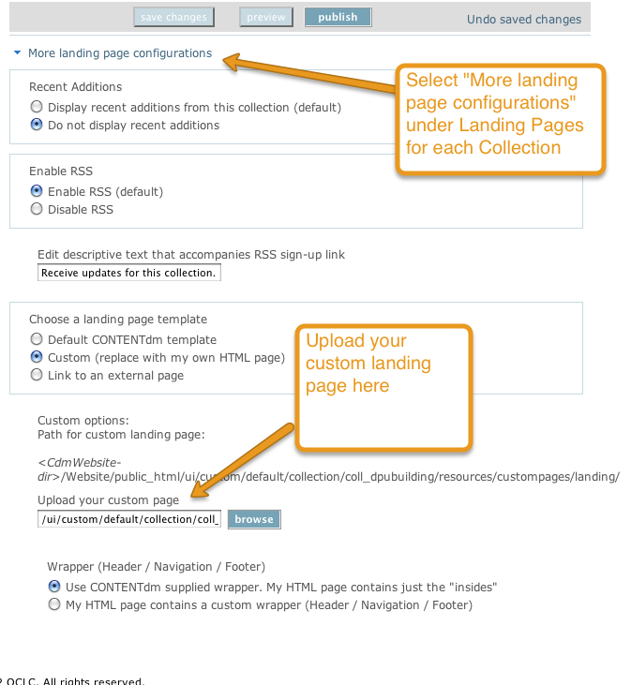

## Google Analytics

In order to include the Google analytics tracking code in CONTENTDM, a separate script was created, googleanalytics.js. Using Custom Scripts Menu, upload the googleanalytics.js file in the ‘Upload bottom Includes’ option at the global level. This insures that Google Analytics is included on every page within CONTENTDM.

// JavaScript Document

//Google Analytics

var _gaq = _gaq || []; _gaq.push(['_setAccount', 'UA-5169126-1']); _gaq.push(['_trackPageview']); (function() { var ga = document.createElement('script'); ga.type = 'text/javascript'; ga.async = true; ga.src = ('https:' == document.location.protocol ? 'https://ssl' : 'http://www') + '.google-analytics.com/ga.js'; var s = document.getElementsByTagName('script')[0]; s.parentNode.insertBefore(ga, s); })(); try{ var pageTracker = _gat._getTracker("UA-5169126-1"); pageTracker._setDomainName("none"); pageTracker._setAllowLinker(true); pageTracker._trackPageview(); } catch(err) {}