“A Comparative Study of GenAI-Generated and Human-Authored Black-Box Test Suites”

1. RESEARCH PROBLEM
Recent advances in Generative Artificial Intelligence (GenAI), especially Large Language Models (LLMs), have enabled automated generation of software testing artifacts from natural-language requirements. AI systems are increasingly capable of transforming software specifications into black-box test scenarios and executable testing scripts. Although these approaches improve testing speed and scalability, concerns remain regarding the logical correctness, edge-case coverage, and real-world defect detection capability of AI-generated test suites. Existing studies mainly focus on generation feasibility and syntax correctness, while limited research directly compares AI-generated test suites with human-authored testing artifacts in terms of testing quality and logical coverage.
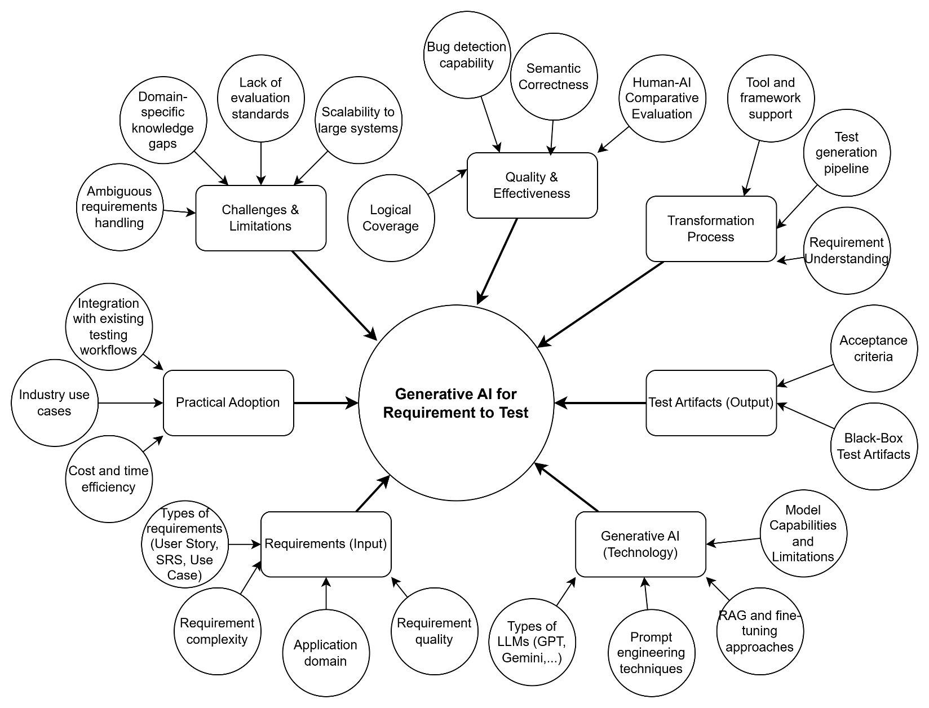
Figure 1. Conceptual overview of the research domain “Generative AI for Requirement-to-Test Generation”.

2. EXPLORATORY RESEARCH QUESTION MATRIX

Aspect 1: Requirements (Input)
- 5 Whys Rationale: GenAI tests deviate from business flows due to input ambiguity (Why 1), causing models to resolve gaps via probabilistic hallucinations (Why 2). Monolithic SRS and Agile User Stories display variant hallucination rates due to token capacity limits versus missing functional constraints (Why 3). Prompt engineering cannot fix this because prompts govern style, not missing source logic (Why 4). Thus, researching input morphology shapes output correctness (Why 5).
- RQ1: How do structural complexity and semantic ambiguity in input specifications quantitatively impact the semantic error and hallucination rates of LLMs?
- RQ2: How do different requirement formatting structures (SRS vs. User Stories) affect a generative architecture's capacity to cover exceptional edge cases?

Aspect 2: Generative AI (Technology)
- 5 Whys Rationale: Generic models fail due to domain knowledge gaps (Why 1). RAG addresses this by grounding context with proprietary databases (Why 2). However, combining RAG with few-shot prompting creates instability because maximizing retrieval ($k$ chunks) conflicts with strict template formatting constraints (Why 3). Variant model architectures manage this conflict differently based on reasoning capabilities (Why 4). Identifying this technical boundary controls artifact quality (Why 5).
- RQ3: How does the interaction between prompt paradigms (Zero-shot vs. Few-shot) and RAG chunking strategies affect the automated text-matching metrics (BLEU, ROUGE, METEOR) of functional test suites?

Aspect 3: Transformation Process
- 5 Whys Rationale: Single-step transformations exhibit low reliability due to excessive cognitive load on a single turn (Why 1). Multi-stage prompt-chaining splits processing load, forcing systematic comprehension before technical code compilation (Why 2). This enables QA engineers to embed validation checkpoints at intermediate stages (Why 3), ensuring functional assets rigidly adhere to target testing framework standards (Why 4). Optimizing pipeline designs improves automation tools (Why 5).
- RQ4: How does a multi-stage prompt-chaining pipeline architecture improve the automation level and structural accuracy of executable scripts compared to single-step workflows?

Aspect 4: Test Artifacts (Output)
- 5 Whys Rationale: Synthesized scripts often possess perfect syntax but fail runtime validation because they lack dynamic awareness of operational web UI selectors (Why 1). Coupling Gherkin scenarios with HTML DOM context maps natural language criteria directly to structural identifiers (Why 2). Context purging is mandatory because raw HTML noise saturates the context window (Why 3). Acceptance test generation suffers from higher failure rates because dynamic UIs require the model to abstractly infer sequential state changes (Why 4). Evaluating these limits verifies runnable fidelity (Why 5).
- RQ5: How is the capacity of generative architectures to translate natural language test artifacts into executable scripts (Cypress) constrained by the structural identifier context (HTML DOM) of the application?

Aspect 5: Quality & Effectiveness
- 5 Whys Rationale: Coverage metrics and logical test correctness exhibit an inverse trend because models easily generate high-volume repetitive scenarios that inflate coverage while degrading step logic (Why 1). Models display lower efficacy than manual testing for mathematical boundaries because they operate as text predictors rather than discrete logical processors (Why 2). Human-AI synergy achieves superior bug-targeting because human engineers share uniform cognitive biases while AI offers complementary perspectives (Why 3). Redundancy filtering suffers from high false-positives because the model misinterprets identical interface steps across different system roles, missing isolated permission paths (Why 4). Mapping this establishes standardized human-machine benchmarks (Why 5).
- RQ6: What specific capability gaps do GenAI-generated black-box test suites exhibit in terms of logical partition coverage and analytical fault-targeting intelligence compared to manual testing?
- RQ7: What logical contextual challenges lead to elevated false-positive rates when generative AI automatically filters redundant test cases across separate system actors?

Aspect 6: Challenges & Limitations
- 5 Whys Rationale: Scaling automated solutions is blocked because monolithic specification density rapidly exceeds optimal context window thresholds (Why 1). Massive scale introduces hidden cross-functional dependencies that cause the model to lose logical consistency (Why 2). Automated text metrics are ineffective because vocabulary-matching (BLEU/ROUGE) only measures surface-level lexical similarity, failing to validate execution logic (Why 3). Domain knowledge gaps compound across sequential stages, collapsing test suite logic (Why 4). Defining these limits maps industrial performance boundaries (Why 5).
- RQ8: How can the context-saturation phenomenon ("Lost in the Middle") in LLMs be mitigated when designing system test scenarios for monolithic, highly complex specification documentation?
- RQ9: What systemic barriers does the absence of execution-aware evaluation standards pose to validating synthesized test suites when contrasted with linguistic similarity metrics?

Aspect 7: Practical Adoption
- 5 Whys Rationale: Organizations hesitate to adopt automated tools due to operational friction within legacy QA workflows (Why 1). Industrial environments demand strict, non-negotiable output schemas to synchronize with JIRA and CI/CD pipelines (Why 2). Privacy concerns are prominent because enterprises face data liabilities exposing proprietary specifications to cloud APIs (Why 3). Human-in-the-loop oversight dictates success because junior testers lack the domain experience to catch subtle semantic anomalies hidden in AI scripts, making senior validation mandatory for positive ROI (Why 4). Formulating this framework ensures safe corporate transition (Why 5).
- RQ10: How do corporate data privacy parameters and the expertise level of human-in-the-loop oversight affect the operational adoption success rate and economic ROI when integrating automated test generators into CI/CD workflows?

2.2. Selection and Synthesis of the Finalized Research Question
The ten candidate RQs established a comprehensive diagnostic map of the domain's technical and operational boundaries. However, rather than executing ten fragmented investigations, the research group conducted a systematic evaluation to synthesize these dimensions.
We discovered that all ten foundational questions logically converge into a singular, high-level empirical comparison between machine capability and human expertise. Therefore, the group selected one finalized, overarching Research Question to drive the entire study:
Finalized Research Question:
"To what extent do GenAI-generated black-box test suites differ from human-authored test suites in terms of logical coverage quality and real-world defect detection effectiveness?"

2.3. Validation Criteria of the Finalized Research Question
The initial 10-candidate matrix served as the direct mechanism to ensure that this Finalized RQ strictly satisfies the four foundational criteria of academic research quality:
- Specific: The candidate matrix prevented the final question from becoming a vague inquiry into "AI quality." By anchoring the scope through Candidate RQ1, RQ2, and RQ5, the Finalized RQ explicitly isolates the input parameters (SRS vs. User Stories) and limits the output parameters to precise dependent variables: "logical coverage quality" and "defect detection effectiveness" within written black-box text.
- Researchable: The technical focus of Candidate RQ3, RQ4, and RQ6 proved that this question can be answered through a controlled empirical experiment. The research group can directly measure and quantify the dynamic performance delta between human and GenAI test text by executing identical specification benchmarks and collecting concrete data.
- Meaningful: Candidate RQ7 and RQ8 exposed severe real-world gaps in current software engineering literature regarding AI's logical consistency and edge-case reasoning. Answering the Finalized RQ delivers critical industry value, as it provides the foundational benchmarks required to design safe, cost-effective human-in-the-loop verification gates before deploying AI-generated assets into production environments.
- Open-ended: Driven by the core anomalies raised in Candidate RQ9 and RQ10, the final question begins with "To what extent...". This phrasing explicitly rejects binary "yes/no" answers, forcing the study to conduct an open-ended, multi-dimensional Comparative Content Analysis to map the complex qualitative trade-offs and behavioral boundaries where generative models diverge from human cognition.

3. RELATED LITERATURE WITH KEYWORD-MAPPING ANALYSIS
Four foundational papers anchor these ten Research Questions within the state-of-the-art domain, mapping directly to the indexing keywords: Specification-Driven Testing, Automated Test Case Generation, Black-Box Test Scenarios, Qualitative Evaluation, Human-AI Baseline Comparison.
- Kirinuki, H. (2024). “ChatGPT and Human Synergy in Black-Box Testing: A Comparative Analysis.” arXiv:2401.13924.
  - Keyword Mapping: Human-AI Baseline Comparison, Black-Box Test Scenarios, Specification-Driven Testing.
  - Relevance: Benchmarks the qualitative delta between human experts and GPT-4 test viewpoints. Provides direct empirical groundwork for Aspect 5 (Quality & Effectiveness) and RQ9 / RQ10.
- Arora, C., Herda, T., & Homm, V. (2024). “Generating Test Scenarios from NL Requirements using Retrieval-Augmented LLMs: An Industrial Study.” arXiv:2404.12772.
  - Keyword Mapping: Specification-Driven Testing, Black-Box Test Scenarios, Qualitative Evaluation.
  - Relevance: Evaluates RAG on industrial NL specifications across five non-execution dimensions (relevance, completeness, correctness, cohesion, feasibility). Acts as a theoretical base for Aspect 2 (Generative AI), Aspect 5 (Quality & Effectiveness), and RQ3 / RQ4 / RQ9.
- Sami, A. M., et al. (2024). “A Tool for Test Case Scenarios Generation Using Large Language Models.” arXiv:2406.07021.
  - Keyword Mapping: Automated Test Case Generation, Specification-Driven Testing, Black-Box Test Scenarios.
  - Relevance: Explores decomposing user requirements (Epics and User Stories) into functional scenarios using LLM agents. Maps directly to Aspect 1 (Requirements), Aspect 3 (Transformation Process), and RQ2 / RQ6.
- Ferreira, M., et al. (2025). “Acceptance Test Generation with Large Language Models: An Industrial Case Study.” arXiv:2504.07244.
  - Keyword Mapping: Automated Test Case Generation, Specification-Driven Testing, Qualitative Evaluation.
  - Relevance: Evaluates translating requirements into Gherkin text and subsequently into executable Cypress scripts using page-level HTML contexts. Formulates foundations for Aspect 3 (Transformation Process), Aspect 4 (Test Artifacts), and RQ5 / RQ7 / RQ8.

4. RELATED LITERATURE AND RESEARCH GAP
To establish the academic foundation of this study, several recent papers related to Generative AI for software testing were reviewed. The selected studies are strongly associated with the core keywords of this research, including:
- Black-Box Testing
- Automated Test Case Generation
- Large Language Models (LLMs)
- Human-AI Comparative Evaluation
- …

Study | Related Keywords | Relevance to This Research
Kirinuki (2024) – ChatGPT and Human Synergy in Black-Box Testing | Black-Box Testing, Human-AI Comparison, Logical Coverage | Compares GPT-generated and human-authored test ideas, highlighting differences in business-logic reasoning and edge-case identification. Supports comparative evaluation in this study.
Arora et al. (2024) – Generating Test Scenarios from NL Requirements using RAG-based LLMs | Requirement-to-Test Generation, RAG, Automated Test Generation | Investigates generating test scenarios from natural-language requirements using Retrieval-Augmented Generation (RAG). Provides methodological foundations for AI-assisted requirement interpretation.
Sami et al. (2024) – A Tool for Test Case Scenario Generation Using LLMs | Automated Test Case Generation, LLM-based Testing | Demonstrates the technical feasibility of transforming software requirements into black-box testing artifacts using LLM systems.
Ferreira et al. (2025) – Acceptance Test Generation with LLMs | Executable Test Scripts, Requirement-to-Test Transformation, UI-aware Testing | Explores generation of executable acceptance tests using Gherkin scenarios and Cypress scripts, emphasizing executable fidelity and UI structural context.
Literature Review and Keyword Mapping. Table
Research Gap
Existing studies demonstrate that Generative AI systems are capable of generating software test scenarios and executable testing artifacts from software requirements. However, most current research focuses primarily on:
- generation feasibility,
- prompt engineering techniques,
- RAG architectures,
- syntax correctness,
- or executable script generation.
Limited research directly compares AI-generated and human-authored black-box test suites in terms of:
- logical coverage quality,
- semantic consistency,
- edge-case reasoning,
- and real-world defect detection effectiveness.
Therefore, this study addresses the gap by conducting a comparative evaluation between GenAI-generated and human-authored black-box test suites generated from the same software requirements. The research specifically focuses on logical coverage and defect detection effectiveness as the primary evaluation dimensions.

