RESEARCH PROPOSAL
Research title | A Comparative Study of GenAI-Generated and Human-Authored Black-Box Test Suites
Sub-committee | Software Testing
Group name | SE1907 – Group 1
Authors | Đặng Phước Vinh, Vũ Hà Ngọc Huyền, Phạm Nguyễn Quyền
Mentor | Nguyễn Nguyên Bình

Abstract
Generative Artificial Intelligence (GenAI) is increasingly proposed as a way to automate black-box test design, yet it remains unclear whether AI-generated test suites match the effectiveness of human-authored ones. This study conducts a controlled empirical comparison of GenAI-generated and human-authored black-box test suites, extending the experimental design of Kirinuki and Tanno (2024). We reuse their three published application specifications and add two new specifications (a Library Fine Calculator and a Task Manager), giving five command-line applications and 158 reference test viewpoints. For each application, black-box test suites are generated by four contemporary large language models (GPT-5.5, Claude Sonnet 4.6, Gemini 3.1, and ChatGPT) and compared against human-authored suites — the original study's non-expert engineers for the three reused applications and third-year software-engineering students for the two new ones. Every test case is mapped onto the reference viewpoints, and suites are evaluated by viewpoint coverage, category coverage, missing rate, unique contribution, and human–AI combined coverage, with differences cross-checked by a Wilcoxon signed-rank test. Across all five applications, each evaluated LLM covered more viewpoints than any individual human tester (e.g., 86.7% for GPT-5.5 versus at most 67.6% for a single tester on the reused applications), while the union of human and AI suites reached almost complete coverage (100% on four of five applications), confirming and updating the human–AI synergy effect. The study contributes an updated, reproducible comparison across model generations and a practitioner-oriented framework for assessing AI-generated test quality beyond simple coverage counts.

1. Introduction

1.1 Background
Software testing is a critical activity in software engineering that ensures software systems satisfy their specified requirements and behave correctly. Among the various testing approaches, black-box testing is widely used because it evaluates software behavior from the requirements and the user's perspective, without requiring access to source code. Traditionally, deriving black-box test cases from requirements, user stories, and functional specifications has been a manual and time-consuming process that depends heavily on tester expertise.
Recent advances in Generative Artificial Intelligence (GenAI) and Large Language Models (LLMs) — such as the GPT, Claude, and Gemini families — have created new opportunities for automating software-testing activities. Recent studies report that LLMs can generate unit tests, black-box test cases, and requirement-based testing scenarios with promising results [1], [5], [6], [17], [20], with functional pass rates above 70% and coverage levels up to 92% in specific settings [1], [2], [14].
At the same time, the growing adoption of AI-generated testing has raised concerns about test quality, reliability, and practical effectiveness. While AI-generated tests can reduce manual effort, it remains unclear whether they achieve the same logical coverage and defect-detection effectiveness as human-authored test suites [2], [3], [12], [23]. The reference study for this proposal — Kirinuki and Tanno's “ChatGPT and Human Synergy in Black-Box Testing” [3] — compared GPT-4 against four human participants on three applications and found that ChatGPT matched or slightly surpassed humans on test-viewpoint coverage, and that human–AI collaboration outperformed either alone. Since that experiment (June 2023), model capabilities have advanced substantially, motivating an updated and broadened empirical comparison.

Problem statement
Although recent studies demonstrate the potential of GenAI for software testing, the effectiveness of AI-generated black-box test suites relative to human-authored ones remains insufficiently characterised, for four reasons.
- Coverage does not equal defect detection. Metrics such as code coverage and execution success do not necessarily reflect real defect-detection capability. TestGenEval reported that although 73.1% of generated tests were usable, only 26.8% of generated test suites were entirely correct [1]; higher functional pass rates do not always translate into better quality outcomes [2].
- Persistent logic-quality issues. Multiple studies report missing boundary-value scenarios, logically incorrect assertions, hallucinated behaviors, and semantically invalid test cases [3], [5], [6], [12], [19], [22].
- Inconsistent evaluation. Existing studies use different metrics — code coverage, mutation score, viewpoint coverage, fault-detection rate, execution correctness — which makes cross-study comparison difficult [1], [3], [9], [18].
- Few direct, updated comparisons. Relatively few studies compare AI-generated and human-authored black-box suites under identical criteria, and existing comparisons (e.g., [3]) predate the current generation of models.
Therefore, a controlled empirical comparison using a common, viewpoint-based evaluation framework is needed to understand the actual effectiveness of current AI-generated black-box test suites, their category-level strengths and weaknesses, and how they complement human testers.

Research Aim
This study aims to empirically evaluate the effectiveness of black-box test suites generated by current GenAI models compared with human-authored test suites, using a shared test-viewpoint framework, in order to characterise their logical coverage, category-level strengths and weaknesses, and the value of human–AI collaboration.

Research Objective
- To reproduce and extend the experimental design of Kirinuki and Tanno [3] by adding contemporary LLMs and two new application specifications.
- To generate black-box test suites for five command-line applications using four current LLMs (GPT-5.5, Claude Sonnet 4.6, Gemini 3.1, and ChatGPT).
- To collect comparable human-authored test suites and map every AI- and human-generated test case onto a common set of reference test viewpoints.
- To measure and compare viewpoint coverage, category coverage, missing rate, unique contribution, and human–AI combined coverage across all sources.
- To identify the test-viewpoint categories in which AI models and human testers respectively excel or fail.
- To assess whether combining human and AI test suites yields higher coverage than either alone, and to test observed differences for statistical significance.
- To propose evaluation criteria and practitioner recommendations for the safe and effective adoption of AI-assisted black-box testing.

2. Literature Review

Overview of Existing Research
Advances in GenAI and LLMs have significantly transformed software-testing practices, particularly automated test generation and requirements-driven black-box testing. Existing studies show that LLMs can generate test cases from natural-language requirements, user stories, acceptance criteria, and bug reports with promising results [1], [5], [7], [17], [20].
A major direction compares AI-generated and human-authored test suites. Several studies report that AI-generated tests achieve coverage comparable to — and sometimes exceeding — human-generated tests in identifying diverse scenarios [3], [14], [15], while noting that AI struggles with complex reasoning, boundary-value analysis, and semantically correct assertions [2], [3], [22]. A recurring theme is human–AI collaboration: combining human expertise with AI suggestions yields higher coverage than either alone [3], [12], [23], with human reviewers remaining essential for validating generated cases and correcting hallucinated outputs. Studies on requirement-to-test transformation further show that generated-test quality depends strongly on the clarity and completeness of the input specification [7], [11], [17], [21].

Research Gaps
- Gap 1 — Outdated AI-versus-human comparisons. The few direct comparisons of AI-generated and human-authored black-box suites (e.g., [3]) used earlier models and have not been revisited as capabilities advanced [2], [3], [15].
- Gap 2 — Inconsistent evaluation metrics. Studies use different measures (code coverage, mutation score, viewpoint coverage, fault-detection rate, execution correctness), limiting cross-study comparison [1], [9], [18].
- Gap 3 — Limited category-level insight. Most work reports aggregate coverage rather than which viewpoint categories AI or humans systematically miss [1], [14], [18].
- Gap 4 — Semantic and logical quality. Hallucinations, invalid assertions, and missed boundary scenarios persist, with no widely accepted framework for semantic correctness [5], [6], [12], [19], [22].
- Gap 5 — Dependency on requirement quality. The extent to which specification clarity drives AI-generated test quality remains under-investigated [7], [11], [17], [21].

3. Research Scope

Research Question
RQ (main): To what extent do GenAI-generated black-box test suites differ from human-authored test suites in terms of test-viewpoint coverage, and in which viewpoint categories does each source excel or fail?
RQ1: How does the viewpoint coverage of each current LLM compare with that of individual human testers on the same specifications?
RQ2: Does combining human and AI test suites achieve higher viewpoint coverage than either alone, and is the difference statistically significant?
RQ3: How does the newest generation of models compare with the GPT-4 baseline reported by Kirinuki and Tanno [3]?

Scope of the study
This study is a primary empirical comparative experiment, complemented by a focused review of related work that grounds its design and evaluation framework. Its core contribution is original experimental data collected by the authors. The scope is bounded as follows:
- Target artifacts: black-box test suites for command-line applications, generated by LLMs and written by human testers.
- Subject systems: five CLI applications — Password Strength Checker, Unit Converter, and Budget Planner (reused from [3]), plus a Library Fine Calculator and a Task Manager (new specifications written for this study).
- AI models: GPT-5.5, Claude Sonnet 4.6, Gemini 3.1, and ChatGPT (GPT-4 as the historical baseline from [3]).
- Human baselines: the four non-expert engineer participants from [3] for the three reused applications, and three third-year software-engineering students for the two new specifications.
- Evaluation focus: test-viewpoint coverage and its derived metrics; a lightweight seeded-fault (mutation) analysis serves as a secondary defect-detection check.
- Exclusions: white-box and grey-box generation where source code is provided as prompt input, test maintenance, and test-result analysis are out of scope.

4. Approach and Method

4.1 Research Approach
The study adopts a controlled comparative experiment. For each application specification, black-box test suites are produced independently by the AI models and by the human testers under the same prompt/instructions, then evaluated against a common reference set of test viewpoints. The reference viewpoints for the three reused applications are taken from Kirinuki and Tanno [3]; for the two new applications, the authors derive a reference viewpoint set from the specification using standard black-box techniques (equivalence partitioning, boundary-value analysis, and decision-table testing) and validate it by independent cross-review.
To keep the extension comparable with the baseline study, the human effort protocol mirrors [3]: each tester designs test cases from the specification alone, without access to the reference viewpoints or to the AI outputs, and self-reports the time spent.

4.2 Data Preparation

Dataset sources
Application specifications for the three reused applications are obtained from the replication package of Kirinuki and Tanno, published on Zenodo (https://zenodo.org/records/10476924). The two new specifications (Library Fine Calculator and Task Manager) are authored by the research team following the same structure and level of detail. All specifications, prompts, generated suites, and the coding sheet are archived in the project repository (https://github.com/dpvinh30092005/research-testing-model-ai).

Participants
Human baselines comprise two groups. For the three reused applications, the human data are the four non-expert engineer participants reported in [3] (experienced in implementation, unit testing, and ad-hoc testing, but not experts in black-box test design). For the two new specifications, three third-year software-engineering students authored the test suites. Because the two groups differ in both experience and size, their results are reported separately and are not pooled (see Section 7).

Data gathering methods
Each LLM is prompted once per application with a fixed prompt template (distinct templates for stateless and stateful applications) instructing it to produce at least 50 test cases sufficient to verify correct behavior, including descriptive error messages for invalid input. Human testers write their suites manually from the same specification. Every resulting test case — AI or human — is then read and mapped by the research team onto exactly one reference viewpoint; a viewpoint is marked covered by a source if that source produced at least one test case addressing it.

Proposed Framework / System Design
The evaluation uses a viewpoint-mapping framework with four analysis dimensions, applied uniformly to every source:
- Logic / requirement coverage — proportion of reference viewpoints covered, overall and per category.
- Defect-detection effectiveness — secondary seeded-fault (mutation) analysis: a small set of one-bug mutants per application (e.g., default priority changed, boundary cap off-by-one) is run against each suite; mutation score = killed / total mutants.
- Test quality — qualitative flags for semantic correctness, boundary-value handling, and hallucinated/unsupported expected results.
- Human–AI collaboration — AI-only, human-only, and combined (union) coverage.
Workflow: (1) prepare/validate specifications and reference viewpoints; (2) generate AI suites and collect human suites; (3) map every test case to a viewpoint in a shared coding sheet; (4) compute metrics with a Python script directly from the coding sheet; (5) run mutation checks; (6) synthesise and test for significance. Tools: the four LLM web/API interfaces for generation, a spreadsheet coding sheet for mapping, and a stdlib Python script (analyze_viewpoints.py) for metric computation.

Evaluation Method

Metrics
Metric | Definition
Viewpoint coverage | covered viewpoints / total viewpoints
Category coverage | covered viewpoints in a category / total viewpoints in that category
Missing rate | missed viewpoints / total viewpoints
Unique contribution | viewpoints covered by exactly one source
Human–AI combined coverage | union(human) ∪ union(AI) / total viewpoints
AI ∩ Human overlap | viewpoints covered by ≥1 AI and ≥1 human / total viewpoints
Mutation score (secondary) | killed mutants / total seeded mutants

Benchmarking
The GPT-4 vs human results from Kirinuki and Tanno [3] serve as the historical benchmark for the three reused applications, enabling a direct model-generation comparison. Human suites (per group) serve as the baseline against which all AI suites are compared.

Validation strategy
Viewpoint mapping is performed independently by at least two team members, with disagreements resolved by discussion, to reduce coding bias. Differences between AI and human coverage are tested with the Wilcoxon signed-rank test (exact two-sided, significance at p < 0.05), computed with an in-house implementation validated against a worked example. Because only five applications are available, an application-level pairing (n = 5) is structurally underpowered — even a perfect five-of-five win yields a minimum two-sided p of 1/16 = 0.0625 — so the primary test pairs AI against human coverage at the finer test-viewpoint-category level, which provides sufficient sample size to detect differences while keeping the pairing meaningful. Both pairings are reported for transparency.

Ethical Considerations
The study involves no sensitive personal data. The reused human data are already published in [3]. Student participants contribute test cases voluntarily and are anonymised (labelled A–D). All external sources are cited according to IEEE standards.

5. Research Plan
Week | Activity | Deliverable
1–2 | Finalise research questions, scope, and reference viewpoints; collect Zenodo specifications | Approved proposal & specification set
3–4 | Author two new specifications; derive and cross-review their reference viewpoints | New specs + validated viewpoint sets
5–6 | Generate AI test suites (4 LLMs × 5 apps); collect human/student suites | Raw test-suite corpus
7–8 | Map every test case to viewpoints in the shared coding sheet (double-coded) | Completed coding sheet
9 | Compute coverage metrics with the Python script; run seeded-fault checks | Metric tables + mutation scores
10 | Statistical testing (Wilcoxon) and category-level analysis | Statistical results
11–12 | Synthesise findings, write recommendations, finalise report | Final research paper

6. Expected Outcomes

Expected findings
Preliminary results from the completed coding sheet already indicate the following patterns, which the full study will consolidate and test for significance.
(a) LLMs exceed individual human testers on viewpoint coverage. On the three reused applications (105 viewpoints), GPT-5.5 covered 86.7%, Claude Sonnet 4.6 81.9%, and Gemini 3.1 79.0%, while the best single human tester reached 67.6%. On the two new applications (53 viewpoints), ChatGPT-5.5 covered 94.3% and Gemini 3.1 / Sonnet 4.6 88.7%, versus a best single student of 79.2%.
(b) Human–AI union approaches complete coverage. Combined human+AI coverage reached 100% on four of the five applications (94.4–100% AI union; 90.5% human union on the reused set), replicating and strengthening the synergy effect reported in [3].
(c) New model generations outperform the 2024 GPT-4 baseline. The 2023 ChatGPT (GPT-4) baseline covered 67.6% of viewpoints on the reused applications, whereas the newest models covered 79–87%, indicating clear cross-generation improvement.
(d) Category-level strengths differ from earlier findings. Contrary to the earlier suggestion that humans lead on boundary values, current LLMs — especially GPT-5.5 — led on boundary/maximum–minimum categories (e.g., Unit Converter Maximum/Minimum: GPT-5.5 4/4 vs at most 2/4 for any human), while humans retained occasional advantages on a few domain-reasoning viewpoints.
(e) The AI advantage is statistically significant at the category level. A Wilcoxon signed-rank test comparing mean AI and mean human coverage per viewpoint category found AI significantly higher (reused applications: n = 20 non-tied category pairs, W = 15.5, exact two-sided p = 0.0003; all five applications pooled: n = 24, W = 16, p = 0.00002). As expected, the coarser application-level pairing (n = 5) could not reach significance (W = 0, p = 0.0625), because five applications are too few for the test — a methodological point that motivates the category-level analysis.
Wilcoxon signed-rank test results (AI vs human viewpoint coverage):
Pairing unit | n | W | Exact p (2-sided) | Result
Per application (all 5) | 5 | 0.0 | 0.0625 | Not significant (underpowered)
Per category (reused apps) | 20 | 15.5 | 0.0003 | Significant, AI > human
Per category (all 5 apps) | 24 | 16.0 | 0.00002 | Significant, AI > human

Illustrative aggregate coverage (viewpoints covered / total):
Source | Reused (105) | % | New (53) | %
GPT-5.5 | 91 | 86.7 | — | —
Claude Sonnet 4.6 | 86 | 81.9 | 47 | 88.7
Gemini 3.1 | 83 | 79.0 | 47 | 88.7
ChatGPT (GPT-4 / 5.5) | 71 | 67.6 | 50 | 94.3
Best single human/student | 71 | 67.6 | 42 | 79.2
AI union | 99 | 94.3 | 50 | 94.3
Human union | 95 | 90.5 | 50 | 94.3
Human + AI combined | 105 | 100.0 | 52 | 98.1

Expected system/model performance
We expect the study to confirm functional viewpoint coverage above 85% for at least one current model on every application, and to quantify the manual-effort gap: human testers in the reused set spent on average about 198 minutes designing suites for three applications, effort that AI generation reduces to a single prompt per application.

Anticipated contributions
- An updated, reproducible comparison of AI-generated vs human-authored black-box suites spanning multiple model generations and five applications.
- A category-level map of where current LLMs and human testers respectively excel or fail in black-box test design.
- A viewpoint-based evaluation framework and open coding sheet for assessing AI-generated test quality beyond aggregate coverage.
- Practitioner guidelines for adopting AI-assisted black-box testing as a complement to, rather than a replacement for, human review.

7. Limitations and Risk

7.1 Limitations
- Non-equivalent human baselines. The human data for the three reused applications come from non-expert engineers [3], whereas the two new applications use third-year students. The two groups are reported separately and never pooled; the shared property that both are non-experts in black-box test design partially mitigates, but does not remove, the difference.
- Small and uneven student baseline. The new applications rely on only three student testers, one of whom (Student C) covered comparatively few viewpoints (e.g., 20.7% on Task Manager). This weakens the human baseline for the new applications; the affected results are flagged, and low-coverage submissions are reported explicitly rather than averaged away.
- Subjectivity of viewpoint mapping. Mapping test cases to viewpoints involves judgement; double-coding reduces but does not eliminate this threat.
- Coverage vs correctness. Viewpoint coverage measures breadth, not assertion correctness; the seeded-fault analysis only partially addresses defect-detection ability.
- Model and prompt volatility. Results are tied to specific model versions and a fixed prompt; different versions or prompting strategies may yield different outcomes.

7.2 Risk and mitigation
Risk | Impact | Mitigation
Baseline skew from mixed human groups | Invalid AI-vs-human conclusions | Report groups separately; add an experienced tester as an optional anchor on the new specifications
Coding bias in viewpoint mapping | Inflated or deflated coverage | Independent double-coding with arbitration
Metric incompatibility with [3] | Non-comparable results | Reuse the exact reference viewpoints and coverage definition from [3] for the reused applications
Model/version drift | Non-reproducibility | Record model versions, dates, and full prompts in the repository

References
- K. Jain, G. Synnaeve, and B. Rozière, “TestGenEval: A Real World Unit Test Generation and Test Completion Benchmark,” arXiv preprint arXiv:2410.00752, 2024.
- S. A. Licorish, A. Bajpai, C. Arora, F. Wang, and K. Tantithamthavorn, “Comparing Human and LLM Generated Code: The Jury is Still Out!,” 2025.
- H. Kirinuki and H. Tanno, “ChatGPT and Human Synergy in Black-Box Testing: A Comparative Analysis,” arXiv preprint arXiv:2401.13924, 2024.
- A. Adham, H. Omar, and M. Hesham, “Comparative Study on Test Case Generation Using Generative AI,” in Proc. IEEE Conference, 2025.
- Z. Yuan, Y. Lou, M. Liu, S. Ding, K. Wang, Y. Chen, and X. Peng, “No More Manual Tests? Evaluating and Improving ChatGPT for Unit Test Generation,” arXiv preprint arXiv:2305.04207, 2024.
- S. Bhatia, T. Gandhi, D. Kumar, and P. Jalote, “Unit Test Generation Using Generative AI: A Comparative Performance Analysis of Autogeneration Tools,” arXiv preprint arXiv:2312.10622, 2024.
- L. Plein, W. C. Ouédraogo, J. Klein, and T. F. Bissyandé, “Automatic Generation of Test Cases Based on Bug Reports: A Feasibility Study with Large Language Models,” arXiv preprint arXiv:2310.06320, 2023.
- E. Viglianisi, M. Dallago, and M. Ceccato, “RESTTESTGEN: Automated Black-Box Testing of RESTful APIs,” 2023.
- J. M. Zhang, L. Zhang, D. Hao, M. Wang, and L. Zhang, “Do Pseudo Test Suites Lead to Inflated Correlation in Measuring Test Effectiveness?,” 2019.
- R. Pan, T. A. Ghaleb, and L. Briand, “ATM: Black-Box Test Case Minimization Based on Test Code Similarity and Evolutionary Search,” arXiv preprint arXiv:2210.16269, 2022.
- A. Mughees et al., “Using Large Language Models for Black-Box Testing of FMU-Based Simulations,” arXiv preprint arXiv:2604.25650, 2026.
- M. Neelapu, “Enhancing Software Testing Efficiency with Generative AI and Large Language Models,” International Journal of Latest Research in Science and Technology, 2024.
- S. Yoshimoto, S. Fujita, K. Horikawa, D. Feitosa, Y. Kashiwa, and H. Iida, “Testing with AI Agents: An Empirical Study of Test Generation Frequency, Quality, and Coverage,” arXiv preprint arXiv:2603.13724, 2026.
- A. Mishra, “Generative AI in Automated Software Testing: A Comparative Study,” International Journal of Science and Technology, 2024.
- S. Dascalescu, D. A. Marius, and M. A. Vasiluta, “Leveraging Generative AI for Enhancing Automated Assessment in Programming Education Contests,” arXiv preprint arXiv:2506.05990, 2025.
- S. Shankar, J. D. Zamfirescu-Pereira, B. Hartmann, A. G. Parameswaran, and I. Arawjo, “Who Validates the Validators? Aligning LLM-Assisted Evaluation of LLM Outputs with Human Preferences,” arXiv preprint arXiv:2404.12272, 2024.
- S. Masuda et al., “Generating High-Level Test Cases from Requirements Using LLM: An Industry Study,” arXiv preprint arXiv:2510.03641, 2025.
- W. Wang et al., “TESTEVAL: Benchmarking Large Language Models for Test Case Generation,” in Findings of NAACL, 2025.
- M. D. Santana, C. Magalhaes, and R. de Souza Santos, “Software Testing with Large Language Models: An Interview Study with Practitioners,” arXiv preprint arXiv:2510.17164, 2025.
- S. R. R. dos Santos et al., “Automated Test Generation Using LLM Based on BDD: A Comparative Study,” in Proc. ICEIS, 2025.
- M. Boukhlif, N. Kharmoum, M. Hanine, and S. N. Lagmiri, “Using LLMs to Analyze Software Requirements for Software Testing: A Comparative Study,” 2025.
- A. Guzu, G. Nicolae, H. Cucu, and C. Burileanu, “Large Language Models for C Test Case Generation: A Comparative Analysis,” Electronics, vol. 14, no. 11, 2025.
- R. Santos, I. Santos, C. Magalhaes, and R. de Souza Santos, “Are We Testing or Being Tested? Exploring Practical Applications of LLMs in Software Testing,” arXiv preprint arXiv:2312.04860, 2023.
- P. Han, Y. Chen, and J. Wang, “TriGen: A Semantic-Feedback Collaborative LLM Test Case Generation Model,” IEEE, 2025.
- Suhas and C. Hegde, “A Comparative Analysis of AI-Driven Black-Box Testing Techniques,” International Journal of Research in Engineering and Science, vol. 13, no. 10, 2025.

Appendix A. Per-Category Viewpoint Coverage
Each cell shows the number of reference viewpoints in that category covered by the source (covered / N). AI models and human/student testers are listed as separate columns. Data are computed directly from the coding sheet by analyze_viewpoints.py.

Password strength checker (total viewpoints: 36)
Category | N | GPT5.5 | Sonnet | Gemini | ChatGPT4 | H-A | H-B | H-C | H-D
Basic Viewpoint: Very Weak judgment | 3 | 3 | 3 | 3 | 2 | 3 | 3 | 2 | 2
Basic Viewpoint: Weak judgment | 3 | 3 | 3 | 3 | 3 | 2 | 3 | 3 | 3
Basic Viewpoint: Medium judgment | 3 | 2 | 3 | 3 | 2 | 2 | 2 | 2 | 2
Basic Viewpoint: Strong judgment | 3 | 3 | 2 | 3 | 2 | 2 | 3 | 2 | 2
Basic Viewpoint: Very Strong judgment | 1 | 1 | 1 | 1 | 1 | 1 | 1 | 1 | 1
Boundary Value | 1 | 1 | 0 | 1 | 0 | 0 | 1 | 1 | 1
Minimum & Maximum | 2 | 2 | 2 | 2 | 0 | 1 | 0 | 2 | 1
Character Type Combinations | 4 | 4 | 4 | 4 | 4 | 0 | 4 | 4 | 4
Inappropriate Strings | 6 | 3 | 3 | 3 | 5 | 5 | 3 | 2 | 4
Others | 10 | 7 | 6 | 6 | 5 | 2 | 0 | 4 | 0

Unit converter (total viewpoints: 29)
Category | N | GPT5.5 | Sonnet | Gemini | ChatGPT4 | H-A | H-B | H-C | H-D
Basic Viewpoint | 2 | 2 | 2 | 2 | 2 | 2 | 2 | 2 | 2
Combination | 4 | 4 | 4 | 4 | 4 | 3 | 4 | 2 | 4
Unit Error | 3 | 3 | 3 | 3 | 3 | 1 | 3 | 2 | 3
Value Variation (Common) | 2 | 2 | 2 | 2 | 2 | 2 | 2 | 2 | 2
Value Error (Common) | 3 | 3 | 3 | 3 | 2 | 3 | 2 | 3 | 3
Length Error | 2 | 2 | 2 | 2 | 1 | 2 | 1 | 2 | 1
Temperature Variation | 2 | 2 | 2 | 2 | 1 | 0 | 0 | 1 | 0
Temperature Error | 3 | 3 | 2 | 2 | 2 | 2 | 1 | 1 | 2
Argument Format Error | 4 | 3 | 3 | 1 | 3 | 0 | 3 | 3 | 1
Maximum/Minimum | 4 | 4 | 1 | 2 | 2 | 0 | 0 | 1 | 2

Budget planner (total viewpoints: 40)
Category | N | GPT5.5 | Sonnet | Gemini | ChatGPT4 | H-A | H-B | H-C | H-D
Basic Viewpoint: add-income | 1 | 1 | 1 | 1 | 1 | 1 | 1 | 1 | 1
Basic Viewpoint: add-expense | 1 | 1 | 1 | 1 | 1 | 1 | 1 | 1 | 1
Basic Viewpoint: remove-income | 1 | 1 | 1 | 1 | 1 | 1 | 1 | 1 | 1
Basic Viewpoint: remove-expense | 1 | 1 | 1 | 1 | 1 | 1 | 1 | 1 | 1
Basic Viewpoint: list-income | 1 | 1 | 1 | 1 | 1 | 1 | 1 | 1 | 1
Basic Viewpoint: list-expense | 1 | 1 | 1 | 1 | 1 | 1 | 1 | 1 | 1
Basic Viewpoint: show-budget | 1 | 1 | 1 | 1 | 0 | 1 | 0 | 1 | 1
Amount Input | 8 | 6 | 7 | 6 | 4 | 6 | 6 | 6 | 7
Source Input | 8 | 6 | 5 | 5 | 4 | 4 | 2 | 2 | 5
Internal State | 8 | 7 | 7 | 5 | 6 | 6 | 5 | 5 | 6
Maximum Value | 3 | 2 | 3 | 2 | 1 | 3 | 1 | 2 | 1
Budget Calculation | 6 | 6 | 6 | 6 | 4 | 0 | 3 | 1 | 5

Library fine calculator (total viewpoints: 24)
Category | N | Sonnet | Gemini | ChatGPT45 | S-A | S-B | S-C
Fine Calculation Rules | 14 | 14 | 14 | 14 | 10 | 11 | 9
CLI Input Validation | 10 | 9 | 9 | 9 | 7 | 8 | 3

Task manager (total viewpoints: 29)
Category | N | Sonnet | Gemini | ChatGPT45 | S-A | S-B | S-C
Functional State and Workflow Behavior | 17 | 15 | 15 | 17 | 10 | 15 | 5
Input Validation and Boundary Behavior | 12 | 9 | 9 | 10 | 10 | 8 | 1

Appendix B. Figures
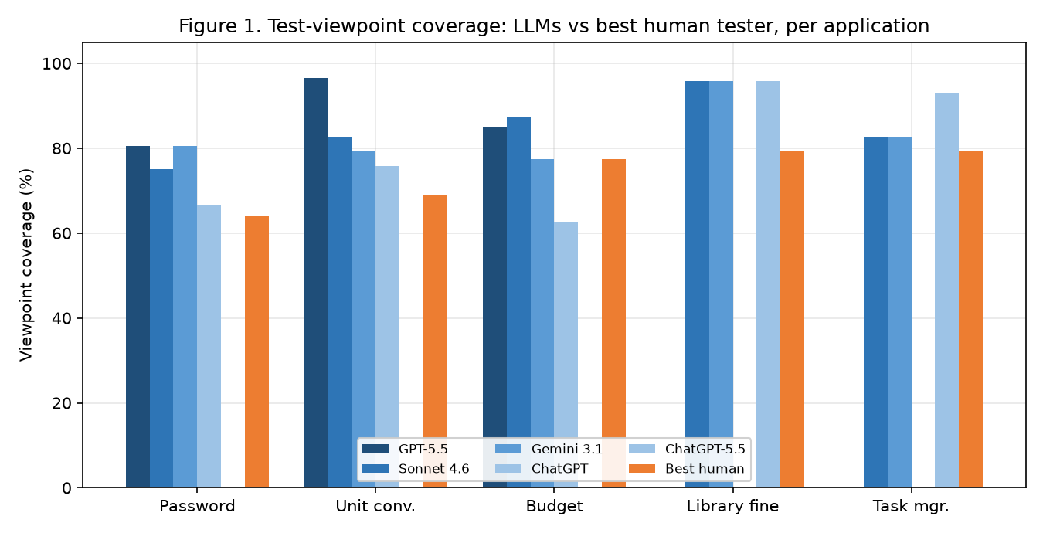
Figure 1. Test-viewpoint coverage of each LLM versus the best human tester, per application. Every LLM exceeds the best individual human on all five applications.
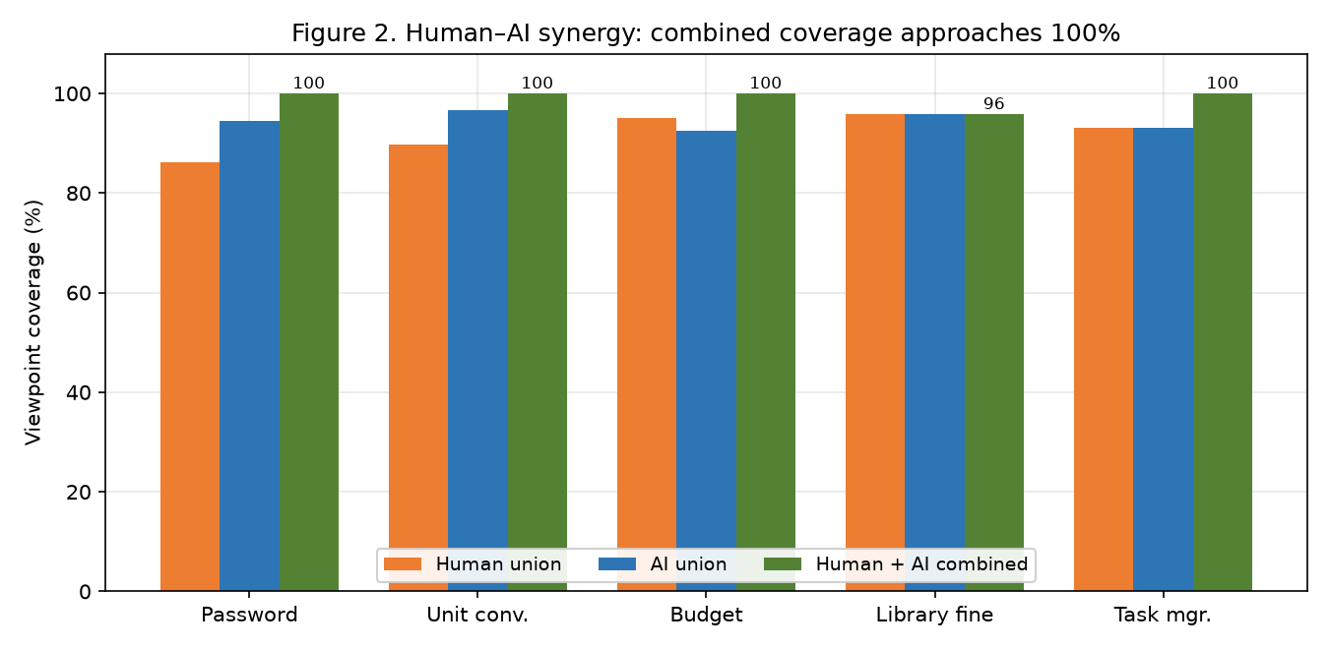
Figure 2. Human-only, AI-only, and combined (union) coverage. The human+AI union reaches ~100% on four of five applications, illustrating the synergy effect.
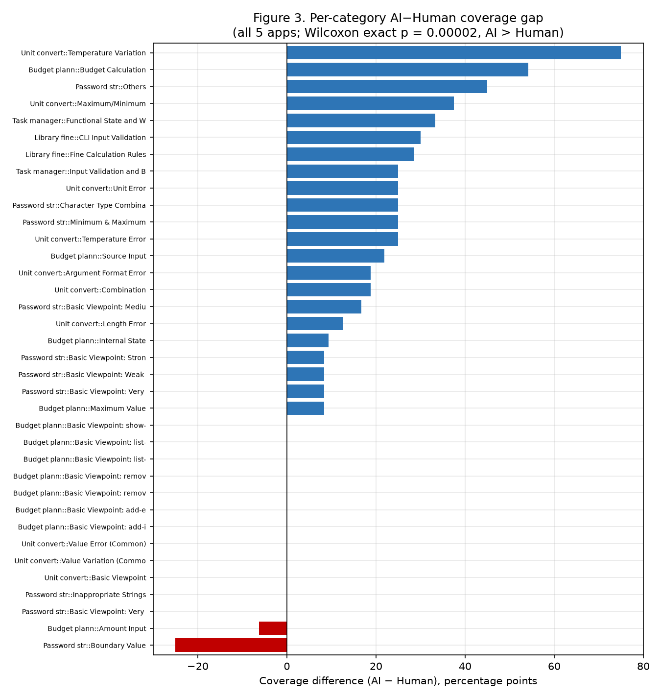
Figure 3. Per-category coverage gap (AI − human), all five applications. Blue = AI higher, red = human higher. Only two categories favour humans, consistent with the Wilcoxon result (p = 0.00002).

Appendix C. Corroboration of Findings with Prior Literature
This table links each empirical finding of the study to supporting evidence reported in the reviewed literature, showing which prior results the findings are consistent with and can be argued from.
Finding (this study) | Supporting evidence reported in prior work | Refs
LLMs match or exceed individual human testers on viewpoint coverage | GPT-4 matched or slightly surpassed human participants on viewpoint coverage; other comparative studies report AI reaching or exceeding human coverage on diverse scenarios. | [3], [14], [15]
Human + AI union exceeds either alone (synergy) | Human–AI collaboration covers substantially more viewpoints than humans or AI individually; human review remains essential for validation. | [3], [12], [23]
High coverage does not guarantee correct tests | TestGenEval: 73.1% of generated tests usable but only 26.8% of suites entirely correct; higher pass rates do not always mean better quality. | [1], [2]
LLMs occasionally miss boundary / edge viewpoints where humans win | Reports of missing boundary-value scenarios, invalid assertions, and semantic errors in AI-generated tests. | [2], [3], [22]
Newer model generations improve over the earlier GPT-4 baseline | Comparative AI test-generation studies report rising capability across model families and versions. | [4], [25]
Generated-test quality depends on specification clarity | Test-from-requirements studies find output quality strongly tied to specification completeness and clarity. | [7], [17], [21]
Coverage must be complemented by defect-detection metrics | Benchmarks and mutation-based studies argue for fault-detection / mutation scoring beyond coverage. | [9], [18], [24]

