**Multi-parameter description of drug sensitivity in cancer cell lines**

There are multiple parameters that can be used to quantitatively describe different aspects of drug sensitivity in cancer cell lines. These parameters are derived from dose-response data collected based on the effect of 72 h of drug treatment on cell viability, growth inhibition or cell death.

Using the cell count (or measurements of the level of a signal representing cell count) at time zero (*T0*), in the test samples treated for 72 h with different drug concentrations (*T*), and in the control (untreated) sample after 72 h (*TC*), the dose-response curves for each drug/cell line combination can be generated and represented mathematically by logistical sigmoidal functions:

**1) Cell viability curve:**

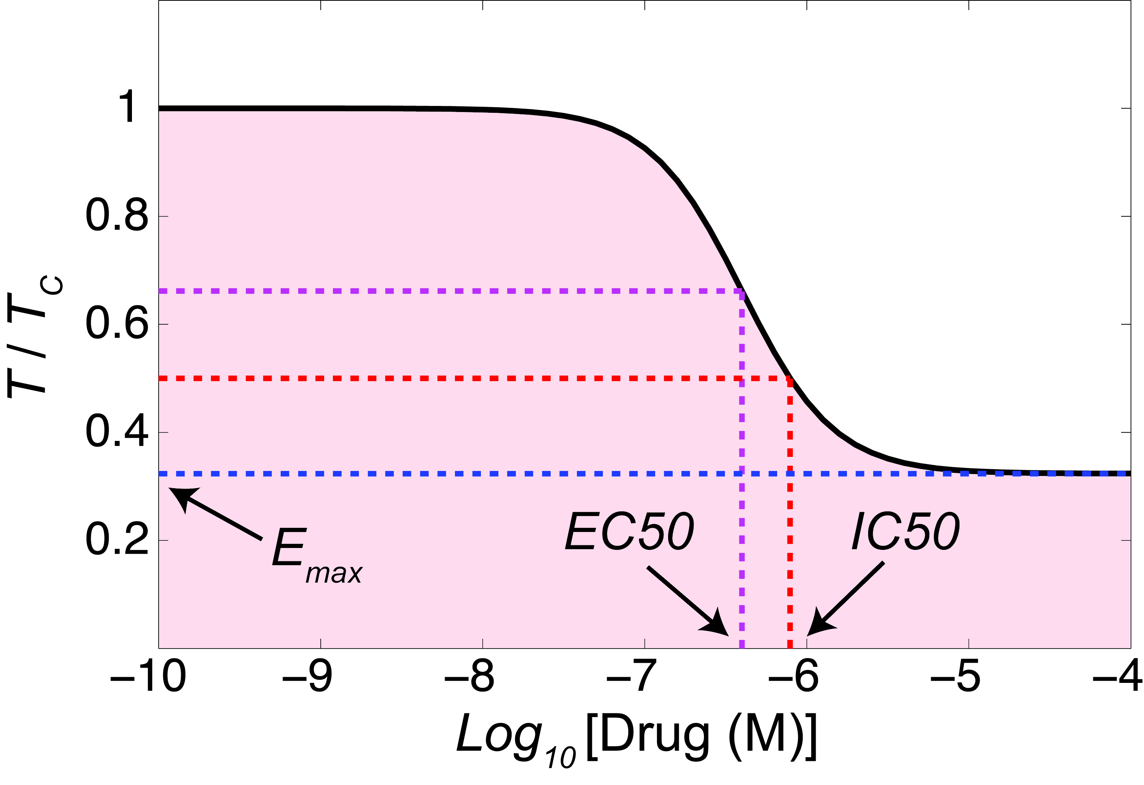

These parameters can be derived from the cell viability curve:

***i) Emax*:** Maximal effect level (minimal cell viability) reached within the tested range of drug concentration

***ii) EC50*:** The concentration at half-maximal activity of the drug is calculated from

***iii) IC50*:** The concentration at which the drug response (cell viability) reaches an absolute inhibition of 50% and is calculated from

**iv) Area under the curve (pink area):** A parameter calculated as the sum of cell viability measured at each of the tested drug concentrations. This parameter captures simultaneously the efficacy and potency of a drug.

**2) Growth inhibition curve:**

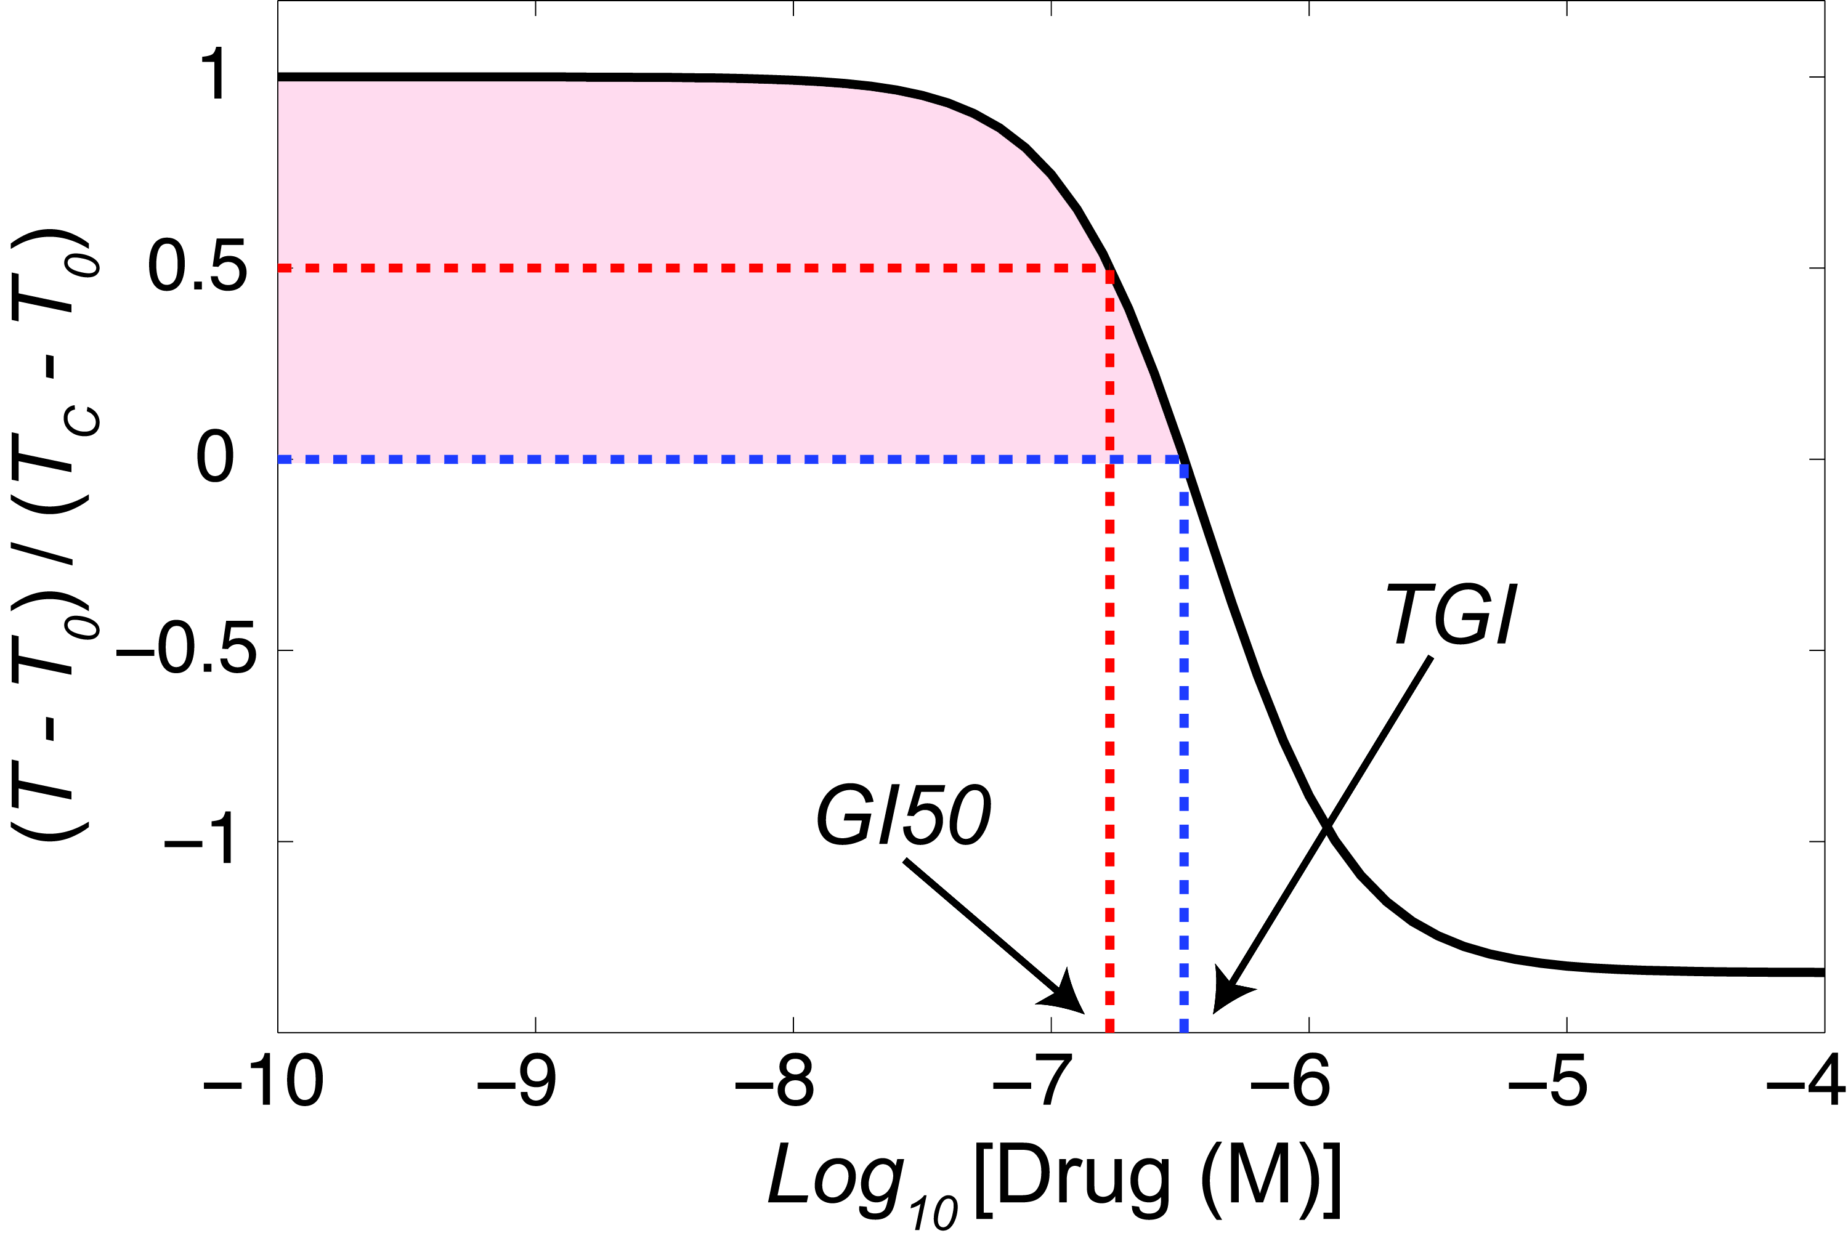

The following parameters can be derived from the growth inhibition curve:

***i) GI50*:** Growth inhibition of 50% is calculated from , which is the drug concentration resulting in a 50% reduction in the net cell growth in cells because of drug treatment.

***ii) TGI*:** Total growth inhibition is the drug concentration resulting in total growth inhibition and is calculated from

**iii) Positive area under the curve (pink area):** A parameter calculated as the sum of drug effect on growth at each of the tested drug concentrations lower than TGI.

**3) Net loss of cells curve:**

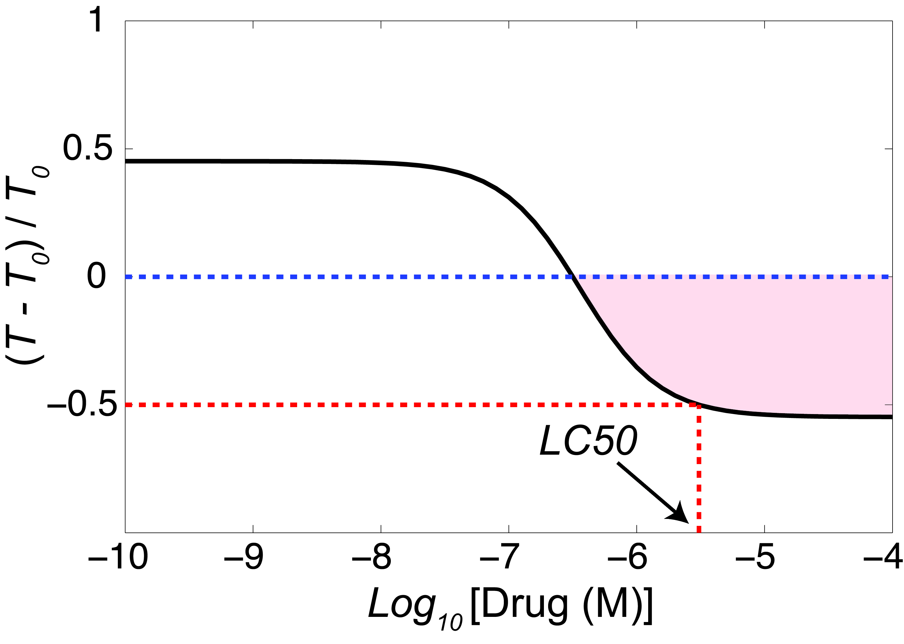

The following parameters can be derived from the cell loss curve:

***i) LC50*:** Concentration of drug resulting in a 50% reduction in cell count at the end of the drug treatment as compared to that at the beginning is calculated from

**ii) Negative area above the curve (pink area):** A parameter calculated as the sum of drug effect on cell loss at each of the tested drug concentrations higher than TGI.

The above metrics can be used to compare the level of sensitivity/responsiveness of different cell lines to a drug. Depending on how cell lines are distributed within the overall range of responsiveness, some metrics can be more useful than others.

For example, the following plot uses two parameters, IC50 and Emax, to show how a group of breast cancer cell lines responds to *erlotinib* treatment (metrics are re-calculated using data from Heiser et al. PNAS 2012). When cell viability does not reach the absolute inhibition of 50%, the highest tested concentration is often reported as the IC50. However, the plot below indicates that different cell lines with the same reported IC50 values might have very different Emax values. This suggests that for these cell lines, Emax might be a better metric for assessing drug sensitivity.

Macintosh HD:Users:mf170:Desktop:Data From Laura Heiser:Initial Comparison:metrics:erlotinib_IC50_Emax.eps

Another metric that might be useful is the area under the cell viability curve. The following plot shows that for cell lines that have the same reported IC50 values (because cell viability does not reach the absolute inhibition of 50% even at the highest concentration of drug) both Emax and the area under the curve can capture the differential responsiveness of cell lines to erlotinib.

Macintosh HD:Users:mf170:Desktop:Data From Laura Heiser:Initial Comparison:metrics:erlotinib_Emax_AA.eps

Another common measure of drug sensitivity in cancer cell lines is GI50. The following plot shows how IC50 and GI50 values for erlotinib are distributed for the same group of cell lines presented above. As expected, there is a significant correlation between IC50 and GI50 values reported for different cell lines. However, the reported GI50 and IC50 values for some cell lines are close to each other, while GI50 is up to one order of magnitude smaller than IC50 in others. As such, different cell lines with the same reported IC50 may have different GI50 values with as large as one order of magnitude difference. Cell lines with similar GI50 values may also have very different IC50 values.

Macintosh HD:Users:mf170:Desktop:Data From Laura Heiser:Initial Comparison:metrics:erlotinib_IC50_GI50.eps

To further clarify the multi-parametric nature of drug sensitivity, the dose-response curve for some example cell lines treated with erlotinib are shown below:

**Example 1:**

(IC50)184A1 < (IC50)AU565

(Emax)184A1 > (Emax)AU565

Using only IC50 to evaluate drug sensitivity, 184A1 cell line will be considered more sensitive to erlotinib as compared with AU565 cell line. However, AU565 cell line responds to high concentrations of erlotinib better than the 184A1 cell line.

Macintosh HD:Users:mf170:Desktop:Data From Laura Heiser:Initial Comparison:metrics:dose_response_1.eps

**Example 2:**

Reported (IC50)HBL100 = Reported (IC50)HCC1806

(Emax)HBL100 > (Emax)HCC1806

Using only IC50 to evaluate drug sensitivity, the differential responsiveness of the two cell lines, HBL100 and HCC1806, could not be discriminated. However, HCC1806 cell line responds to high concentrations of erlotinib significantly better than the HBL100 cell line.

Macintosh HD:Users:mf170:Desktop:Data From Laura Heiser:Initial Comparison:metrics:dose_response_2.eps

**Example 3:**

(Emax)MCF10F ≈ (Emax)MDAMB175VII  & (Emax)184A1 ≈ (Emax)BT474

(IC50)MCF10F < (IC50)MDAMB175VII  & (IC50)184A1 < (IC50)BT474

Using only Emax to evaluate drug sensitivity, the differential responsiveness of the two cell lines MCF10F and MDAMB175VII, and the two cell lines 184A1 and BT474 could not be discriminated. However, MCF10F and 184A1 cell lines respond to low concentrations of erlotinib significantly better than MDAMB175VII and BT474 cell lines, respectively.

Macintosh HD:Users:mf170:Desktop:Data From Laura Heiser:Initial Comparison:metrics:dose_response_3.eps

Macintosh HD:Users:mf170:Desktop:Data From Laura Heiser:Initial Comparison:metrics:dose_response_4.eps

**Example 4:**

(IC50)MCF10A / (GI50)MCF10A ≈ 1.25

(IC50)HCC1806 / (GI50)HCC1806 ≈ 19.0

Although the GI50 values for the two cell lines MCF10A and HCC1806 are approximately 2-fold different, there is an approximately 40-fold difference between their IC50 values. This suggests that for these two cell lines IC50 might be a better measure for comparing drug sensitivity as compared with GI50.

Macintosh HD:Users:mf170:Desktop:Data From Laura Heiser:Initial Comparison:metrics:dose_response_5.eps

Macintosh HD:Users:mf170:Desktop:Data From Laura Heiser:Initial Comparison:metrics:dose_response_5_v2.eps

**Example 5:**

Reported (IC50)HCC1806 = Reported (IC50)CAMA1

Reported (GI50)HCC1806 < Reported (GI50)CAMA1

Using only IC50 to evaluate drug sensitivity, the differential responsiveness of the two cell lines, HCC1806 and CAMA1, could not be discriminated. However, the value of GI50 for HCC1806 is smaller than the reported GI50 value for CAMA1 suggesting that for these two cell lines GI50 might be a better measure than IC50 for comparing drug sensitivity.

Macintosh HD:Users:mf170:Desktop:Data From Laura Heiser:Initial Comparison:metrics:dose_response_6.eps

Macintosh HD:Users:mf170:Desktop:Data From Laura Heiser:Initial Comparison:metrics:dose_response_6_v2.eps