
UNIVERSITY OF NAIROBI
DEPARTMENT OF COMPUTER SCIENCE
FACULTY OF SCIENCE AND TECHNOLOGY
SMART CAMPUS LOST & FOUND SYSTEM
BY
KARIMI DAN THIONG'O
SCS3/2362/2024
SUPERVISOR
PROF. LAWRENCE MUCHEMI
DEPARTMENT OF COMPUTING AND INFORMATICS
A Project Report Submitted in Partial Fulfillment of the Requirements for the Award of Bachelor of Science in Computer Science of the University of Nairobi
June 2026

DECLARATION
This project is my original work and, to the best of my knowledge, has not been submitted for any other award at any University.

Signature: ________________________ Date: _______________

Name: KARIMI DAN THIONG'O
Registration No: SCS3/2362/2024

This project was submitted in partial fulfillment of the requirements for the award of the degree of Bachelor of Science in Computer Science at the University of Nairobi, with my approval as the University supervisor.

Signed: ________________________ Date: _______________

PROF. LAWRENCE MUCHEMI
DEPARTMENT OF COMPUTING AND INFORMATICS

ACKNOWLEDGEMENT
I would like to express my sincere gratitude to all those who contributed to the successful development and completion of this project, the Smart Campus Lost & Found System. First and foremost, I am deeply thankful to my supervisor, Prof. Lawrence Muchemi, for his continuous guidance, encouragement, and invaluable feedback throughout every stage of this project. His mentorship and expertise were instrumental in shaping the direction and design of the system.
I also wish to acknowledge the support of the Department of Computing and Informatics, University of Nairobi, for providing the academic resources and environment that made this work possible. Special thanks go to my lecturers and fellow students whose insights, critique, and encouragement served as a constant source of motivation.
Lastly, I am profoundly grateful to my family and friends for their unwavering moral support, patience, and belief in my abilities. Their encouragement gave me the strength to overcome challenges and remain focused throughout the development process.

ABSTRACT
Lost and found management on university campuses is largely informal, relying on physical notice boards, social media groups, and word-of-mouth. This approach is inefficient, lacks accountability, and creates trust issues when attempting to return items and compensate finders. There is no mechanism to verify ownership claims, protect the privacy of involved parties, or facilitate safe financial transactions between strangers.
This project presents the Smart Campus Lost & Found System, a full-stack web application built to address these challenges through a structured, trust-based workflow. The system enables students and staff to post lost and found item reports, submit and review ownership claims, and coordinate physical handoffs through a secure OTP-based verification mechanism. An escrow-style payment flow was designed to facilitate finder rewards, ensuring that money is committed before a handoff occurs and released only upon confirmed receipt of the item.
The platform was developed using the MERN stack — MongoDB, Express.js, React.js, and Node.js — with JWT-based authentication and role-based access control supporting both regular users and administrators. The system implements a strict privacy model: sensitive information such as phone numbers, exact item locations, and serial numbers are revealed progressively, only to the relevant parties, and only after the appropriate stage of the workflow has been completed.
The M-Pesa Daraja API (STK Push and B2C) was architected and designed for integration as the payment layer, but was not deployed due to Safaricom sandbox account restrictions encountered during development. The payment functionality was replaced with a fully functional mock payment flow that simulates the escrow lifecycle end-to-end, including OTP generation and fund release, allowing all other system components to be verified in production conditions.
The result is a secure, responsive, and scalable web application that demonstrates how digital trust mechanisms — claim verification, escrow logic, and OTP handshakes — can transform an informal campus process into a reliable and transparent system.

Table of Contents
DECLARATION 2
ACKNOWLEDGEMENT 3
ABSTRACT 4
LIST OF TABLES 8
ABBREVIATIONS 9
DEFINITION OF TERMS 10
CHAPTER 1: INTRODUCTION 11
1.1 Background 11
1.2 Problem Statement 11
1.3 Objectives 12
1.4 Scope 12
1.5 Significance 12
1.6 Justification 13
CHAPTER 2: REVIEW OF SIMILAR SYSTEMS 14
2.1 Use of ICT in Campus Management Systems 14
2.2 Overview of Similar Systems 14
2.2.1 iLost 14
2.2.2 Facebook Lost & Found Groups 14
2.2.3 FoundIt (International Platform) 15
2.2.4 University Security Office Manual Systems 15
2.3 Technology Used in Similar Systems 15
2.4 Gaps in Current Systems 15
2.5 The Proposed System 16
CHAPTER 3: SYSTEM ANALYSIS AND DESIGN 17
3.1 Systems Analysis and Design Methodology 17
3.2 System Analysis 18
3.2.1 Requirements Elicitation 18
3.2.2 Requirements Analysis 18
Functional Requirements 18
Non-Functional Requirements 19
3.3 System Design 19
3.3.1 Architectural Design 19
3.3.2 Process Design 20
3.3.3 Database Design 21
3.3.4 Application Design 22
3.3.5 Item Lifecycle Design 23
3.3.6 OTP Handshake Design 24
3.4 Resources 25
3.5 Project Gantt Chart 26
CHAPTER 4: SYSTEM IMPLEMENTATION 27
4.1 Design and Implementation Platform 27
4.2 Installation and Setup 27
4.3 Testing 27
4.4 Maintenance Plan 29
4.5 Security and Ethical Considerations 30
CHAPTER 5: CONCLUSION AND RECOMMENDATIONS 31
5.1 Achievements 31
5.2 Limitations 31
5.3 Recommendations 32
5.4 Conclusion 32
REFERENCES 34
APPENDICES 35
Appendix 1: User Manual 35
1.1 Account Registration 35
1.2 Login 35
Appendix 2: Using the System 36
2.1 Browsing the Global Feed 36
2.2 Reporting a Lost or Found Item 37
2.3 Claiming a Found Item 38
Appendix 3: The Dashboard 39
3.1 My Lost Reports 39
3.2 My Found Reports 39
3.3 My Active Claims 40
Appendix 4: Admin Panel 41
4.1 Pending Claims Queue 41
Appendix 5: OTP Handshake Flow 42
5.1 Owner View After Payment 42
5.2 Finder View During Handoff 43
Appendix 6: Sample Code 44

LIST OF FIGURES
Figure 1 Agile Development Process 18
Figure 2 System Architectural Design 21
Figure 3 System Context Diagram (DFD Level 0) 21
Figure 4 System Process Diagram (DFD Level 1) 22
Figure 5 Database Entity-Relationship Diagram 23
Figure 6 Application Design / Module Map 24
Figure 7 Item Lifecycle State Machine 25
Figure 8 OTP Handshake Sequence Diagram 26
Figure 9 Landing Page 36
Figure 10 User Registration Page 36
Figure 11Login Page 37
Figure 12 Global Feed — Lost Items Tab 37
Figure 13 Global Feed — Found Items Tab 38
Figure 14 Report Item Form 39
Figure 15 Claim Submission Modal 40
Figure 16 User Dashboard — My Lost Reports 40
Figure 17: User Dashboard — My Found Reports 41
Figure 18 User Dashboard — My Active Claims 42
Figure 19 Admin Panel — Pending Claims Queue 43
Figure 20: Admin Panel — Claim Review (Side-by-Side) 43
Figure 21 OTP Handshake — Owner View 44
Figure 22 OTP Handshake — Finder View 45
Figure 23 Resolved Item State 45
Figure 24 Sample code 46

LIST OF TABLES
Table 1: Item Status Reference — Found Items 29
Table 2: Item Status Reference — Lost Items 29
Table 3: API Routes Summary 35
Table 4: Functional Requirements 22
Table 5: Non-Functional Requirements 23
Table 6: Project Timeline and Milestones 32
Table 7: System Test Cases 36

ABBREVIATIONS
API – Application Programming Interface
CRUD – Create, Read, Update, Delete
CSS – Cascading Style Sheets
DFD – Data Flow Diagram
HTML – HyperText Markup Language
HTTP – Hypertext Transfer Protocol
ICT – Information and Communication Technology
JWT – JSON Web Token
MERN – MongoDB, Express.js, React.js, Node.js
MongoDB – A NoSQL document-oriented database management system
OTP – One-Time Password
REST – Representational State Transfer
STK – SIM Toolkit
UON – University of Nairobi
UI – User Interface
UX – User Experience
VS Code – Visual Studio Code

DEFINITION OF TERMS
Claimant / Owner: A registered user who believes a found item belongs to them and submits a proof-of-ownership claim.
Escrow: A financial arrangement in which a third party temporarily holds funds on behalf of two transacting parties until a predefined condition is met.
Finder: A registered user who discovers a lost item and reports it on the platform.
Global Feed: The publicly visible listing of all active lost and found item posts on the platform.
Handshake Code / OTP: A system-generated four-digit code shared only with the Owner after payment, used to confirm physical item handoff.
Item Lifecycle: The sequence of statuses an item passes through from initial reporting to final resolution.
M-Pesa: A mobile money transfer and payment service operated by Safaricom in Kenya.
Mock Payment: A simulated payment transaction used during development to replicate the escrow flow without real financial transactions.
Role-Based Access Control (RBAC): A security model that restricts system access based on the user's assigned role (user or admin).

CHAPTER 1: INTRODUCTION

1.1 Background
University campuses are dynamic environments hosting thousands of students, faculty, and staff, all of whom move between lecture halls, libraries, cafeterias, and common areas on a daily basis. The high footfall and shared nature of these spaces inevitably lead to frequent instances of lost and found items — from student identification cards and laptops to personal accessories, books, and keys.
Despite the frequency of these incidents, most Kenyan universities manage lost and found items through informal, manual processes. Physical lost-and-found boxes at security points, WhatsApp group announcements, and verbal word-of-mouth remain the dominant channels. These approaches suffer from several critical shortcomings: there is no central record of reported items, no mechanism to verify that a claimant is the true owner, no structured way to compensate finders, and no guarantee of privacy for either party during the recovery process.
The advancement of web technologies and the widespread adoption of mobile internet among Kenyan university students present a strong foundation for a digital solution. Systems in other domains — such as e-commerce escrow services and gig economy platforms — have demonstrated that digital trust mechanisms, including identity verification, staged disclosure, and payment escrow, can successfully facilitate transactions between strangers. Applying these same principles to campus lost and found management offers a compelling opportunity to improve both efficiency and trust.
This project therefore proposes and implements the Smart Campus Lost & Found System, a full-stack web application that digitizes the entire lost-and-found workflow: from item reporting and ownership verification, through admin review, to a secure physical handoff mediated by a one-time password (OTP) and an escrow-based reward system.

1.2 Problem Statement
The current approach to lost and found management lacks structure, accountability, and trust. Specific problems include:
- There is no centralized digital record of lost or found items, making it difficult for owners to identify whether their item has been turned in.
- Anyone can claim a found item without providing any proof of ownership, creating opportunities for dishonest retrieval.
- Finders have no formal incentive or reward mechanism, which discourages the reporting of found items through official channels.
- Contact information must be exchanged between strangers before either party has committed to the transaction, creating privacy and safety risks.
- There is no mechanism to hold reward money in escrow, meaning a finder can be underpaid or an owner can pay without receiving their item.
The Smart Campus Lost & Found System addresses each of these problems through a structured digital workflow, admin-mediated claim verification, and a secure OTP-based handoff mechanism.

1.3 Objectives
The objectives of this project were:
- To design and implement a centralized web platform for reporting, browsing, and managing lost and found items on a university campus.
- To develop a secure ownership claim and admin review system that verifies proof-of-ownership answers against private item details before approving a claim.
- To implement a privacy-preserving OTP handshake mechanism that mediates the physical handoff of items, ensuring phone numbers and item specifics are revealed only to the relevant parties and only at the appropriate stage.
- To design an escrow-based reward payment architecture using the M-Pesa Daraja API (STK Push and B2C), with a fully functional mock payment flow implemented for development and testing.
- To implement an admin panel with claim review queues, escrow ledger oversight, and user management capabilities.

1.4 Scope
The system targets the campus community, including students and staff. It provides the following core capabilities:
- User registration and JWT-authenticated login with role-based access (user / admin).
- Public lost and found item feeds with search and filter functionality.
- A private user dashboard for managing personal lost reports, found reports, and active claims.
- A category-specific proof-of-ownership claim submission and admin review workflow.
- A mock escrow and OTP handshake flow covering the full lifecycle from payment through physical handoff to fund release.
- An admin panel covering claim adjudication, escrow monitoring, and user management.
The system does not include in-app messaging, real-time push notifications, or a mobile native application. The M-Pesa Daraja integration was fully designed and architected but not deployed in the final submission due to Safaricom sandbox account restrictions.

1.5 Significance
The Smart Campus Lost & Found System addresses a gap that affects a significant proportion of the campus community on a regular basis. Its significance spans several dimensions:
From a security and trust perspective, the system's privacy-by-default model ensures that personal contact details and identifying information are never exposed to unverified parties. The admin review layer adds a human checkpoint that significantly reduces the likelihood of fraudulent item retrieval.
From an economic perspective, the escrow-based reward mechanism incentivises finders to report items through the platform rather than keeping them or discarding them. By guaranteeing payment security for both parties, the system increases participation and improves recovery rates.
From an operational perspective, the system provides administrators with real-time visibility into all active claims, payment statuses, and item lifecycles, replacing a fragmented informal process with a structured, auditable workflow.

1.6 Justification
This project is aligned with the commitment to leveraging technology to improve campus operations and student welfare. The use of a modern, scalable MERN stack ensures that the platform can be extended and maintained by future developers. The escrow design, though using a mock payment layer in the current build, is directly map-able to the Safaricom Daraja API, making the transition to a live payment system straightforward once account access is resolved.
The project also demonstrates the practical application of concepts spanning full-stack web development, database design, role-based access control, RESTful API design, and system security — representing a comprehensive synthesis of the Computer Science curriculum at the undergraduate level.

CHAPTER 2: REVIEW OF SIMILAR SYSTEMS

2.1 Use of ICT in Campus Management Systems
Information and Communication Technology has fundamentally transformed how institutions manage shared resources and community interactions. In university environments specifically, web-based platforms and mobile applications have been deployed for room booking, campus navigation, student services portals, and academic administration. The common thread across these applications is the use of digital identity, role-based workflows, and persistent data storage to replace previously manual or informal processes (Laudon & Laudon, 2022).
Lost and found management, while seemingly a minor administrative function, sits at the intersection of identity verification, financial incentivisation, and trust between strangers — all of which are areas where ICT has demonstrated transformative impact. Platforms such as online marketplaces and gig economy applications have shown that structured digital workflows, escrow payment systems, and reputation mechanisms can enable large-scale, high-trust transactions between parties who have no prior relationship.
Applying these principles to the campus context is therefore a natural progression. A digital lost and found system that incorporates ownership verification and reward escrow can replicate the trust mechanisms of commercial platforms while tailoring the workflow to the specific operational context of a university.

2.2 Overview of Similar Systems

2.2.1 iLost
iLost is an international lost and found platform used by airports, transit networks, and public venues. It allows institutions to register found items and enables users to submit ownership claims through a structured online form. While iLost provides a centralized database and a formal claim process, it is designed for large institutional deployment and does not include a financial reward or incentive mechanism for finders. It also does not implement an OTP or escrow system for handoff verification. It is not available or adapted for Kenyan university campuses.

2.2.2 Facebook Lost & Found Groups
Campus-specific Facebook groups and WhatsApp communities are the most commonly used lost and found mechanisms at Kenyan universities. These social media channels allow community members to post photos and descriptions of lost or found items. However, they offer no ownership verification, no privacy controls, no admin oversight, and no financial transaction mechanism. Contact information is exchanged publicly, and there is no structured process to confirm that the person who collects an item is its legitimate owner.

2.2.3 FoundIt (International Platform)
FoundIt is a web platform that allows users to report lost and found items with photos and location details. It supports direct messaging between users and basic categorization. While it improves on social media channels by providing a dedicated interface, it lacks an admin review layer, an escrow payment system, and any form of OTP handshake. Privacy is not enforced — contact details and item specifics are often visible to all registered users regardless of claim status.

2.2.4 University Security Office Manual Systems
At the University of Nairobi and most Kenyan public universities, the primary formal channel for lost and found items is the campus security office. Items turned in to security are logged manually, and claimants are required to present identification and describe the item. While this provides a basic verification step, it depends entirely on items being physically surrendered to security, is not accessible remotely, generates no digital record, and offers no reward mechanism to incentivize finders.

2.3 Technology Used in Similar Systems
A review of the technology stacks employed by comparable platforms reveals several common patterns:
- Web-based platforms (React.js, Vue.js, or Angular on the frontend) paired with RESTful Node.js or Django backend are standard for modern lost and found management systems.
- Relational databases (PostgreSQL, MySQL) are used by structured claim-management platforms, while NoSQL databases (MongoDB) are preferred where item descriptions and proof fields are variable and schema-flexible.
- JWT-based authentication and role-based access control are standard security primitives in all reviewed systems.
- Payment escrow functionality in analogous platforms (e.g., online marketplaces) is typically implemented via Stripe, PayPal, or mobile money APIs such as M-Pesa.

2.4 Gaps in Current Systems
The review of existing systems reveals the following gaps that the proposed system directly addresses:
- No existing platform offers an admin-mediated, category-specific ownership verification workflow tailored to a campus environment.
- No comparable system implements a combined escrow-and-OTP handshake mechanism that ties payment to confirmed physical item handoff.
- Existing platforms either expose contact information too early (social media groups) or not at all (institutional security), rather than revealing it progressively based on workflow stage.
- Reward incentives for finders are absent from all reviewed campus-focused systems, reducing the motivation to report found items officially.
- No platform reviewed is specifically designed for or adapted to the Kenyan mobile money ecosystem (M-Pesa), despite this being the dominant payment method for the target demographic.

2.5 The Proposed System
The Smart Campus Lost & Found System addresses each of the identified gaps by combining a structured digital workflow with privacy-by-default data handling, admin oversight, and an escrow-based reward mechanism. Unlike any of the reviewed systems, it implements all of the following in a single platform: centralized item reporting, category-specific proof-of-ownership claims, admin review queues, staged phone number disclosure, OTP handshake verification, and a complete escrow transaction lifecycle.

CHAPTER 3: SYSTEM ANALYSIS AND DESIGN
This chapter details the methodology, requirements analysis, and design decisions used to develop the Smart Campus Lost & Found System.

3.1 Systems Analysis and Design Methodology
The Agile Software Development Methodology was adopted for this project. Agile’s iterative approach allowed the system to be built incrementally in well-defined stages, with each stage producing a working, testable set of features before the next was begun. This was particularly appropriate for this project because the complexity of the workflow — spanning authentication, item management, claims, admin review, and the OTP handshake — meant that later stages had hard dependencies on the correctness of earlier ones.
Development proceeded through six defined stages, each producing a functional milestone: Stage 1 (Authentication & Roles), Stage 2 (Items CRUD & Global Feed), Stage 3 (Private Dashboard), Stage 4 (Claims & Admin Review), Stage 5 (OTP Handshake & Mock Payments), and Stage 6 (M-Pesa Integration — designed but not deployed).
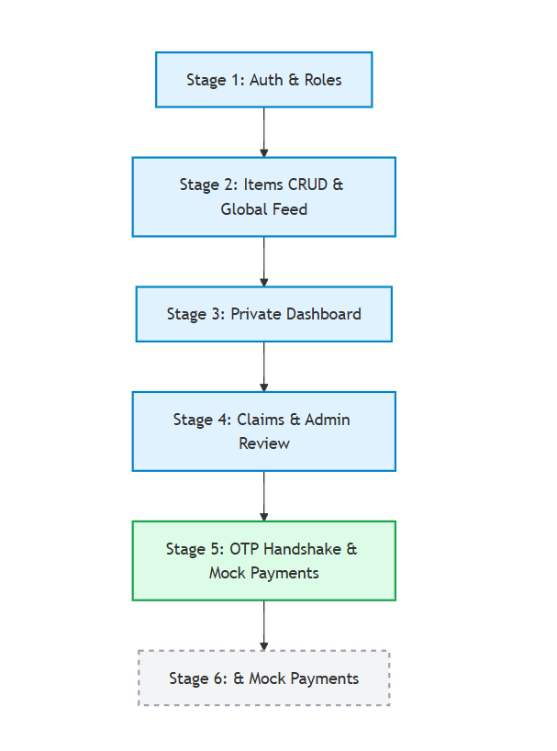
Figure 1 Agile Development Process

3.2 System Analysis

3.2.1 Requirements Elicitation
Requirements were elicited through the following methods:
Observation: Informal observation of how lost and found items are currently handled— specifically the use of WhatsApp groups and the security office — provided insight into the key pain points: lack of verification, no privacy, and no financial incentive.
Interviews: Informal interviews were conducted with fellow students to understand what features would encourage them to use a digital lost and found platform and what concerns they would have about sharing contact information with strangers.
Use Case Analysis: Use cases were developed for each of the three user roles — Guest (unauthenticated), User, and Admin — to define the full set of system interactions.

3.2.2 Requirements Analysis
Based on the elicitation process, the following functional and non-functional requirements were identified.

Functional Requirements

ID | Requirement | Description
FR1 | User Registration & Authentication | Users can register with name, email, phone, and password. JWT tokens are issued on login. Passwords are hashed with bcrypt.
FR2 | Item Reporting | Authenticated users can post lost or found items with public fields (title, category, general location, photo, reward) and private fields (exact location, serial number, private description).
FR3 | Global Feed | All visitors can browse the public feed of lost and found items, filtered by category, location, and date. Private fields are never exposed.
FR4 | Ownership Claims | Authenticated users can submit category-specific proof-of-ownership claims on found items they believe are theirs.
FR5 | Admin Review | Admins can view a side-by-side comparison of Finder's private details and Owner's proof answers, and approve or reject claims with an optional note.
FR6 | OTP Handshake | On payment confirmation, the system generates a 4-digit OTP shown only to the Owner. The Finder enters this code to release their payout, confirming physical handoff.
FR7 | Dashboard | Each user has a private dashboard showing their lost reports, found reports, and active claims, with status-specific UI elements at each stage.
FR8 | Admin Panel | Admin users have access to a claim review queue, escrow ledger, and user management interface within the dashboard.

Table 4: Functional Requirements

Non-Functional Requirements

Category | Requirement
Security | JWT tokens expire after 24 hours. Passwords are bcrypt-hashed. Private item fields are filtered at the API level and never exposed in public endpoints.
Privacy | Phone numbers are only returned in API responses after transaction escrow is confirmed. OTP codes are stripped from responses to the Finder.
Performance | Dashboard data is loaded via parallel Promise.all requests. API responses should complete within 2 seconds under normal load.
Usability | The interface is responsive across desktop and mobile browsers. Status badges, empty states, and loading skeletons guide users at every stage.
Scalability | MongoDB's schema-flexible document model supports variable item descriptions across categories. The MERN stack can be horizontally scaled.
Reliability | Atomic database updates (Promise.all across Claim, Found Item, and Lost Item documents) prevent orphaned states on claim approval or rejection.

Table 5: Non-Functional Requirements

3.3 System Design

3.3.1 Architectural Design
The system follows a three-tier architecture:
- Presentation Tier (React.js): A single-page application built with React and Tailwind CSS. Handles all user interaction, routing (React Router), and API communication via Axios.
- Application Tier (Node.js + Express.js): A RESTful API server handling authentication, business logic, and data access. Middleware enforces JWT authentication and role-based access on all protected routes.
- Data Tier (MongoDB + Mongoose): A document-oriented NoSQL database hosting four collections: Users, Items, Claims, and Transactions.
- 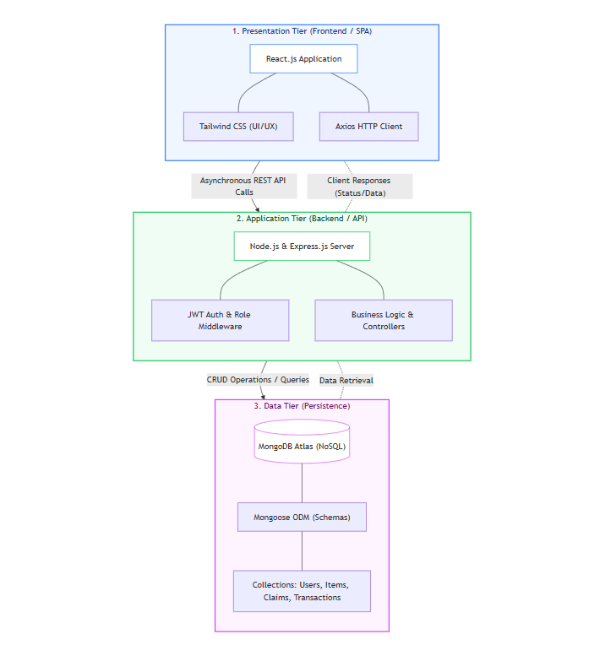
Figure 2 System Architectural Design

3.3.2 Process Design
The following diagrams illustrate the system's data flows. The Level 0 Context Diagram shows the system's external interactions with its three actor types: Guest, User, and Admin. The Level 1 DFD details the internal processes including item reporting, claim submission, admin review, and the payment/OTP flow.
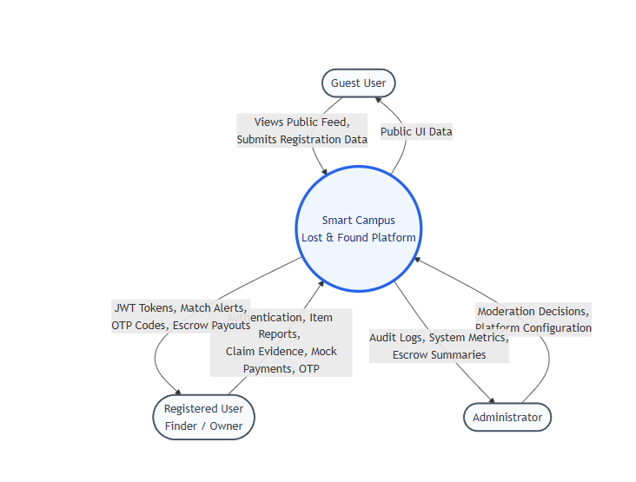
Figure 3 System Context Diagram (DFD Level 0)
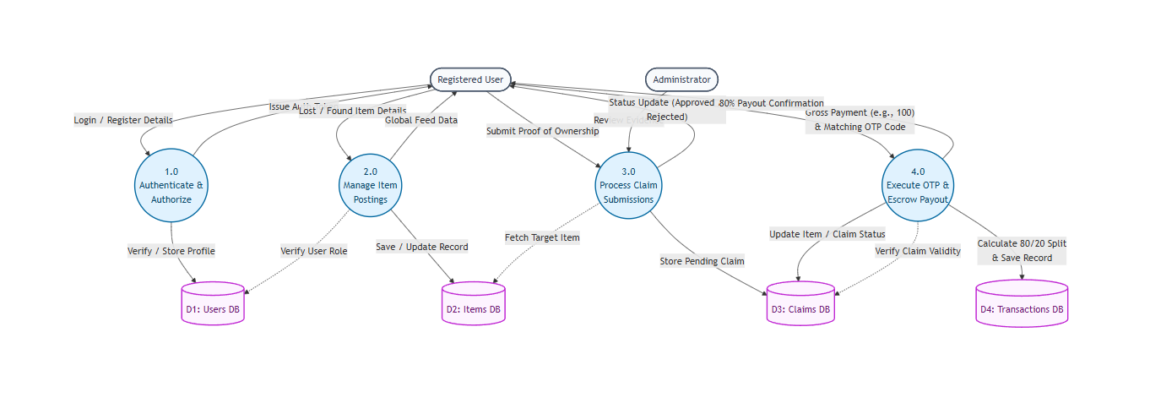
Figure 4 System Process Diagram (DFD Level 1)

3.3.3 Database Design
The database consists of four Mongoose-modelled collections:
Users Collection: Stores name, email, bcrypt-hashed password, phone number, and role (user | admin). The phone number is the M-Pesa-registered number used for payment and payout.
Items Collection: A unified collection for both lost and found posts, distinguished by a type field. Each document contains public fields (title, category, general location, photo, reward amount) and private fields (exact location, private description, private photo, serial number). The status field tracks the item through its lifecycle.
Claims Collection: Created when an Owner submits a claim on a Found item. Contains the claimant's user ID, the found and lost item IDs, proof answers (free-text), the admin verdict, the reviewing admin's ID, and any admin notes.
Transactions Collection: Created by the system when an admin approves a claim. Tracks the full payment lifecycle including mock STK Push status, the OTP code and verification state, mock B2C payout status, and the overall transaction status (awaiting_payment | escrowed | released | refunded | disputed).
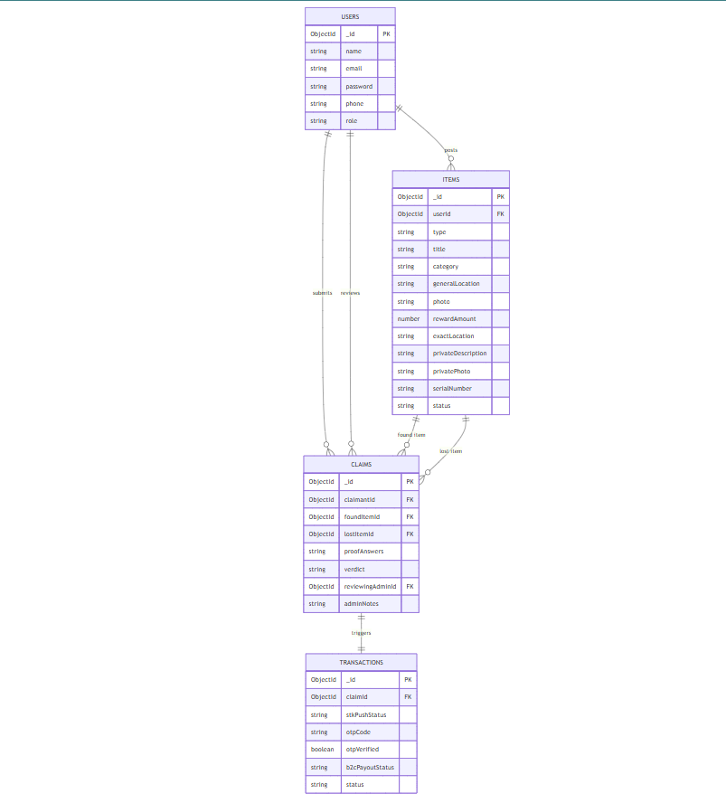
Figure 5 Database Entity-Relationship Diagram

3.3.4 Application Design
The application is organized into the following frontend pages and corresponding backend route groups:
- Landing Page: Hero section with campus-focused copy, live counters, and calls-to-action for lost and found reporting.
- Global Feed Page: Tabbed view of Lost and Found items. Public fields only. Search and filter bar. Claim button visible to authenticated users.
- Report Item Page: Dynamic form rendering public and private fields. Category selection adjusts field labels and placeholder text.
- Dashboard Page: Three-tab private interface (My Lost Reports, My Found Reports, My Active Claims) plus a conditional Admin Panel tab. Status-specific UI components render at each lifecycle stage.
- Auth Pages: Register and Login pages with form validation and JWT handling.
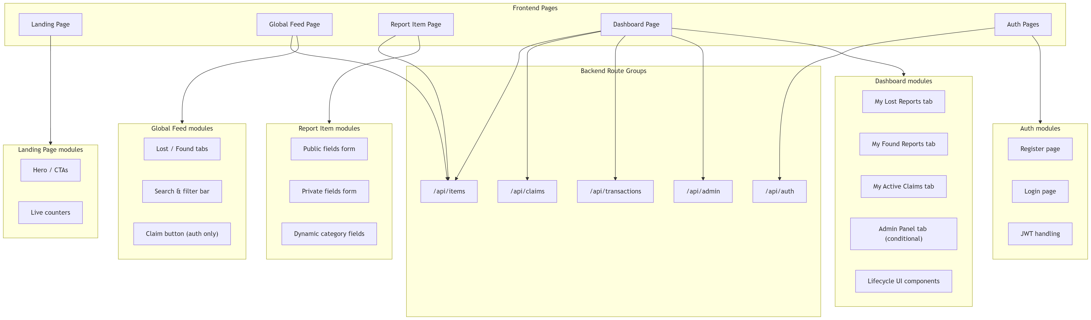
Figure 6 Application Design / Module Map

3.3.5 Item Lifecycle Design
The item lifecycle is the central design artefact of the system. It defines the sequence of statuses that Found and Lost items move through, the conditions that trigger each transition, and the actions available to each user role at each stage. The lifecycle was designed to be atomic — transitions across multiple documents (Claim, Found Item, Lost Item) are executed simultaneously using Promise.all to prevent data desynchronization.

Status | Meaning | Visible on Feed?
unclaimed | Posted by Finder; awaiting Owner claim | Yes
pending_review | Owner submitted claim; admin reviewing | No
awaiting_payment | Claim approved; waiting for Owner to pay reward | No
ready_for_handoff | Payment received; OTP active; phones revealed | No
resolved | OTP verified; payout sent; item returned | No
disputed | Admin intervention required | No

Table 1: Item Status Reference — Found Items

Status | Meaning
searching | Posted by Owner; no match or claim yet
claim_pending | A linked claim is under admin review
claim_approved | Admin approved; awaiting Owner payment
awaiting_handoff | Payment made; OTP handshake in progress
resolved | Item successfully returned to Owner

Table 2: Item Status Reference — Lost Items

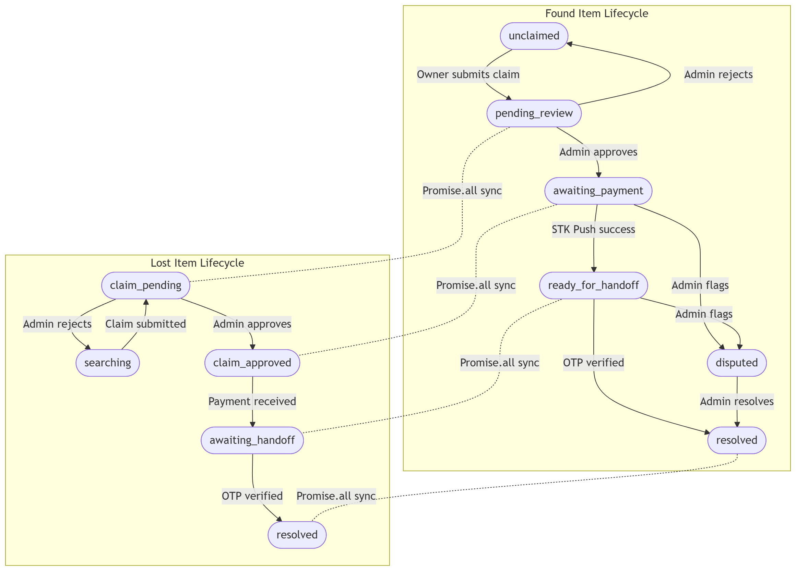
Figure 7 Item Lifecycle State Machine

3.3.6 OTP Handshake Design
The OTP handshake is the trust mechanism at the heart of the system's payment flow. Its design addresses the core problem of releasing escrow funds without a trusted third party physically present at the handoff. The mechanism works as follows:
- Admin approves the Owner's claim. A Transaction document is created with status awaiting_payment.
- Owner clicks 'Pay Reward'. The mock payment endpoint sets the transaction status to escrowed and generates a cryptographically random 4-digit OTP stored in the Transaction document.
- The Owner's dashboard reveals the Finder's phone number and displays the OTP in large, bold typography with the instruction to share it only after inspecting the received item.
- The Finder's dashboard reveals the Owner's phone number and renders an OTP input field with a 'Verify & Release Funds' button.
- They meet in person. The Owner inspects the item. If satisfied, the Owner verbally communicates the OTP to the Finder.
- The Finder enters the OTP. The backend verifies it, sets otpVerified to true, updates both items to resolved, and triggers the mock B2C payout to the Finder.
This design ensures that the Finder cannot receive the OTP without the Owner being physically present and satisfied, and the Owner cannot withhold payment once the OTP has been shared, since the funds are already in escrow.
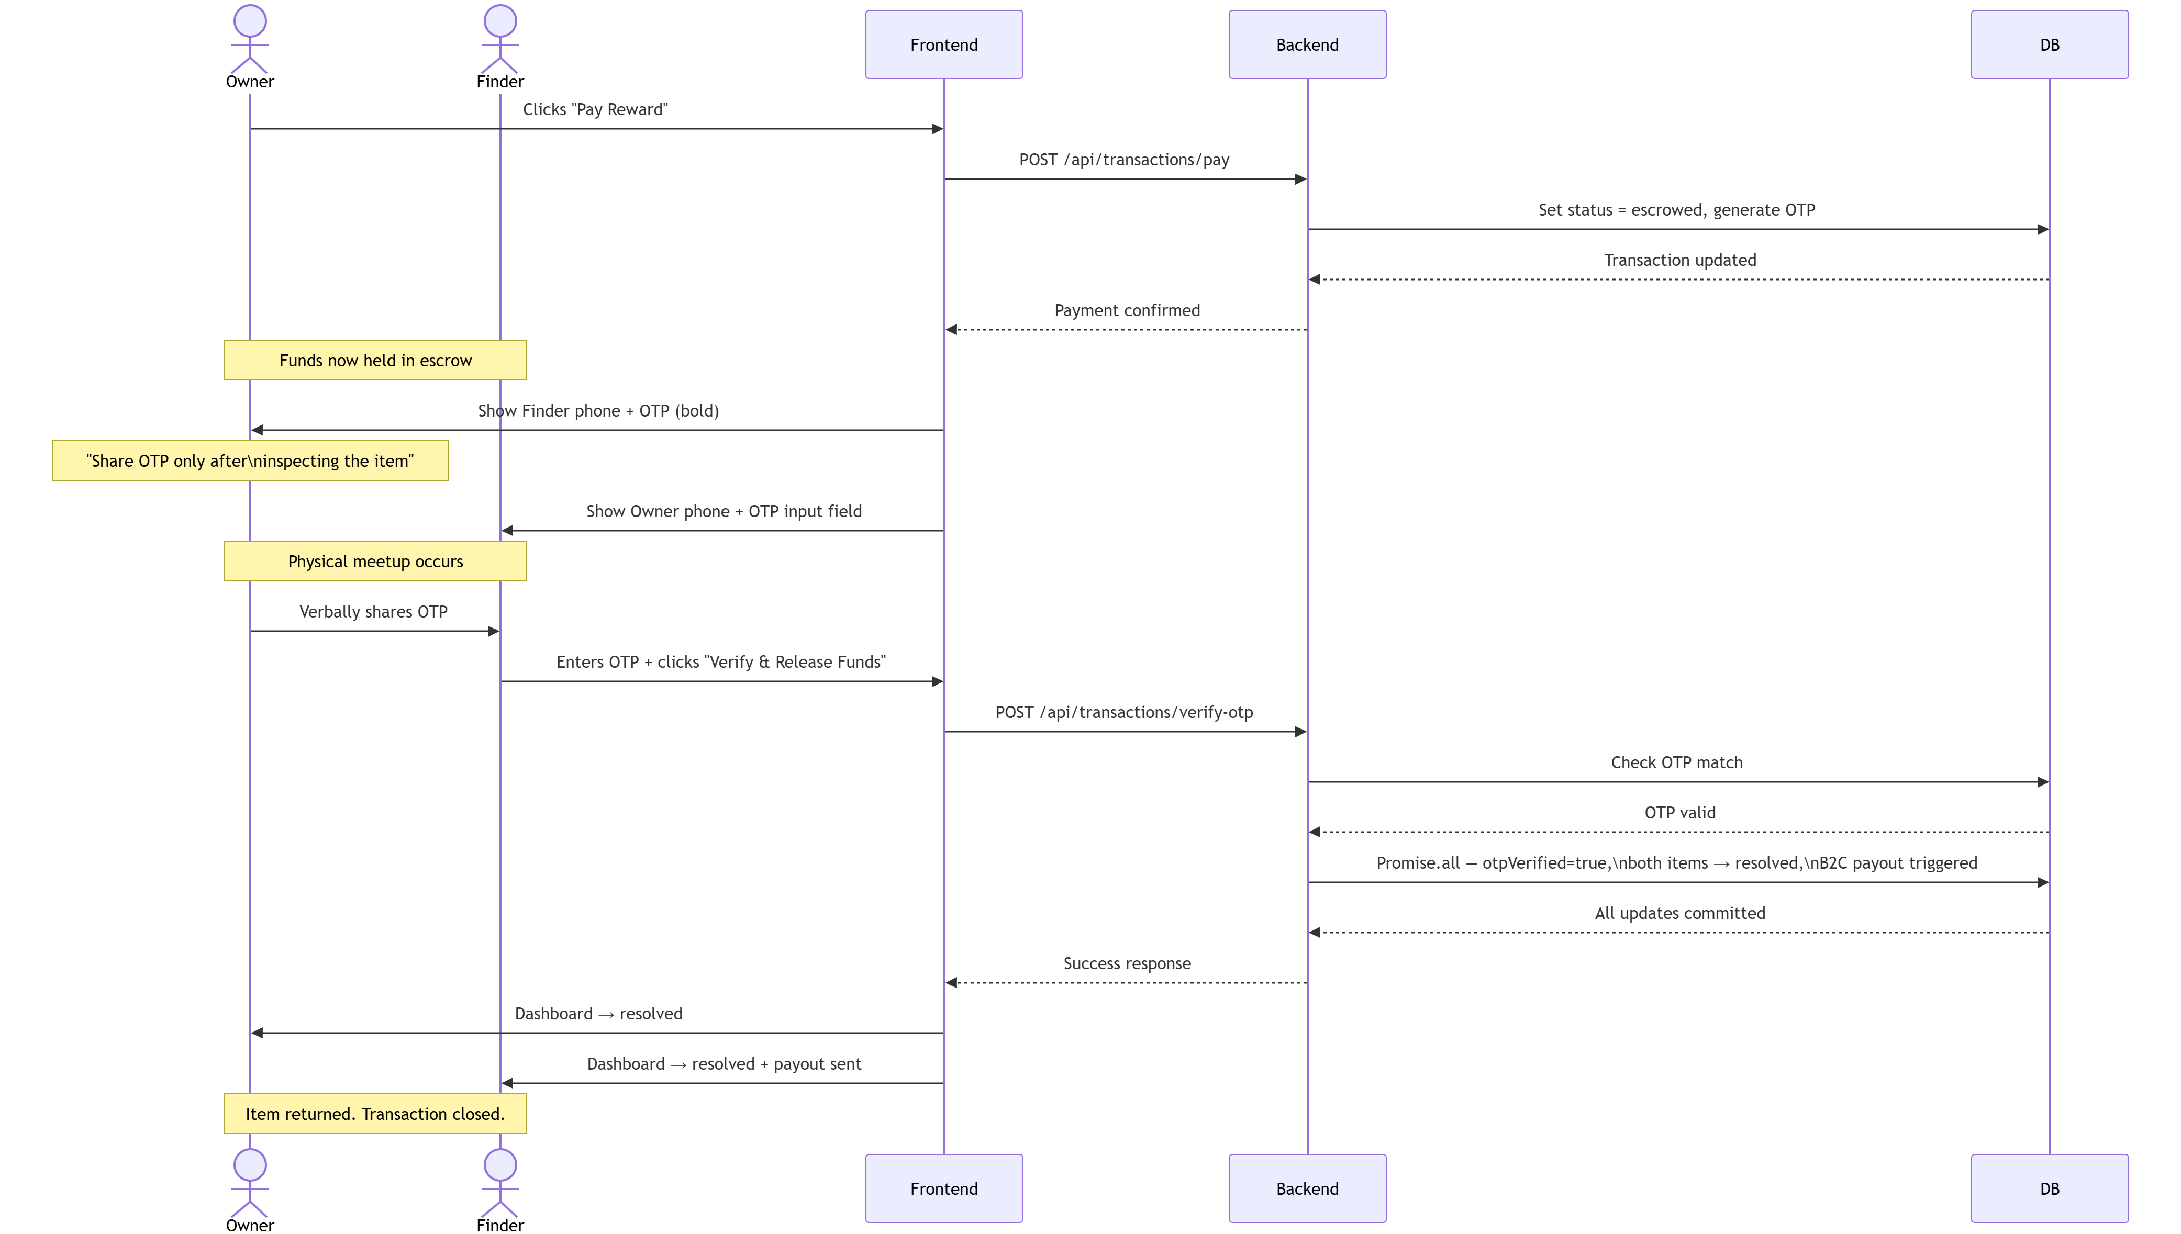
Figure 8 OTP Handshake Sequence Diagram

3.4 Resources
The following resources were used in the development of the system:
Hardware: A laptop with 16GB RAM and an Intel Core i7 processor, used for all development, testing, and demonstration.
Software: Visual Studio Code as the primary development environment; Git and GitHub for version control; Postman for API testing; MongoDB Compass for database inspection; Google Chrome for browser-based testing.
Programming Languages and Frameworks: JavaScript (ES6+) throughout. React.js with Tailwind CSS for the frontend. Node.js with Express.js for the backend. Mongoose for MongoDB object modelling.
Libraries and Tools: Axios for HTTP requests; React Router for client-side navigation; bcryptjs for password hashing; jsonwebtoken for JWT generation and verification; dotenv for environment variable management.

3.5 Project Gantt Chart
The project was executed across the second semester of the 2025/2026 academic year, from February to June 2026. The timeline was structured around the six development stages defined in Section 3.1.

Stage / Activity | Mar | Apr | May (1-20) | May (21-30) | Jun (1-4)
Stage 1: Auth & Roles | ✓
Stage 2: Items CRUD & Feed | ✓
Stage 3: Dashboard | ✓
Stage 4: Claims & Admin Review | ✓ | ✓
Stage 5: OTP Handshake |  | ✓ | ✓
Stage 6: Mock Payments |  |  | ✓
Testing & Bug Fixes |  | ✓ | ✓ | ✓
Documentation & Report |  |  | ✓ | ✓ | ✓

Table 6: Project Timeline and Milestones

CHAPTER 4: SYSTEM IMPLEMENTATION

4.1 Design and Implementation Platform
The Smart Campus Lost & Found System was implemented as a full-stack web application using the MERN stack. The frontend and backend are maintained as separate applications within a single repository, communicating exclusively through a RESTful HTTP API.
The frontend was built with React.js using a component-based architecture. Tailwind CSS was used for all styling, providing utility-first class names that enabled rapid, consistent UI development across all pages and components. React Router handled client-side navigation with protected route wrappers that redirect unauthenticated users to the login page.
The backend was implemented with Node.js and Express.js. All routes are grouped by domain (auth, items, claims, admin, payments) and protected by JWT authentication middleware and a separate admin-check middleware. Mongoose provided schema validation and document modelling for all four MongoDB collections.
The design system used Royal Purple (#6C63FF) as the primary accent colour for navigation and interactive elements, with Soft Yellow (#FFD166) for highlights and a neutral off-white (#F9F9F9) background. These choices were made to reflect the trust-oriented, campus-friendly character of the platform.

4.2 Installation and Setup
The development environment was configured as follows:
- Node.js (v20) and MongoDB (v7, local instance) were installed as the core runtime and database.
- The backend was initialised with npm init, and dependencies (express, mongoose, bcryptjs, jsonwebtoken, dotenv, cors) were installed.
- The frontend was bootstrapped with Vite (React template), with Tailwind CSS, Axios, and React Router added as dependencies.
- MongoDB collections were seeded with initial test data for users (including one admin), items, and claims to facilitate testing of the full workflow.
- Postman was used to verify all API endpoints prior to frontend integration, ensuring correct response structures and error handling.
- The mock payment endpoints (/api/payments/mock-pay and /api/payments/verify-otp) were tested end-to-end through Postman before being wired to the dashboard UI.

4.3 Testing
A structured testing strategy was applied across the full development lifecycle. The following test cases cover the critical paths of the system:

Method | Endpoint | Access | Description
POST | /api/auth/register | Public | Register a new user account
POST | /api/auth/login | Public | Authenticate and receive JWT
POST | /api/items | Private | Create a new lost or found item post
GET | /api/items | Public | Retrieve all public items (feed)
GET | /api/items/mine/:type | Private | Retrieve logged-in user's items
POST | /api/claims | Private | Submit an ownership claim
GET | /api/claims/mine | Private | Retrieve user's submitted claims
GET | /api/admin/claims | Admin | Retrieve all pending claims
PUT | /api/admin/claims/:id | Admin | Approve or reject a claim (atomic)
POST | /api/payments/mock-pay | Private | Simulate payment; generate OTP
POST | /api/payments/verify-otp | Private | Verify OTP; resolve items & payout
GET | /api/payments/transaction/:claimId | Private | Role-aware transaction details
GET | /api/admin/users | Admin | List all users
PUT | /api/admin/users/:id | Admin | Promote to admin or ban user

Table 3: API Routes Summary

TC | Test Case | Expected Result | Status
TC01 | Register with valid credentials | Account created; JWT returned | Pass
TC02 | Login with incorrect password | 401 Unauthorized returned | Pass
TC03 | Post a found item with all fields | Item saved; appears on Global Feed | Pass
TC04 | Claim own found item | 400 error: cannot claim own post | Pass
TC05 | Submit duplicate active claim | 400 error: claim already active | Pass
TC06 | Admin approves claim | Claim marked approved; items update atomically; Transaction created | Pass
TC07 | Admin rejects claim | Found item returns to unclaimed; Owner notified | Pass
TC08 | Owner triggers mock payment | Transaction set to escrowed; OTP generated; phones revealed | Pass
TC09 | Finder requests transaction — OTP not returned | Response payload contains no otpCode field | Pass
TC10 | Finder submits correct OTP | Items resolved; B2C mock triggered; resolved badge shown | Pass
TC11 | Finder submits incorrect OTP | Error shown; no status change; OTP remains valid | Pass
TC12 | Non-admin accesses admin endpoint | 403 Forbidden returned | Pass

Table 7: System Test Cases

Unit testing focused on individual backend controller functions — in particular, the atomicity of the claim approval logic, the OTP generation function, and the role-aware getTransaction controller that strips the OTP from Finder responses.
Integration testing verified the full end-to-end workflow from item posting through claim submission, admin review, mock payment, OTP entry, and item resolution across both the Owner and Finder dashboards.
Manual testing simulated real user scenarios including edge cases: attempting to claim one's own found post, submitting a second claim on an already-locked item, entering an incorrect OTP, and accessing admin endpoints with a standard user token.

4.4 Maintenance Plan
The following maintenance considerations are built into the system's design:
Database Backups: MongoDB Atlas (or a local mongodump cron job in development) should be scheduled for daily backups of all collections. The Transaction collection in particular must be preserved as a financial audit trail.
Dependency Management: npm audit should be run regularly to identify security vulnerabilities in Node.js and React dependencies. Major version upgrades should be tested in a staging branch before deployment.
Auto-Archiving: Claims that remain in awaiting_payment status for more than 48 hours should be auto-expired via a scheduled task (node-cron), returning the found item to unclaimed status. This logic was designed but deferred to post-launch implementation.
Environment Variables: All sensitive configuration (MongoDB URI, JWT secret, M-Pesa credentials) is stored in .env files excluded from version control. These must be rotated on any suspected exposure.

4.5 Security and Ethical Considerations
Several security and ethical safeguards are implemented throughout the system:
Authentication and Authorisation: All non-public routes require a valid JWT. The token encodes the user's ID and role and is verified on every request by the auth middleware. Admin-only routes apply a second middleware layer that checks role === 'admin'.
Privacy by Default: The Global Feed never exposes serial numbers, exact locations, or contact information. These fields are deliberately excluded from public-facing API responses using Mongoose select and manual field stripping. Phone numbers are only included in transaction response payloads after the transaction status is confirmed as escrowed.
OTP Security: The OTP code is stored in the Transaction document and is stripped from the getTransaction response when the requester is identified as the Finder. This is enforced at the backend, not the frontend, ensuring it cannot be bypassed by client-side manipulation.
Data Minimisation: Users are not required to provide phone numbers at registration (though it is recommended for the payment flow). No location data beyond the user's general campus area is collected or stored.
Ethical Considerations: The system does not store private item photos indefinitely. The admin review process introduces a human checkpoint that protects against automated or bulk false claims. The escrow mechanism protects both parties from non-delivery fraud.

CHAPTER 5: CONCLUSION AND RECOMMENDATIONS

5.1 Achievements
The Smart Campus Lost & Found System successfully achieves its core objectives. The following key milestones were delivered:
Full-Stack MERN Implementation: A complete, production-ready web application was built from scratch, covering user authentication, item management, admin review, and an OTP-based handoff mechanism — all integrated into a cohesive, responsive user interface.
Trust-Based Workflow: The system's claim-and-review workflow, in which an admin compares a Finder's private item details against an Owner's proof-of-ownership answers, provides a reliable human-mediated verification step that is absent from all reviewed comparable systems.
Privacy-by-Default Architecture: Sensitive information — phone numbers, OTP codes, serial numbers, and exact locations — is revealed progressively and only to the appropriate parties at the correct workflow stage. This is enforced at the API level, not merely the UI level.
Escrow Lifecycle with OTP Handshake: The complete escrow and OTP flow was implemented and verified end-to-end using a mock payment layer. The architecture is directly compatible with the M-Pesa Daraja API and requires only credential substitution to go live.
Admin Panel: A fully functional admin panel was built into the dashboard, providing claim review queues, side-by-side evidence comparison, approval and rejection controls, an escrow ledger view, and user management functionality.
Atomic State Management: All multi-document state transitions (claim approval, OTP verification) use parallel Promise.all updates, preventing data desynchronisation across the Claims, Items, and Transactions collections.

5.2 Limitations
The following limitations were identified in the current implementation:
M-Pesa Integration Not Deployed: The Daraja API integration (STK Push and B2C) was fully designed and architecturally prepared but could not be deployed due to Safaricom sandbox account restrictions. All payment functionality currently operates through a mock layer.
No Real-Time Updates: The dashboard does not use WebSockets or server-sent events. Users must manually refresh to see status changes made by the other party or by an admin. This creates a friction point during the handoff phase, where both parties are actively waiting for status updates.
No Push Notifications: There is currently no email or SMS notification system. Users are not alerted when their claim is reviewed, their payment is confirmed, or an OTP is available. This reduces the system's responsiveness for time-sensitive handoffs.
No Dispute Resolution Automation: While the dispute status and admin override buttons are implemented, the 48-hour auto-escalation logic and automated refund trigger were designed but not implemented in the current build.
Single-Institution Scope: The system is currently configured for a single campus. Multi-campus or multi-institution deployment would require additional tenant management logic.

5.3 Recommendations
Based on the development and testing of the platform, the following recommendations are made for future development:
Activate M-Pesa Integration: The highest priority next step is resolving the Safaricom sandbox account issue and activating the Daraja STK Push and B2C endpoints. The mock payment architecture maps directly to the live API, making this a low-effort, high-impact upgrade.
Add WebSocket Real-Time Updates: Integrating Socket.IO for real-time dashboard updates would significantly improve the user experience during the handoff phase, eliminating the need for manual refresh.
Implement Email/SMS Notifications: Adding Nodemailer (email) or Africa's Talking (SMS) integration would close the notification gap and reduce the time between workflow events and user awareness.
Build a Mobile-Responsive Progressive Web App (PWA): Converting the React frontend into a PWA would allow users to install the application on their phones and receive push notifications, improving engagement and accessibility on the campus.
Add a Suggested Matching Algorithm: A background job that compares newly reported Found items against existing Lost posts using category, location, and keyword matching could proactively surface potential matches on the Owner's dashboard, reducing the time owners spend searching the feed.

5.4 Conclusion
The Smart Campus Lost & Found System was successfully designed, developed, and tested as a full-stack web application that addresses a genuine operational gap. The system demonstrates that the trust mechanisms pioneered by commercial platforms — escrow, identity verification, staged disclosure, and OTP confirmation — can be effectively adapted to the campus lost and found context, transforming an informal and unreliable process into a structured, accountable, and privacy-preserving workflow.
The project represents a comprehensive application of undergraduate Computer Science concepts including full-stack development, database design, RESTful API architecture, role-based access control, and secure system design. Despite the M-Pesa integration remaining at the design stage, every other component of the system was implemented, tested, and verified end-to-end.
The platform is architected for extensibility. The transition from mock to live payments is a configuration change. Real-time notifications, advanced matching, and multi-campus support are natural extensions of the existing architecture. The Smart Campus Lost & Found System is ready for pilot deployment and provides a replicable model for digital lost and found management at institutions across Kenya.

REFERENCES
Laudon, K. C., & Laudon, J. P. (2022). Management information systems: Managing the digital firm (17th ed.). Pearson Education.
Schwaber, K., & Beedle, M. (2002). Agile software development with Scrum. Prentice Hall.
Safaricom PLC. (2024). Daraja API documentation. https://developer.safaricom.co.ke/docs
MongoDB, Inc. (2024). MongoDB documentation. https://www.mongodb.com/docs/
OpenJS Foundation. (2024). Node.js documentation. https://nodejs.org/en/docs
Meta Open Source. (2024). React – A JavaScript library for building user interfaces. https://react.dev
Axios Contributors. (2024). Axios documentation. https://axios-http.com/docs/intro
Mongoose Contributors. (2024). Mongoose ODM documentation. https://mongoosejs.com/docs/
Auth0. (2024). Introduction to JSON Web Tokens. https://jwt.io/introduction
Tailwind Labs. (2024). Tailwind CSS documentation. https://tailwindcss.com/docs
Express.js. (2024). Express — Fast, unopinionated, minimalist web framework for Node.js. https://expressjs.com
OWASP Foundation. (2024). OWASP top ten web application security risks. https://owasp.org/www-project-top-ten/
Vitejs. (2024). Vite — Next generation frontend tooling. https://vitejs.dev
University of Nairobi. (2024). Department of Computing and Informatics. https://computing.uonbi.ac.ke

APPENDICES

Appendix 1: User Manual

1.1 Account Registration
- Navigate to the application's landing page.
- Click the 'Register' button in the navigation bar.
- Enter your full name, email address, phone number (M-Pesa registered), and a password.
- Click 'Create Account'. You will be redirected to the dashboard on success.
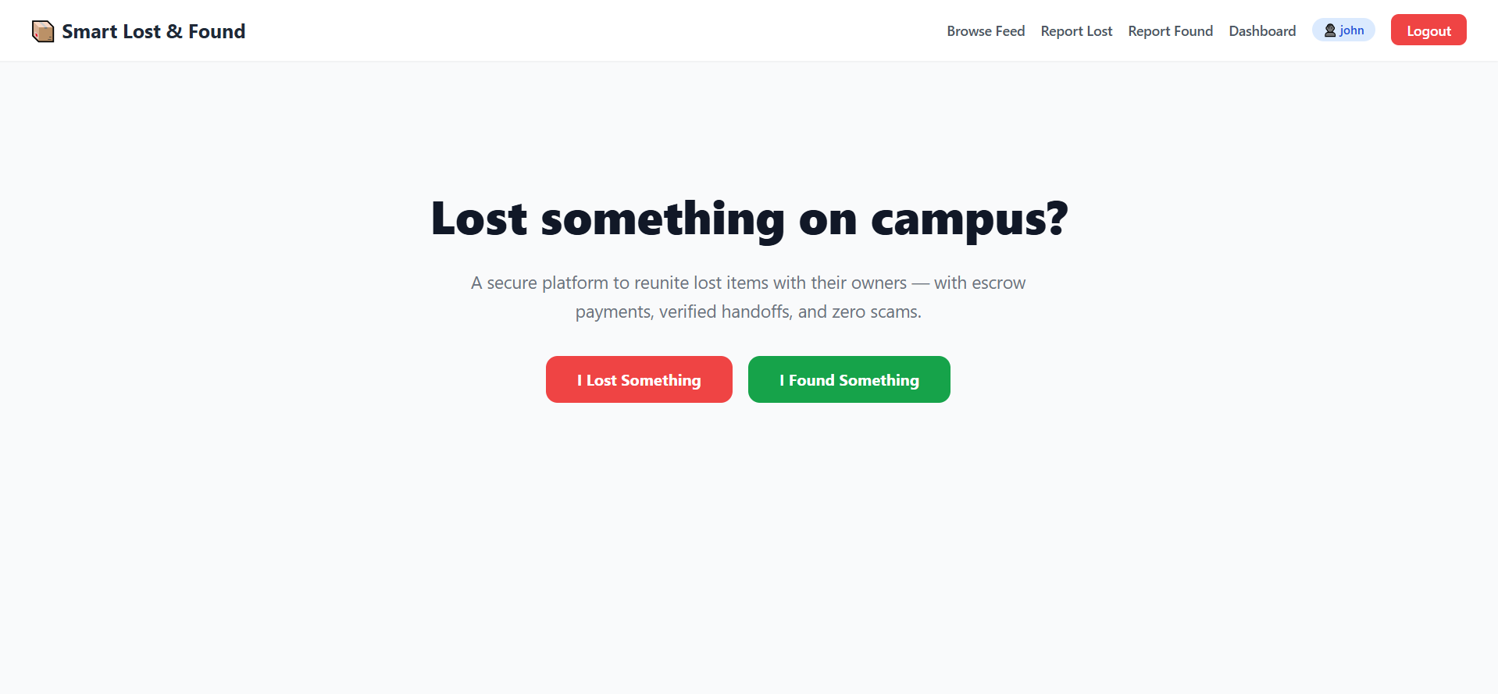
Figure 9 Landing Page
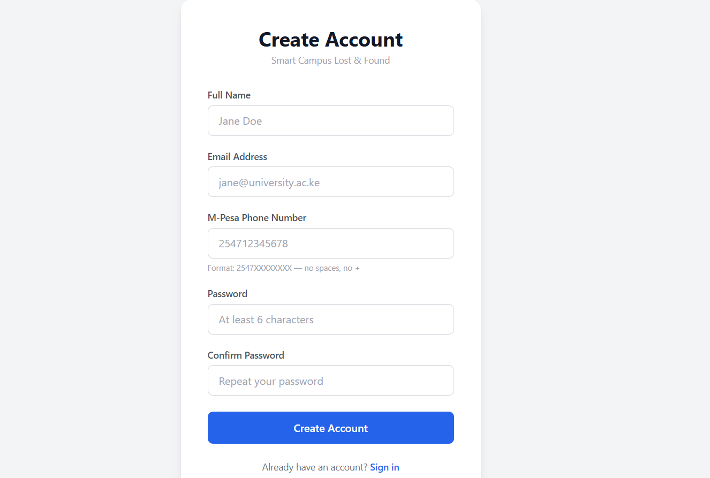
Figure 10 User Registration Page

1.2 Login
- Click 'Login' in the navigation bar.
- Enter your registered email and password.
- Click 'Login'. Your JWT session is stored in the browser and you are redirected to your dashboard.
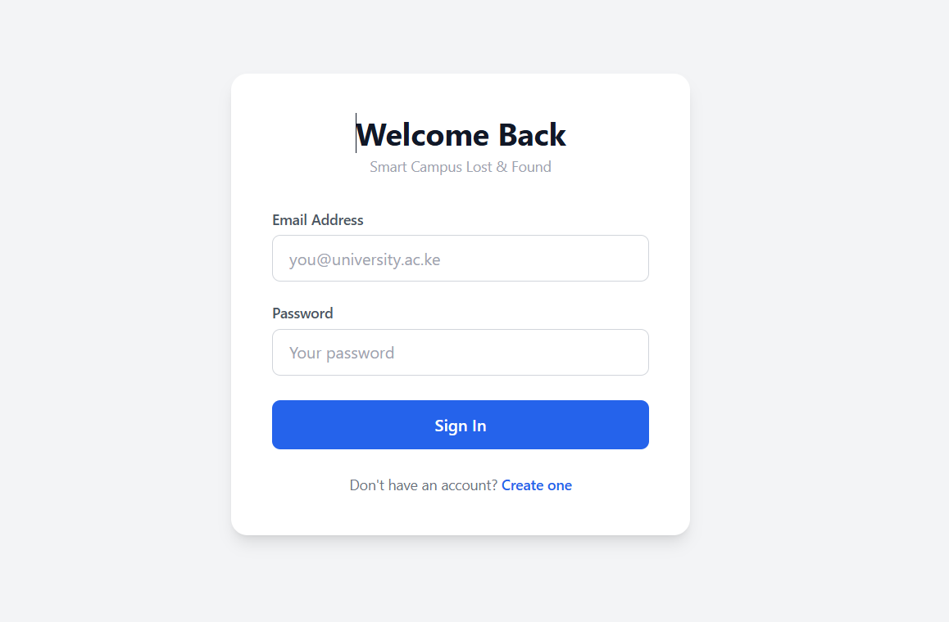
Figure 11Login Page

Appendix 2: Using the System

2.1 Browsing the Global Feed
- The Global Feed is accessible from the navigation bar without logging in.
- Use the 'Lost Items' and 'Found Items' tabs to switch between the two feeds.
- Use the search and filter bar to narrow results by category, general location, or date range.
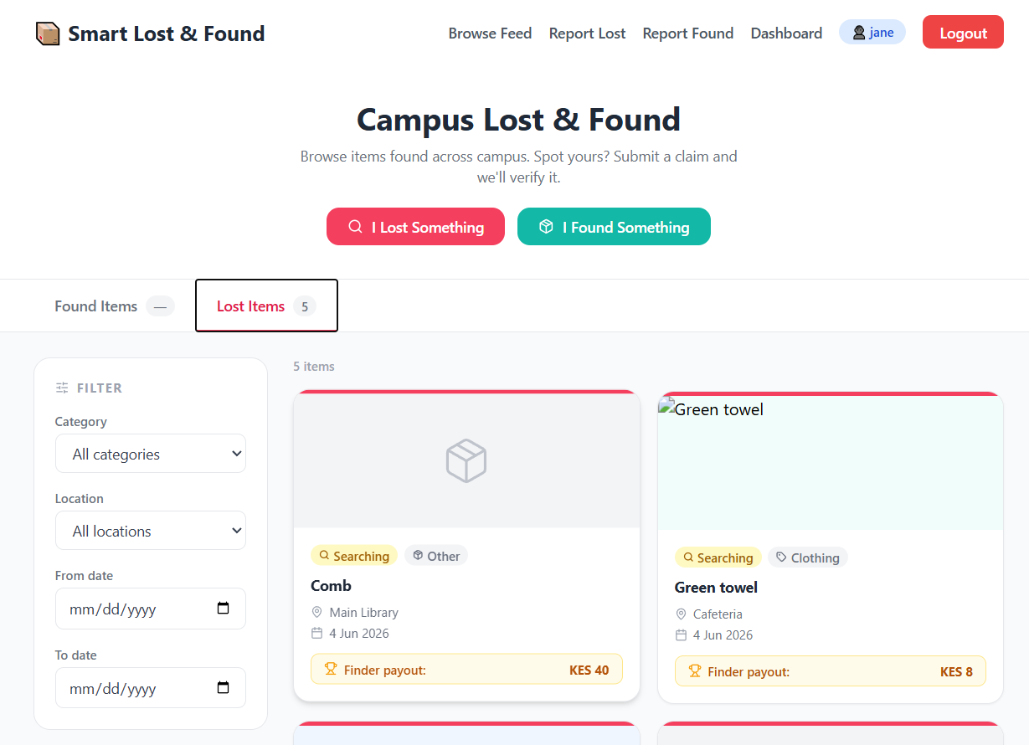
Figure 12 Global Feed — Lost Items Tab
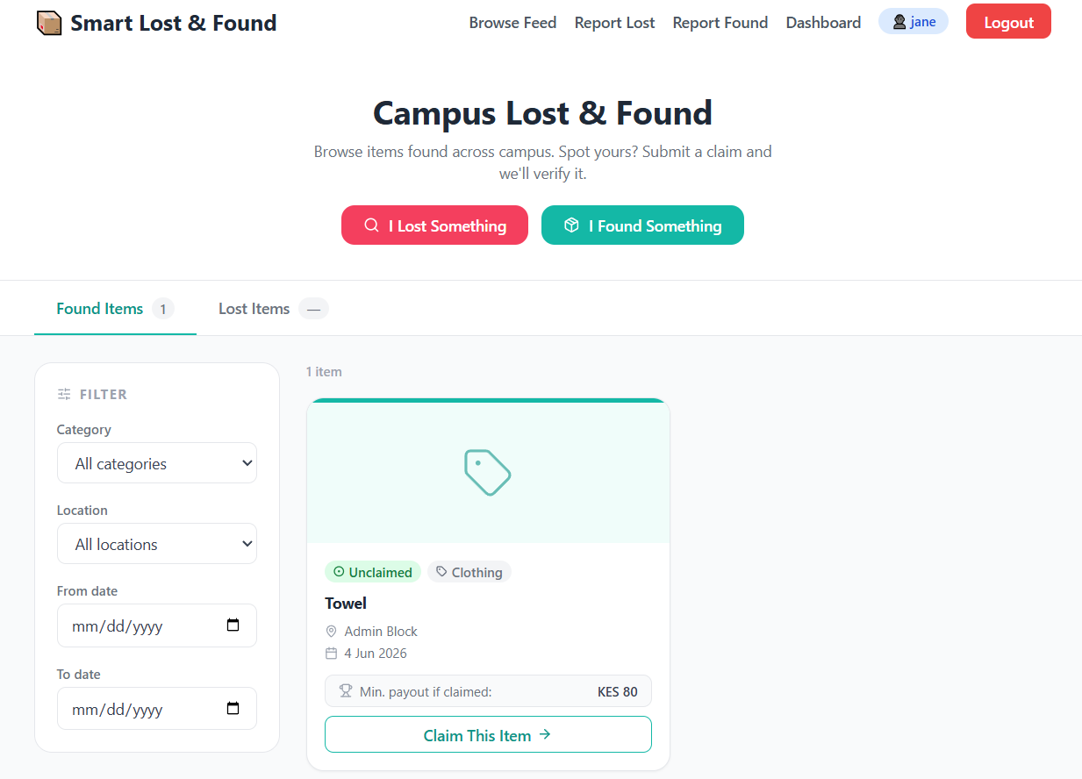
Figure 13 Global Feed — Found Items Tab

2.2 Reporting a Lost or Found Item
- Click 'Report Lost Item' or 'Report Found Item' from the dashboard or navigation.
- Fill in all public fields: title (generic), category, general location, photo, and reward amount (for lost items).
- Fill in the private fields: exact location, serial number or unique description, and a close-up private photo.
- Click 'Submit'. The item appears on the appropriate feed immediately.
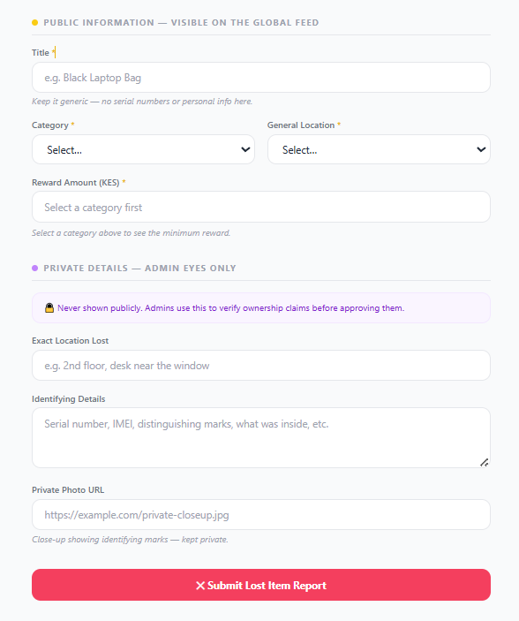
Figure 14 Report Item Form

2.3 Claiming a Found Item
- On the Global Found Feed, click 'Claim This Item' on the item you believe is yours.
- A modal opens with category-specific proof-of-ownership questions.
- Answer all questions as accurately as possible. Your answers will be compared against the Finder's private description by an admin.
- Click 'Submit Claim'. The item is locked from other claimants and appears in your 'My Active Claims' tab.
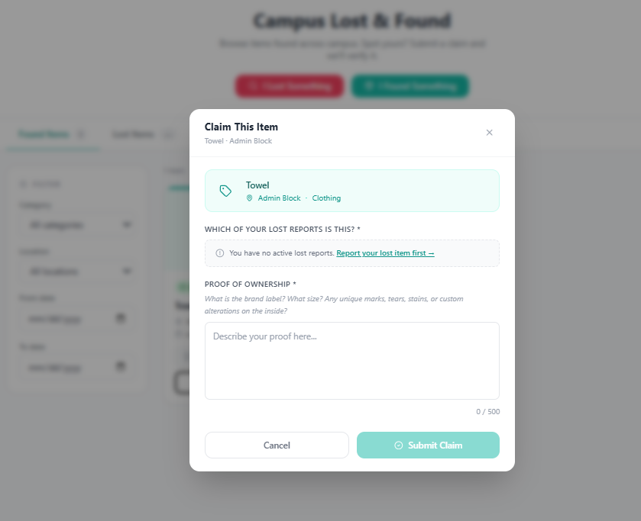
Figure 15 Claim Submission Modal

Appendix 3: The Dashboard

3.1 My Lost Reports
Lists all lost item posts you have created, showing current status, category, location, and reward amount. Once a claim on your item is approved and you complete payment, this tab reveals the Finder's phone number.
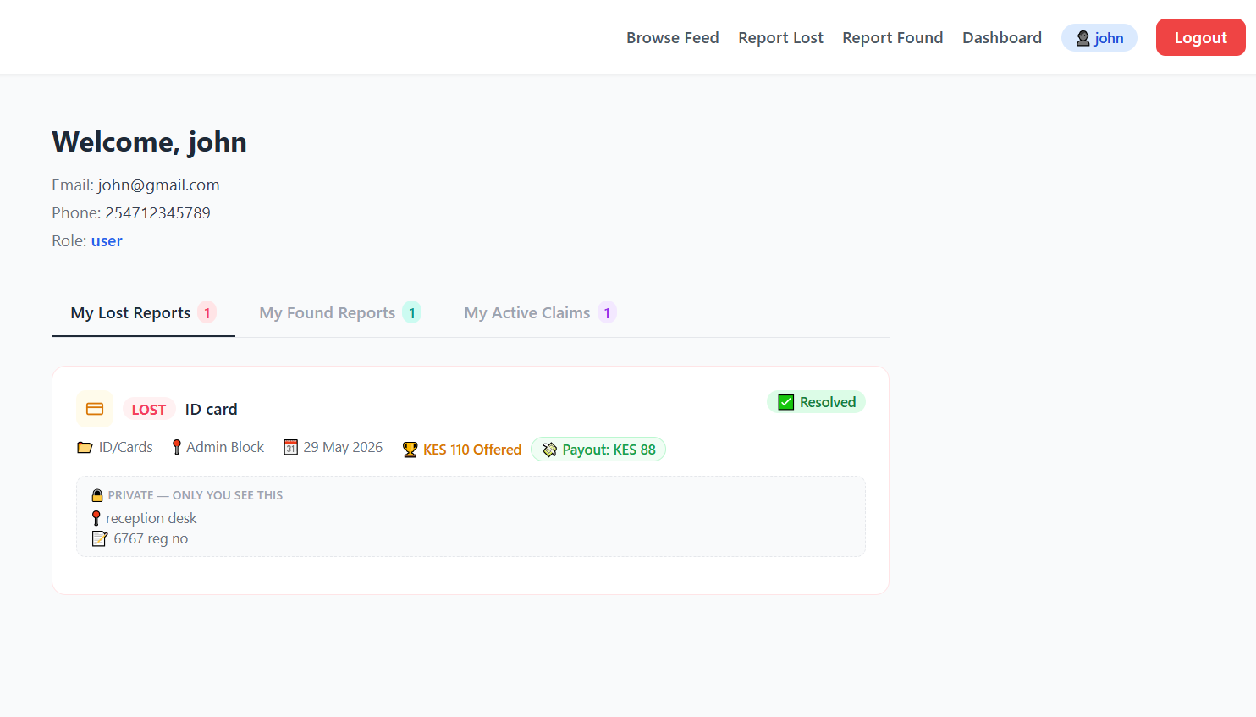
Figure 16 User Dashboard — My Lost Reports

3.2 My Found Reports
Lists all found item posts you have reported. When the item reaches the ready_for_handoff status, this tab reveals the Owner's phone number and renders the OTP input field.
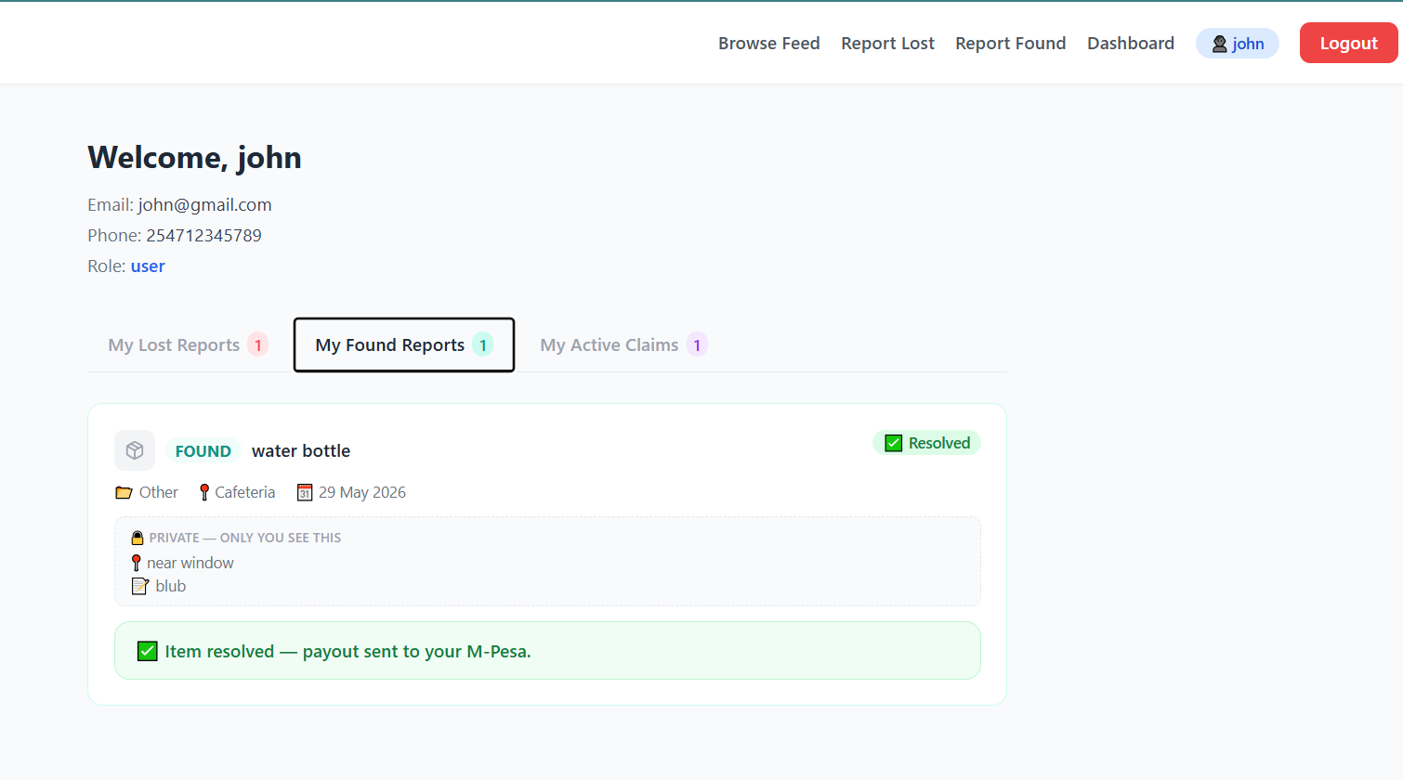
Figure 17: User Dashboard — My Found Reports

3.3 My Active Claims
Lists all ownership claims you have submitted. Shows the current review status. When a claim is approved, a 'Pay Reward' button appears. Once payment is confirmed, the Finder's phone number and the 4-digit Handshake Code are displayed here.
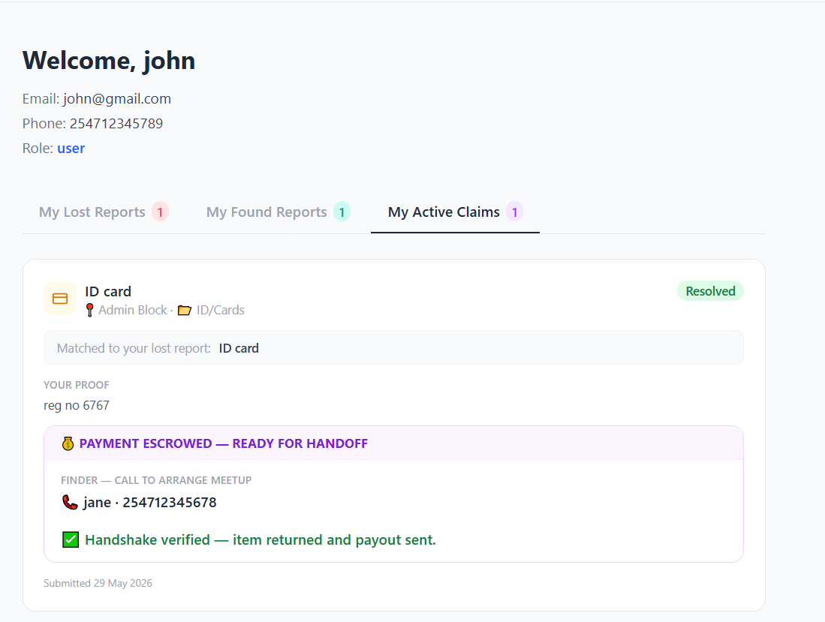
Figure 18 User Dashboard — My Active Claims

Appendix 4: Admin Panel

4.1 Pending Claims Queue
Visible only to users with admin role. Lists all claims pending review. Click any claim card to open the side-by-side review modal.
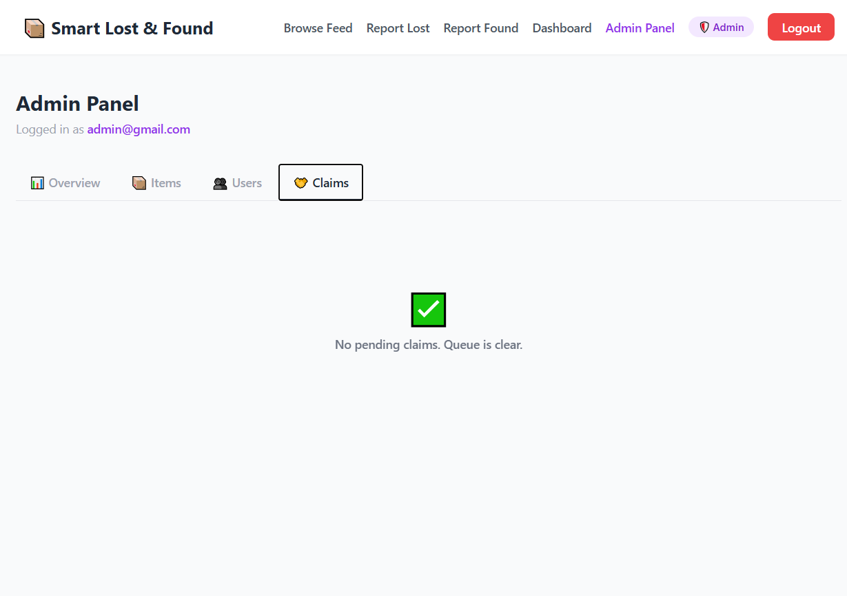
Figure 19 Admin Panel — Pending Claims Queue
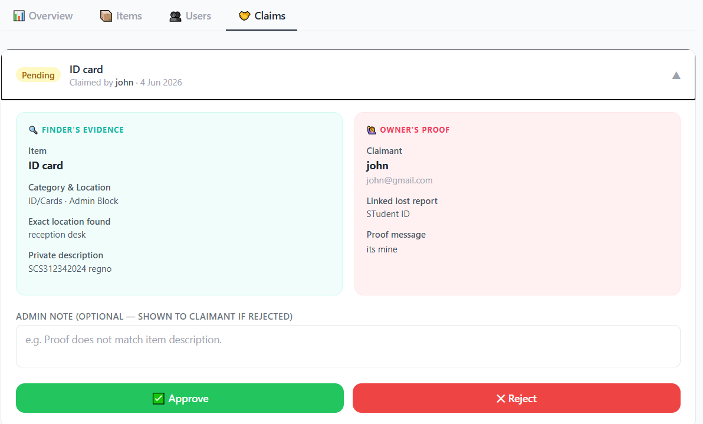
Figure 20: Admin Panel — Claim Review (Side-by-Side)

Appendix 5: OTP Handshake Flow

5.1 Owner View After Payment
Once mock payment is confirmed, the Owner's claim card reveals the Finder's phone number and the 4-digit Handshake Code in large bold text. The instruction reads: 'Only give this code to the Finder after you have inspected and received your item.'
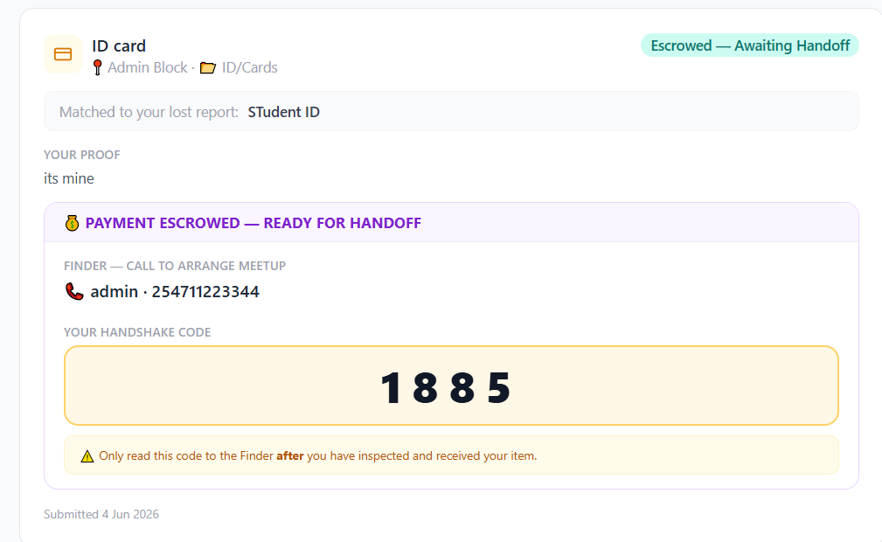
Figure 21 OTP Handshake — Owner View

5.2 Finder View During Handoff
The Finder's found item card reveals the Owner's phone number and an input field labelled 'Enter Handshake Code'. After the physical handoff, the Finder types the code and clicks 'Verify & Release Funds'.
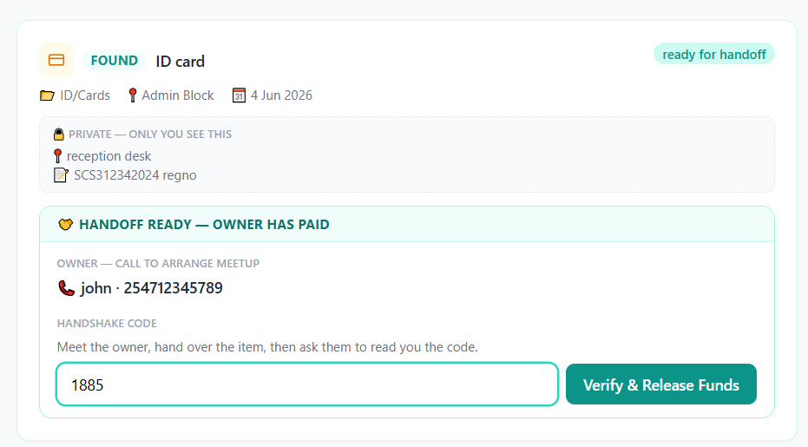
Figure 22 OTP Handshake — Finder View
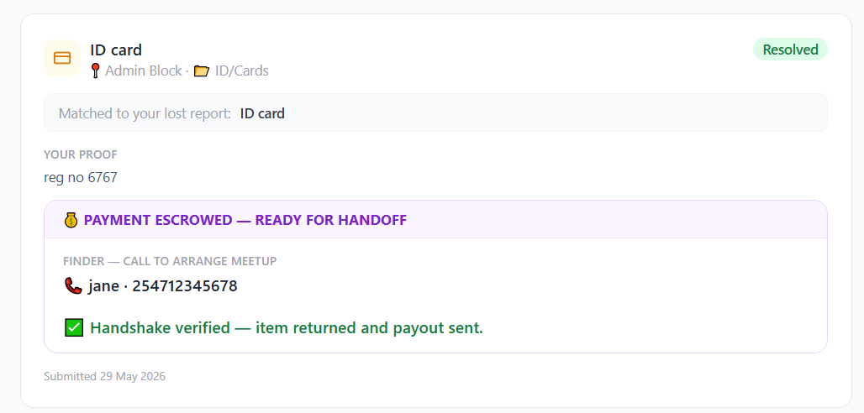
Figure 23 Resolved Item State

Appendix 6: Sample Code
The following excerpt illustrates the server.js file for the backend
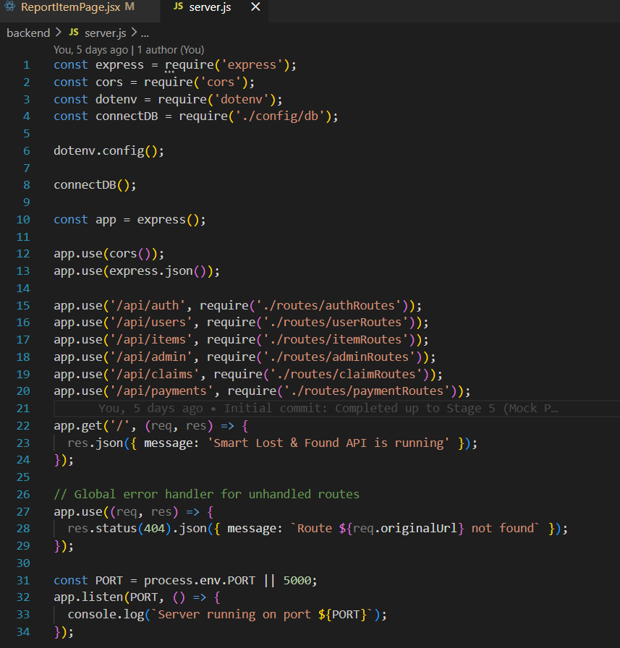
Figure 24 Sample code

