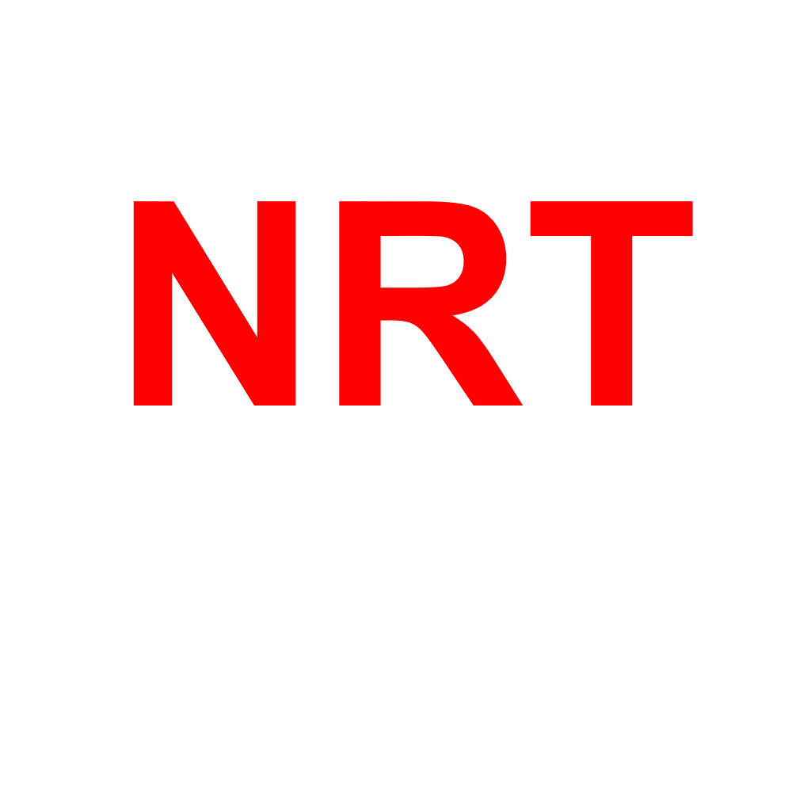
Dining car menu
19 June 2026
NEther Republic transport

Coffee

Espresso 1.40 EUR
Double Espresso 1.90 EUR
Americano 1.60 EUR
Cappuccino 1.90 EUR
Caffè Latte 2.10 EUR
Flat White 2.30 EUR
Mocha 2.40 EUR
Iced Latte 2.20 EUR
Macchiato 1.70 EUR
Cortado 1.80 EUR
Decaf Coffee 1.60 EUR
Soft drinks

Coca-Cola / Coca-Cola Zero (500 ml bottle) 1.40 EUR
Fanta Orange (500 ml bottle) 1.60 EUR
Sprite 1.70 EUR
7up 1.40 EUR
Lipton Green Tea 1.40 EUR
Lipton Lemon Tea 0.80 EUR
Cakes

Chocolate Cake 0.50 EUR
Apples Cake 0.50 EUR

