

**SiSy Short-Exam-1:**

Duration: 45 Minutes   
Open book exam, without calculator. Your calculations and solution approach need to be readable and comprehensible in order to get the full points. Please write your final results in the reserved gray fields and use the provided spaces for calculations.

|  |  |  |  |  |  |  |
| --- | --- | --- | --- | --- | --- | --- |
| Name: | | | | | Class: | |
| 1: | 2: | 3: |  |  | Points: | Grade: |

**Exercise 1** *Continuous and Discrete Sinusoidal Function* [4+4=8 points].

The plot of a discrete cosine function y[n] is shown below. The corresponding continuous function y(t) is also added in dashed lines, but the horizontal axis are the indexes n of the discrete function.

$y\left[n\right]=\cos\left(Ω.n\right)$ with $Ω :normalised angular frequency \left[\frac{radians}{sample}\right]$

$n ∈Z$

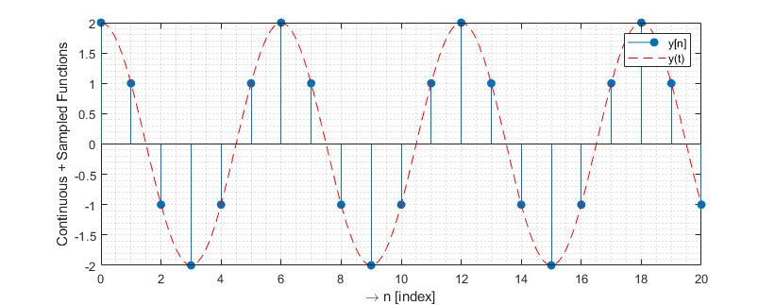

1. Determine the value of Ω. Comment your solution with a short sentence.

Solution:

Observing the plot, one can see that there are 6 points per period. Since cos(alpha) is 2pi periodic, this implies that:

$Ω=\frac{2π}{6}=\frac{π}{3} \left[\frac{rad}{sample}\right]$ and $y\left[n\right]=\cos\left(\frac{π}{3}.n\right)$

1. Consider that y[n] was obtained by sampling a continuous function y(t) with frequency fsig [Hz]. Given the sampling frequency Fs = 120Hz, determine the value of fsig.

Solution: We can represent the sampling process as t => n.Ts , which means

$$y[n]=\cos\left(2π.f_{sig}.n.T_{s}\right)=\cos\left(2π.\frac{f_{sig}}{F_{s}}.n\right)= \cos\left(Ω.n\right)$$

Therefore $$Ω=2π\frac{f_{sig}}{F_{s}}=\frac{π}{3} → \frac{f_{sig}}{F_{s}}=\frac{1}{6} → f_{sig}=20Hz$$

**Exercise 2** *Spectrum of a Harmonic Function and Decibels* [2+6+4+4=16 points].

The plot of the time function x(t) in the time domain is shown below:

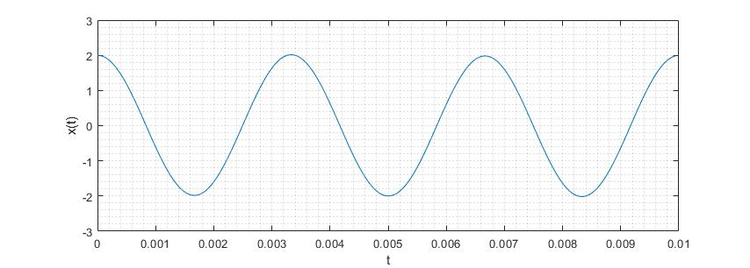

Then calculating the spectrum with fft() function, plus plotting and zooming at the range [0 600]Hz gives the following results:

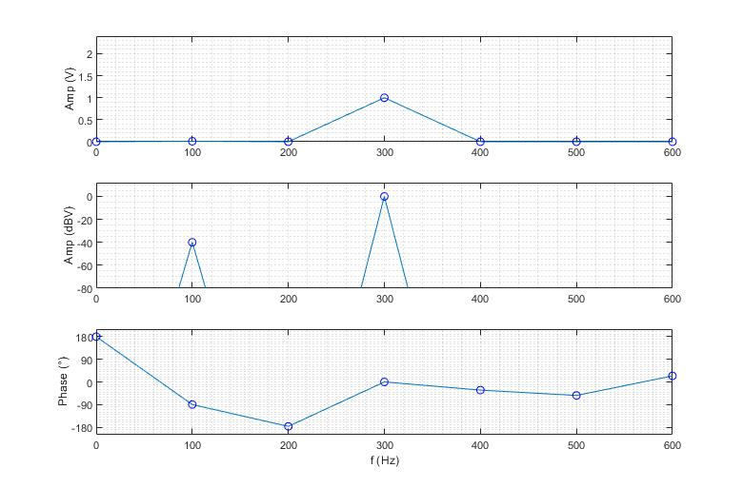

**Questions:**

1. Check the units and explain the differences between the two graphics showing the amplitude spectrum.
2. Which harmonics are present in the signal x(t) ? Determine the **frequency [Hz], amplitude [V] and phase [rad]** of each harmonic.
3. The fft() function estimates numerically the complex coefficients ck of the periodic function x(t). Determine which ck coefficients are not equal to zero, and determine their value in polar form.
4. Use your results from items (b) and (c) and write an equation describing x(t). Remember:

$$x\left(t\right)=\sum_{k=-∞}^{+∞}{\left[c_{k}∙e^{j\left(k2πf_{0}t\right)}\right]}$$

**Solution:**

(a)

The 1st graphic show the amplitude spectrum with a linear scale in volts, and since the 1st harmonic has a very small amplitude, it is not visible in a plot with a linear scale.

The 2nd graphic uses a logarithmic scale dBV, and one can see that the 1st harmonic is 40dB smaller than the 3rd harmonic, which means 100 times smaller amplitude.

(b)

1st and 3rd harmonics with:

A1 = 2e-2; f1 = 100; phi1 = -pi/2; % units [V], [Hz] and [rad]

A3 = 2; f3 = 300; phi2 = 0

(c)

The following ck coefficients are non-zero, plus have following amplitude and phase (from the graphic):

c+1 = 1e-2 * exp(-j.pi/2) so expecting also c-1 = 1e-2 * exp(+j.pi/2)

c+3 = 1e0 * exp(j.0) so expecting also c-3 = 1e0 * exp(j.0)

(d)

Then using the formula above you get: x_t = A1*sin(2*pi*f1*t) + A3*cos(2*pi*f3*t)

Detailed calculation, taking f0=100Hz :

(a)

(b)

(c)

(d)

**Exercise 3** *Analysing a Noisy Measurement* [3+4+3 = 10 points].

The graphic below shows the plot of a noisy measurement y(t), and its correlation (once full pane and once zoomed in).

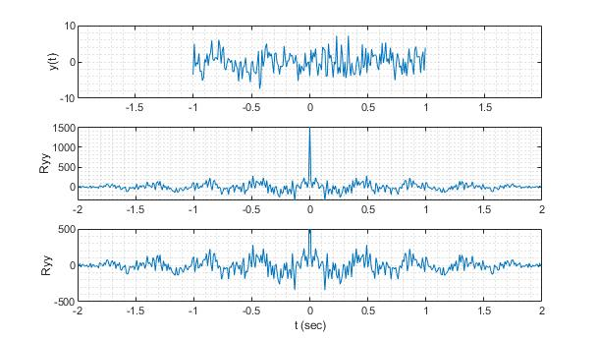

1. Explain which characteristics of the signal y(t) you can observe in its autocorrelation Ryy.   
   Do you expect to find a harmonic component in y(t) ? Why?

Solution:

The plot of the autocorrelation shows a narrow peak at t=0, and a periodic behaviour elsewhere. The peak at t=0 indicates the presence of random noise (which only correlates to itself when shift=0), and the periodic behaviour indicates a harmonic component. The frequency of this component is slightly higher than 2Hz, because 2 periods are slightly shorter than 1 second.

1. In order to confirm the presence of harmonic components, you decide to calculate an FFT. Complete the code below to calculate and plot the amplitude spectrum of y(t).

% consider that the vectors t and y_t, and the constant Ts are already defined

N = length(t);

Fs = 1/Ts;

aux = 0:1:N-1;

f = (Fs/N)*aux;

Y_f = (1/N)*fft(y_t);

figure()

subplot(211),plot( f,abs(Y_f) ),grid minor,ylabel('Amp.Spec.')

subplot(212),plot( f,angle(Y_f) ),grid minor,ylabel('Phas.Spec.'),  
 xlabel('f [Hz]')

1. Consider that:   
   Ts = 1e-2; % sampling period  
   N = 200; % number of points for fft  
   Which resolution will you get in the frequency domain for the spectrum calculated in item (b)?

In case this resolution is not fine enough, how could you improve it without doing a new measurement? Explain your idea with a short sentence and/or equation.

Solution:

Initial resolution : fstep = Fs / N = 100 / 200 = 0.5Hz

In case you need finer resolution without redoing the measurement, you can use zero-padding to prolong the vector y_t and re-calculate the fft with a higher N value. Since fstep = Fs/N, the new fstep will be smaller.

**Exercise 4** Complex Function in Polar Form [4+4=8 points].

The following complex function G(ω) is defined below:

$$G\left(ω\right)=\frac{1}{jωτ+1}$$

What is the value of ω when :

$\left|G\left(ω\right)\right|=\frac{1}{\sqrt{2}}$

$\left\langle G\left(ω\right)\right.=phase\{G\left(ω\right)\}=-45°$