

**SiSy Short-Exam-1:**

Duration: 45 Minutes   
Open book exam, without calculator. Your calculations and solution approach need to be readable and comprehensible in order to get the full points. Please write your final results in the reserved gray fields and use the provided spaces for calculations.

|  |  |  |  |  |  |  |
| --- | --- | --- | --- | --- | --- | --- |
| Name: | | | | | Class: | |
| 1: | 2: | 3: |  |  | Points: | Grade: |

**Exercise 1** Fourier Series with complex Coefficients [4+4+4=12 points].

1. The equation of a periodic signal x(t) is given below:

$$x\left(t\right)=A∙sin⁡(2πf_{0}t)=\sum_{k=-∞}^{+∞}{\left[c_{k}∙e^{j\left(k2πf_{0}t\right)}\right]}$$

You are looking for the Fourier Series of x(t) using the notation with complex coefficients ck.

Determine which ck coefficients are **not** equal to zero, and determine their value both in polar and in cartesian form.

Justify your answer with a short calculation. ***Hint*** : no integral calculation is needed.

**Solution:**

Calculation with variation-1:

Remembering Euler identity $e^{j∝}= cos{∝}+j\sin{∝}$ and setting $α={2πf_{0}t}$

you can express x(t) as

$$x\left(t\right)=A∙\sin\left(2πf_{0}t\right)=\frac{A}{2j}∙\left[e^{+j2πf_{0}t}- e^{-j2πf_{0}t}\right]=\left(c_{+1}∙e^{+j2πf_{0}t}\right)+\left(c_{-1}∙e^{-j2πf_{0}t}\right)$$

Therefore only $c_{±1}≠0 for ∀ k∈Z$

and

$c_{±1}=±\left(\frac{A}{2j}\right)= ∓\left(j\frac{A}{2}\right)= \left(\frac{A}{2}\right)∙e^{∓j\frac{π}{2}}$

Calculation with variation-2:

Compare with Notation II Ak, phik, and use relationship to ck coefficients

Calculation with variation-3:

Compare with Notation I ak, bk, and use relationship to ck coefficients

In cartesian form :

ck = ?

In polar form :

ck = ?

1. What changes in the ck coefficients from x(t) if the function changes as indicated below:

$$\hat{x}\left(t\right)=A∙\sin\left(2πf_{0}t- φ_{1}\right) with φ_{1}= \frac{π}{2}$$

Determine the value of the new ĉk coefficients from $\hat{x}\left(t\right)$ both in polar and cartesian form.

**Solution:**  only the phase of the ck coefficients change.

Calculation with variation-1:

$$\hat{x}\left(t\right)=A∙\sin\left(2πf_{0}t- \frac{π}{2}\right)= -A ∙\cos\left(2πf_{0}t\right)$$

Therefore

$$\hat{x}\left(t\right)= -\left(\frac{A}{2}\right)∙\left[e^{+j2πf_{0}t}+ e^{-j2πf_{0}t}\right]=\left({\hat{c}}_{+1}∙e^{+j2πf_{0}t}\right)+\left({\hat{c}}_{-1}∙e^{-j2πf_{0}t}\right)$$

So only ${\hat{c}}_{±1}≠0 for ∀ k∈Z$

and

${\hat{c}}_{±1}=-\left(\frac{A}{2}\right)= \left(\frac{A}{2}\right)∙e^{±jπ}$

Calculation with variation-2:

Consider again the Euler identity with $α={2πf_{0}t}- \frac{π}{2}$ then rewrite $\hat{x}\left(t\right)$ and compare

$\hat{x}\left(t\right)=A∙\sin\left(2πf_{0}t- \frac{π}{2}\right)=\frac{A}{2j}∙\left[\left(e^{+j2πf_{0}t}∙e^{-j\frac{π}{2}}\right)- \left(e^{-j2πf_{0}t}∙e^{+j\frac{π}{2}}\right)\right]=$

$\hat{x}\left(t\right)=$ $\left({\hat{c}}_{+1}∙e^{+j2πf_{0}t}\right) + \left({\hat{c}}_{-1}∙e^{-j2πf_{0}t}\right)$

Therefore

${\hat{c}}_{±1}≠0 for ∀ k∈Z$

and

${\hat{c}}_{±1}=±\left(\frac{A}{2j}\right)∙e^{∓j\frac{π}{2}}=±\left(\frac{A}{2j}\right)∙\left(∓j\right)=-\left(\frac{A}{2}\right)= \left(\frac{A}{2}\right)∙e^{±jπ}$

In cartesian form :

ĉk = ?

In polar form :

ĉk =

1. Describe the relationship between $\hat{x}\left(t\right)$ and $x\left(t\right)$ as a time shift, and use the time shift property of the Fourier series to verify your result from item (b).

**Solution:**

$$\hat{x}\left(t\right)=x\left(t-λ\right) with λ=\frac{T_{0}}{4}$$

Therefore, applying the time shift property, we expect:

$${\hat{c}}_{k}=c_{k}∙e^{-jkω_{0}λ} and -jkω_{0}λ=-jk\frac{2π}{T_{0}}\frac{T_{0}}{4}=-jk\frac{π}{2}$$

Which gives

$${\hat{c}}_{±1}=c_{±1}∙e^{∓j\frac{π}{2}}= ±\left(\frac{A}{2j}\right)∙e^{∓j\frac{π}{2}}$$

And confirms the result from item (b)

**Exercise 2** Measuring Speed with Correlation [6 points].

On the roof of a train, there were mounted two optical sensors (e.g. high speed cameras), which take pictures of the passing landscape.

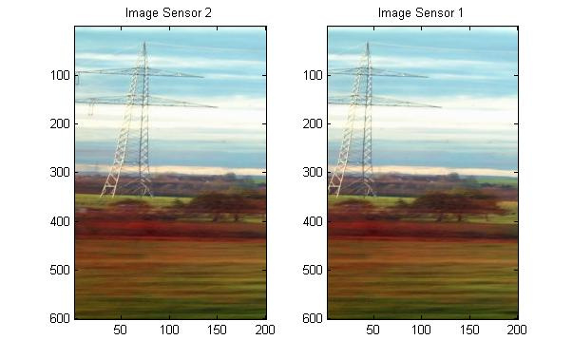

v=?

d

A snapshot of sensor-1 is compared with subsequent snapshots from sensor-2 using correlation, and produce the following result:

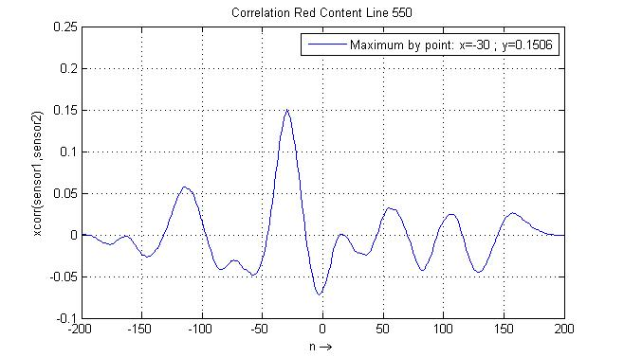

Determine the speed of the train, given the following parameters:

* d = 1m (distance between the two cameras);
* Fs = 1kHz (sampling frequency for sensor input signal )

**Solution:**

**Exercise 3** Discrete Fourier Transformation with FFT Function [12 points].



$$30ms ↔ 1m \\ 1s ↔ v \left[m/s\right]$$

Numerical approximations of the spectrum of three signals x1(t), x2(t) and x3(t) are calculated using the FFT function. Determine which spectrum corresponds to which signal. Justify your answer, by filling out the table on the next page:

Time signals:

|  |  |
| --- | --- |
| x1(t) |  |
| x2(t) |  |
| x3(t) |  |

Spectra: Solution: Observations in Spectrum below in green, then further in the table

|  |  |
| --- | --- |
| Xa[k] N=8 ; fstep =2Hz ; Fs=16Hz | Xb[k] N=16 ; fstep =2Hz ; Fs=32Hz |
| Xc[k] N=16 ; fstep =1Hz ; Fs=16Hz | Xd[k] N=16 ; fstep =2Hz ; Fs=32Hz |

|  |  |  |  |  |  |  |  |  |
| --- | --- | --- | --- | --- | --- | --- | --- | --- |
| Time Fct | Number of points | Observation Window | Time Step = Time resolution | Sampling Frequency | Frequency Resolution |  | Corresponding  Spectrum | Why? |
| signal | **N** | **N*Ts = N/Fs**  [s] | **Ts = tstep**  [s] | **Fs**  [Hz] | **Fs/N = fstep**  [Hz] |  | **abs(X[k])** | Matching parameter? |
| x1(t) | 16 | 1 | 1/16 | 16 | 1 |  | abs(Xc[k]) | fstep=1Hz  tstep=1/16 s=1/Fs |
| x2(t) | 16 | 0,5 | 1/32 | 32 | 2 |  | abs(Xd[k]) | Tsig=T0=2Hz |
| x3(t) | 8 | 0,5 | 1/16 | 16 | 2 |  | abs(Xa[k]) | N=8 |