SiSy Short-Exam-2:

Duration: 45 Minutes Open book exam, without calculator. Your calculations and solution approach need to be readable and comprehensible in order to get the full points. Please write your final results in the reserved gray fields and use the provided spaces for the sketches. Do not forget to label your axes.

|  |  |  |  |  |  |  |
| --- | --- | --- | --- | --- | --- | --- |
| Name: | | | | | Class: | |
| 1: | 2: | 3: |  |  | Points: | Grade: |

**Exercise 1**  System Views *[3+3+4=10 Points].*

The blockdiagram of an LTI system is given below.

y(t)





x(t)

B

C

A

-

-

+

1. Calculate the differential equation, which describes the complete LTI system. In this equation there should only appear terms with x(t), y(t) and corresponding derivatives.

Diff.Equ.:

1. Use Fourier transformation properties to show that the following frequency response G(jω) also describes the LTI system above.

$$G\left(jω\right)=\frac{A}{{\left(jω\right)}^{2}+B∙\left(jω\right)+C}$$

*Obs:* In this way, you can check your answer for item (a).

1. Challenge: calculate the characteristic equation of the LTI system above, and determine for which conditions is the system able to oscillate.

**Exercise 2** ADC and Aliasing  *[2+3+2+2+3+3=15 Points].*

Consider the following chain of ADC, DSP and DAC plus filters, and an incoming signal x(t).

AAF

ADC

**DSP**

DAC

**mit ZOH**\*

Fs

Fs

LPF

fcut < Fs/2

**ADC**

**DAC**

LPF

fcut < Fs/2

**x(t)**

**xs(t)**

**xr(t)**

The expression describing a signal x(t) in the time domain, is given below:

$x\left(t\right)=1∙\sin\left(2πf_{0}t+\frac{π}{4}\right)+2.\cos\left(2π{∙3∙f}_{0}t\right)$ with $f_{0}=20kHz$

1. Draw a sketch of the amplitude spectrum abs(X(f)) in the axis below:

-Fs -Fs/2 Fs/2 Fs f (Hz)

1. The signal x(t) is sampled by an ADC working with a sampling frequency of Fs=100kHz.   
   Suppose here that, there is no Anti-Aliasing-Filter before the ADC.

Draw a sketch of the amplitude spectrum of the sampled signal abs(Xs(f)) .

-Fs -Fs/2 Fs/2 Fs f (Hz)

1. The sampled signal is directly sent to the DAC (type zero order holder) without any processing in the DSP. A reconstruction filter (low pass filter with cut frequency Fs/2) follows the DAC.

Draw a sketch of the amplitude spectrum of the reconstructed signal abs(Xr(f)) .

-Fs -Fs/2 Fs/2 Fs f (Hz)

1. Are the reconstructed signal xr(t) and the original signal x(t) identical? Comment and justify your answer, referring to your sketches above.
2. What would change in the spectrum of Xs(f) and Xr(f) , if an Anti-Aliasing filter was deployed before the ADC? Use a coloured pencil/pen to indicate in your drawings above, which component would change, and comment your answer below.
3. You would like to check the results of item(b) using a Matlab code and the fft() function. Complete the code below, and select the value of N, such that you match the “bars” of the spectrum calculated with fft() with the harmonics of x(t).

**?**

**?**

**?**

clear all, close all, clc;

N = 50;

Fs = 50e3; % sampling frequency

aux = 0:1:N-1;

t = (1/Fs)*aux;

f = (Fs/N)*aux;

fsig = [ 10e3 , 20e3 ];

y_t = 1*sin(2*pi*fsig(1)*t + pi/4) + 2*cos(2*pi*fsig(2)*t);

Y_f = (1/N)*fft(y_t);

stem(f,abs(Y_f)), …

**?**

**?**

**?**

**?**

**Exercise 3** Impulse Response and Convolution  *[3+3+4 = 10 Points].*

1. The step responses of three systems are plotted below. Fill out the 1st column of the table below, indicating which step response matches each type of filter.

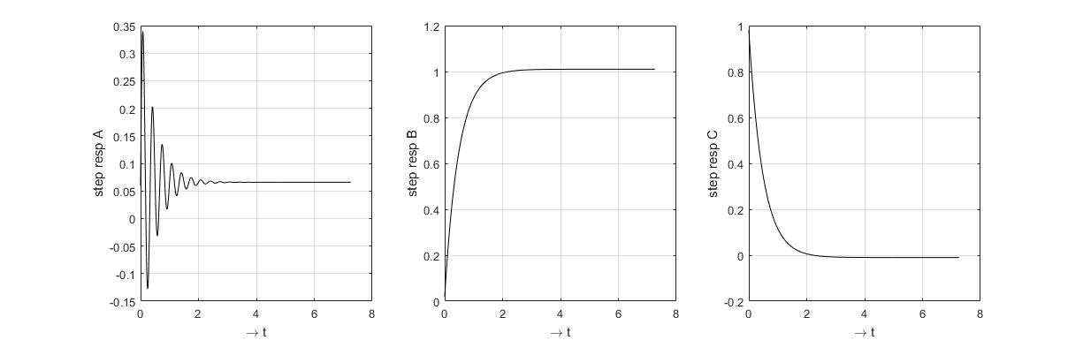

|  |  |  |  |
| --- | --- | --- | --- |
| Filter Type →  System Output ↓ | LPF | BPF | HPF |
| Step response |  |  |  |
| Signal response |  |  |  |

1. Now, the same three systems received a periodic rectangular wave as input signal. The plots below show the system responses and the input signal in dashed lines. Fill out the 2nd column of the table above, indicating which response matches each type of filter.

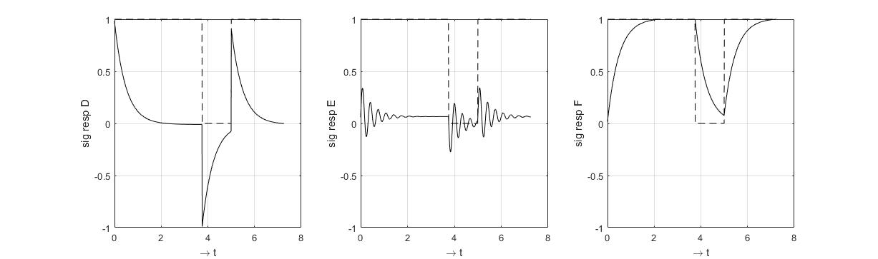

1. How can you calculate numerically the step responses and the signal responses, if you have available the impulse response of the system? Which mathematical expressions are you approximating with these numerical calculations?

Explain your answer, by giving the main line of Matlab code and the corresponding mathematical equation.