**Test 1**

This is a home assignment. You can discuss your ideas with colleagues, but you should upload your individual solution, as a *.mlx file, with comments, formulas and code snippets.

**Exercise 1** *Cosine Wave with Exponential Envelope*

1. Write a script in Matlab which generates a plot of a cosine function, defined as:

 ; and 

Define your time vector so, that your plot shows exactly 10 periods of the sine wave, and has 20 points per period of the sine wave.

1. What are the changes you observe in your plot for the following values of s?



1. Find the equation of the envelope curve for the three different values of s .

**Exercise 2** *Fourier Series: calculate complex coefficients plus check with synthesis*

1. Calculate the complex Fourier coefficients ck for a ramp-function, like the one which is available in the FuGe (signal generator in lab). Name A the maximum value, and T0 the period of the function.

Hint: follow the calculation steps recommended in List-2 exercise-7.

-T0 0 T0 2.T0 t[s]

x(t)

A

1. Verify the expression of your ck coefficients with a plot in Matlab (Fourier synthesis).

Hint: Either your code from Lab2A, or the code in List-2 exercise-7f can help you here.

1. Determine the corresponding real Fourier coefficients Ak, and generate in Matlab a plot of the single sided amplitude spectrum. Make two versions of your plot, one with a linear scale and another with a dB scale for the amplitude values.
2. Determine the corresponding complex Fourier coeffiients ck, and generate in Matlab a plot of the double sided amplitude spectrum.
3. Calculate now a numerical approximation of the ck coefficients using the fft function. And compare this approximation to the results of item (c).

**Exercise 3** *Parseval Theorem: power in time and frequency domains*

The following two time functions have the same harmonics (1st, 3rd and 5th), and same amplitudes but different phases:

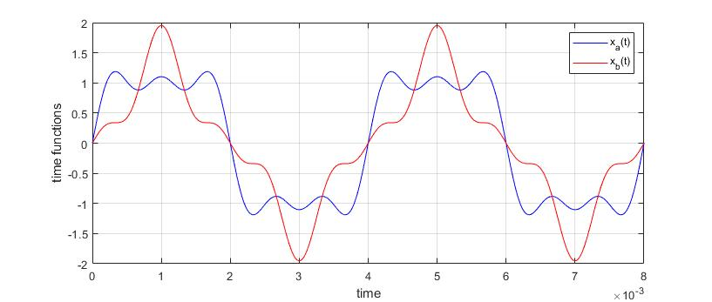

Complete the Matlab template *audio_vs_phase.m* script in order to:

* Define the expressions for the 3 harmonics
* Define the expressions for xa(t) and xb(t)
* Calculate the power of xa(t) and xb(t), both in the time and frequency domain, and confirm the Parseval Theorem.

**Exercise 4** *Audio Waveforms*

The following sound waveforms are defined in the Matlab script *Waveshapes_matrix.m* .

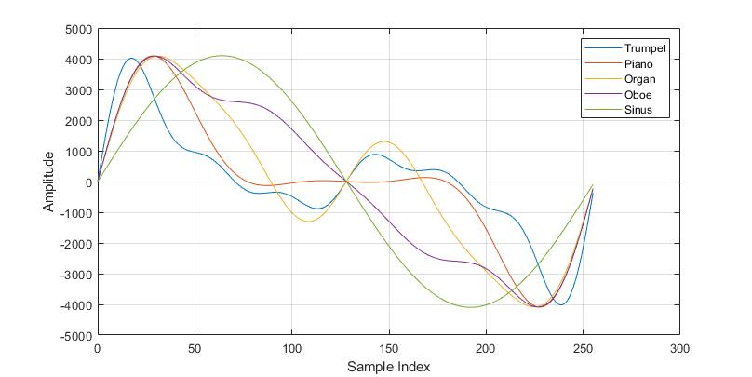

Study and expand the Matlab script in order to:

* Calculate the fft() of each sound waveform and generate a plot of the amplitude spectra, zooming on the first 10 harmonic . Use aux as the k vector (index of the harmonics).
* Given the differences in the spectra, which 2 sounds do you expect to differ the most? Check your assumption, using the loop to generate longer vectors and play them.
* Inside the loop there are 2 lines with the comments:

% here get fundamental tone = 187.5Hz

% here get fundamental tone = 375Hz

Check what is calculated in these two lines and explain why they generate vectors with these two fundamental frequencies.