**Test 2**

**Exercise 1** *Fourier Transformation and Properties*

Two church bells sound 4 seconds after another (*“bing-beng”*). We simplify and approximate each of the bell sounds, by a single oscillation with an envelope of a decaying exponential.

Bell 1: - - Envelope: 

- Tone: 

Bell 2: - Envelope: 

- Tone: 

1. Prepare a sketch in time domain of the sum of the envelopes:



(b) Calculate the Fourier Transformation of x(t): 

Hint: expect a paper calculation, based on the FT definition with the integral plus FT properties.

(c) Calculate the zeros of  . Hint: this is also a paper calculation.

1. Prepare a sketch in the frequency domain of the amplitude spectrum    
   (amplitude spectrum of the tone from Bell-1).

Hint: consider the modulation property of the Fourier transformation.

**Exercise 2** *The Uncertainty Principle (or Time-Bandwidth Produkt)*

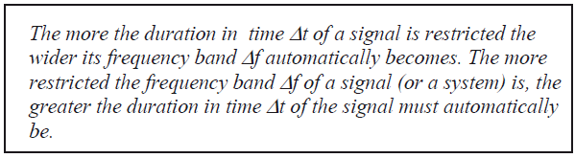

*Source : Ulrich Karrenberg „Signals, Processes and Systems“*

*Uncertainty Principle in german „Unschärferelation“*

1. Let us experiment with the Uncertainty Principle as expressed above. Define in Matlab three rectangle functions x1(t), x2(t) and x3(t), corresponding to the time function in the left side of figure 1 below.

*Hint: Define a time vector with exactly 1’000 points, and a sampling frequency of 5kHz. In the function x1(t) all the points are equal to ‘1’, in x2(t) half of the points, and in x3(t) one fourth of the points are equal to ‘1’. You can use for example the functions ones() and zeros(), and concatenate the vectors together.*

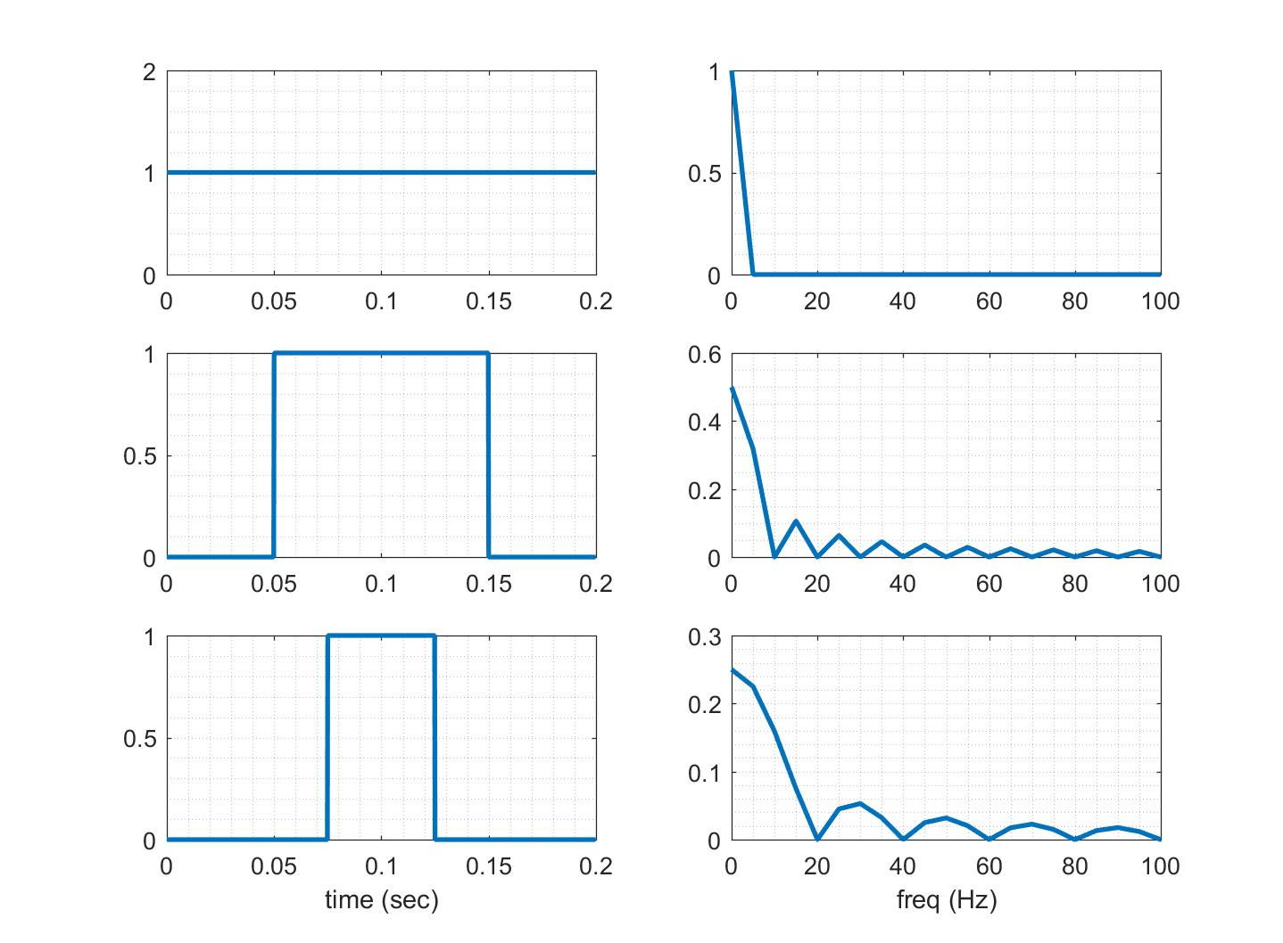

Figure 1 Three rectangular pulse with different widths.

1. Use the FFT to calculate the corresponding spectra X1(f), X2(f) and X3(f), and generate a plot of the amplitude spectra. Explain the differences among these spectra based on the property time-bandwidth product.

*Hint: Use the command xlim(), to zoom around and fix the frequency range [0; 100]Hz .*

In the next exercise, you will use these rectangular pulses as envelope curves for a carrier signal.

**Exercise 3** *The Frequency Shift Property*

1. Define now the signals y1(t), y2(t) and y3(t), which correspond to the multiplication of the envelope curves x1(t), x2(t) and x3(t) with a sinus wave of frequency 400Hz.
2. Calculate and plot the spectra Y1(f), Y2(f) and Y3(f), and use *xlim()* to zoom around the interesting part of the spectrum. Where is it now (which frequency range) ?

Check the frequency shift property and explain the differences among the Xn(f) and Yn(f) spectra.

1. How do these spectra change, if you take instead of the rectangular envelope curves, three new envelope curves with the form of slow sinuses with frequency 5Hz, 10Hz and 20Hz ? You can consider these envelope curves last over the entire time window [0 0.2]s   
   Justify your answer with a plot in Matlab.

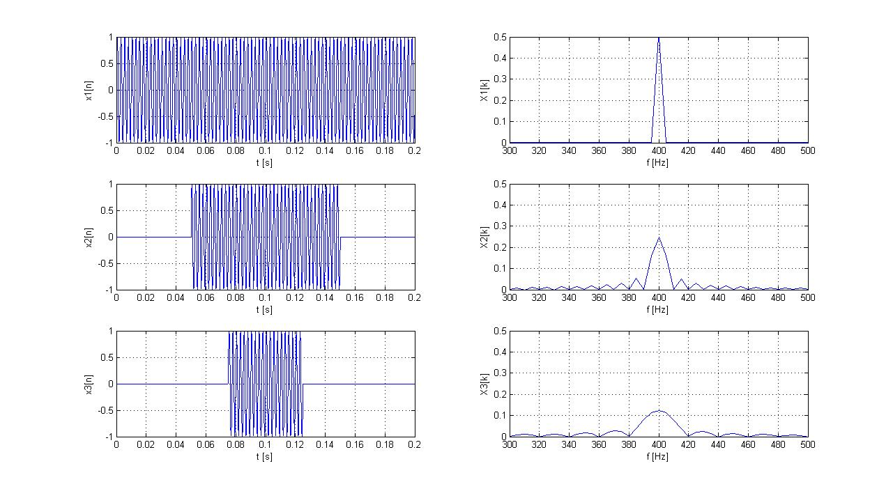

Figure 2 Three rectangular envelope curves in red, defining the width of the modulated pulses