**Test-2:**

Fourier Tranformation Properties and Applications

In this test you exercise different properties of the Fourier Transformation as: time-bandwidth, duality and frequency shift or modulation.

**Exercise 1** *The Uncertainty Principle (or Time-Bandwidth Produkt)*

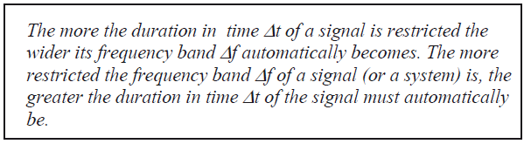

*Source : Ulrich Karrenberg „Signals, Processes and Systems“*

*Uncertainty Principle in german „Unschärferelation“*

1. Let us experiment with the Uncertainty Principle as expressed above. Define in Matlab three rectangle functions x1(t), x2(t) and x3(t), corresponding to the red dotted functions in figure 1 below (these are the envelope functions in figure 1).

*Hint: Define a time vector with exactly 1’000 points, and a sampling frequency of 5kHz. In the function x1(t) all the points are equal to ‘1’, in x2(t) half of the points, and in x3(t) one fourth of the points are equal to ‘1’.*

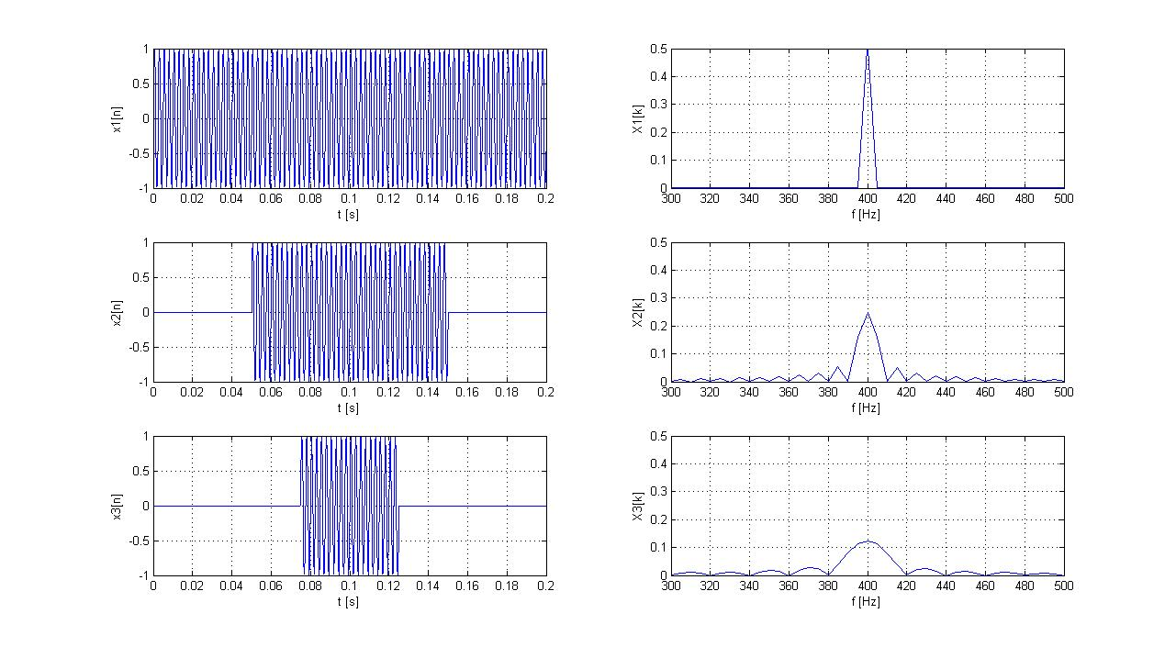

Figur 1 Three rectangular envelope curves in red, defining the width of the sinus impulses

1. Use the FFT to calculate the corresponding spectra X1(f), X2(f) and X3(f), and generate a plot of the amplitude spectra. Explain the differences among these spectra based on the property time-bandwidth product.

*Hint: Use the command xlim(), to zoom around and fix the frequency range [0; 100]Hz .*

**Exercise 2 : *Frequency Shift or Amplitude Modulation***

1. Define now the signals y1(t), y2(t) and y3(t), which correspond to the multiplication of the envelope curves x1(t), x2(t) and x3(t) with a sinus wave of frequency 400Hz.
2. Calculate and plot the spectra Y1(f), Y2(f) and Y3(f), and use *xlim()* to zoom around the interesting part of the spectrum. Where is it now (which frequency range) ?

Check the frequency shift property and explain the differences among the Xn(f) and Yn(f) spectra.

1. How do these spectra change, if you take instead of the rectangular envelope curves, three new envelope curves with the form of slow sinuses with frequency 5Hz, 10Hz and 20Hz ? You can consider these envelope curves last over the entire time window [0 0.2]s Justify your answer with a plot in Matlab.
2. The frequency shift observed in the items above, can also be explained using the convolution vs. multiplication property. Draw a series of sketches and equations to show the correspondences between time and frequency domain, and explain one of the modulations which you simulated above using the convolution vs. multiplication proiperty.

**Exercise 3: DAC Reconstruction**

1. The plot of a discrete signal u[n] is given below. This signal is converted into a continuous signal by a DAC, with a ZOH (zero order holder) and an additional low pass filter (reconstruction filter or anti-imaging filter).

**ZOH**

**Ts = 2ms**

u[n]

u2(t)

**Tiefpass**

u1(t)

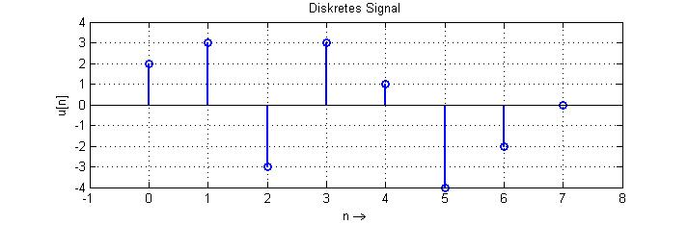

1. What do the signals u1(t) (after the ZOH) and u2(t) (after the reconstruction filter) look like? Complete the sketch below and justify your answer with a short statement.

Obs: Please draw u1(t) and u2(t) with different colors and identify their color in the legend. Don't forget to label the time axis. You can also hand this drawing as a Matlab plot if you prefer.

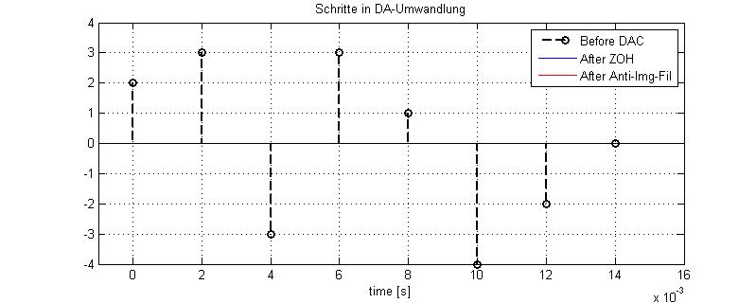

1. The impulse response of the ZOH gZOH(t) is given below. Draw a sketch of the corresponding amplitude spectrum.

Hint: Compare the impulse response of the ZOH with the reference signal "square-pulse".

¦gZOH(t)¦

1

Ts t [s]

Ts = 2 ms

1. Which effect do you expect the ZOH and the anti-imaging filter have on the spectrum of the input signal u[n] ? Consider that u[n] was obtained by sampling a bad limited continuous signal u(t). Draw a series of sketches in the frequency domain representing the original spectrum of u[n], and then the spectrum of u1(t) and u2(t). Don’t forget to comment your spectra.