**Laboratory 1B:**

**Signals from Smartphone Sensors**

Sample Solution

# Setup on Smartphone (mobile device)

# Experiments with Rotation Movements

# Measuring rotation around each axis

Using: RawData_gyro_1.csv

After part generated by command import data:

%% Process & Plot sensor data recorded

Ang_Velocity_x_degs = 180/pi * Gyroscopexrads;

Ang_Velocity_y_degs = 180/pi * Gyroscopeyrads;

Ang_Velocity_z_degs = 180/pi * Gyroscopezrads;

% Vector with time steps between measurements

% Add 1 element at beginning to match vector sizes

delta_t = [0; Times(2:end) - Times(1:end-1)];

% Numerical Integration to get angular_position

Ang_Position_x_deg = delta_t.*cumsum(Ang_Velocity_x_degs);

Ang_Position_y_deg = delta_t.*cumsum(Ang_Velocity_y_degs);

Ang_Position_z_deg = delta_t.*cumsum(Ang_Velocity_z_degs);

% Generate Plot

figure();

subplot(211),plot(Times,Ang_Velocity_x_degs,'b',...

Times,Ang_Velocity_y_degs,'r',...

Times,Ang_Velocity_z_degs,'g');

grid on,ylabel('Angular Velocity');

legend('x','y','z')

subplot(212),plot(Times,Ang_Position_x_deg,'b',...

Times,Ang_Position_y_deg,'r',...

Times,Ang_Position_z_deg,'g');

grid on,ylabel('Angular Position');

Ein Bild, das Text, Karte enthält.

In which direction is the rotation positive? Usually clockwise

# Analyzing recorded sequences of movements

* *Remember to store the import function in same directory as script.*
* RawData_gyro_2.csv

Pause, sharp angular acceleration, than rolling 10 times in one sense. Stop and 2 more slower rolls. Can use wrapTo180() but as time advances, the integral contains more and more noise.

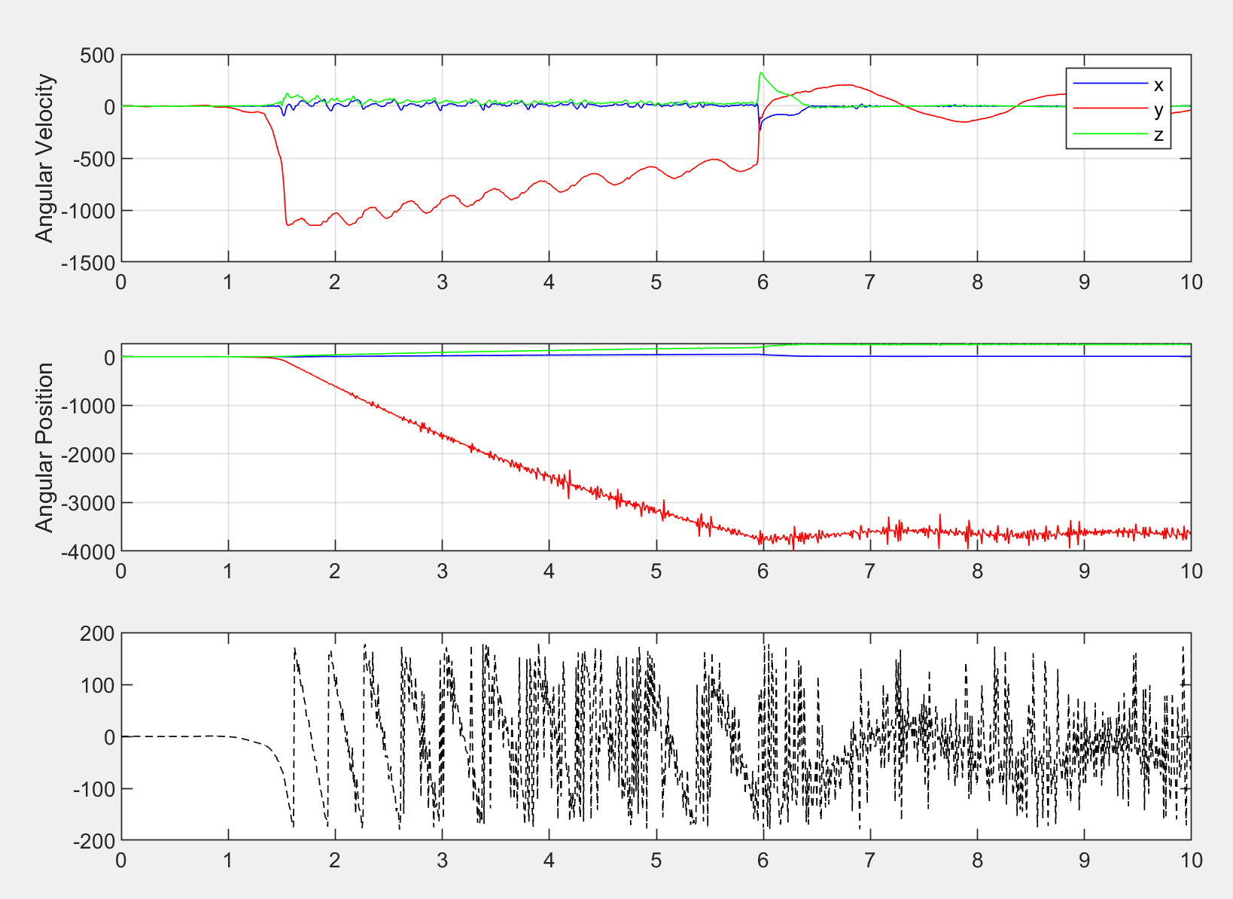

* RawData_gyro_3.csv

Sequence: A C D B A  
But if you look at measurement have the impression that initial and final positions are not the same. This is a limitation of the 3D angle notation in this format. There are other formats which would allow to avoid this difference from initial to final status.

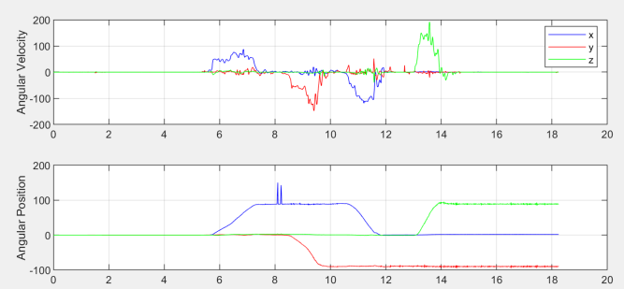

# Experiments with Translation Movements

To get the position from acceleration you need to carry out a double integration. This causes sensor errors to be intensively increased over time. The errors increase more rapidly than with the gyros, where we just integrated once. These errors are often called drift (e.g. deviation from a zero reference-point).

The drift is particularly visible in the end of the movement, where you expect to see a rest position, but find a linearly varying position.

IMU applications often combine data from several sensors (data fusion) to reduce drift. For example, here one could observe the gyro data in parallel, and decide that if no absolute value above a certain threshold is observed, one considers the object is in rest, and ignores the drift of the position calculated by double integration of the accelerometer.

