**Laboratory 2A:**

**Sample Solution**

# Exercise-1 : Refresh Log-Base-10

For this purpose, fill up the table below. Please solve this without a calculator!

|  |  |
| --- | --- |
| **Powers of 2** | **Powers of 10** |
| $$20\log_{10}\left(2\right)=6 dB$$ | $$20\log_{10}\left(10\right)=20 dB$$ |
| $20\log_{10}\left(4\right)=$ 12 dB | $20\log_{10}\left(100\right)=$ 40 dB |
| $20\log_{10}\left(8\right)=$ 18 dB | $20\log_{10}\left(1000\right)=$ 60 dB |
| $20\log_{10}\left(\frac{1}{2}\right)=$-6 dB | $20\log_{10}\left(\frac{1}{10}\right)=$-20 dB |
| $20\log_{10}\left(\frac{1}{4}\right)=$-12 dB | $20\log_{10}\left(\frac{1}{100}\right)=$-40 dB |
| $20\log_{10}\left(\sqrt{2}\right)=$ 3 dB | **Mixed** |
| $20\log_{10}\left(\frac{1}{\sqrt{2}}\right)=$-3 dB | $20\log_{10}\left(5\right)=$ 20 – 6 = 14 dB |

# Exercise-2 : Measurements in dBV and dBm

FuGe : sinus Frequency = 200kHz Amplitude = 1Vrms Load = 50Ω

FuGE + Oscilloscope: single sinus

1. What is the amplitude value in Vpeak and in Vpp that you expect to measure?  
   Vpeak = sqrt(2) = 1.4142 V Vpp = 2*sqrt(2) = 2.8284 V
2. What is the input impedance of the oscilloscope? ([Link User Manual for Tektronix TDS 20xx](https://de.tek.com/oscilloscope/tds1002-manual/tds1000-and-tds2000-series-user-manual))

Can you explain the mismatch between the FuGe setting and the reading in the oscilloscope?

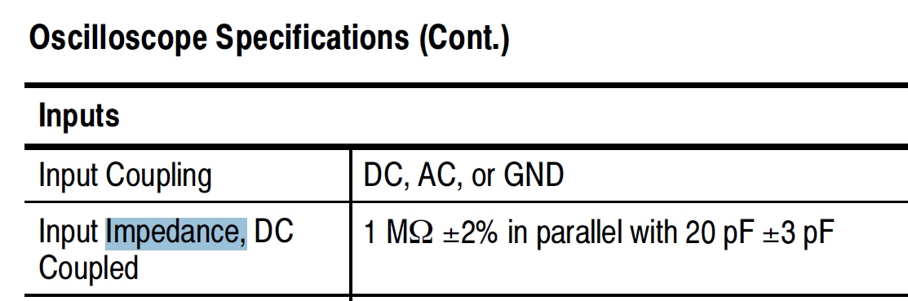

Since not a matching impedance of 50 ohms, and rather a much higher impedance, will see almost double voltage value.

1. Change the load setting in the FuGe: Output > Load > **High-Z** > Done

Which amplitude value in Vrms are you measuring now in the oscilloscope?

About the expected values: ~1 Vrms

1. Return the Load setting to **50Ω,** and add a T-joint plus a 50Ohms termination in parallel to the oscilloscope input. Which amplitude value in Vrms are you measuring now in the oscilloscope?

About the expected values: ~1 Vrms

1. Which signal amplitude do you expect to measure in the frequency domain in the oscilloscope? Express your result in dBV.

About 0 dBV (oscilloscope measuring Vrms)

Otherwise +3dBV (if oscilloscope measuring Vpeak)

1. Check your calculation with a measurement using the FFT in the oscilloscope and the cursor (type frequency, source math)

About expected value: between 0 and -0.3 dBV (some losses, evtl not perfect Z-match, or calibration mismatch)

FuGE + Oscilloscope + Spectrum Analyzer: single sinus

1. Which signal power do you expect to measure in the spectrum analyzer? Express your result in dBm.

P = (Vrms)^2 / 50 = 20mW => 10*log10(20) = 13.01 dBm

1. Check your calculation with a measurement in the spectrum analyzer. Use the menu marker (or marker →), and the function set to peak.

About expected value: between 12.4dBm and 13.0 dBm

1. Change the Resolution Bandwidth (RBW under Menu BW) to manual and reduce the value (e.g. 10KHz) to get finer peaks.

Obs.: attention to return to auto if you later changing significantly the frequency range.

# Exercise-3 : Spectrum Measurements

**Spectrum Analyzer: square and ramp signals**

1. FuGe square wave with frequency 500kHz, amplitude 1Vpp

Expected RMS value quite close to 0.5 V, measured A = __0.483____Vrms

Total power in dBm : P = 0.483^2/50 = 4.7mW = 10*log10(4.7) = 6.69 dBm

Total power in dBV (corresponding to rms value) A = 20*log10(0.483) = -6.32 dBV

1. Table for square
2. Also with theoretical values.

|  |  |  |  |  |  |
| --- | --- | --- | --- | --- | --- |
| Harmonic Nr. | Freq (kHz) | Power (dBm) SpekA. | Amp dBV  In Oscil  Wdw=flattop | Relative amplitude with respect to 1st harmonic  (select either SA or Osc) | Theoretical value based on Fourier Series |
| 1 | 500 | 5.7 dBm | 500kHz -7.39dBV | 1 = 0 dB | Reference 1 =>  0 dB |
| 3 | 1500 | -3.9 | 1.5MHz -16.6dBV | -9.2 dB (osc) | 1/3 =>  20*log10(1/3) =  -9.5 dB |
| 5 | 2508 | -8.4 | 2.5MHz  -21dBV | -13.6 dB | 1/5 =>  20*log10(1/5) =  -13.98 dB |
| 7 | 3508 | -11.35 | 3.5MHz  -23.8dBV | -16.4 | 1/7 =>  20*log10(1/7) =  -16.90 dB |
| 9 | 4508 | -13.6 | 4.5MHz  -25.4dBV | -18.0 | 1/9 =>  20*log10(1/9) =  -19.08 dB |

Obs.: SA with preset, adjust freq and attenu but not changing RBW gave better frequency values read out.

1. Change the FuGe output signal to a ramp or sawtooth, and repeat steps (l) and (m). check which harmonics are present in the output spectrum.

Ramp or sawtooth: all harmonics are present with amplitude-relationship 1/k.