

Laboratory 3A:

**Fourier Transformation and FFT**

In this laboratory you experiment with some properties of the Fourier Transformation such as duality and time-bandwidth product. Plus, you will gather further experience with applications of the numerical algorithm Fast Fourier Transformation (FFT).

**Exercise 1: Working with the USB-Scope**

We use an USB-Scope and Signal generator for the following experiments. Let us start with a simple measurement to understand how this device works.

|  |  |  |
| --- | --- | --- |
| Step | Setup | Hint |
| 1 | Start a new workspace and select a scope and a wave-generator   * Workspace > New * Drag & Drop selected windows |  |
| 2 | Set the wave-generator for a single sinus with fsig = 1KHz |  |
| 3 | Connect the output of the wave-generator to one input channel of the scope |  |
| 4 | Observe the signal in the time and frequency domain | * Scope: Default pane * Scope: FFT pane |
| 5 | Observe the following snapshots and answer to the question | Unfortunately for HS20 we still do not have USB-scopes for the students to take home. Therefore copied the measurement snapshots below. Plus you can remotely control the scope. |

**Snapshot-A: Full Range**

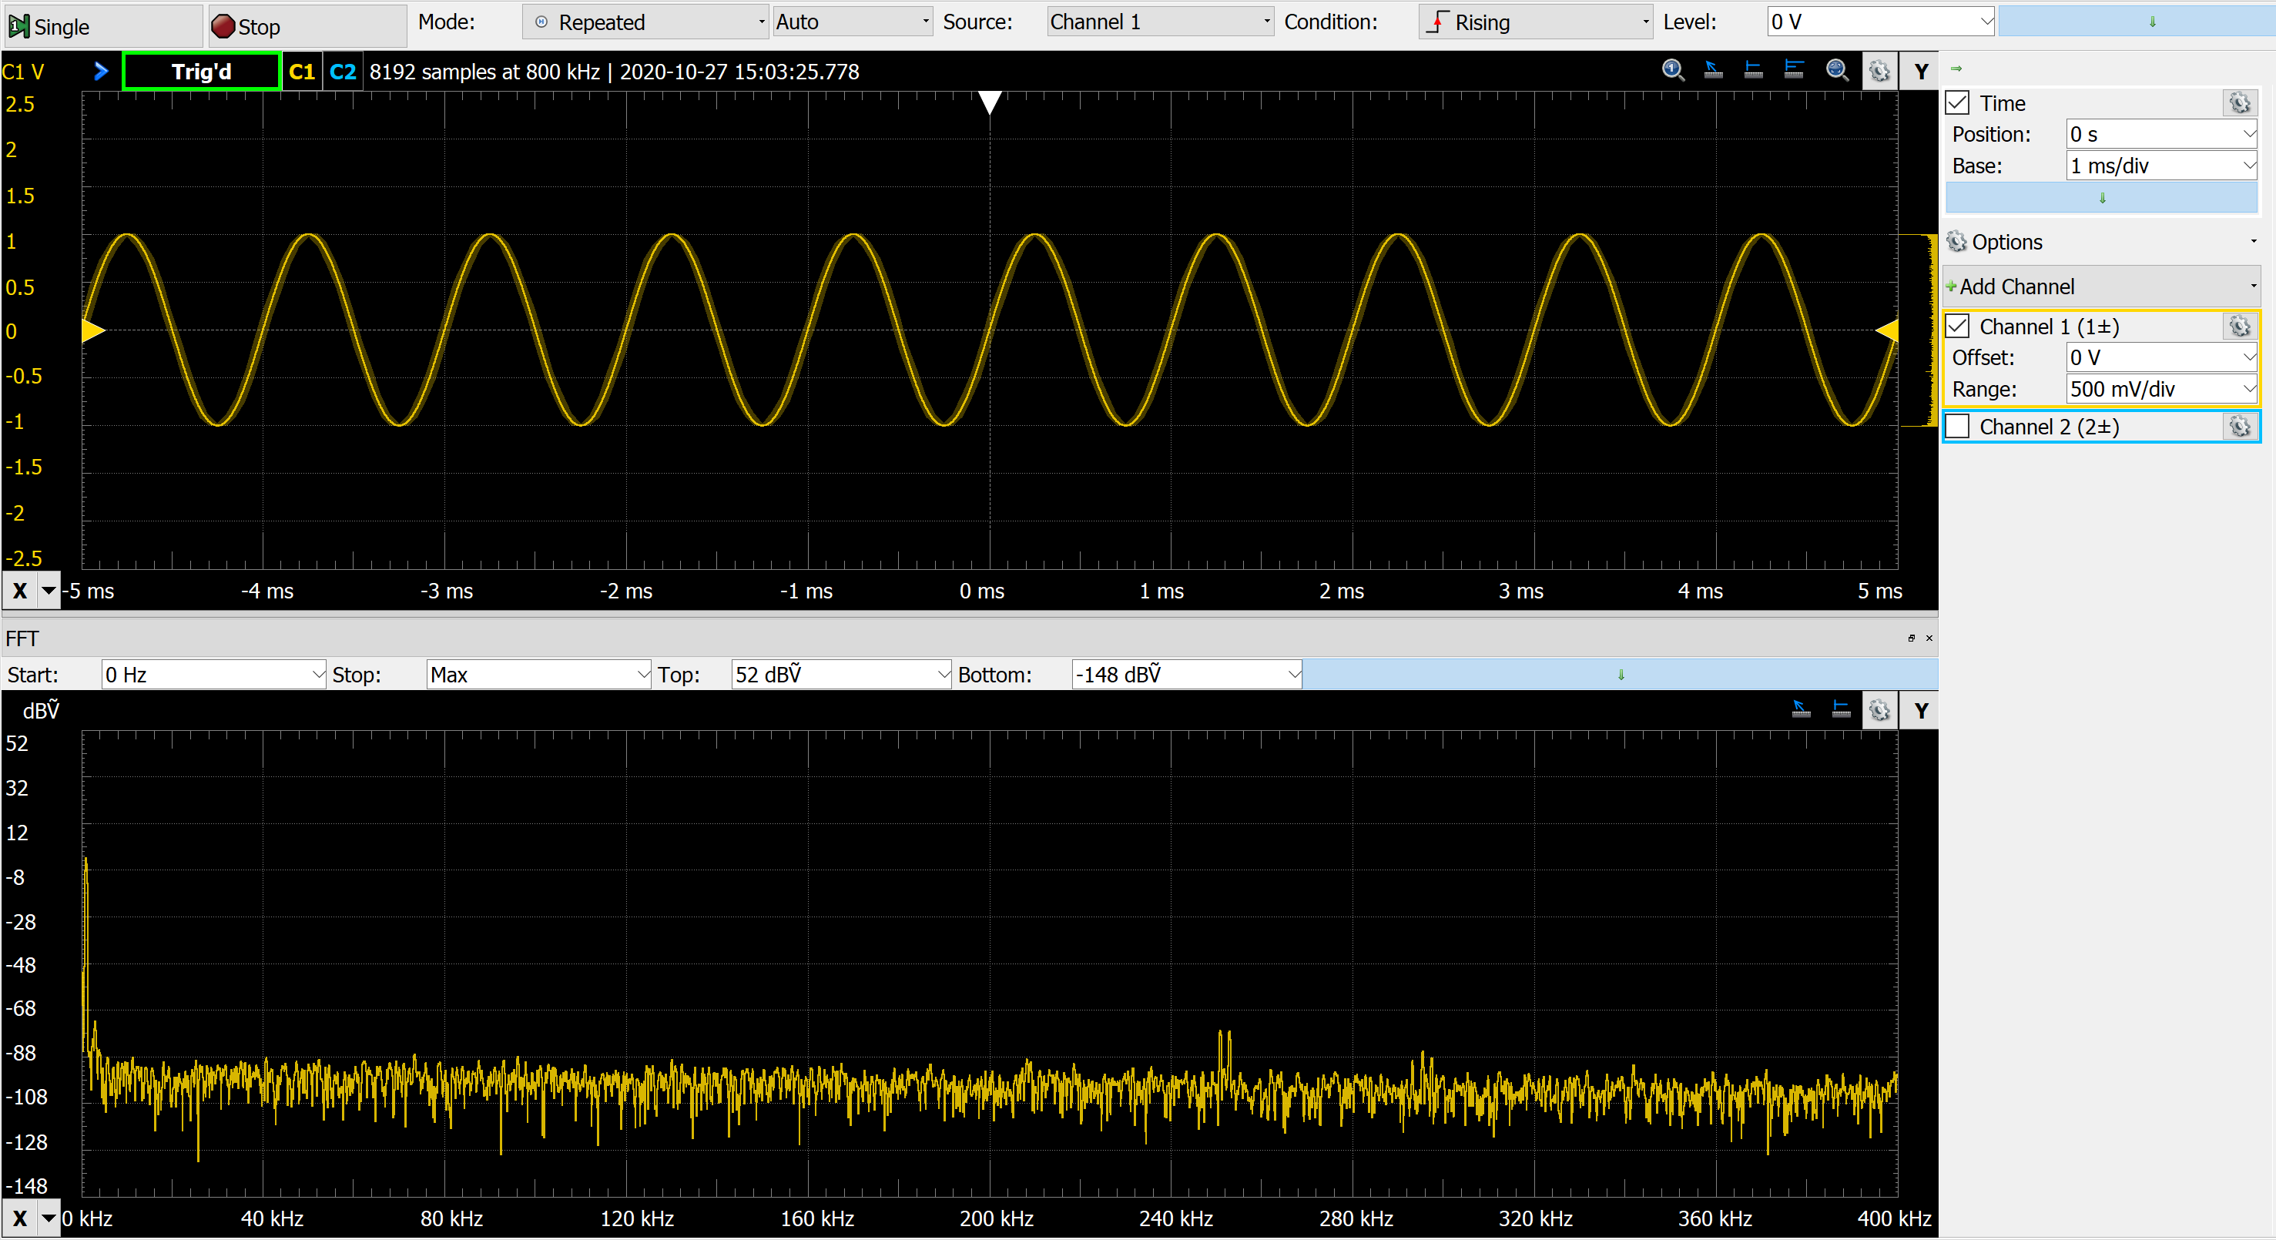

1. Consider the indication in the top of the time domain window:

What are the implications for the measurement in the frequency domain using the FFT?

1. What is the resolution of the spectrum measurement? How do you need to change the measurement setup in order to confirm your answer?
2. Which harmonics do you expect in this spectrum? How do you need to change the measurement setup in order to confirm your answer?
3. Are there also unexpected harmonics? Which ones? How do you need to change the measurement setup in order to confirm your answer?

**Snapshot-B: Zoom in frequency domain**

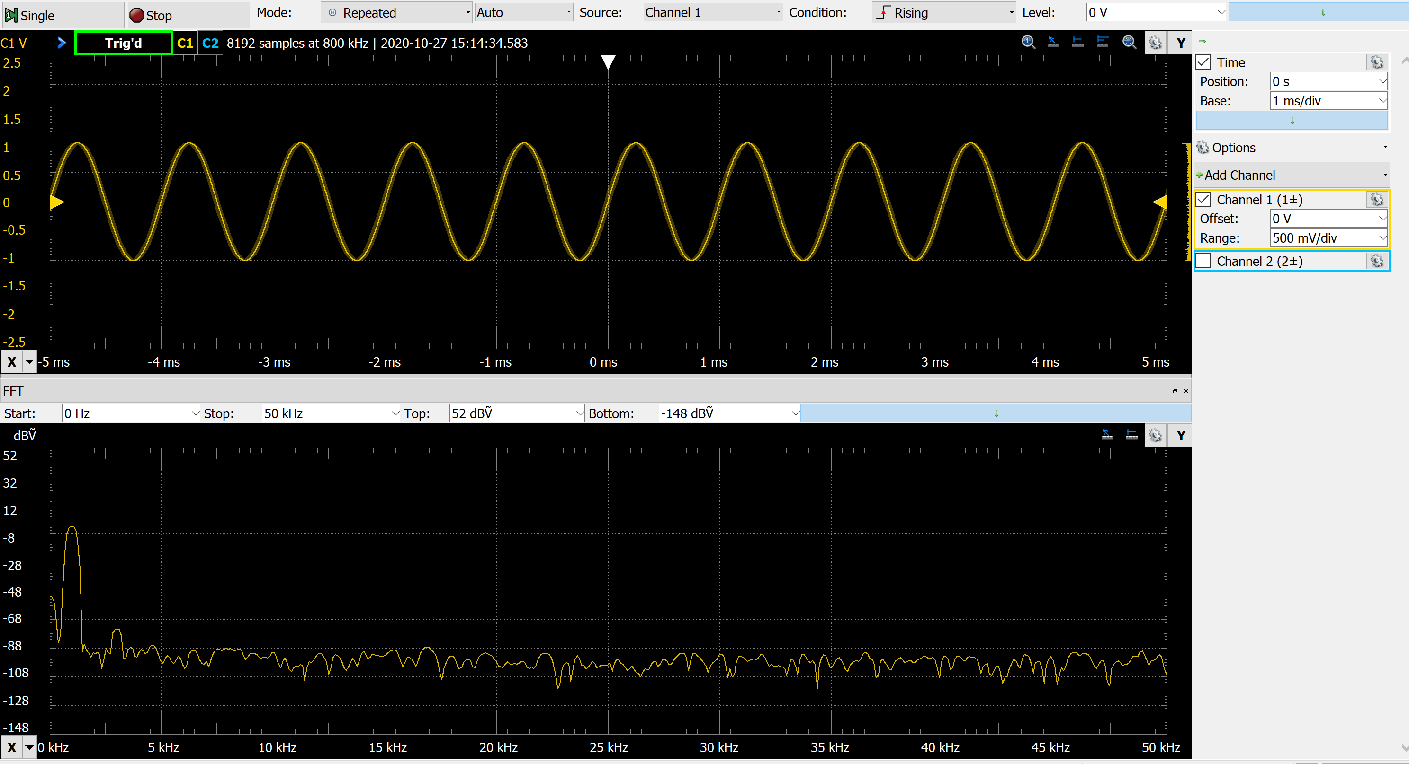

1. What do you need to change in the settings to the time domain measurement to achieve a finer frequency resolution in the spectrum plot? Explain your answer with a short calculation.

**Exercise 2: Duality Property of the Fourier Transformation**

1. Add a 2nd channel in the wave generator and describe a custom waveform with a sinc shape.

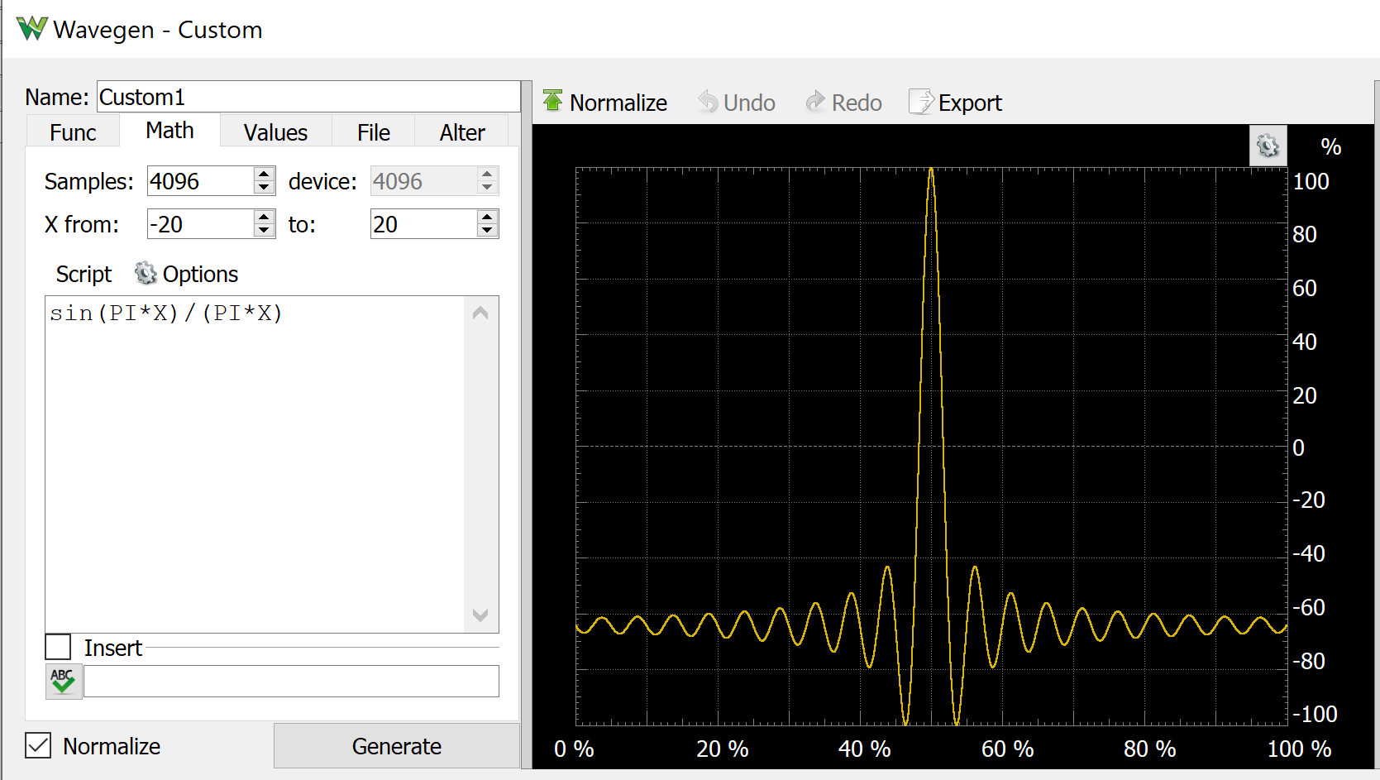

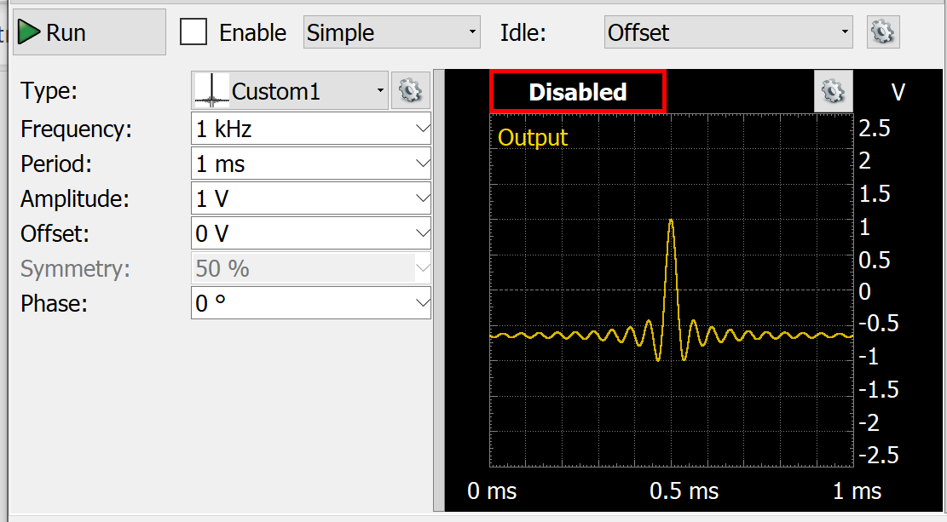

1. Once you save your custom wave-shape, you can now select the desired parameters, like: frequency, amplitude, …

Once enabled the wave-generator will output a periodic sinc shaped pulse, with the selected parameters.

**Snapshot-C: Periodic Sinc-Pulse**

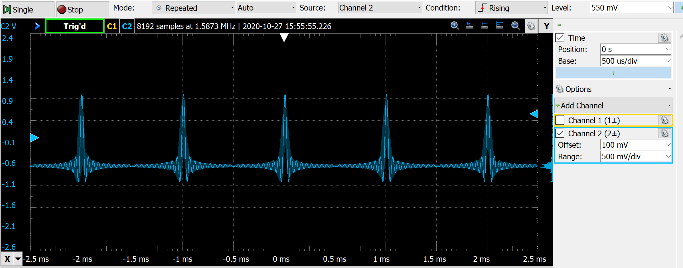

1. Before you turn to the next page, think about what do you expect to observe in the FFT window of the scope, when observing this periodic sinc pulses?

*Hint:* Check now the description of the duality property of the Fourier Transformation (in chapter 3 of the script),

**Snapshot-D: Periodic Sinc-Pulse in the Time and Frequency Domain**

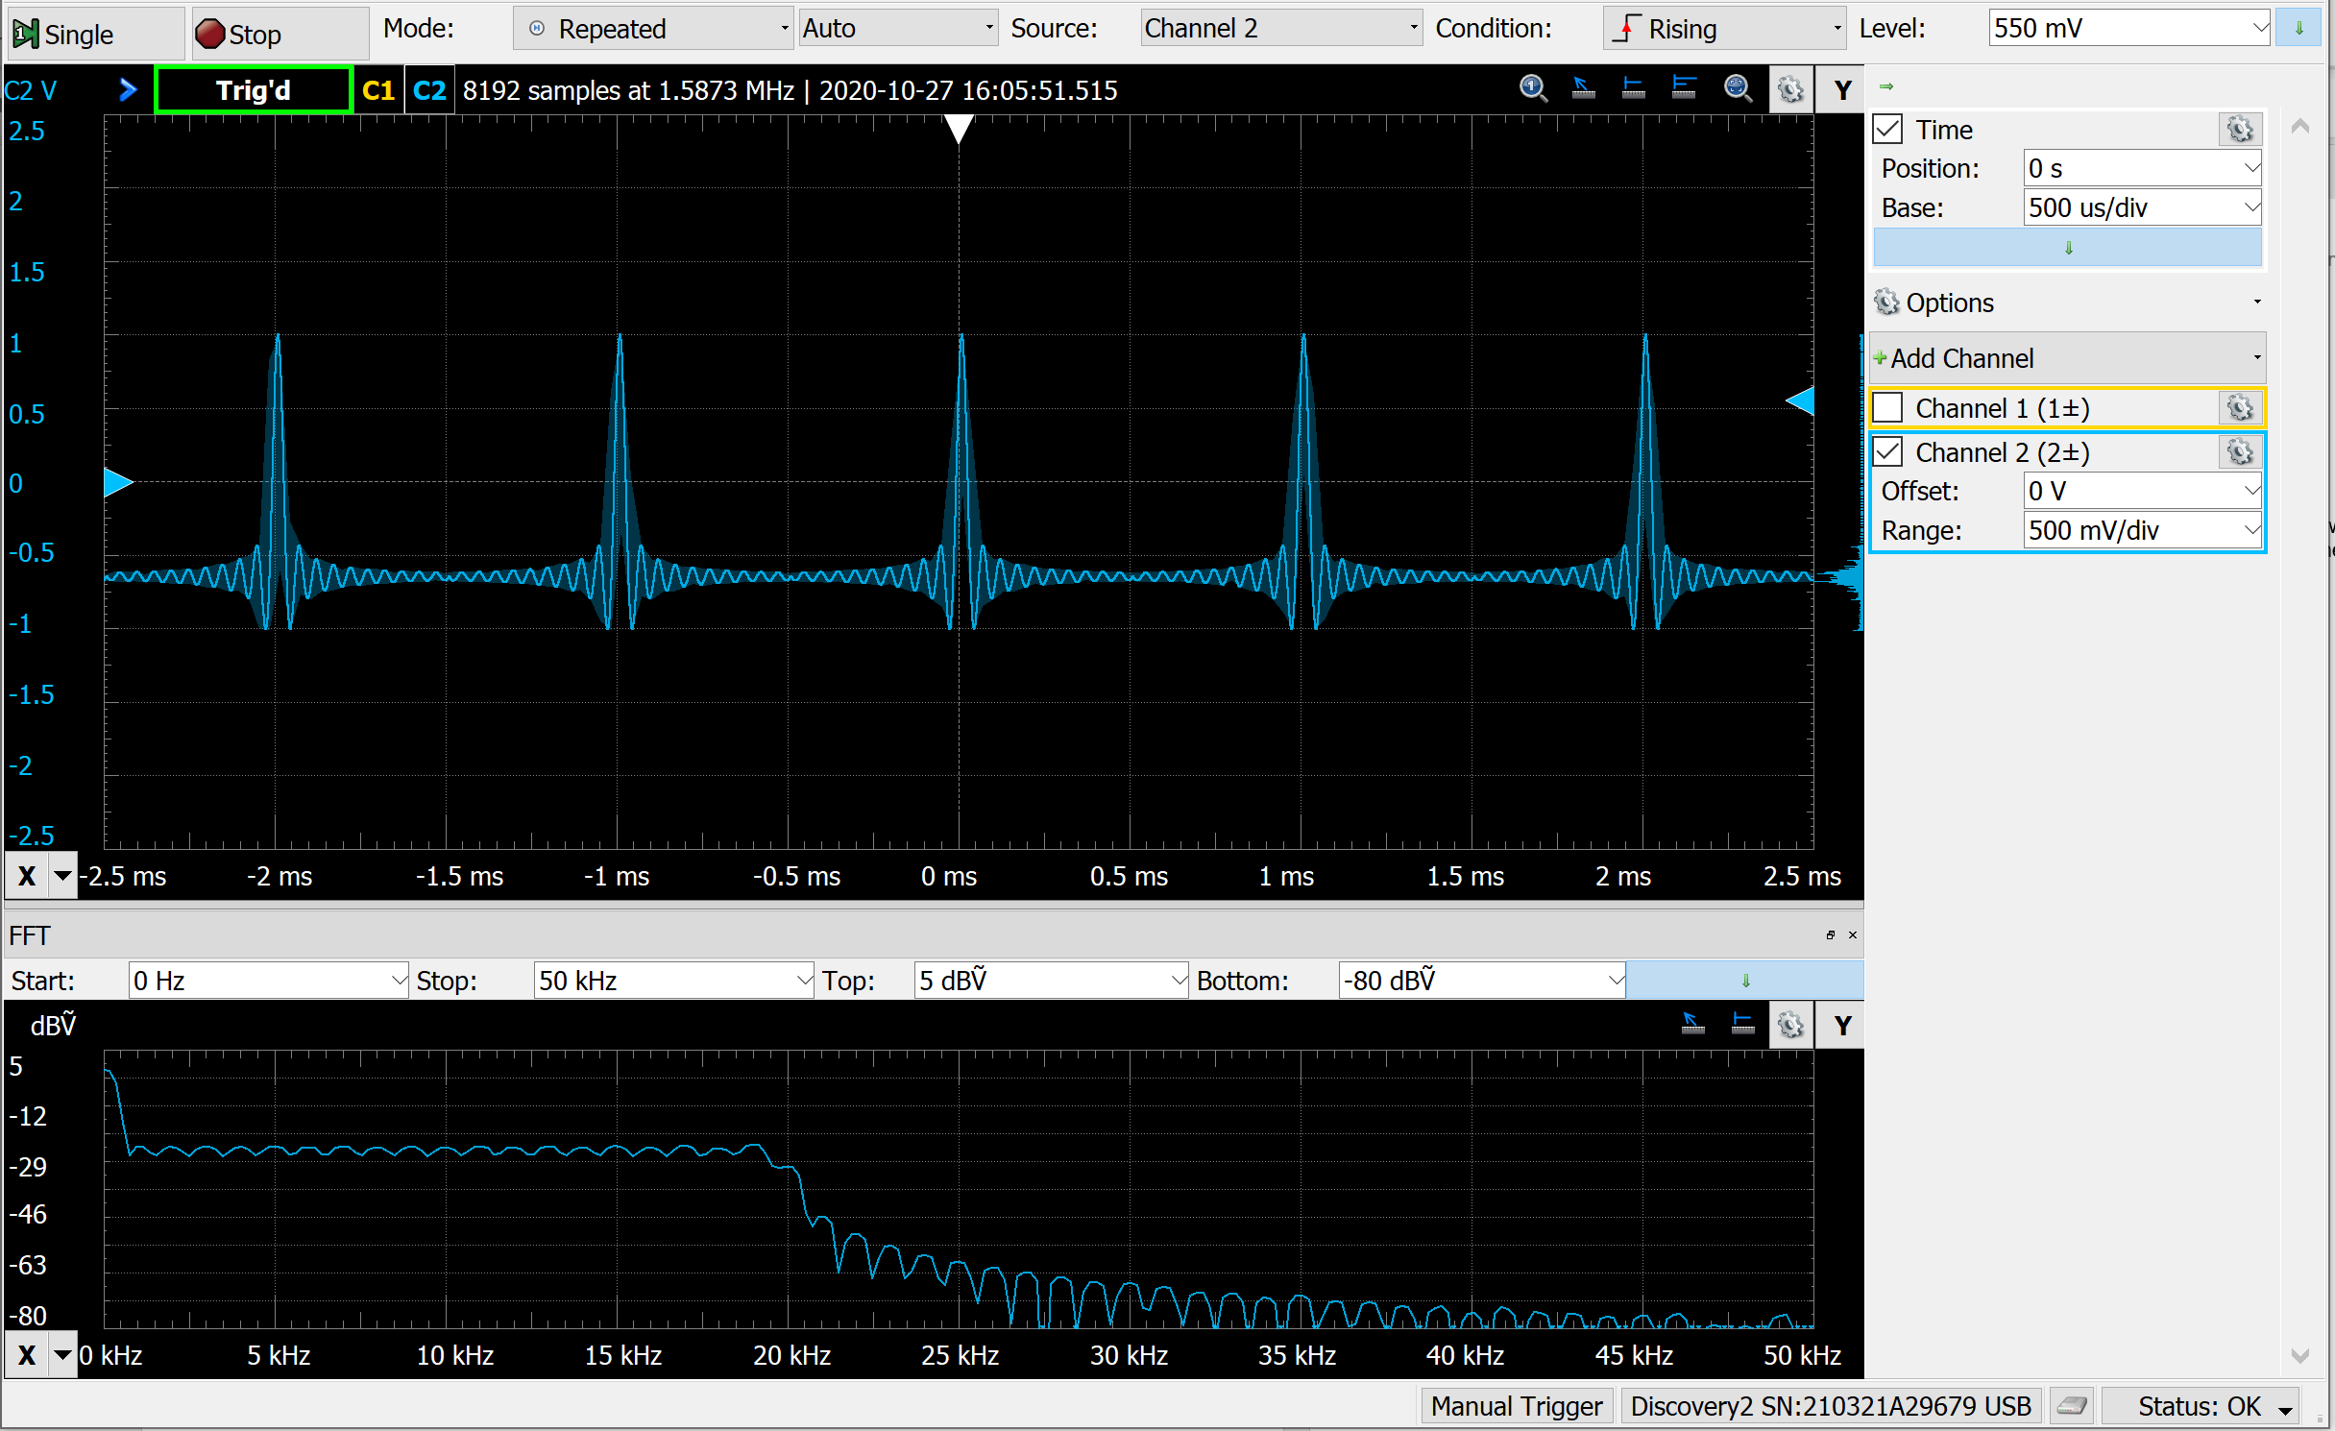

1. Which parameter do you need to change in the wave-generator to decrease the DC-value and get closer to a square shaped spectrum? Make the necessary changes and verify the result.
2. Control now the spectrum plots below, and relate to the signal characteristics in the time domain like: frequency and width of the lobes or zero-crossings.

**Snapshot-E: Periodic Sinc-Pulse Zoom-out**

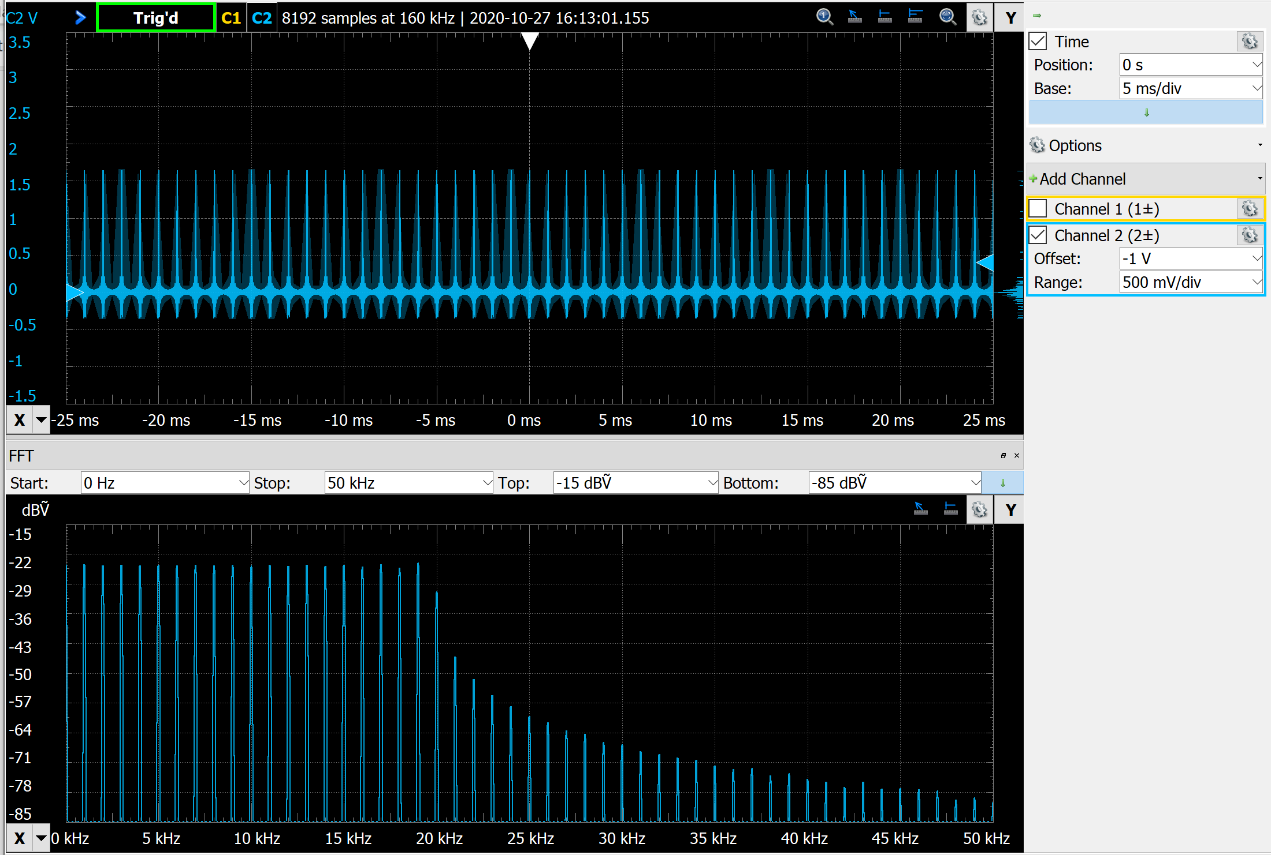

**Snapshot-F: Periodic Sinc-Pulse Zoom-mid**

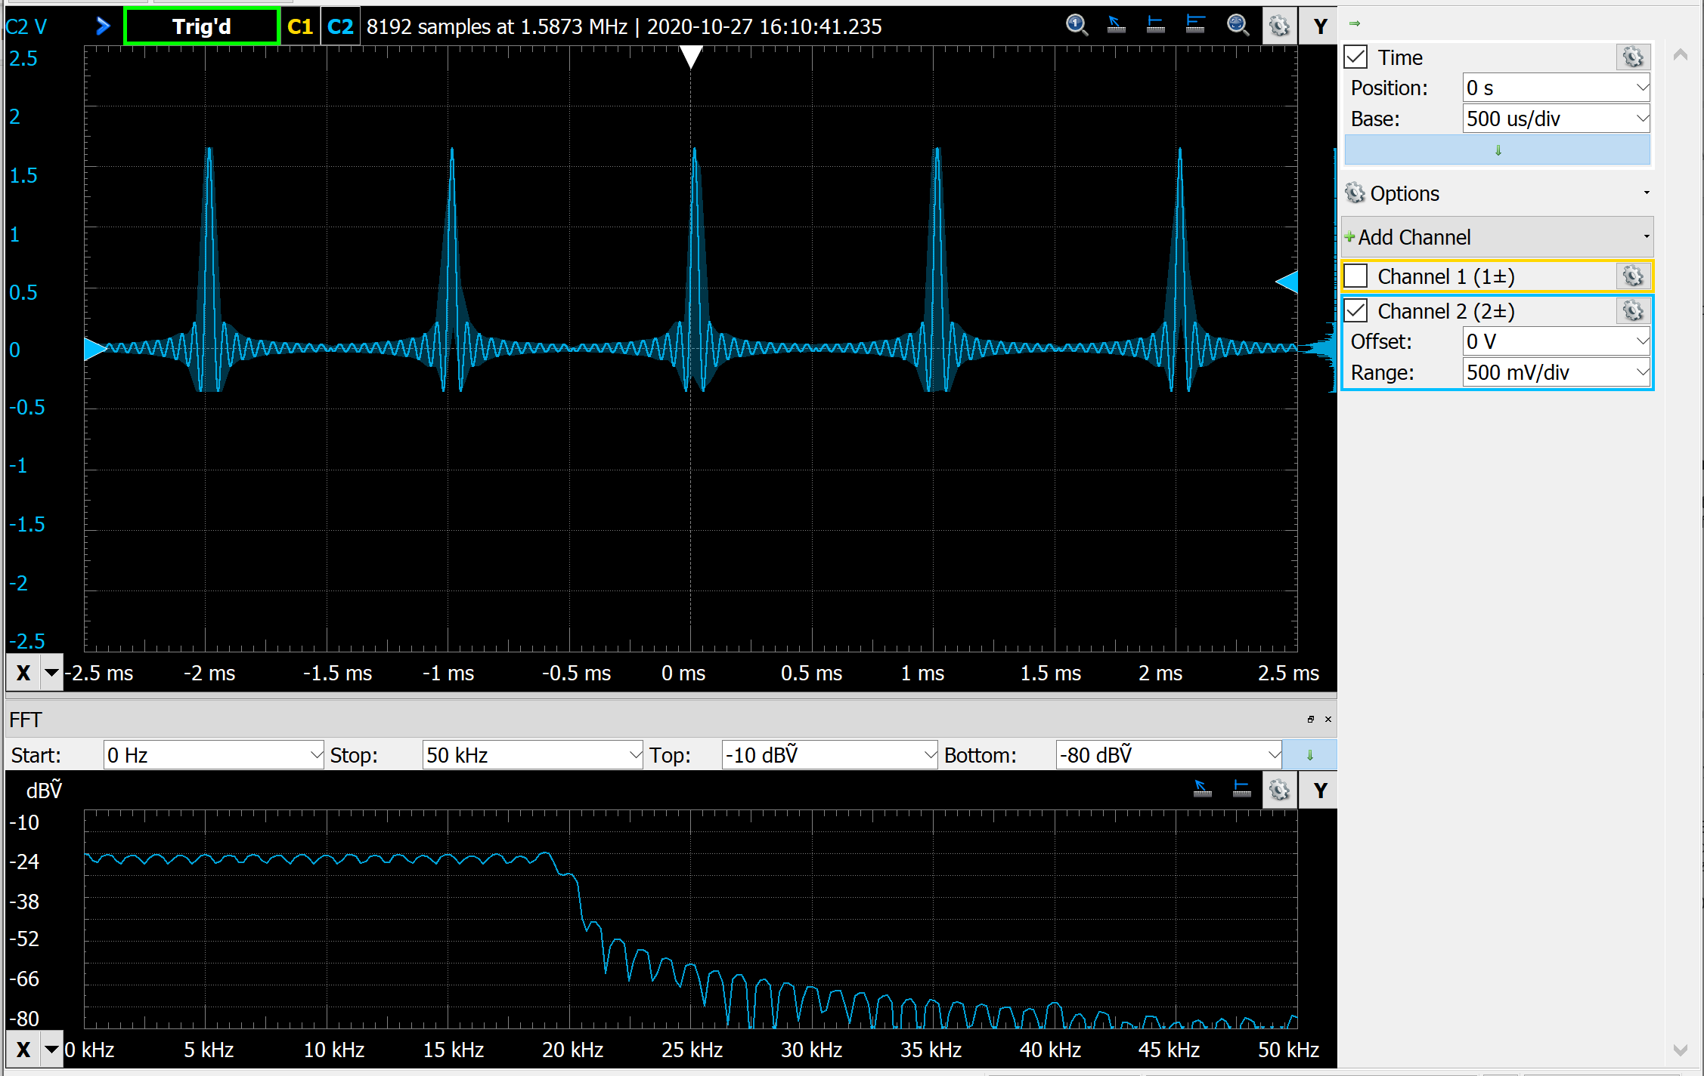

**Snapshot-G: Periodic Sinc-Pulse Zoom-in**

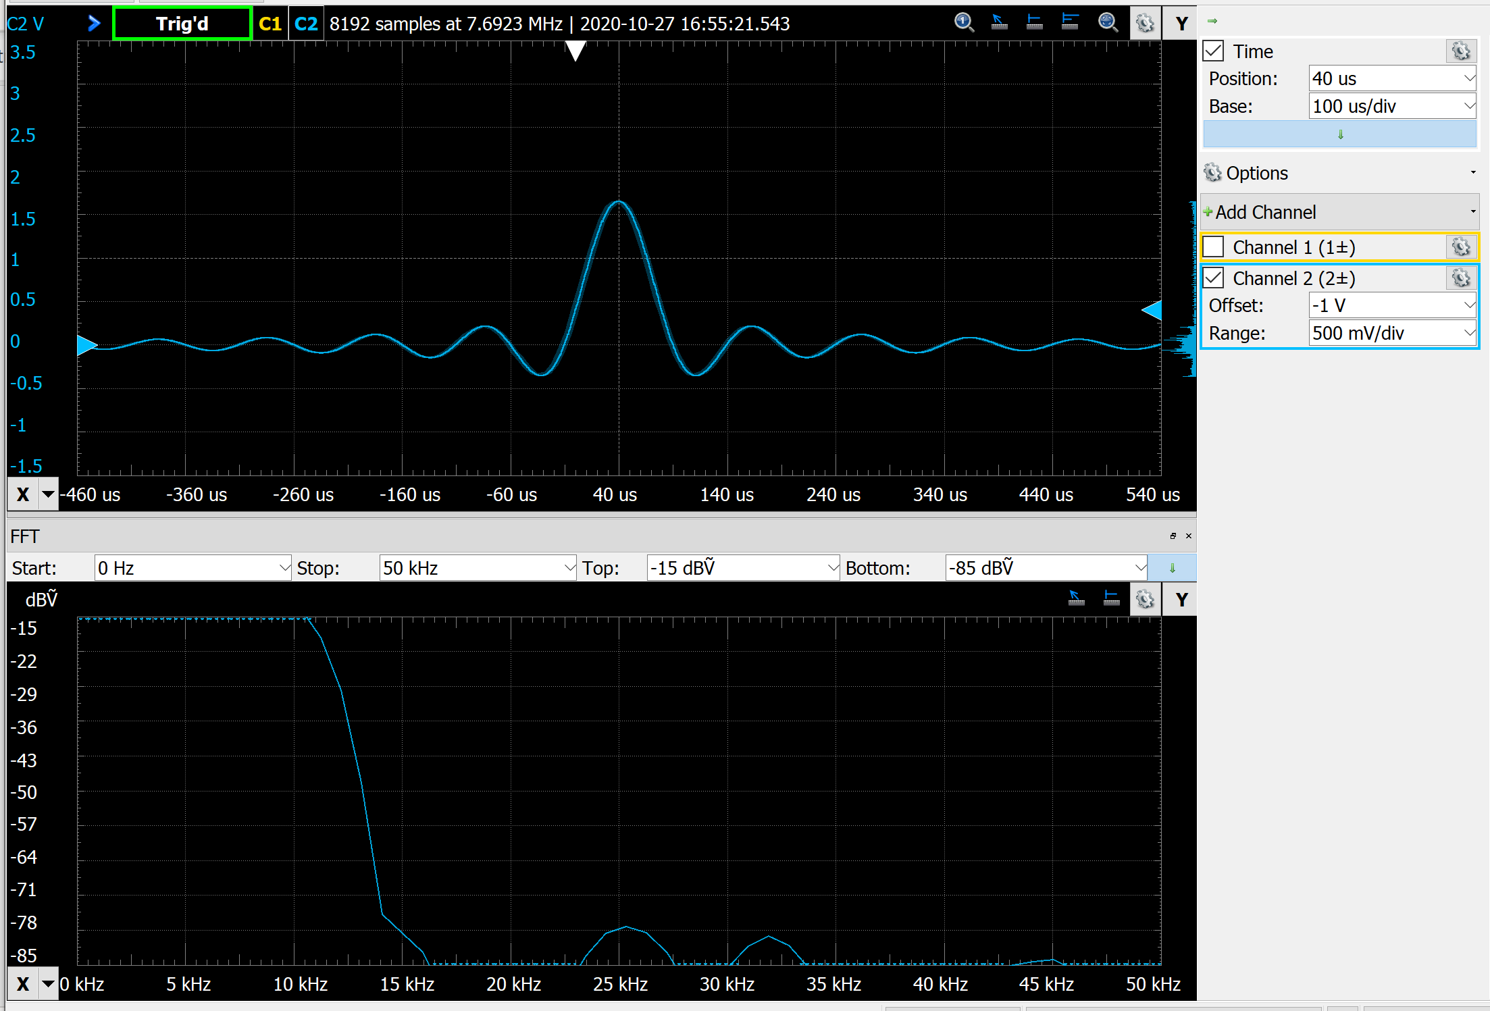

**Exercise 3 : Time-Bandwidth Product**

Read now the description of the FT property Time-Scaling or Time-Bandwidth product. How can you confirm this property by changing one of the settings from the current measurement? Try out your supposition.

*Hint :* in order to easily observe the changes in the bandwidth, fix the frequency range which you want to observe. For example start=0Hz and stop=50kHz.

**Exercise 4** *Tchin-Tchin: Synthesis of a Glass-Sound.*

In this exercise you analyze and synthesize a copy of a given glass sound.

Take the recorded sound example in file *Glas.mat*, and conduct the following steps:

* Analyze the audio signal in the recorded sound-file using the FFT;
* Generate a plot of the audio signal in time and in frequency domain;
* Complete the Matlab script, which synthesizes the glass-sound by adding up the few dominant frequency components, and weighting the signal with an envelope in the time domain.

Tip-1 : Use the exp() function to implement the envelop curve;

Tip-2 : The file *sisy1_lab3A_exer_synthesis.m* is available as a start point.