Laboratory 6b:

**System Transfer Function   
&**

**System Responses to Test Signals**

In this laboratory, you calculate the transfer function of two passive RLC circuit topologies, sketch their Bode diagram and check their responses to test signals both with Matlab and with measurements.

**Exercise 1** *System Transfer Function*

1. Select two topologies out of the 8 possibilities in table 1. Try to select two topologies with different behaviours (LPF, BPF, HPF) and different arrangements (serial and parallel) among topologies 2 till 8 [[1]](#footnote-1).
2. Calculate the frequency response of the two topologies you selected in the frequency domain, using complex impedances and the principle of a voltage divider.
3. Verify your result with the G(s) function in table 1, with s=jω . When replacing s=jω, you get the G(ω) which is called the frequency response of the system.

x(t)

X(f) = X(ω)

System

RLC-Topo

y(t)

Y(f) = Y(ω)

G(f) = Y(f) / X(f)

G(ω) = Y(ω) / X(ω)

**Exercise 2** *LTI-System Frequency Response*

1. Prepare a sketch of the Bode diagram of the two topologies, which you calculated in exercise (1). In order to prepare your sketch, use the method of the calculation table with different regions for the frequency response as discussed in chapter 6 of the script.
2. Open the description of Lab-3C, and recall the notation you learned in exercise 2 to describe LTI systems in Matlab using the function ***tf()*** (short for transfer function) [[2]](#footnote-2).
3. Describe your selected RLC topologies from exercise 1 with this Matlab LTI-system notation and generate the corresponding responses:

* Step response: command ***step(sys)*** in Matlab
* Impulse response: command ***impulse(sys)*** in Matlab
* Bode diagrams: command ***bode(sys)*** in Matlab

Use the following numeric values:

* series topologies: R= 560Ω ; C= 1nF; L in the range 3.3mH – 100mH;
* parallel topologies: R= 5.6kΩ ; C= 1nF; L in the range 3.3mH – 100mH;

1. Calculate the natural frequency ω0 = 1/sqrt(LC) of the RLC topologies.
2. Mount now in the Hirschmann-Board the parallel BPF topology 6 and set as input signal a sinus wave with amplitude1Veff. Check the output value for its amplitude and phase shift with respect to the input signal. Compare your response for 3 different frequency values (ω1 = ω0 /10 ; ω2 = ω0 ; ω3 = 10.ω0 ) and compare to the bode diagram from item (a).

FuGe

Scope

System

RLC-Topo

Fill out the table below to help on the calculation and comparison:

Input signal (with a constant amplitude for all measurements)

amplitude value (linear) = amplitude (dB) =

|  |  |  |  |  |  |
| --- | --- | --- | --- | --- | --- |
| Input Signal | Output signal | | | | |
| frequency  (Hz) | frequency  (Hz) | amplitude  linear  (V) | amplitude  (dB) | time-shift  (s) | phase-shift  (°) |
|  |  |  |  |  |  |
|  |  |  |  |  |  |
|  |  |  |  |  |  |

1. Which non-ideal effects do you expect to interfere with your measurement, as compared to your simulation? For which topologies would these effects be most remarkable?
2. Extra : Try out measuring the system responses which approximate a step, impulse and a chirp response (sinus shaped pulse with increasing frequency). Comment the results of your measurements in comparison with the simulations for item (c).   
   Hint: in the Analog Discovery Scope you can describe a chirp as a custom generated wave with settings similar to the ones in the snapshot below.

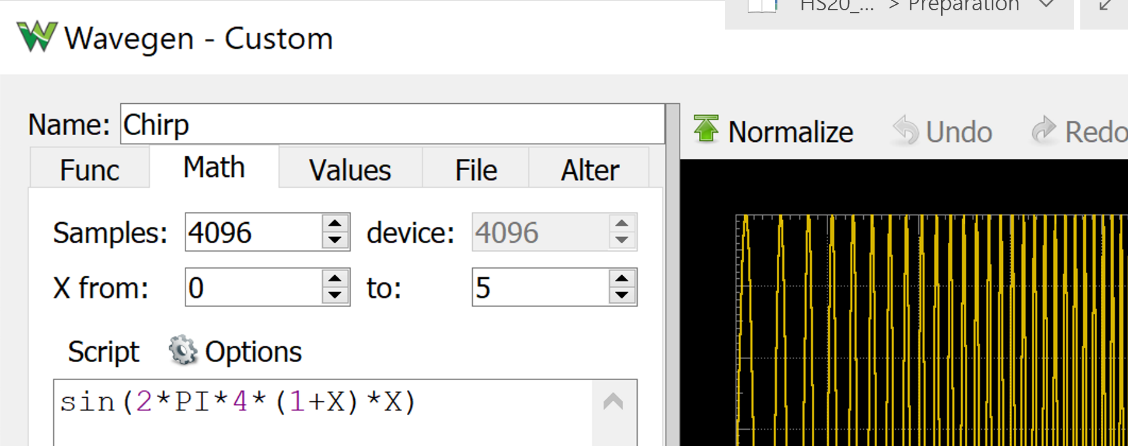

**Table1 Passive RLC Topologies**

*(siehe Matlab demo: > rlc\_gui)*

|  |  |  |
| --- | --- | --- |
| Filter-Typ | Topologie & Üebertragungsfunktion | Skizze Frequenzgang (Bode) |
| LP 1– series | RLC_LPF_ser |  |
| LP 2– parallel | RLC_LPF_par |  |
| HP 3– series | RLC_HPF_ser |  |
| HP 4– parallel | RLC_HPF_par |  |
| BP 5– series | RLC_BPF_ser |  |
| BP 6– parallel | RLC_BPF_par |  |
| BS 7– series | RLC_BSF_ser |  |
| BS 8– parallel | RLC_BSF_par |  |

1. Do not take topology 1, since we already calculated that one in the lecture as an example. [↑](#footnote-ref-1)
2. The transfer function of an LTI system is equivalent to its frequency response, but uses the variable “s” from the Laplace Transformation, instead of the jω from the Fourier Transformation. [↑](#footnote-ref-2)