

Laboratory 7:

ADC-DAC and MAV-Filter with Arduino

In this lab you experiment with an analog to digital converter (ADC) which is embedded in the Arduino microcontroller and also with a digital to analog converter (DAC) in an external component (integrated circuit or IC of type TLC7528).

Exercise 1 : Setup Hardware and Firmware plus Check

- Place the DAC component TLC7528 in the breadboard of the Arduino and wire it according to the schematics below (left side of figure 1). Please pay attention on the position of the pins (indicated in the package view on right side of figure 1).

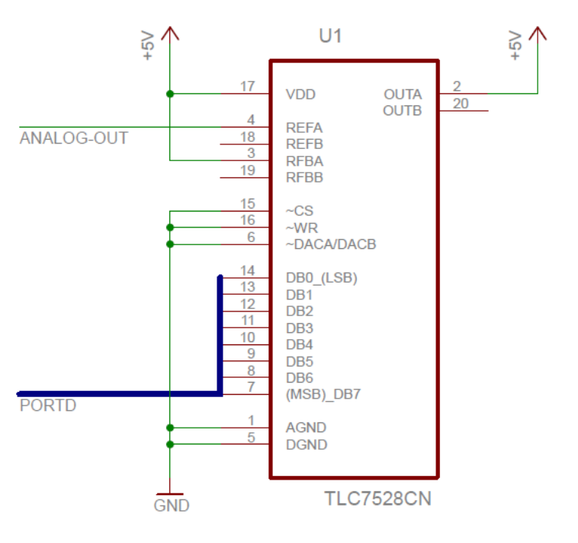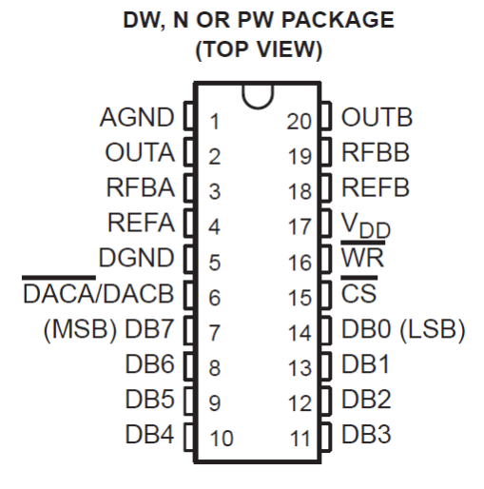
Arduino Digital Connector Pins:
0 - 7: PortD[0 - 7] : DB0 - DB7
8 : PortB[0]

TLC7528 CN Package Pinning
Figure 1 Connecting the TLC7528 DAC with Arduino, and pinning information

The integrated circuit TLC7528 contains two DAC with 8 bits resolution, with input buffers and latches. The output can be a current or a voltage signal proportional to the digital input value. We will be using only the DAC-A (with reference input REFA and output OUTA) and select the voltage output signal or voltage mode.

- Open and load the Arduino the program exer1_adc.ino . In this program we read the analog input with the embedded ADC and send the result directly to the output port D (with 8 bits). The ADC has a resolution of 10 bits, but the output port D (and also the DAC) has only 8 bits. Therefore in order not to lose the 2 MSBs (most significant bits) we need to shift the input ADC value by 2 bits before sending it to the portD.

- Check now your settings by connecting the output of the FuGe (Function Generator) as analog signal to be sampled. Choose a sinus wave with 1kHz frequency, amplitude 2Vpp and offset of 1Vdc. Check on the program exer1_adc.ino which pin is used for the analog input. The DAC works with the principle of a “Zero-Order-Holder”. How do you expect the DAC output signal to look like? Check it with the oscilloscope.

Exercise 2 : Sampling Frequency and Aliasing

- The program exer1_adc.ino also toggles the bit0 of the portB, which corresponds to pin 8 on the Arduino Board digital connector. Observe this output in the 2nd channel of the oscilloscope and determine the sampling frequency which is used for the AD and DA conversion.

- Compare the port B pin 0 to the DAC outA signal. How could you also determine the sampling period by observing the DAC output signal?

- What is the maximum frequency for the input signal which you can observe without aliasing with this sampling frequency? Verify your answer in the hardware setup.

- What is another frequency that gives the same output as 1kHz because of the aliasing effect? Verify your answer in the hardware setup.

- Open and load the Arduino the program exer2_adc.ino . This program is very similar to exer1 but contains statements, which allows one to vary the clock used for the analog to digital conversion. What is the new sampling period and sampling frequency with these changes? Verify the influence in the DAC output signal and repeat items (c) and (d) above for this new sampling frequency.

Exercise 3 : Sampling driven via SW and Jitter Issue

Another factor affecting the accuracy of the analog to digital conversion is the regularity of the sampling period. Variations in the sampling period are also called jitter.

So far the triggering of the ADC is done within the Arduino program and it is dependent on the hardware settings and a fix firmware loop which are most regular. If we have though the triggering taking place via a software loop (in the PC) we can observe the jitter effect.

- Open and load in the Arduino the program adiosrv.pde (although the extension is different you can open as a *.ino file). Once you have uploaded the program close again the Arduino IDE (development environment SW).
This program implements a server in the Arduino, which can execute commands sent from Matlab via the serial COM port. But since Matlab will use the same port as the IDE, we have to close the IDE before attempting to connect Matlab to the Arduino board.

- Open in Matlab the script exer3_readAnalogIn.m and adapt the COM port number according to your setup. Re-adjust the FuGe as in exercise 1-c, but lower down the signal frequency to 50Hz.
Execute the Matlab script, observe the resulting plots and answer to the following questions: What is the value of the sampling period? Where is the effect of the jitter visible?

- Change the Matlab script to stop the analog input data acquisition after a loop with N input samples, and calculate the FFT of this signal. Compare to the FFT of an ideal sinus signal with the same frequency and comment about the effect of the jitter.

If you have interest and time, there are here some further exercises and ideas, which can be tried out with this same hardware setup.

Exercise 4 : Adding an Analog Reconstruction Filter

The output of a DAC of type ZOH is not very smooth. In fact most of times it is required to have an additional low pass filter as reconstruction filter.

- Re-adjust the FuGe and Arduino as in exercise (1c) and observe in the oscilloscope the DAC output signal in time and in frequency domain (with the FFT).

- Use the information of the sampling frequency you calculated in exercise (2a) to calculate the value of a capacitor for an RC-passive low pass filter with a break-point frequency of about 0,4*Fs/2 . Use for the resistor R=10kΩ.

- Build in this low pass filter on the output of the DAC as a reconstruction filter. Observe its effect on the oscilloscope in time and in frequency domain.

Exercise 5 : Adding an Analog Anti-Aliasing Filter

So far we have only observed the conversion of sinus-waves which have a single harmonic (and therefore an easy identifiable maximal frequency and/or bandwidth). But what happens if we convert a signal which is not initially band limited?

- Start with the same settings as exercise (1c) but change the input signal for a periodic square wave. Observe the input analog signal and the output analog signal in the oscilloscope in time and in frequency domain. Is the effect of the aliasing visible?

- In order to avoid the aliasing effect, we need to limit the bandwidth of the analog input signal before the ADC. This filter is called an anti-aliasing filter (AAF). You can use as AAF the same filter you calculated in exercise (4b). Build in the AAF and observe its effect in the input and output analog signals on the oscilloscope in time and in frequency domain.

Exercise 6 : Implementing a Digital Moving Average Filter

Most times analog signals are converted to digital signals in order to carry out signal processing steps with a microcontroller or a PC.

Start with the same settings as exercise (5b) and change the Arduino program to implement a moving average filter, which takes the input signal and sums with the previous 3 samples before sending the output value to the port D.
Hints: do not forget to shift the output because of the 8-bit width limitation on the port D output.

The ADC-clock is derived from the main processor clock via a clock divider, with the commands CBI and SBI (clear and set bit) you can change the value of the clock divider and vary the frequency of the ADC-clock. The sampling period Ts is a multiple of the ADC clock period Tadc, because it takes about 12 clock cycles for each ADC conversion. The exact amount of clock cycles depends also on the sample and hold settings.
The term jitter in general refers to an undesired variation of a signal period (e.g. clock signal).

