
SiSy Semester Exam

Duration: 90 Minutes Open book exam, without calculator. Your calculations and solution approach need to be readable and comprehensible in order to get the full points. Please write your final results in the reserved gray fields and use the provided spaces for the sketches. Do not forget to label your axes.

Name: |  |  |  |  |  |  |  |  | Class:
1: | 2: | 3: | 4: | 5: | 6: |  |  |  | Points: | Grade:

Exercise 1 Fourier Transformation Properties [9 Points]

The double sided amplitude spectrum of a low pass filter G_{LPF}(f) is given below. The bandwidth or cutting frequency of the filter equals f_{c} = 1kHz .

|G_{LPF}(f)|

1
-1k 1k f [Hz]
- You want to modify this low-pass filter so, that the filter responds twice as fast in the time domain (for example the impulse response of the filter gets twice as fast).
What does that mean for the bandwidth of the filter?
Justify your answer with a statement about the corresponding property of the Fourier transformation. [3P]

- Now modify the filter again by multiplying its impulse response g(t) with a cosine function in the form 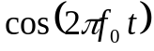 (with f₀ = 10kHz).
Which type of filter do you get now? Justify your answer with a statement about the corresponding property of the Fourier transformation and with a sketch in the frequency domain. [6P]
Hint : The impulse response and frequency response are an FT pair 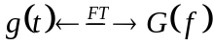

Exercise 2 Fourier Series : Complex and Real Coefficients [18 Points].

The complex coefficients c_{k} of the Fourier series of the periodic signal x(t) are given below:

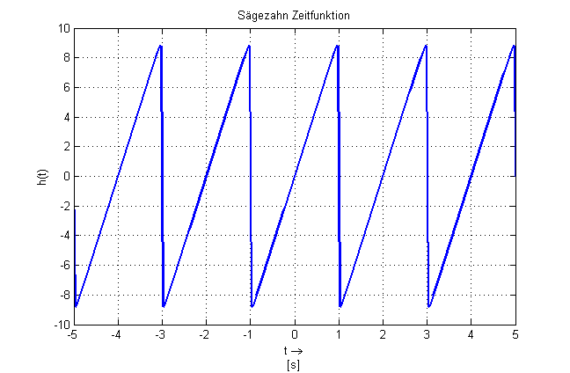
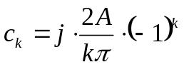

für 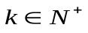

with

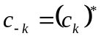

and 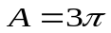
A
x(t)

- For which values of the index k is the expression of ck given above valid? [1P]

- Which of the following expressions is equivalent to the ck expression given above? [3P]

  - 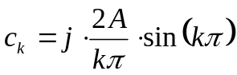

  - 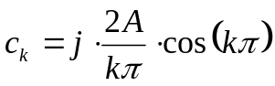

  - 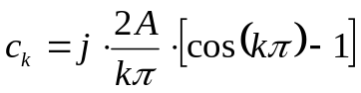

- Determine the period, the fundamental angular frequency ( ω₀ ) , the symmetry properties and the average value of x(t) . [4P]

- Determine the real coefficients ak and bk of the Fourier Series of x(t).
And add for which range of the index k are the expressions you determined valid. [3P]

- Draw a sketch of the two-sided line spectrum of x (t) for k values in the range [-3 ; +3]. Please notice that the horizontal axis has f (Hz) as a running variable. Do not forget to label the axes.
[7P]
0 f [Hz]
|c_{k}|

0 f [Hz]
ϕ_{k}
Exercise 3 System Representation Forms [ 17 Points].

The Bode diagram of the system Sys-A is given below:
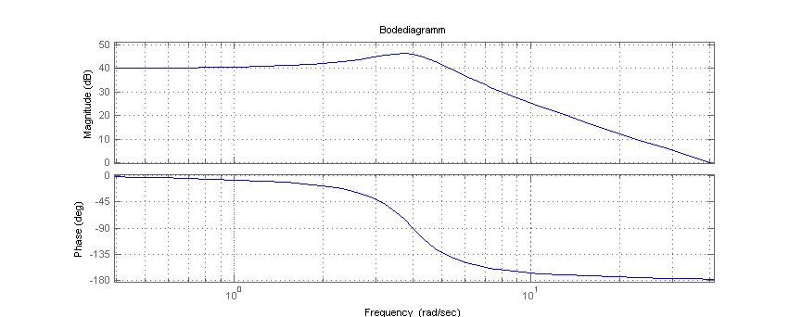
46dB

- Which type of filter (LPF, HPF or BPF) is implemented with Sys-A ? [1P]

- Two transfer functions G_{B}(ω) and G_{C}(ω) are given below.

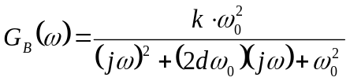 ; 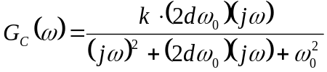

Which of these two transfer functions correspond to the transfer function G_{A}(ω) of the system Sys-A? Justify your answer with the calculation of the expected slopes for │G_{A}(ω) │ in the ranges ( ω << ω₀ ) and ( ω >> ω₀ ) , and a comparison to the corresponding transfer function.
[4P]

- Which step response (h₁(t) or h₂(t)) belongs to the system Sys-A? Justify your answer with an estimation of the expected oscillation frequency for the step response based on the bode diagram. [4P]

h₁(t) | 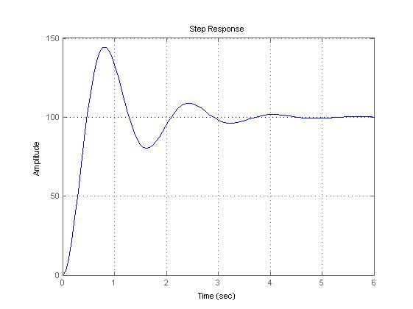
h₂(t) | 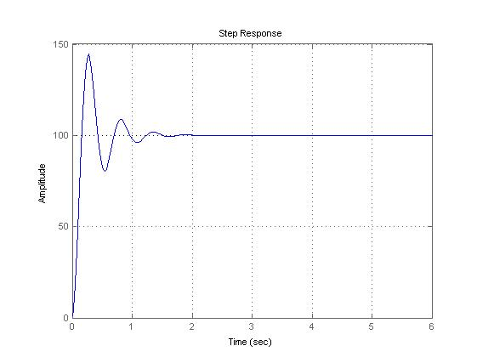

- Which other parameter of the transfer function can be determined observing the bode diagram, and also confirmed with observation of the step response? Determine the numerical value of this parameter. [3P]

- Draw the block diagram which describes the system Sys-A (the integrator blocks are already given). OBS.: Determine first the differential equation of Sys-A. [5P]

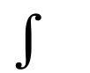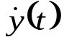
y(t)
x(t)

Exercise 4 Frequency response of an electrical LTI System [18 points].

The amplitude part of the Bode Diagram of a frequency response G(ω) is given below:

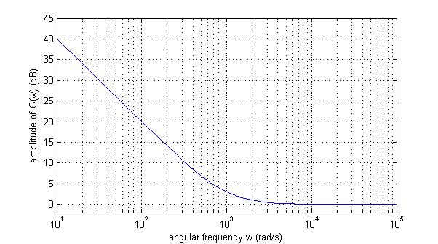

- Determine the equation describing G(ω) . [5P]
Hint: The term in the denominator describes a line with constant slope of -20dB/decade, and the term in the numerator describes a curve with a corner and slopes of 0dB/decade before the corner, and
+20dB/decade after the corner point.

- Sketch the corresponding phase part of the Bode diagram. [3P]
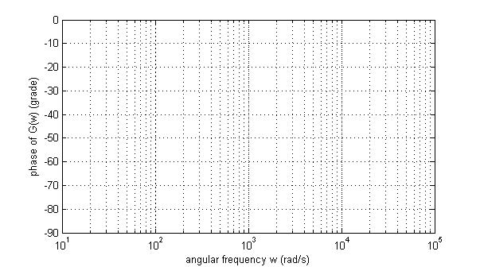

- Which of the following circuits can be used to implement the frequency response of item (a)? Justify your response by calculating the frequency response of both circuits using the method of the complex impedances. [5P]
Remark: suppose an ideal op-amp.

X(ω)
C
+

-
R
Y(ω)
A
B
X(ω)
L
+

-
R
Y(ω)

- Using R=10k Ω, determine the corresponding value for L and/or C . [2P]

- Determine the response of a system with the frequency response G(ω) above, for an input signal 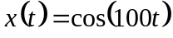 . Justify your answer with a short sentence. [3P]

Exercise 5 ADC-DAC Chain: Sampling and Reconstruction [23 Punkte].

A cosinusoid analog signal u(t) is sampled in an ADC. One period of the resulting discrete signal u[n] is shown below.

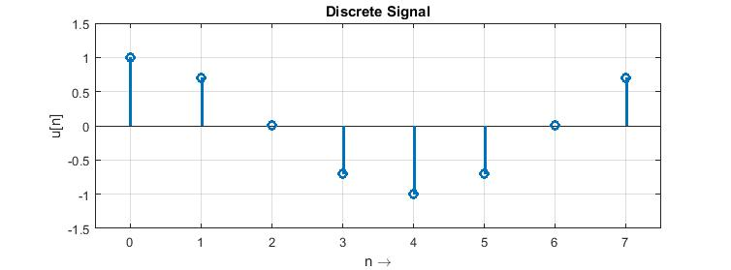

- The sampling frequency of the ADC equals Fs = 8kHz .
Determine the expression, which describes u(t) in the time domain. [2P]

- The expression describing u[n] is given below. Show how this expression can also be derived from the expression of u(t), and verify your answer for item (a). [1P]
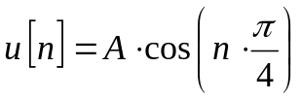 with A = 1

- Prepare a sketch of the double sided spectrum of u(t) and u[n]. Make a short comment about the changes caused in the spectrum of u[n] due to the sampling operation. [5P]
Remark: do not forget to label your axes.
f (Hz)
f (Hz)
The signal u[n] is fed into a DAC with a ZOH (Zero-Order-Holder) and an additional low pass filter (reconstruction filter or anti-imaging filter), which convert it back into an analog signal.

ZOH
T_{s} = 125us
u[n]
u₂(t)
Low Pass
u₁(t)

- What do the signals u1 (t) (after ZOH) and u2 (t) (after the reconstruction filter) look like? Complete the sketch below and justify your answer with a short statement. [4P]
Remark: Please draw u1 (t) and u2 (t) with different colours, and identify their colour in the legend.

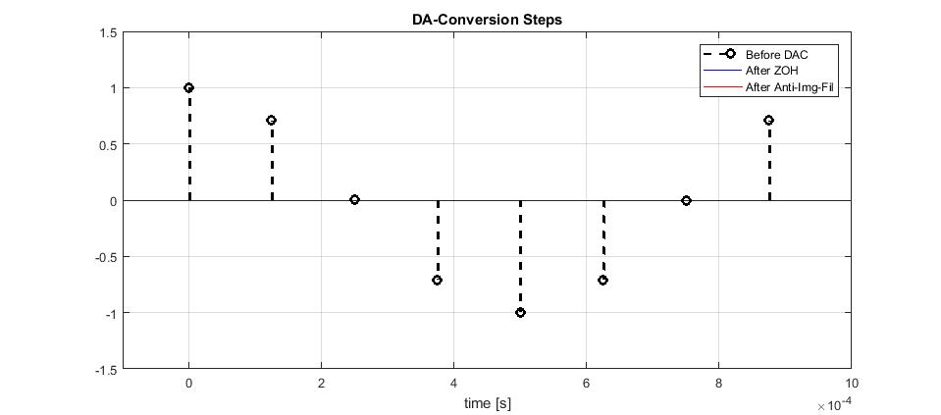

- Prepare a sketch of the double sided spectrum of u1(t) and u2(t). Make a short comment about the changes caused in the spectrum due to the ZOH and anti-imaging filter. [6P]
Remark: do not forget to label your axes.
f (Hz)
f (Hz)

- The impulse response of the ZOH g_{ZOH} (t) is given below. Draw a sketch of the corresponding amplitude spectrum |G_{ZOH}(f)| . [5P]
Remark: Comment your solution approach, for example: by comparing g_{ZOH} (t) with a <….> (known reference signal) and using the <…..> Fourier transformation property, then you get <…..>
g_{ZOH}(t)

1
T_{s} t [s]
T_{s} = 125 us

f (Hz)

Exercise 6 Matlab code: Filter Description, Convolution and DFT [9+ Points].

- The graphics and results of exercise 5 can be generated and checked with a Matlab code. Complete the skelet of this code (in the grey rectangles) given below.

clear all, close all, clc;

N = 8; % nr of points in window (for discrete signal u[n])
Fs = 8e3; % sampling frequency

aux = 0:1:N-1; % declare an index vector with N points

t = (1/Fs)*aux; % time vector based on index vector

f = (Fs/N)*aux; % frequency vector based on index vector

u_n = cos(aux*pi/4); % aux used as index vector n
figure(1), stem(aux,u_n,'LineWidth',2),grid on, …

% For "continuous" signals on DAC: fine resolution time vector
% ==========================
M = 20; % upsampling factor for fine resolution time vector
tstep_fine = (1/Fs)/M;
t_fine = tstep_fine*[0:1:N*M-1];

% Zero-Order-Holder: Impulse response
% ============================
imp_zoh = [ones(1,M)]; % one-pulse with width equals Ts
u1_t_us = upsample(u_n,M); % upsamples u_n by M: inserts zeros
% between original samples.
% Use this upsampled signal for convolution with ZOH

% calculates the output of the ZOH, by convolution
u1_zoh = conv(u1_t_us,imp_zoh);

% Reconstruction or Anti-imaging Filter
% ==============
fcut = 0.4*Fs; % Cut-frequency = 40% of Fs
wcut = 2*pi*fcut;
tau= 1/wcut;

sys_lpf = tf( [1],[tau 1] ); % Low-Pass Filter 1st order

imp_rek = impulse(sys_lpf,[0:tstep_fine:2/Fs]);

% calculates the output of the LPF, by convolution
u2_rek = tstep_fine*conv(u1_zoh,imp_rek);

- If you still have time, write the Matlab code lines you need to calculate and plot the amplitude spectra asked in exercise 5 : …. [2P / spectrum ]

Only the stationary part of the response is expected.

