**HANOI UNIVERSITY OF SCIENCE AND TECHNOLOGY**

**School of Information and Communication Technology**



**REPORT**

Course**: Computer Graphics and Virtual Reality**

Game: **Shooting and Surviving**

Instructor: **MSc. Hung Le Tan**

Class: **LTU15**

Member: 1. Nguyen Duc Thien ID: 20168806

2. Vu Hoang Duc Hieu ID: 20168199

3. Vu Duc Huy ID: 2012

4. Le Duc Thang ID: 20168497

This document contents a Gamification Model Canvas and Project Report.

After a long time researching, collecting and analyzing data from game market: steam market, EA, … and with our knowledge about Unity and Computer Graphics, we decided to develop this game

Thanks to our instructor, Mr. Le Tan Hung for supporting us in this project

During the developing process, due to the limit of our ability about graphics technical and physics algorithm, this game still has some errors need to fix for exploits purpose in the future.

**Table of Contents**

Table of Work breakdown structure 4

**1.** **Reason we choose this game** 5

**2.** **Game overview** 5

a. Game concept 5

b. Genre 5

c. Game flow summary 5

**3. Game play** 6

a. Game progression 6

b. Mission / Challenge Structure 6

c. Puzzle Structure 6

d. Screen flow 7

**4. Character** 10

a. List Character 10

b. Characteristic 12

c. Movement 12

**5. Interface** 12

a. Visual Interface 12

b. Control System 12

c. Audio, music, sound effect 13

d. Help System 13

# Table of Work breakdown structure

|  |  |  |  |  |  |
| --- | --- | --- | --- | --- | --- |
|  | | Nguyen Duc Thien | Vu Hoang Duc Hieu | Vu Duc Huy | Le Duc Thang |
| Business  domain | Market researching |  | x | x | x |
| Raise ideas | x |  | x |  |
| Technical domain | Build system architecture | x |  |  | x |
| Prepare gaming resource |  | x |  |  |
| Game coding | x | x |  | x |
| Summaries and report | x |  | x |  |

Shooting and Surviving

1. **Reason we choose this game**

Survival games have exploded over the past few years. The Steam charts last year filled with all kinds of examples, including classic survival game: collecting and surviving and new survival game: Battle Royale

Zombie is a fictional undead being which is created through the reanimation of a corpse. They are most commonly found in horror and fantasy films. So, we choose to develop a zombie survival game – a unique kind of survival game that still not have on the Steam charts recent years

1. **Game overview** 
   1. Game concept

Shooting and Surviving is a survival game, that players must decide to avoid combat to run to a safety place or use weapons to kill zombies. The movement of the zombies as compared to the players, and they will try to find the players and kill them.

In this game, player will be a solider with 4 different weapons, try to avoid or fight with the zombies to survival. Moreover, player will discover how to kill zombies with 4 different weapons namely: Axe, revolver, shotgun and assault rifle.

If you are finding a game to relax after a hard-working day, this game is for you.

* 1. Genre

3D FPS Game

## c. Game flow summary

* Purpose: Survival and find the Easter Egg
* Game flow:
  + After entering the game, player will click into the start button to play
  + The game screen will show up, zombies will spawn and try to kill the player
  + Choose 4 different weapons to kill the zombies
  + Player must aim correctly into a zombie to kill them
  + Each zombie must be killed by a specified weapon. If you use wrong weapon, you will lose this weapon.
  + People will go to the next level after kill all the zombies or find out the Easter Egg in that level.
  + In the playing process, each time zombies touch the player, the health score will decrease
  + Health bar show the player’s health score. If the health score below to zero, player will die
  + Player can run, the mana score show by mana bar describes how long player can run
  + Player will finish the game after finishing all levels and kill the boss

# **3. Game play**

## a. Game progression

After kill a zombie with wrong weapon, the weapon you used to kill them will be disable. Player must find another way to kill them. This will make the game more creative, and player has to take care of each shot. Make the game more interesting.

## b. Mission / Challenge Structure

Player will move and use different weapons to kill all the zombies in order to survive. Victory after the player kill the final boss in the final level

## Puzzle Structure

Zombies have an algorithm to move closer to the player. Moreover, there are different kinds of zombies with different movement speed and damage

* 1. Screen flow

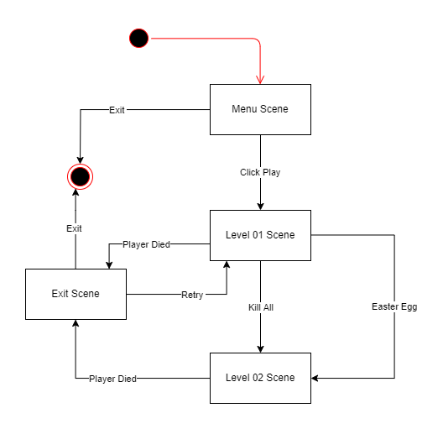

Menu Scene



Level 01 Scene

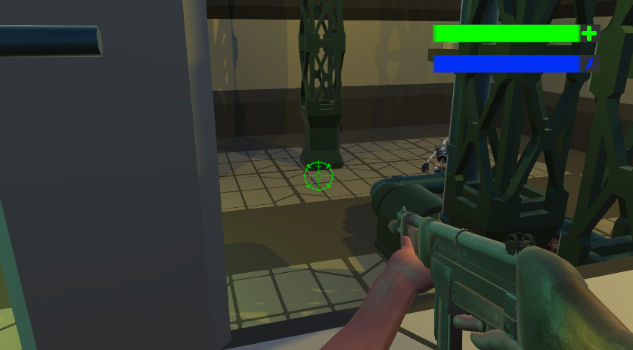

Level 02 Scene

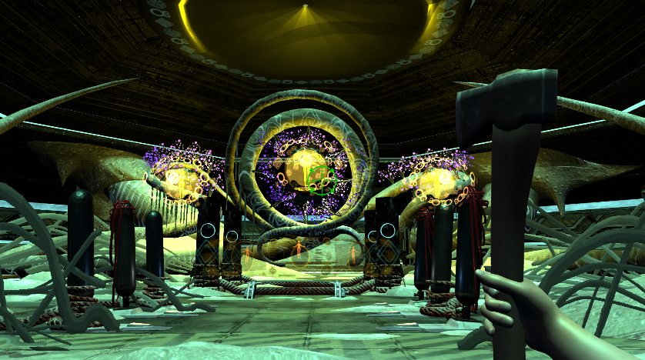

Exit Scene

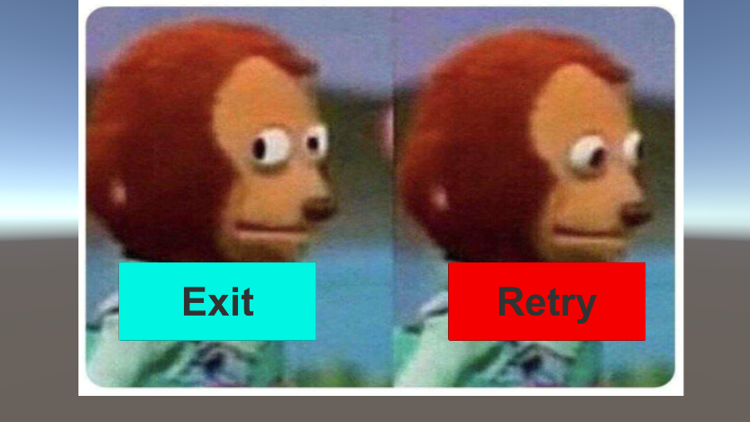

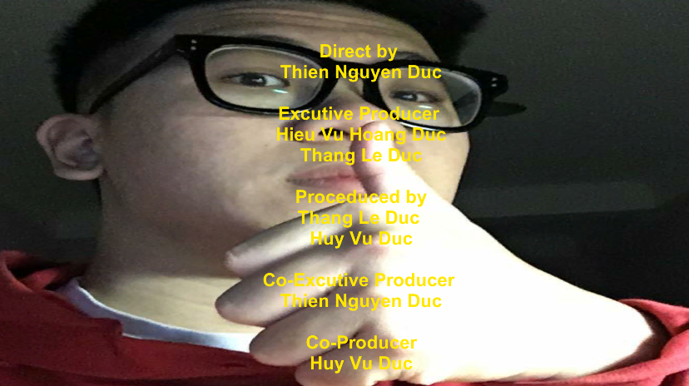

# **4. Character**

## a. List Character

One character – 4 different weapons

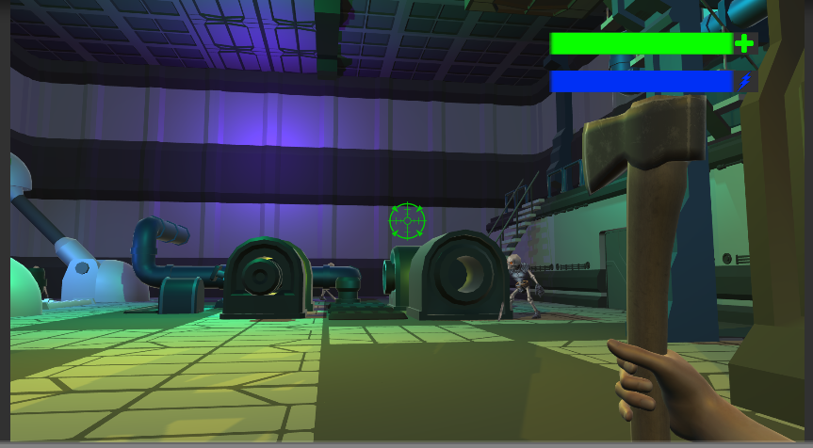

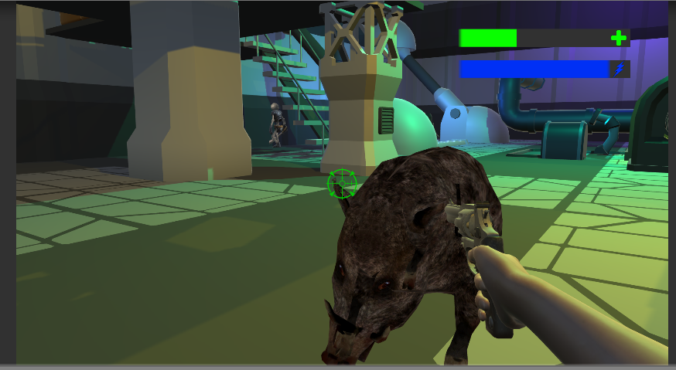

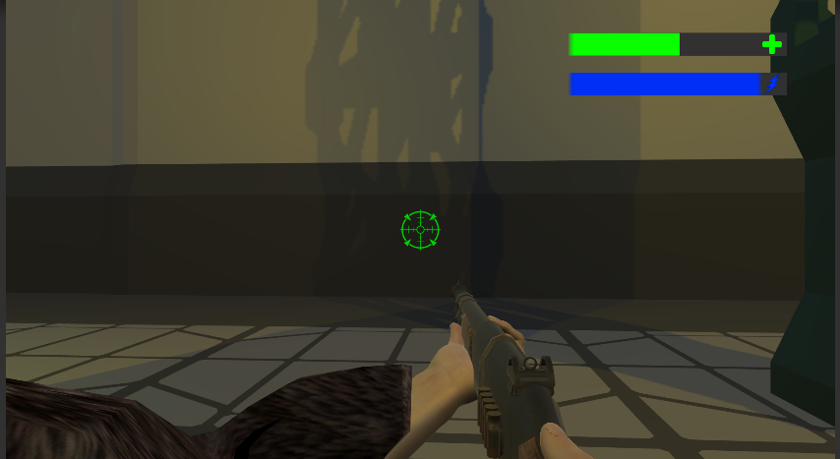

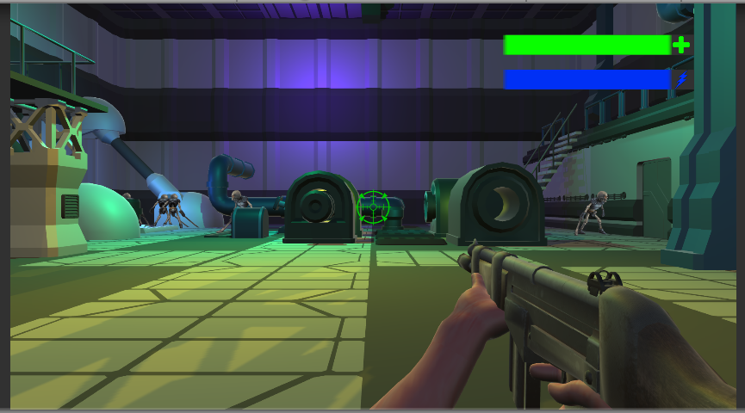

## b. Characteristic

* Each weapon has different damage, range, speed and bullet.
* Axe:
* Type: Melee
* Damage: 20
* Speed: Slow and single
* Revolver
* Type: Gun
* Damage: 10
* Speed: Normal and reload required
* Shotgun
* Type: Gun
* Damage: 15
* Speed: Slow and reload required
* Assault Rifle
* Type: Gun
* Damage: 5
* Speed: Fast and continue

## c. Movement

Up, down, left, right, jump

Melee attack with axe, aim and shoot with guns.

Speed boost

# **5. Interface**

## a. Visual Interface

None

## b. Control System

Player use 4 different keys: W, A, S, D to move up, left, down, right

Use mouse to aim and left click to fire.

Hold Shift to boost the player’s speed.

Space to jump.

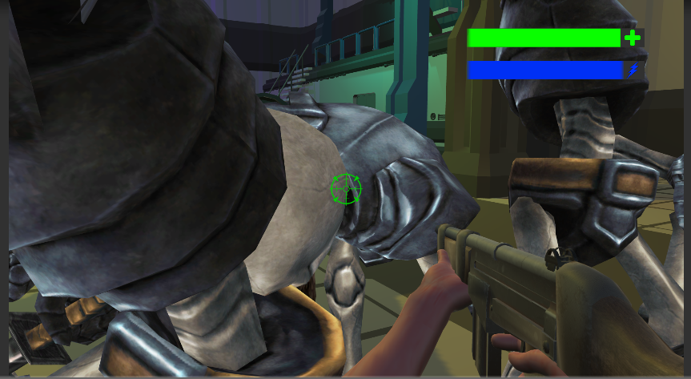

## c. Audio, music, sound effect

This game has Sci-Fi theme music.

When fire, each weapon has different sound effect.

Each zombie when attack or die has different sound effect.

## d. Help System

None