DQClock Users Manual
Congratulations on your new clock! DQClock is your new friendly alarm clock and sleep trainer.

Main Parts

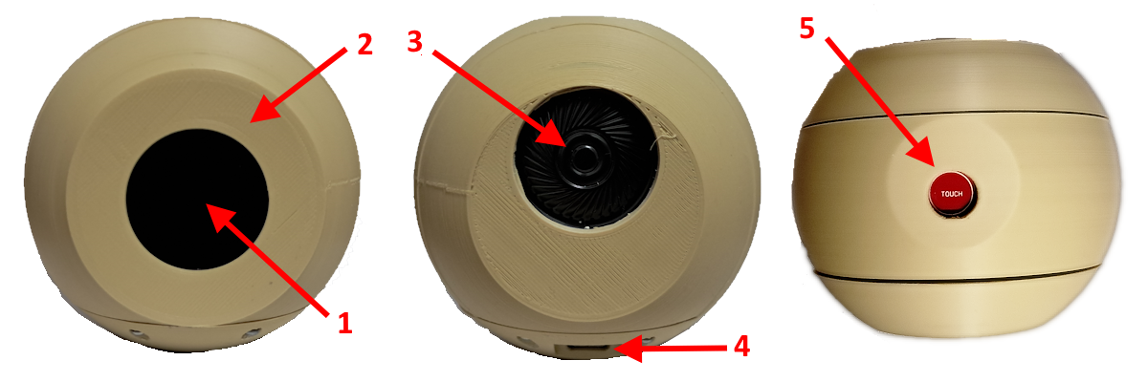

- The screen shows the current time.
- The LED Ring will set the mood. During the day, it is green; when the alarm rings, it flashes red. You can configure the color and brightness at night.
- The speaker will play the configured sounds at alarm time.
- The USB connector is used to power the clock.
- The touch sensor on the top is used to stop or snooze the alarm and to see the information screen.

Initial Setup
The first time you power up the clock, you need to set up its WiFi connection.
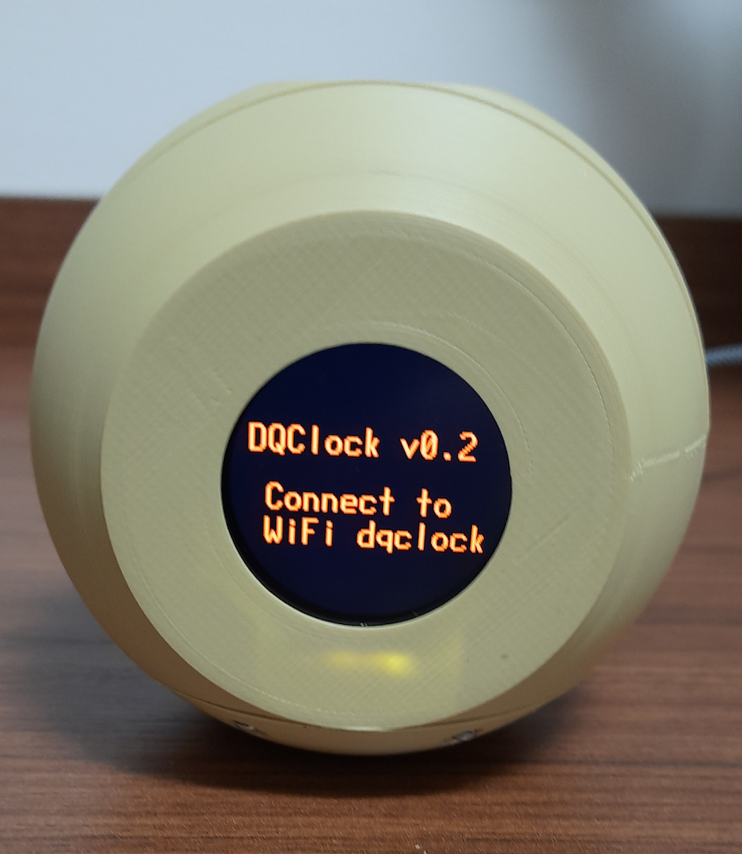
Connect your cellphone or PC to the dqsoft WiFi network (no password is required) and use a browser to navigate to 192.168.4.1 (you may get a warning that a secure connection cannot be established; ignore it).
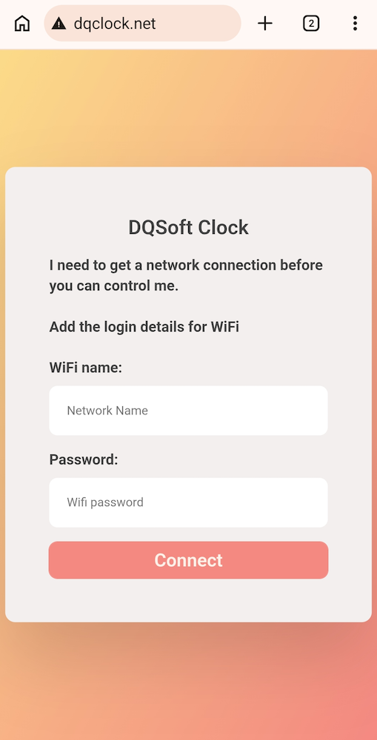
Enter the WiFi name and Password for your WiFi connection.
The clock will restart when you press Connect.

Configuration
You can change the clock’s configuration by accessing it in a browser (again, you may get a warning that a secure connection cannot be established; ignore it). The clock IP address appears when it turns on; you can also view it by touching the top sensor for more than 5 seconds and releasing it.
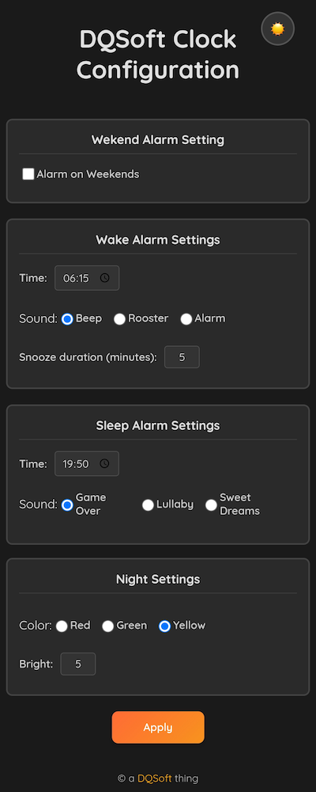

The configurations available are:
- Alarm on weekends: selects whether the alarm will be active on Saturdays and Sundays.
- Wake Alarm: selects the wake time and sound. You can also select how many minutes the snooze will give.
- Sleep Alarm: selects the sleep time and sound.
- Night settings: selects the color and brightness of the LED ring during the night period (from 7 PM to 6 AM).
The clock will restart when you press Apply.

Operation
The screen shows the current time and a pair of eyes. During the day, the eyes are open; during the night, they are closed.
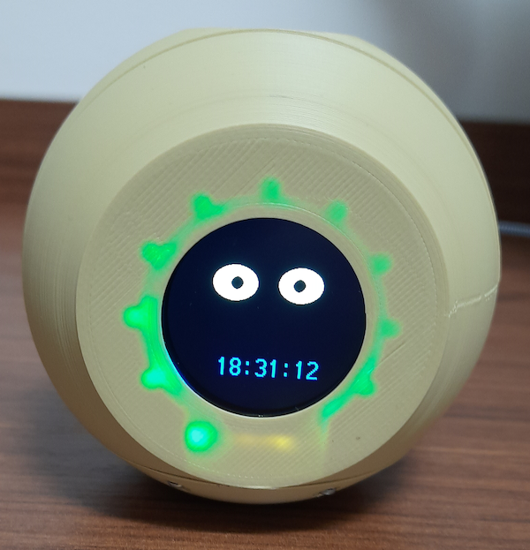
When the alarm time is reached, the alarm sounds through the speaker, the LED ring flashes red, and the eyes change. A short press (less than 5 seconds) on the touch sensor stops the alarm. A long (more than 5 seconds) press on the touch sensor activates the snooze feature.
When the alarm is off, a long press (more than 5 seconds) on the touch sensor brings up the information screen.
