1)

Attached is the function I have created for clock function and the output after running it with what was instructed.

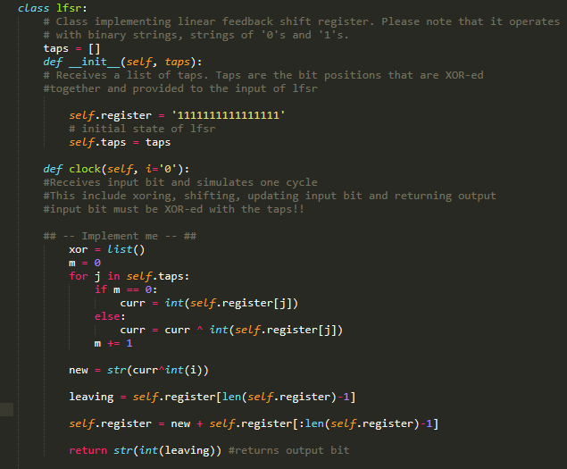

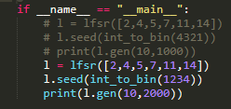

2)

Attached you will see a screenshot of the code I created the Hash function with along with the sentence that I decided to encrypt using the hash function.

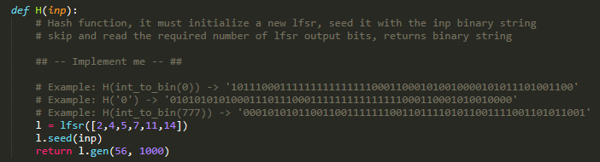

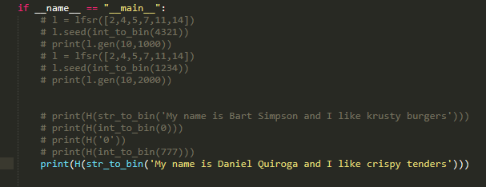



3)

Below is my implementation of the function enc_pad() and how I call the function to encrypt and decrypt my message, I have added spaces in between outputs to make readability easier.

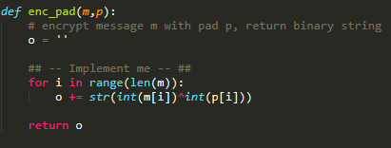

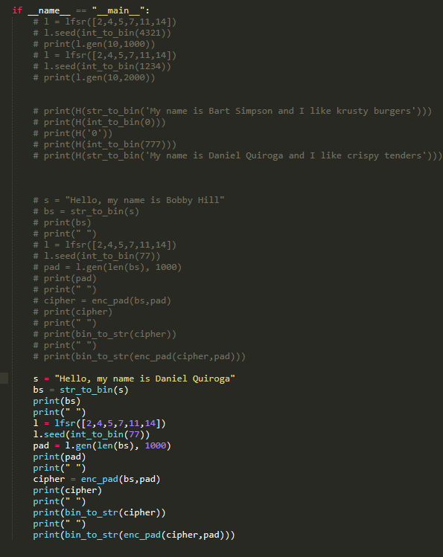

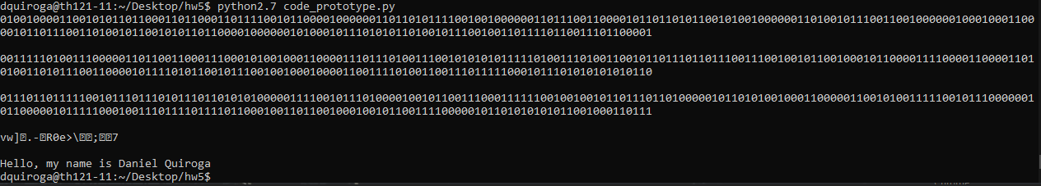

4)

Below is a screenshot of my implementation of the GenRSA() function and the output of each of the variables. Along with a validation using the t=100 example:

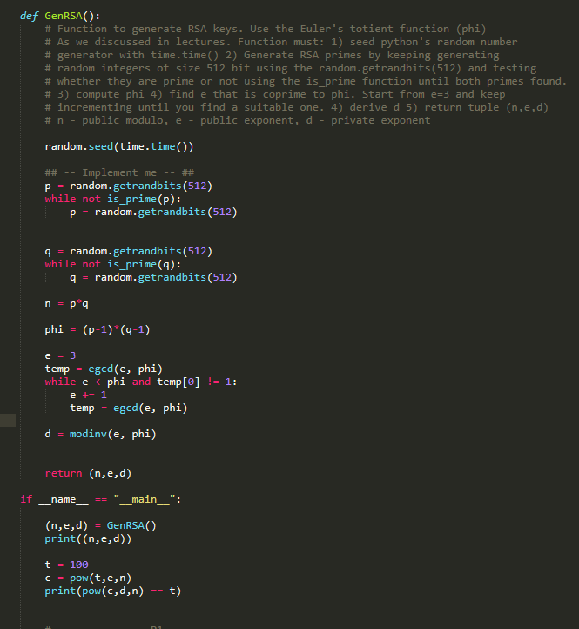

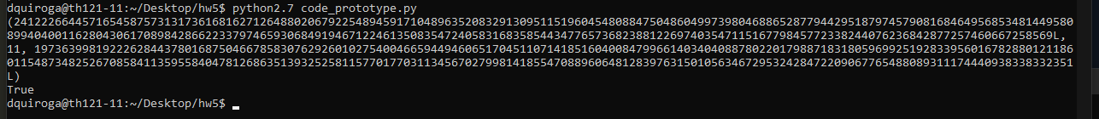

As seen, true was outputted meaning that the encryption and decryption was successful.

5)

5.1)

Using the GenRSA() I would use those values returned along with what the message in integer is to compute an integer value and then convert that integer value into a binary representation to send the string:

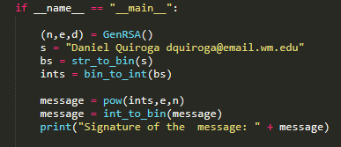

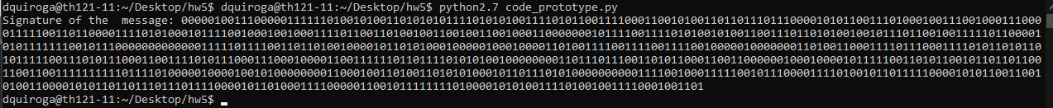

5.2)

In order to decrypt the message the other party would need the secret d key and the public modulo, n. The would need to convert the binary signature into an integer and then pow(integer, d, n) which would return the original message in integer form. By converting the int to string you would get the original message:

