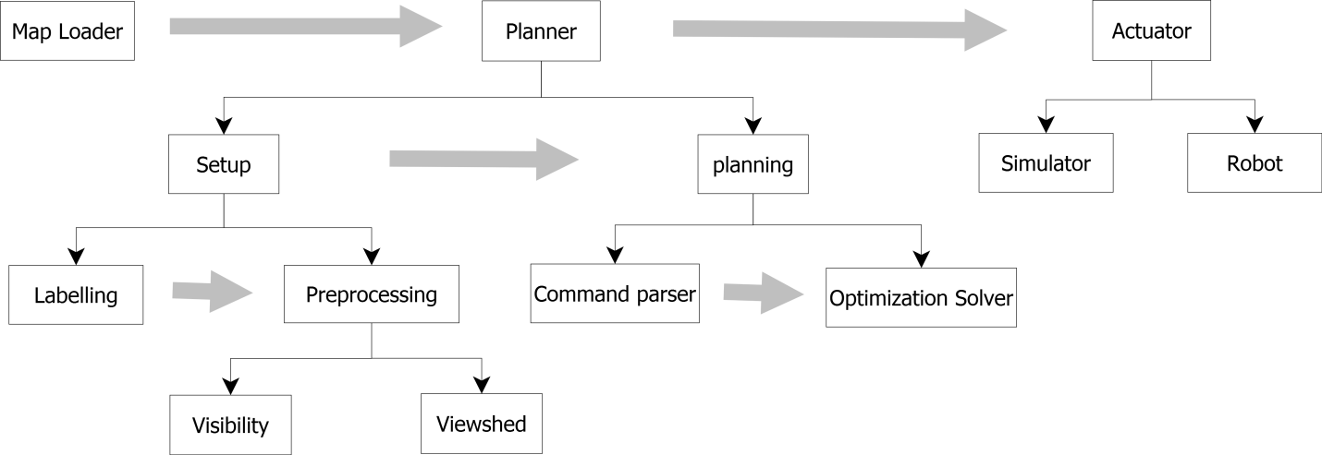

I try to have a diagram to show what we will have for a complete demo. The gray line shows the information flow between modules.

To have everything well finished, this should be some long term plan. Given a limited time and resource for coming demo, it will be helpful to me to figure out what are those we expect to reach.

Assume we are selling our ideas and “products” to our funders, we have several ways to promote in the demo:

1. Design specification;
2. Concept Prototype;
3. Runnable Modules;
4. Alpha version product.

Using “Design specification” shows how we are going to , probably in the form of slides. It gives framework designs, UI designs and more details

Using “Concept Prototype” can give how the operation flow is like in a single case, which usually does not adapt to other cases. But it provides a direct experience to the user on how the thing is like, if the focus is on user experience.

Using “Runnable Modules” supports the feasibility of each part, assuming future work will provide adaptor to connect relevant parts and make each part complete and bug free.

Using “Alpha version” means we are almost done with what we need in this project, assume the research work does not focus on product release so it will stop at this phase.

If we are inclined to have something to show, we probably shall try to have more coverage on all the modules. Having a system to log the bugs and tuning them in the future. This way is sort of agile development; we are interested with collecting the feedback from the users.

If we are inclined to have something persuadable, we probably shall make step made solid. This way is sort of waterfall development; we are telling the users that we are making progress steadily and we are trustable.