ACADEMIC INTEGRITY NOTICE
تنبيه هام:
تؤكد الجامعة على الالتزام التام بالنزاهة الأكاديمية خلال فترة الاختبارات. ويُمنع منعًا باتًا إدخال أو استخدام أي أجهزة إلكترونية داخل قاعة الاختبار، بما في ذلك على سبيل المثال لا الحصر: الهواتف المحمولة، الساعات الذكية، النظارات الذكية، السماعات، أو أي جهاز يحتوي على كاميرا أو متصل بالإنترنت. ويُعد حيازة أو استخدام أي من هذه الأجهزة محاولة غش تُطبق بشأنها العقوبات المنصوص عليها في قواعد السلوك والانضباط الطلابي المعتمدة بالجامعة.

Important Notice:
The University emphasizes full adherence to academic integrity during examinations. The possession or use of any electronic devices inside the examination hall is strictly prohibited, including but not limited to mobile phones, smart watches, smart glasses, earphones, or any device equipped with a camera or internet connectivity. Possession or use of such devices will be considered an attempt to cheat and will be subject to disciplinary actions in accordance with the University’s approved Student Code of Conduct and Discipline.

PART I — Multiple Choice Questions [20 points]
Select ONE best answer for each question. 10 questions × 2 points.

1. Which activity belongs to software engineering rather than coding alone? [2 pts | T1] [CLO 1 · SO-1]
A. Choosing syntax highlighting
B. Eliciting stakeholder requirements
C. Renaming local variables
D. Running a single program

2. Which quality attribute best describes ease of modifying software? [2 pts | T2] [CLO 2 · SO-1]
A. Usability
B. Availability
C. Maintainability
D. Throughput

3. Which output of the design phase helps guide implementation? [2 pts | T3] [CLO 3 · SO-1]
A. A list of editor shortcuts
B. An architecture describing components and interfaces
C. A record of post-release support tickets
D. A compiled application executable

4. Which process is most suitable when requirements are stable and staged sign-off is mandatory? [2 pts | T4] [CLO 4 · SO-1]
A. Waterfall
B. Spiral only
C. Unplanned coding
D. Continuous deployment only

5. A team reviews a completed feature against its written specification. Which activity is this? [2 pts | T2] [CLO 2 · SO-1]
A. Validation
B. Verification
C. Requirements elicitation
D. Interface prototyping

6. Which statement is the BEST example of a measurable software quality target? [2 pts | T2] [CLO 2 · SO-1]
A. The application should be user-friendly
B. The system should be modern
C. 95% of searches must finish within 2 seconds
D. The interface should look attractive

7. Why is software engineering more than writing source code? [2 pts | T1] [CLO 1 · SO-1]
A. It coordinates requirements, design, testing, and maintenance
B. It removes the need to communicate with stakeholders
C. It focuses only on selecting programming languages
D. It guarantees software never needs maintenance

8. Which activity is primarily performed during software maintenance? [2 pts | T3] [CLO 3 · SO-1]
A. Identifying initial stakeholders before development
B. Correcting a defect discovered after deployment
C. Choosing the first system architecture
D. Writing the original project proposal

9. A team expects high technical uncertainty and needs explicit risk analysis during development. Which process model is MOST appropriate? [2 pts | T4] [CLO 4 · SO-1]
A. Waterfall with no iteration
B. Code-and-fix
C. Spiral
D. A single deployment phase

10. A mobile app works correctly but users struggle to navigate it. Which quality attribute needs improvement? [2 pts | T2] [CLO 2 · SO-1]
A. Usability
B. Portability
C. Availability
D. Interoperability

PART II — Short Answers [15 points]
Answer in 2–5 sentences per question. 3 questions × 5 points.
1. Distinguish verification and validation. Provide one concrete example of each. [5 pts | T2] [CLO 2 · SO-1]
ANSWER: Verification checks conformance to specifications (e.g., review the booking feature against its documented rules). Validation checks whether users’ needs are met (e.g., clinic staff confirm the booking workflow is useful).

2. Compare Waterfall and iterative development in terms of feedback and changing requirements. [5 pts | T4] [CLO 4 · SO-1]
ANSWER: Waterfall follows sequential stages and usually incorporates feedback late; changes may require formal rework. Iterative development delivers repeated increments, collects feedback early, and adapts requirements between iterations.

3. Explain why software development phases may need to be revisited rather than completed only once. Give ONE hospital appointment-system example in which testing feedback leads to a change in an earlier phase. [5 pts | T3] [CLO 3 · SO-1]

ANSWER: Phases are revisited because testing can expose defects in earlier decisions. Example: tests reveal that double-booking is possible; the team revisits design to introduce an atomic availability check and then reimplements and retests it.

PART III — Software Lifecycle Activities [15 points] [CLO 1, 3 · SO-1: 15 pts]
A university is developing a campus service application. The following activities take place during its software lifecycle.
For each activity, identify its PRIMARY lifecycle phase using these codes: R = Requirements, D = Design, I = Implementation, T = Testing, M = Maintenance. Use each code as often as appropriate. 10 × 1.5 points.
# | Lifecycle activity | Phase | Points
1 | Interview users to determine the services they need. | R | 1.5
2 | Define the main components and their responsibilities. | D | 1.5
3 | Write source code for the reservation feature. | I | 1.5
4 | Execute test cases to detect incorrect booking results. | T | 1.5
5 | Fix a defect reported after the system has been released. | M | 1.5
6 | Document measurable response-time expectations. | R | 1.5
7 | Select how components will exchange information. | D | 1.5
8 | Implement the agreed validation logic in code. | I | 1.5
9 | Run integration tests on connected components. | T | 1.5
10 | Update the released application tocampus policy. | M | 1.5

PART IV — Applied Requirements and Software Design [15 points] [CLO 5, 6, 7 · SO-2: 15 pts]
SCENARIO
CampusCare: Students book and cancel clinic appointments. Staff manage appointment availability. Currently, one module handles screens, booking rules, and database access.

Instructions: Answer each task using the scenario above. Write your answers in the spaces provided. Different technically correct solutions are acceptable.

TASK A | Requirements and Stakeholder Elicitation
Write one functional requirement and one measurable non-functional requirement. For EACH, explain how you would verify that the system meets it (for example, a test or measurement). Then ask one specific question to a stakeholder to clarify an unclear requirement.
REQUIRED RESPONSE | YOUR ANSWER | PTS
1. Functional requirement  What must the system do? | The system shall allow a student to cancel a future clinic appointment. | 1
How will you verify it?  State a test or observable result. | Create a future booking, cancel it, and verify that its status becomes Cancelled. | 1
2. Non-functional requirement  State a measurable quality target. | At least 95% of booking requests shall complete within 2 seconds under 100 concurrent users. | 1
How will you measure it?  State a method or metric. | Run a load test with 100 users; record response times and confirm at least 95% meet 2 seconds. | 1
3. Stakeholder question  Ask about an unclear business rule. | How long before an appointment may a student cancel it? | 1
What will the answer clarify?  Explain the decision it supports. | Defines the cancellation cut-off and its validation rule. | 1

TASK B | Modular Design
The current system combines the user interface, business rules, and database access in one module. Propose THREE separate modules. Give each a meaningful name and describe its specific responsibility.
MODULE | MODULE NAME | MAIN RESPONSIBILITY | PTS
1 | UserInterfaceModule | Displays appointment availability and collects user actions. | 2
2 | BookingRulesModule | Checks eligibility, conflicts, booking and cancellation rules. | 2
3 | AppointmentRepository | Reads/writes appointments through a stable persistence interface. | 2

TASK C | Design Principle and Change Isolation
Name ONE software design principle (1 point). Explain how separating database access from business rules would allow the database technology to change without modifying those rules (2 points).
REQUIRED RESPONSE | YOUR ANSWER | PTS
Design principle | Separation of Concerns / Information Hiding. | 1
Explanation  Explain what remains unchanged and why. | The booking module depends on a repository interface, not a particular database. Replace the database adapter (e.g., MySQL with PostgreSQL); booking rules remain unchanged. | 2

PART V — Problem Solving and UML Diagramming [35 points]
FINAL ENGINEERING CHALLENGE — Scenario-based design
A university plans to introduce ParkSmart, a smart parking management system that helps Students and Faculty Members find and reserve parking spaces on campus.
The campus has several ParkingZones, each containing multiple ParkingSpaces. Every parking space has a unique identifier and belongs to exactly one zone. Spaces are classified as Regular, Faculty-Only, or Accessible.
Registered Students and Faculty Members can search for available spaces, select a parking location, and make reservations for specific dates and time periods. Each Reservation is associated with exactly one user and one parking space. A user may have multiple reservations, and a parking space may be reserved multiple times on different occasions. However, two active reservations for the same space must never overlap in time.
The system must enforce parking eligibility rules. For example, Students cannot reserve Faculty-Only spaces, and a reservation must be rejected if the selected space is unavailable during the requested period. Users may also cancel their reservations, provided the cancellation occurs before the scheduled starting time.
Upon arrival, a ParkingOfficer verifies the user’s reservation and records the vehicle’s entry. When the vehicle leaves, the officer records its exit, allowing the system to update the parking space’s availability.
If a user fails to arrive within 15 minutes of the reservation’s starting time, the system automatically changes the reservation status to No-Show and releases the reserved space for other users.
ParkSmart also sends notifications whenever a reservation is confirmed, cancelled, or marked as No-Show.

TASK 1 — UML Use Case Diagram [10 points] [CLO 9 · SO-2: 10 pts]
Draw a system boundary labeled with the platform name. Identify external actors, at least 4 appropriate use cases and correct actor–use-case associations. Use <<include>> / <<extend>> only if justified; they are NOT required.
Use case rubric | Points
Correct external actors | 3
Relevant use cases (at least 4) | 4
Correct associations | 2
System boundary and UML notation | 1

DRAWING SPACE — USE CASE DIAGRAM
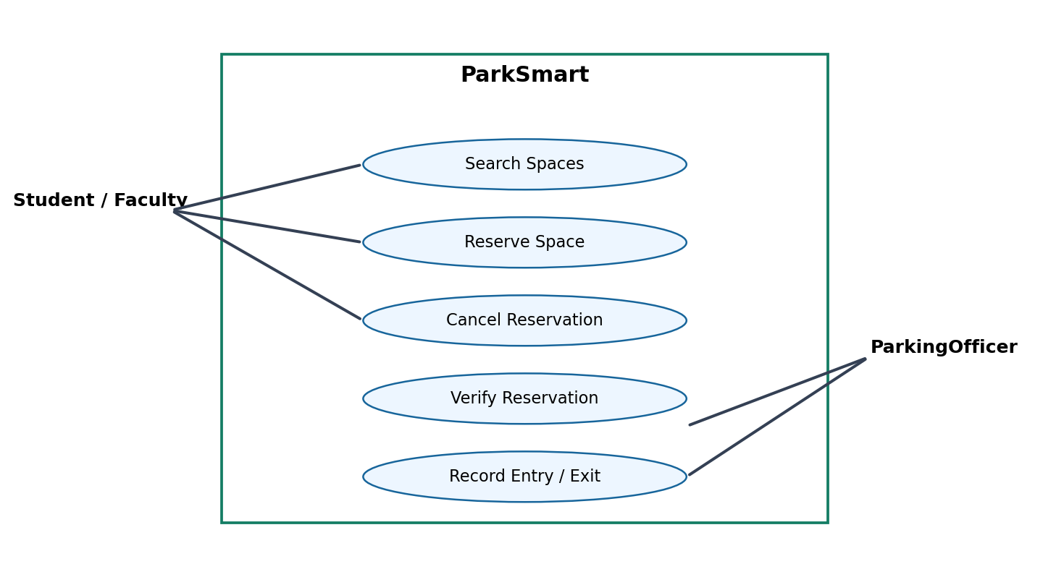

TASK 2 — Candidate Domain Classes [5 points] [CLO 8 · SO-2: 5 pts]
Identify five essential candidate domain classes and briefly describe each responsibility. Avoid UI widgets, database tables, and implementation-only utilities. You may refine or extend these classes in Task 3.
Candidate-class rubric |  |  | Points
5 appropriate domain classes (0.6 each) and correct responsibilities (0.4 each) |  |  | 5
# | Class Name | Responsibility
1 | ParkingZone | Groups parking spaces.
2 | ParkingSpace | Represents a reservable space and its type.
3 | Reservation | Tracks user, space, period and status.
4 | User | Represents a registered parking customer.
5 | ParkingOfficer | Verifies reservations and records entry/exit.
TASK 3 — UML Class Diagram [20 points] [CLO 10 · SO-2: 20 pts]
Draw a conceptual UML Class Diagram (Compact View) for the ParkSmart system based on the given scenario.
Attributes and operations are NOT required. You may refine or extend the candidate classes from Task 2. Your diagram must include:
(a) At least 5 relevant domain classes, represented by class names only.
(b) Correct associations between the identified classes.
(c) Appropriate UML relationship types, such as association, generalization, aggregation, or composition, where justified.
(d) Correct multiplicities at both ends of each association.
Class diagram rubric — detailed | Points
Identification of at least 5 appropriate domain classes | 5
Correct associations between classes | 5
Appropriate relationship types and UML notation | 4
Correct multiplicities at both ends of associations | 5
Overall diagram clarity and readability | 1
TOTAL | 20

DRAWING SPACE — CLASS DIAGRAM
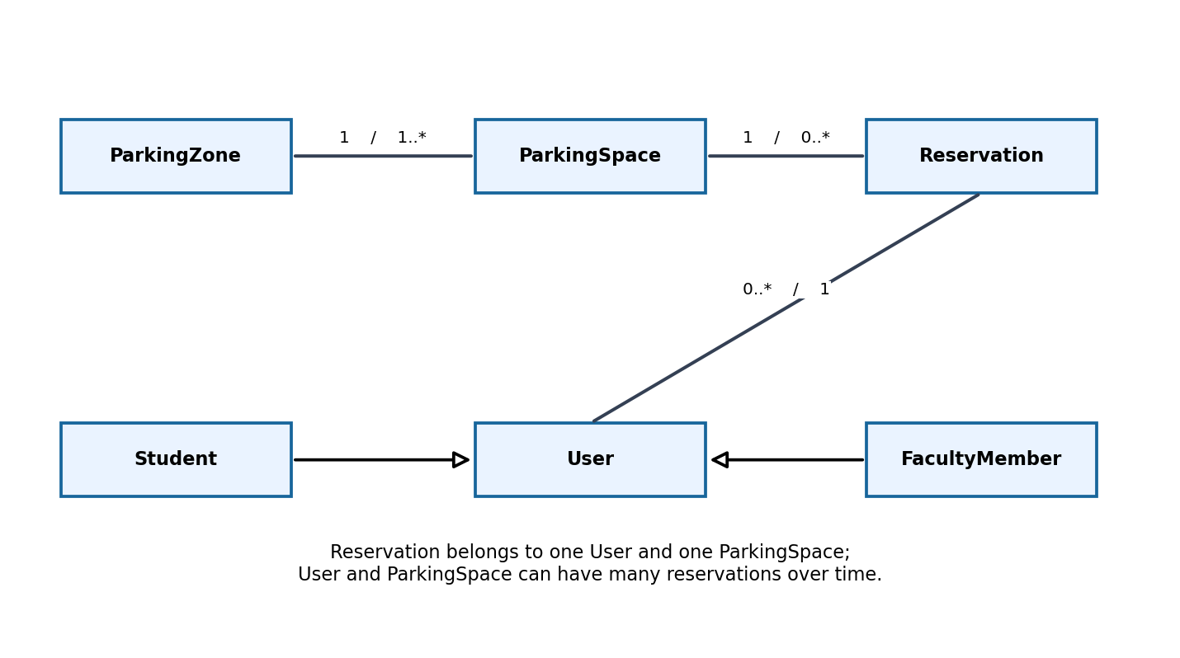

The End of The Exam

