ACADEMIC INTEGRITY NOTICE
تنبيه هام:
تؤكد الجامعة على الالتزام التام بالنزاهة الأكاديمية خلال فترة الاختبارات. ويُمنع منعًا باتًا إدخال أو استخدام أي أجهزة إلكترونية داخل قاعة الاختبار، بما في ذلك على سبيل المثال لا الحصر: الهواتف المحمولة، الساعات الذكية، النظارات الذكية، السماعات، أو أي جهاز يحتوي على كاميرا أو متصل بالإنترنت. ويُعد حيازة أو استخدام أي من هذه الأجهزة محاولة غش تُطبق بشأنها العقوبات المنصوص عليها في قواعد السلوك والانضباط الطلابي المعتمدة بالجامعة.

Important Notice:
The University emphasizes full adherence to academic integrity during examinations. The possession or use of any electronic devices inside the examination hall is strictly prohibited, including but not limited to mobile phones, smart watches, smart glasses, earphones, or any device equipped with a camera or internet connectivity. Possession or use of such devices will be considered an attempt to cheat and will be subject to disciplinary actions in accordance with the University’s approved Student Code of Conduct and Discipline.

PART I — Multiple Choice Questions [20 points]
Select ONE best answer for each question. 10 questions × 2 points.

1. A project has stable requirements and requires formal approval at each major stage. Which approach is most suitable? [2 pts | T4] [CLO 4 · SO-1]
A. Continuous deployment without approvals
B. Waterfall
C. Spiral in every case
D. Unplanned coding

2. Why might a development team return to design after testing has started? [2 pts | T3] [CLO 3 · SO-1]
A. The lifecycle prohibits revisiting previous phases
B. Testing replaces the need for design
C. All requirements become irrelevant after coding
D. Testing may reveal a design defect that requires revision

3. Which statement expresses a measurable quality objective? [2 pts | T2] [CLO 2 · SO-1]
A. At least 99.8% monthly service availability
B. The system should be intuitive
C. The interface should be attractive
D. The system should feel modern

4. Which activity best illustrates a software engineering responsibility beyond coding? [2 pts | T1] [CLO 1 · SO-1]
A. Renaming a variable
B. Selecting an editor theme
C. Coordinating stakeholder requirements and testing
D. Adjusting indentation

5. Which activity most clearly belongs to software maintenance? [2 pts | T3] [CLO 3 · SO-1]
A. Choosing the initial architecture
B. Updating a released system for a new regulation
C. Drafting the first project proposal
D. Identifying initial users

6. Which process model explicitly prioritizes risk assessment during repeated development cycles? [2 pts | T4] [CLO 4 · SO-1]
A. Spiral
B. A single deployment phase
C. Code-and-fix
D. Waterfall without iteration

7. Which quality attribute describes how easily software can operate in different environments?
[2 pts | T2] [CLO 2 · SO-1]
A. Availability
B. Reliability
C. Portability
D. Usability

8. Which quality attribute concerns dependable operation under specified conditions? [2 pts | T2] [CLO 2 · SO-1]
A. Learnability
B. Aesthetics
C. Reliability
D. Portability

9. Which statement best characterizes the software lifecycle? [2 pts | T1] [CLO 1 · SO-1]
A. It includes development, operation, and evolution activities
B. It consists solely of programming
C. It ends as soon as source code compiles
D. It excludes stakeholder communication

10. A team checks whether a completed feature satisfies its approved specification. This is: [2 pts | T2] [CLO 2 · SO-1]
A. Prototyping
B. Verification
C. Deployment
D. Validation only

PART II — Short Answers [15 points]
Answer in 2–5 sentences per question. 3 questions × 5 points.
1. Differentiate a software product quality attribute from a software quality assurance activity. Give ONE example of each. [5 pts | T2] [CLO 2 · SO-1]
ANSWER: A product quality attribute describes a property of the software (e.g., reliability). Quality assurance is a process activity to prevent or detect quality problems (e.g., code review or test planning).

2. Explain ONE advantage and ONE limitation of the Spiral process model, with reference to risk management. [5 pts | T4] [CLO 4 · SO-1]
ANSWER: Advantage: Spiral explicitly identifies and mitigates high-priority risks in each cycle. Limitation: it requires expertise and additional time/cost for repeated risk analysis, making it less suitable for simple low-risk projects.

3. Explain how feedback from testing can influence an earlier software development phase. Give ONE example involving an equipment-lending service, and identify the earlier phase that would be revisited. [5 pts | T3] [CLO 3 · SO-1]
ANSWER: Testing may uncover an earlier design or requirement defect. Example: an integration test allows two active loans for the same item; revisit design to enforce a single-active-loan rule, then update implementation and retest.

PART III — Software Lifecycle Activities [15 points] [CLO 1, 3 · SO-1: 15 pts]
A university is developing LabEquip, a campus equipment-lending service. Identify the PRIMARY lifecycle phase for each activity.For each activity, identify its PRIMARY lifecycle phase using these codes: R = Requirements, D = Design, I = Implementation, T = Testing, M = Maintenance. Use each code as often as appropriate. 10 × 1.5 points.
# | Lifecycle activity | Phase | Points
1 | Code the overdue-loan notification logic. | I | 1.5
2 | Run test cases for rejection of unavailable equipment. | T | 1.5
3 | Interview students and technicians to learn equipment-borrowing needs. | R | 1.5
4 | Modify the released system to follow a new laboratory borrowing policy. | M | 1.5
5 | Design how the loan service communicates with the inventory component. | D | 1.5
6 | Define responsibilities of the loan and inventory components. | D | 1.5
7 | Execute integration tests across approval and inventory updates. | T | 1.5
8 | Fix an incorrect availability status reported after deployment. | M | 1.5
9 | Specify measurable response-time and service-availability targets. | R | 1.5
10 | Implement the equipment request feature in source code. | I | 1.5

PART IV — Applied Requirements and Software Design [15 points] [CLO 5, 6, 7 · SO-2: 15 pts]
SCENARIO
LabEquip: Students request laboratory equipment; technicians approve loans and record returns; administrators maintain the catalog. Currently, one module handles screens, eligibility rules, and database access.

Instructions: Answer each task using the scenario above. Write your answers in the spaces provided. Different technically correct solutions are acceptable.

TASK A | Requirements and Stakeholder Elicitation
Write one functional requirement and one measurable non-functional requirement. For EACH, explain how you would verify that the system meets it (for example, a test or measurement). Then ask one specific question to a stakeholder to clarify an unclear requirement.
REQUIRED RESPONSE | YOUR ANSWER | PTS
1. Functional requirement  What must the system do? | The system shall allow a technician to approve an eligible equipment-loan request. | 1
How will you verify it?  State a test or observable result. | Submit an eligible request; approve it as a technician and confirm its status becomes Approved. | 1
2. Non-functional requirement  State a measurable quality target. | At least 95% of equipment searches shall complete within 2 seconds under 100 concurrent users. | 1
How will you measure it?  State a method or metric. | Load-test 100 concurrent users and measure the 95th-percentile search response time. | 1
3. Stakeholder question  Ask about an unclear business rule. | What makes a student eligible to borrow laboratory equipment? | 1
What will the answer clarify?  Explain the decision it supports. | Clarifies the eligibility policy that the approval module must enforce. | 1

TASK B | Modular Design
The current system combines the user interface, business rules, and database access in one module. Propose THREE separate modules. Give each a meaningful name and describe its specific responsibility.
MODULE | MODULE NAME | MAIN RESPONSIBILITY | PTS
1 | LoanInterfaceModule | Displays equipment and accepts loan requests/decisions. | 2
2 | EligibilityRulesModule | Validates loan eligibility and equipment availability. | 2
3 | EquipmentRepository | Stores and retrieves equipment and loan data through an interface. | 2

TASK C | Design Principle and Change Isolation
Name ONE software design principle (1 point). Explain how separating database access from business rules would allow the database technology to change without modifying those rules (2 points).
REQUIRED RESPONSE | YOUR ANSWER | PTS
Design principle | Separation of Concerns / Information Hiding. | 1
Explanation  Explain what remains unchanged and why. | Loan eligibility logic calls a persistence interface. Changing the database requires replacing only the repository adapter; the eligibility rules stay the same. | 2

PART V — Problem Solving and UML Diagramming [35 points]
FINAL ENGINEERING CHALLENGE — Scenario-based design
LabEquip is a university laboratory equipment-lending system. Registered Students request EquipmentItems, LabTechnicians approve equipment handovers and returns, and Administrators manage the equipment catalog.
The university maintains EquipmentCategories (for example, Cameras, Sensors, and Robotics Kits). Each EquipmentItem belongs to exactly one EquipmentCategory, while a category may contain many items. Each item has a unique identifier and can be available, on loan, or unavailable for maintenance.
Each Loan belongs to exactly one Student and one EquipmentItem. A Student may have many Loans over time, and an EquipmentItem may appear in many historical Loans. However, an EquipmentItem cannot have more than one active Loan at the same time.
A Student can browse available equipment and request a Loan with a start date and due date. A LabTechnician checks eligibility, approves or rejects the request, and records the equipment handover. Requests for unavailable equipment must be rejected.
On return, a LabTechnician records the return and creates an InspectionRecord describing the item condition. Each InspectionRecord refers to exactly one Loan and one LabTechnician; a Loan may have multiple inspection records.
If an item is damaged, the LabTechnician marks it unavailable for maintenance. An Administrator may update EquipmentCategory information and deactivate an EquipmentItem that is no longer safe to lend.
LabEquip notifies the Student when a loan is approved, rejected, or becomes overdue. The system identifies overdue loans when the due date has passed and the item has not been returned.

TASK 1 — UML Use Case Diagram [10 points] [CLO 9 · SO-2: 10 pts]
Draw a system boundary labeled with the platform name. Identify external actors, at least four appropriate use cases and correct actor–use-case associations. Use <<include>> / <<extend>> only if justified; they are NOT required.
Use case rubric | Points
Correct external actors | 3
Relevant use cases (at least four) | 4
Correct associations | 2
System boundary and UML notation | 1

DRAWING SPACE — USE CASE DIAGRAM
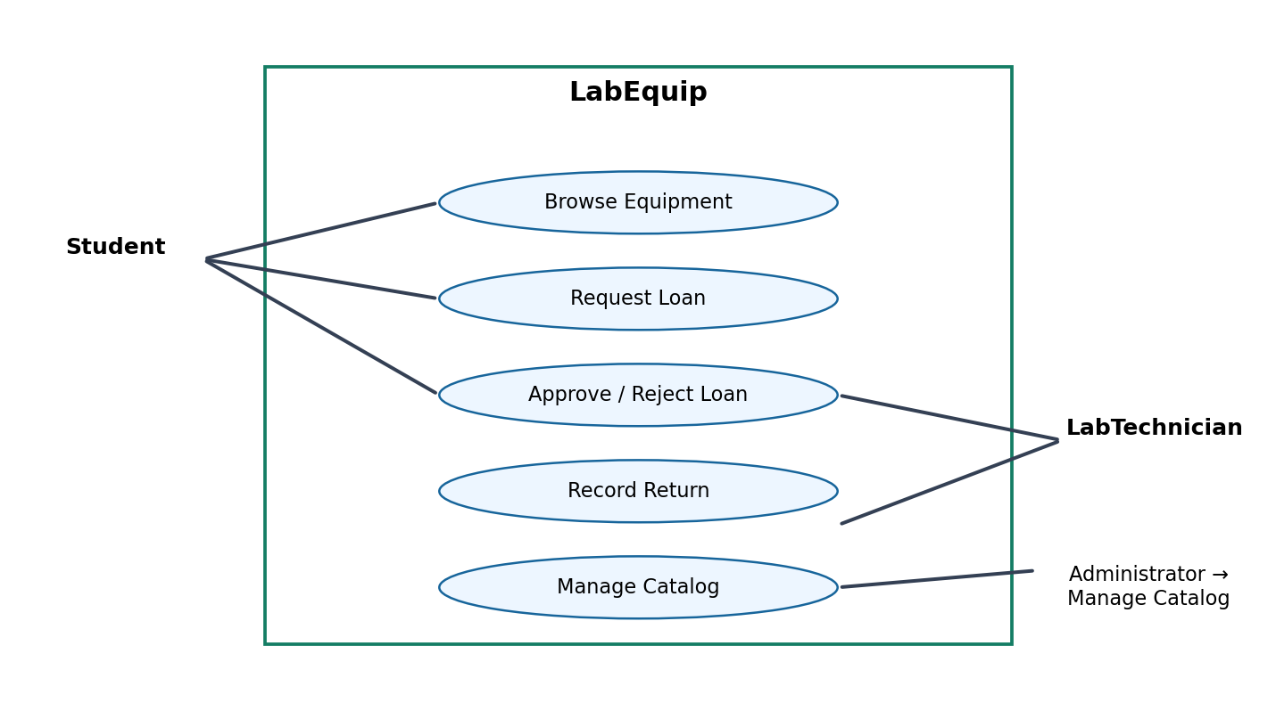

TASK 2 — Candidate Domain Classes [5 points] [CLO 8 · SO-2: 5 pts]
Identify five essential candidate domain classes and briefly describe each responsibility. Avoid UI widgets, database tables, and implementation-only utilities. You may refine or extend these classes in Task 3.
Candidate-class rubric |  |  | Points
Five appropriate domain classes (0.6 each) and correct responsibilities (0.4 each) |  |  | 5
# | Class Name | Responsibility
1 | EquipmentCategory | Groups related equipment items.
2 | EquipmentItem | Represents a unique lendable item.
3 | Loan | Tracks student, item, dates and loan status.
4 | Student | Requests and receives equipment loans.
5 | InspectionRecord | Records an item inspection on return.
TASK 3 — UML Class Diagram [20 points] [CLO 10 · SO-2: 20 pts]
Draw a conceptual UML Class Diagram (Compact View) for the LabEquip system based on the given scenario.
Attributes and operations are NOT required. You may refine or extend the candidate classes from Task 2. Your diagram must include:
(a) At least five relevant domain classes, represented by class names only.
(b) Correct associations between the identified classes.
(c) Appropriate UML relationship types, such as association, generalization, aggregation, or composition, where justified.
(d) Correct multiplicities at both ends of each association.
Class diagram rubric — detailed | Points
Identification of at least five appropriate domain classes | 5
Correct associations between classes | 5
Appropriate relationship types and UML notation | 4
Correct multiplicities at both ends of associations | 5
Overall diagram clarity and readability | 1
TOTAL | 20

DRAWING SPACE — CLASS DIAGRAM
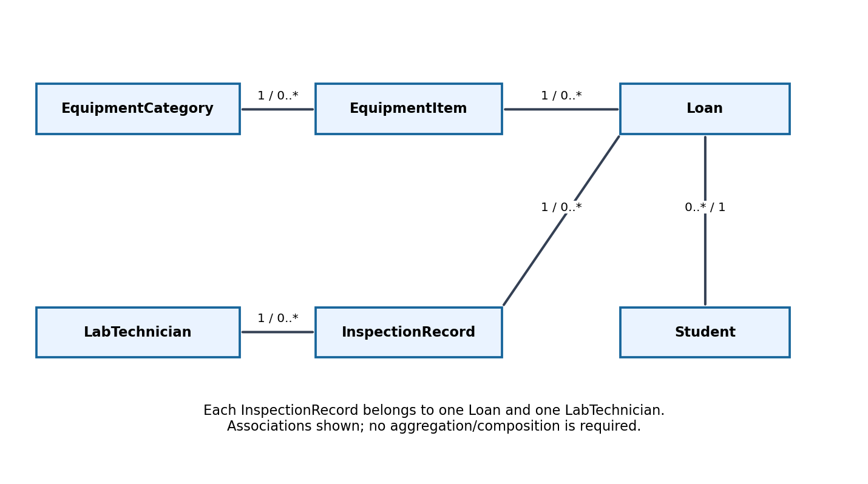

The End of The Exam

