‎**Embedded Algorithm Program**

1- Input any text plan file name and the correct root. In this example, we use a text ‎file named “Little Red Riding Hood.txt.” We download it from the internet and ‎put it in the same Python project root.‎

‎2- Input any text cover file name and root to create it in the specific root. We use ‎‎“output.txt”, which will be created in the same Python project root.‎

‎3- Input the secret message. You can put any message containing characters, ‎numbers, and samples in this example; we input “hi” as a secret message.‎

‎4- Press the “HIDING” button to start the embedding algorithm. ‎

‎5- When the embedding algorithm finishes the processing, the message will show ‎‎“YOUR SECRET MESSAGE WAS HIDDEN SUCCESSFULLY”.

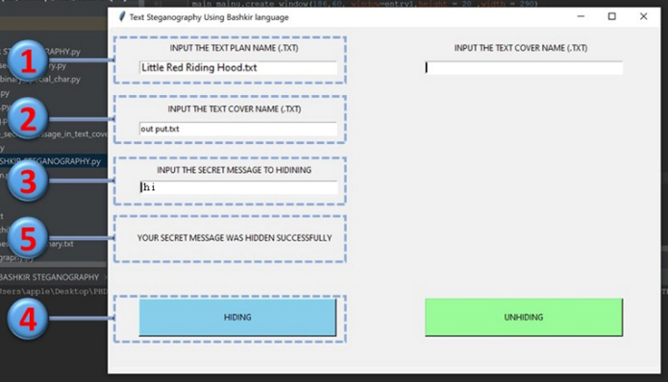

**Unembedded Algorithm Program**

‎1- Input the cover text name and root. In this example, we use the same file name ‎and root we created before “output.txt” and the root in the same Python object ‎directory.‎

‎2- Press the “UNHIDING” button to start the extraction algorithm. ‎

‎3- When the extraction algorithm finishes the secret message will appear in this dia-‎logue box.‎

