**Compare two cities (Hama and Homs) ‘neighborhood**

**By Mohammad askar MD,MSC,PhD, Syria**

**Introduction:**

**Syria has multi culture history and is considered one of the most adorable place to be visited by tourist. It has 14 cities. Both Hama and Homs locate in the middle of the country and can be good option as main residency place for tourist who can go to all other cities easily. Which one more suitable to you as Tourist?**

**The aim of this project to discover the similarity and difference of two cities regarding Neighborhoods.**

**We will collect information about Neighborhood of each city (Name of Neighborhood, Venues, Location) and the cluster them and study the results.**

**Data Collection and Curation:**

**Unfortunately, Syria doesn’t have formal source for information to depend on it. So I scrap the required data from internet.**

**Data collected from the following sources:**

* **Names of Neighborhood: wikiwand.com**
* **Geographic location: wikimapia.org**
* **Venues: Foursquare API**
* **Final data frame contains: City, Neighborhood, Ten most common venues (within 500-meter radius)**

**Data Analysis and Visualization:**

**Maps show the Neighborhood in both cities. We notice that there are many of Neighborhoods. On the following section we will try to cluster them according to similarity in venues which may be important for tourist.**

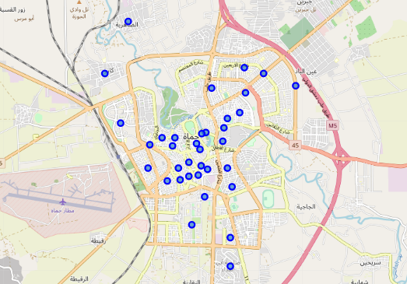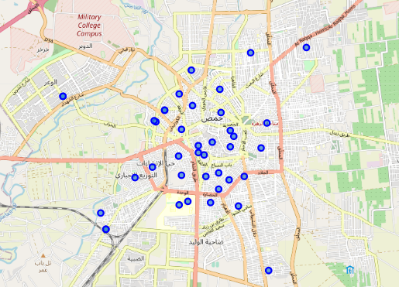

**Figure 1 Hama & Homs maps**

**After scraping the data of cities from wikiwand and wikimapia to get the name of Neighborhood and geo location, we use foursquare api to get venues in each Neighborhood and sort them according to frequency (10 most common in each Neighborhood). All data from the two cities are used to build predictive model.**

**Predictive Models:**

**We use k-means to cluster the Neighborhood regarding venues within 500 meter.**

**Elbow technique used to determine the number of cluster (k=5).**

**Then we retrain the K-means using k=5 and redraw the result om map using Folium.**

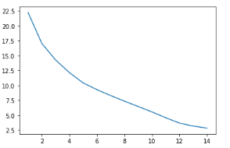

**Figure 1 error curve for trained models regarding K**

**Results and Discussion:**

**Following maps show the results and comparing between the two cities**

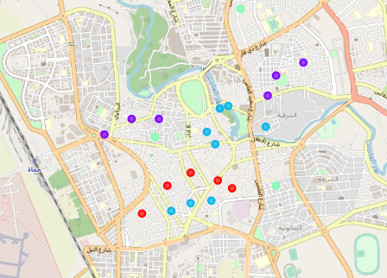 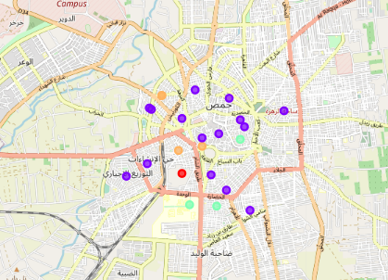

**Figure 3 Hama & Homs maps**

**Red cluster: Neighborhood with Hotel, Supermarket, and bar which may be suitable for residency of tourist**

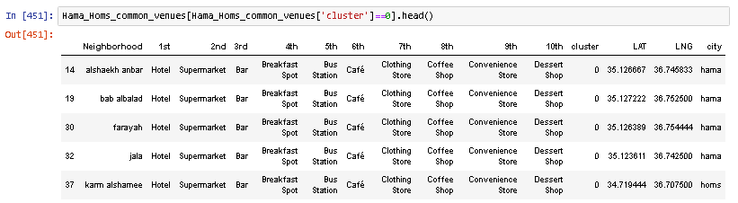

**purple cluster: Neighborhood with Bakery, Restaurant, and Café which may be suitable for out-going (shopping mainly, eating, Drinking)**

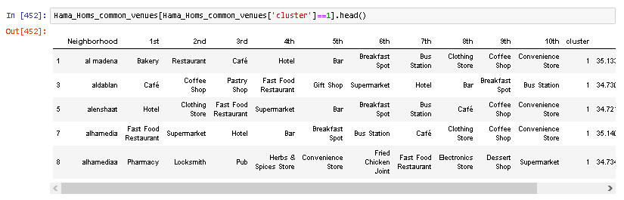

**Dark cyan cluster: Neighborhood with Hotel and Dessert shop which is unique for Hama and may be suitable for tourist who like dessert**

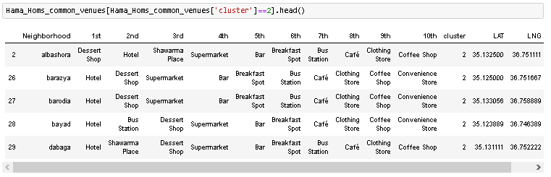

**Light cyan cluster: Neighbourhood with restaurant and markets (supermarket, market, or bakery) which may be suitable for outgoing   
(eating mainly and shopping)**

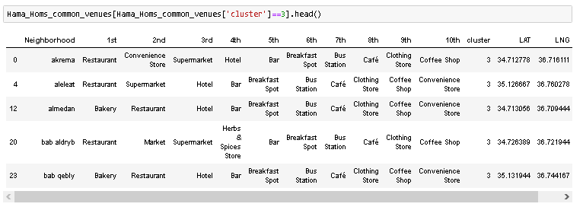

**Beige cluster: Neighbourhood with Pastry Shop mainly which is unique for Homs and may be suitable for who like Pastry.**

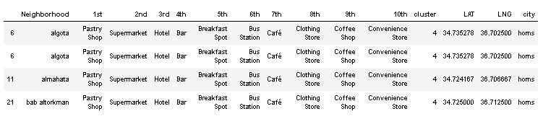

**Conclusion:**

**From the previous results we can conclude that:**

* **Hama has more common Neighborhood which may be suitable for tourist’s accommodation**
* **Homs has more suitable Neighborhood for out-going (shopping mainly)**
* **Both of them have few Neighborhood for out-going (eating mainly)**
* **Hama is famous for dessert shops whereas Homs is famous for pastry shops**

**References:**

* [1] Wikiwand
* [2] [Wikimapia](https://geo.nyu.edu/catalog/stanford-nj696zj1674" \t "_blank)
* [3] [Forsquare API](https://developer.foursquare.com/" \t "_blank)
* [4] Python 3.6 and Sklearn
* [5] [Folium](https://www.google.com/maps/)