Cloud Identity & Access Management (IAM) Lab with Microsoft Entra ID

Overview
This project demonstrates the implementation of a cloud-based Identity & Access Management (IAM) environment using Microsoft Entra ID (formerly Azure Active Directory).
The lab was designed to simulate real-world IAM operations including identity administration, Role-Based Access Control (RBAC), Joiner-Mover-Leaver (JML) lifecycle management, access reviews, audit monitoring, privileged access management, and authentication governance.
The goal was to gain hands-on experience with cloud identity management while documenting IAM processes using enterprise-style standards.

Architecture Diagram
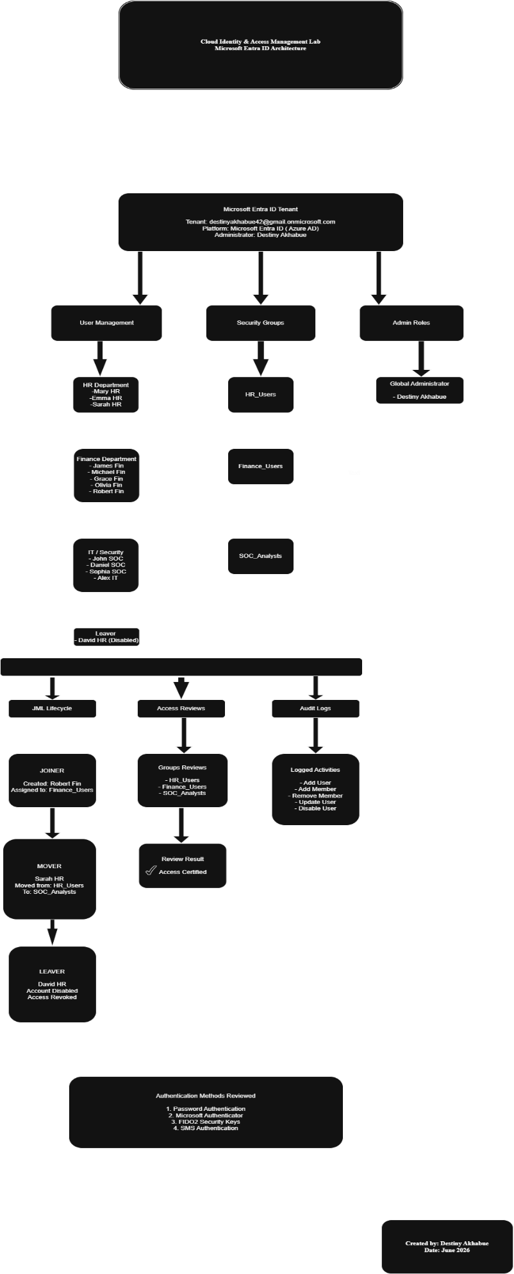

Lab Environment
Component | Details
Platform | Microsoft Entra ID
Environment Type | Cloud IAM Lab
Identity Provider | Microsoft Entra ID
Administrative Role | Global Administrator
Access Model | Role-Based Access Control (RBAC)
Departments Simulated | HR, Finance, SOC, IT

Key IAM Capabilities Demonstrated

Identity Administration
- User provisioning
- User modification
- User deprovisioning
- Group membership management

Role Based Access Control (RBAC)
- Department-based security groups
- Group-based access assignments
- Least privilege implementation
- Access segregation

Joiner-Mover-Leaver (JML)
- New user onboarding
- Role change management
- User offboarding
- Access revocation

Identity Governance
- Access reviews
- Access certification
- Membership validation
- Governance controls

Audit & Compliance
- Audit log monitoring
- Administrative activity tracking
- Identity lifecycle auditing
- Governance visibility

Authentication & Security
- Authentication methods review
- Multi-Factor Authentication (MFA) concepts
- Passwordless authentication concepts
- Privileged access security

Project Components

Architecture
Designed and documented a Microsoft Entra ID architecture illustrating users, departments, security groups, RBAC assignments, administrative roles, and governance controls.

User Management
Created and managed users representing multiple business departments while maintaining structured identity administration practices.

RBAC Implementation
Implemented Role-Based Access Control using Microsoft Entra ID security groups to simplify access management and support least privilege principles.

JML Lifecycle Management
Simulated Joiner-Mover-Leaver processes to demonstrate user provisioning, role transitions, and secure offboarding procedures.

Access Reviews
Performed access validation activities to ensure group memberships remained aligned with business requirements.

Audit Monitoring
Reviewed Microsoft Entra ID audit logs to verify administrative actions and identity lifecycle events.

Administrative Roles
Reviewed privileged role assignments and administrative access management concepts.

Authentication Methods
Explored available authentication methods and identity protection capabilities within Microsoft Entra ID.

Repository Structure
Cloud-IAM-EntraID-Lab

├── README.md

├── Architecture
│ ├── EntraID-Architecture-Diagram.drawio
│ └── EntraID-Architecture-Diagram.png

├── Screenshots
│ ├── 01-TenantSetup
│ ├── 02-UserManagement
│ ├── 03-RBAC
│ ├── 04-JML
│ ├── 05-AccessReviews
│ ├── 06-AuditLogs
│ ├── 07-AdminRoles
│ └── 08-AuthenticationMethods

├── Documentation

└── Lessons-Learned

Skills Demonstrated
- Identity & Access Management (IAM)
- Microsoft Entra ID Administration
- Role Based Access Control (RBAC)
- Identity Governance & Administration (IGA)
- User Provisioning & Deprovisioning
- Joiner-Mover-Leaver (JML)
- Access Reviews
- Audit Log Analysis
- Authentication Management
- Privileged Access Concepts
- Security Documentation
- Technical Documentation

Key Takeaways
This project provided practical experience implementing cloud IAM concepts within Microsoft Entra ID and strengthened my understanding of identity governance, access management, authentication security, auditability, and lifecycle management within modern enterprise environments.

Author
Destiny Akhabue
Aspiring Identity & Access Management (IAM) Professional
Focused on Identity Governance, Access Management, Microsoft Entra ID, Active Directory, and Cybersecurity.

