LaCantina
Architecture

Authors: D.Ritz, S.Freihofer
State: Draft
Revision 2010-12-11

Table Of Contents
0.Table Of Contents 2
1.Introduction 3
1.1.Purpose 3
1.2.Scope 3
1.3.Definition, Acronyms and Abbreviations 3
1.4.Referenced Documents 3
2.General 4
2.1.Apache Struts 4
2.1.1.Templates 5
3.Security 6
3.1.Overview 6
3.2.Implementation and function 6
3.3.security-config.xml 6
3.4.Configuration in web.xml 7
4.Database 8
4.1.Schema 8
4.1.1.Description 8
4.1.1.1.Table “users” 8
4.1.1.2.Table “winecellars” 8
4.1.1.3.Table “wines” 9
4.1.1.4.Table “wine_years” 9
4.2.Database interaction 9
4.2.1.Database connection 9
4.2.2.Database access 10
4.2.2.1.Structure, interfaces and classes 10
4.2.3.Typical usage pattern 11
5.Testing 12
5.1.Unit testing 12
5.1.1.Problems 12
5.2.Code coverage 13

Introduction

Purpose
This document describes the requirements and the architecture for the HSZ-T project "LaCantina".

Scope
This document describes the general overview what each component does, responsibility of each component and design thoughts. It does not describe unimportant API details that are documented in JavaDoc.
This document is changed and updated regularly as the application evolves.

Definition, Acronyms and Abbreviations
This table should provide the definition of all terms, acronyms and abbreviations required to interpret the requirements specification.
Expression | Definition
maven | Apache Maven (http://maven.apache.org/) is a build and deployment tool.
git | Git (http://www.git-scm.com/) the one and only version control system

Referenced Documents
The following table represents a list of all referenced documents.
Ref. | Document | Edition

General
The application is uses the following technologies/components:
- Java
- Web framework: Apache Struts 1.3.x
- Database: MySQL 5.x with InnoDB tables
- Servlet container: Tomcat 6
- Testing: JUnit 4, Mockrunner 0.4.2

Apache Struts
Since the application is based on Apache Struts, it follows the MVC design patterns used in Struts. The MVC components are basically the following:
- ActionForms
- Actions
- JSPs
- Additional beans and DAO components
The following picture shows a rough overview of components in a Struts application:
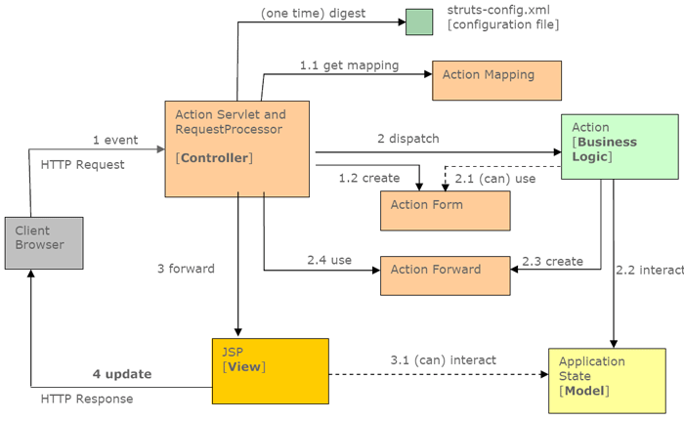Illustration 1: Struts component overview
The following sequence diagram shows the basic interactions in Struts applications:
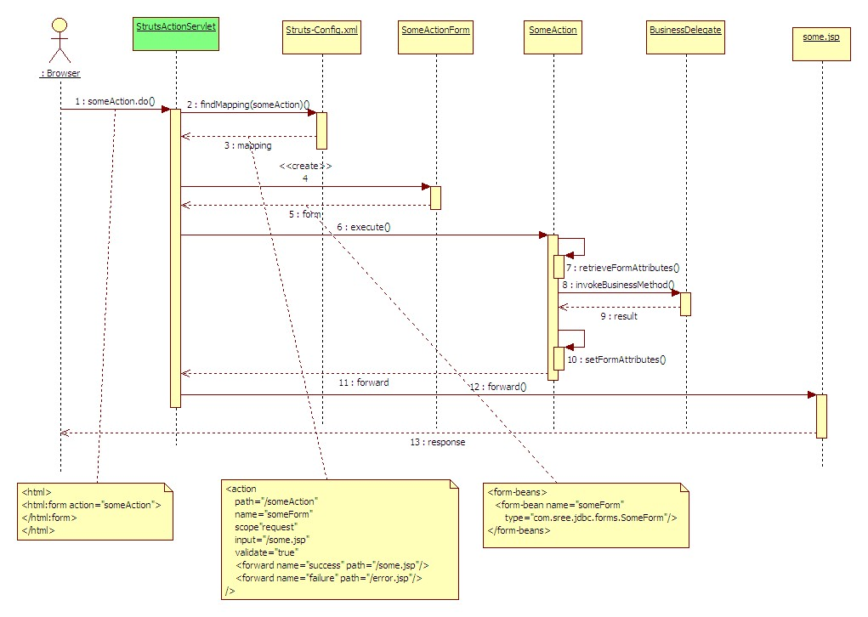Illustration 2: Struts sequence diagram
For more information on how Struts work and Struts applications are built, refer to the Struts documentation under http://struts.apache.org/

Templates
The application uses the Struts templating engine Struts-Tiles. The layout is based on a single template where the body part is inserted on the fly. This allows keeping each JSP to minimum which increases maintainability.
The tiles (templates) are defined in WEB-INF/struts-tiles.xml

Security

Overview
Security is entirely based on Servlet Filters, not Container based authentication and authorization. Not using container based security has the following reasons:
- Requires additional configuration in the servlet container. Configuration required in the container should be kept to an absolute minimum.
- Configuration of the security in the servlet container is not portable among different implementations (config is different from Tomcat to Jetty)
- Filter based security is very extensible, for example using a single sign on infrastructure

Implementation and function
The implementation is largely imported from another project into the name space of LaCantina. The filter bases security system consists of the following components:
- SecConfig
This holds the configuration loaded from an XML file configured via web.xml
- SecManager
This manages the security configuration, the session and offers helper functions to parse requests and redirect to either a login, a deny or the home page.
- SecFilter
This is an implementation of the javax.servlet.Filter API. It uses SecManager and SecConfig to filter each request. For each request, the URL is matched against the security config to check if a login is required for the specified address or if admin privileges are required. Based on these checks, the request is passed on to the next filter in the chain, or a redirect to the appropriate page is generated.
- SessionToken
The session token hold a minimal set of the current user. This is currently the login name, the user ID and a flag indicating if the user has admin privileges.
- security-config.xml
This files configures the filtering
- configuration in web.xml
The filter is setup in this file

security-config.xml
The file security-config.xml holds the configuration for the SecFilter. It has the following sections:
<default-constraint>
<login>required</login>
</default-constraint>
This defines if a login is required globally. If set to “required”, URLs that do not require a login need to be configured separately.

<constraint>
<url-pattern>/admin/.*</url-pattern>
<privilege>admin</privilege>
<login>required</login>
</constraint>
The “constraint” section can be repeated as many times as required. It defines one ore more URL pattern (standard Java regular expressions), A required level of privilege (optional), and if a login is required (optional). If no login is required, set to “none”.

<!-- redirectors. can be overridden in code -->
<redirectors>
<!-- the local login form -->
<login-url>/login.jsp</login-url>

<!-- access denied message when already logged in -->
<deny-url>/deny.do</deny-url>

<!-- the start point once logged in -->
<home-url>/home.do</home-url>
</redirectors>
Self-explanatory.

<!-- user authentication class -->
<user-auth>
<class>ch.sfdr.lacantina.security.UserAuth</class>
</user-auth>
The class used to authenticate users. This class must implement IUserAuth and is only instantiated once.

Configuration in web.xml
For the filter bases security to work, it must be configured in web.xml. This configures the Filter and the location of security-config.xml:
<!-- security is done via filtering. -->
<context-param>
<param-name>security-config</param-name>
<param-value>/WEB-INF/security-config.xml</param-value>
</context-param>
<filter>
<filter-name>SecFilter</filter-name>
<filter-class>
ch.sfdr.common.security.SecFilter
</filter-class>
</filter>
<filter-mapping>
<filter-name>SecFilter</filter-name>
<url-pattern>/*</url-pattern>
</filter-mapping>

Database
The following database schema is by no means complete. It's a first rough draft that will change while the features are implemented. New attributes will be added, maybe some new tables too. It's a starting point to have something to work with.

Schema
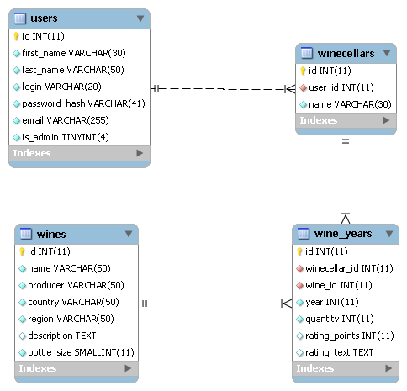Illustration 3: Database schema.

Description

Table “users”
This table contains all users with the usual data like first name, last name, email address. The password is saves as a SHA-1 hash. A flag indicates if a user has administrative privileges.

Table “winecellars”
A wine cellar of a user. Each user can have more that one wine cellar even tough it might not me used all that much in practice.

Table “wines”
A list of wines with name, producer, etc.

Table “wine_years”
The content of a wine cellar, based on the vintage/year of a wine. References a wine cellar and a wine, holds the number of bottles available. Also contains an optional rating and a rating description.

Database interaction
Database interaction is (obviously) done with JDBC.

Database connection
The database connection is configured at Tomcat level as a JNDI resource. The connection parameters are configured in Tomcat's context.xml as follows:
<Resource name="jdbc/LaCantinaDB" auth="Container"
type="javax.sql.DataSource" maxActive="100" maxIdle="30"
maxWait="10000" validationQuery="SELECT 1;"
username="user" password="pass"
driverClassName="com.mysql.jdbc.Driver"
url="jdbc:mysql://localhost:3306/lacantina"
removeAbandoned="true" removeAbandonedTimeout="60"
logAbandoned="true"
/>
The JNDI name is “jdbc/LaCantinaDB”. This is also configured in web.xml and hard coded in DBConnection.java.
To retrieve the DataSource, the main database connection class “DBConnection” does a JDNI lookup through an InitialContext.

Database access
Access to the database is implemented using the DAO pattern.

Structure, interfaces and classes
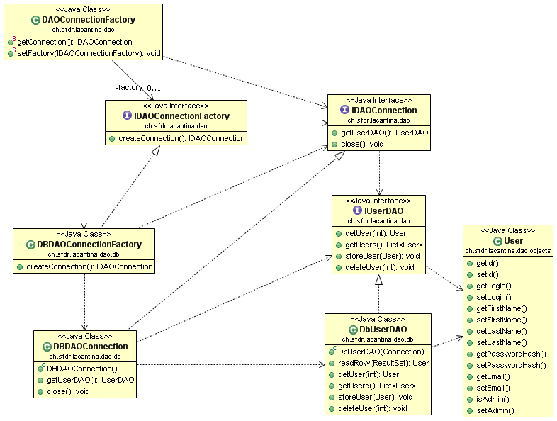Illustration 4: DAO class diagram with User DAO as example
Objects
Objects represent the data read from and written to the database. Those are simple Java Beans with no additional logic. Eg. the class User holds data about a user like first name, last name, login, email, etc.
I*DAO and Db*DAO
DAOs are the Data Access Objects. For each type of object, there is an interface defining the methods on how to read and write the objects. For each of those interfaces a concrete implementation using JDBC calls exists.
IDAOConnection and DBDAOConnection
The interface IDAOConnection represents a connection to a data source. It defines a getter for each of the different DAOs and a close() method. An instance of IDAOConnection is connected to the data source until close() is called.
DBDAOConnection is a concrete implementation using a JDBC connection. The DAOs returned by this are Db*DAOs.
IDAOConnectionFactory and DBDAOConnectionFactory
IDAOConnectionFactory defines a single method createConnection() which returns a IDAOConnection, connected to the data source. DBDAOConnection is a concrete implementation returning a DBDAOConnection.
DAOConnectionFactory
DAOConnectionFactory provides a static method returning an IDAOConnection, connected to the data source. The default implementation returned is DBDAOConnection. A static setter is provided to set the IDAOConnectionFactory used to create the connection. This allows easy mocking.

Typical usage pattern
A typical usage patter looks like this:
IDAOConnection conn = DAOConnectionFactory.getConnection();
try {
IUserDAO dao = conn.getUserDAO();
...
dao.storeUser(form.getUser());
...
List<User> userList = dao.getUsers();
...
} finally {
conn.close();
}

This pattern with the try-finally ensures that the DB connection is always closed. Once a IDAOConnection is retrieved it can be used to get one or more DAOs to perform various operations, all using the same DB connection.

Testing

Unit testing
Testing is done with JUnit4 unit tests. To be able to test the javax.servlet.* interfacing components, JDBC accesses and Apache Struts components, the testing framework “Mockrunner” is used which allows to mock these components:
- javax.servlet.*:
- ServletContext
- HttpServletRequest
- HttpServletResonse
- FilterChain
- ...
- java.sql.*
- DataSource
- Connection
- Statement/PreparedStatement
- ResultSet
- org.apache.struts.*
- ActionMapping
- ActionErrors
- ActionServlet
- ...

Problems
Not everything can be mocked, or at least no easily. For this reason not everything is tested with unit tests. This mainly includes the following: JNDI resource lookups.
For this reason, DBConnection.java has two different ways of how to retrieve the DataSource:
- JNDI lookup when running in the container
- A static setter that can be used to define a global DataSource. This is used in the unit tests to provide a mocked DataSource

Code coverage
As a quality measurement of the unit tests, code coverage is an important indicator on how well the tests are written. While missing “asserts” in the test cases can let bugs slip through unnoticed, code that has no coverage at all is more likely to fail.

To test code coverage, two different coverage tools are used to run the unit tests:
- EclEmma with EMMA as back-end in Eclipse
- Cobertura from the ant build process to produce HTML reports

The reason to use different tools is simple: Cobertura generates the better coverage reports, while lacking an Eclipse plugin, EclEmma is very simple to operate in Eclipse.

