LaCantina
Processes and work flows

Authors: D.Ritz
State: Released
Revision 2010-12-01

Table Of Contents
1.Table Of Contents 2
2.Introduction 3
2.1.Purpose 3
2.2.Scope 3
2.3.Definition, Acronyms and Abbreviations 3
2.4.Referenced Documents 3
3.Repositories 4
3.1.Repositories and relationships 4
3.1.1.Master 4
3.1.2.Personal shared 4
3.1.3.Personal private 4
3.1.4.Relationships 5
4.Rules 6
4.1.Change sets/commits 6
4.1.1.One Change At A Time 6
4.1.2.Proper Use Of Change Sets 6
4.1.3.Don't break the build 6
4.1.4.Change log and author information 6
4.1.5.Don't commit generated files 6
4.1.6.Coding conventions 6
4.2.Branching 7
4.3.Implementing a feature 7
4.4.API changes 7
5.Tracking 8
5.1.Features 8
5.2.Outstanding documentation updates 8
5.3.Bug reports 8
5.4.Change requests 8
6.Work flows 9
6.1.Making a change 9
6.1.1.Purpose 10
6.1.2.Activities 10
6.1.2.1.Pull latest code 10
6.1.2.2.Create Topic Branch 10
6.1.2.3.Implement changes 10
6.1.2.4.Run Tests 10
6.1.2.5.Push changes 10
6.1.2.6.Notify integrator 11
6.1.2.7.Pull changes 11
6.1.2.8.Review changes 11
6.1.2.9.Merge topic branch into development branch 11
6.1.2.10.Push result to Master repository 11
6.1.2.11.Notify project team of change 12
6.1.2.12.Notify developer of failed review 12
6.1.2.13.Resolve problems 12
7.git Setup 13
7.1.Name and e-mail address 13
7.2.Correct line endings 13

Introduction

Purpose
This document describes the processes and work flows used for the HSZ-T project "LaCantina". This is basically an almost unmodified version of a the same document of a previous project (define something once and stick to it)

Scope
This document describes the processes and work flows used in the project. The processes describes how people work together, how the project evolves and how quality is assured. The processes are designed around the "git" distributed version control system.

Definition, Acronyms and Abbreviations
This table should provide the definition of all terms, acronyms and abbreviations required to interpret the requirements specification.
Expression | Definition
git | A powerful distributed version control system, open source. See  http://www.git-scm.com/

Referenced Documents
The following table represents a list of all referenced documents.
Ref. | Document | Edition

Repositories

Repositories and relationships

Master
The Master repository contains all official code of a project. Official code is considered the code from which any release is built. Only selected people are allowed to commit code to this repository.

Personal shared
The Personal Shared repository is owned by a particular developer and is used to make his/her changes accessible to other members of the project.
All changes implemented by a developer will be staged in the Personal Shared repository from which they can be retrieved and be integrated into the code living in the Master repository.
The Personal Shared repository must be on a server that is accessible to all team members.

Personal private
Personal Private repositories are owned and used each one by a single developer. They are used by their owner to do actual implementation work. A developer is free to maintain any number of Personal Private repositories and they can be stored on any arbitrary computer without having to provide access to anyone else than the owner.

Relationships
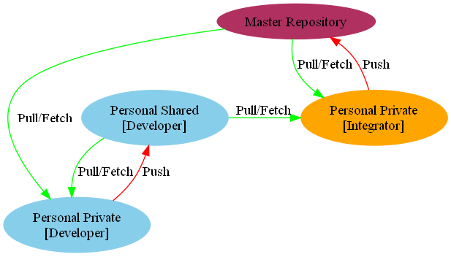Illustration 1: Repositories
- Developers pull/fetch from the Master into their Personal Private
- Developers push their Personal Private to their Personal Shared
- The Integrator pulls/fetches from a developers Personal Shared, merges and pushes to the Master

Rules

Change sets/commits
Following is a set of rules each change set (or "commit" in git terms) must meet.

One Change At A Time
Each time one or more changes are needed to be implemented, it is important that they be implemented independent of each other. More precisely, they have to be committed to the repository independent of each other. The purpose of this strict separation is to avoid confusion by committing two or more unrelated changes. If unrelated changes are committed together it is much more complicated to undo a change, in particular if only one of these unrelated changes has to be undone.
Committing unrelated changes at the same time will also make review processes and later understanding of what has changed at which time for what reason much more complicated.

Proper Use Of Change Sets
Changes in multiple files that logically belong together must be committed to the repository together in the same change set. By doing so it is ensured that either all changes are applied or none of them. In contrast, committing on a file-by-file basis might leave the repository in an inconsistent state as some files might fail to be committed because concurrent changes have been made; The repository should never be in an inconsistent state at any given time.

Don't break the build
A change set should not break the build. If the build process was working properly before applying the change set, it must continue to work after applying the changes.

Change log and author information
Any change that is committed to the repository must be accompanied by a change log message that explains what was changed and, if possible, why. Empty change log messages must be avoided. The first line of a change log message is a summary, a detailed description follows the summary.

Don't commit generated files
A change set must not add files that are generated by the build process. Such files do not contain any information worth tracking.

Coding conventions
Code added or changed by a change set must meet the requirements of the coding conventions.

Branching
Whenever a Developer is working on a particular piece of code, this work will be done in a topic branch. A topic branch is usually created of the Master branch in order to allow a developer work on his/her code in a stable environment. Once the feature is complete and has been reviewed it will be merged back into the development branch by the Integrator.

Implementing a feature
When implementing a feature, it can consist of multiple small change sets. These have all to follow the change set rules. The change sets split logically into one of these categories;
- API changes
- New infrastructure
- The new feature itself, can also be split into small logical pieces.
- Bug fix
- Optimization

API changes
Often during implementing a change, it is also necessary to change an existing API that has other users already. These steps should be followed when doing such an API change.
- Extend/change the API signature as required (ie. add a new argument to a method). The behavior should remain unchanged
- Change all callers as necessary
- Commit as a single change set
- Implement the changed behavior
- Commit as a single change set
- Add users of the new/changed API
- Commit in logical steps.
When doing the commit in step 3, the behavior of the software should still be unchanged, no regressions should be added by these steps.
This tries to ensure that changes are done in small logical steps, ease of review and ease of tracking regressions.

Tracking
The followings things are tracked in the web-based tracking tool Redmine. Since Scrum is used as an agile process, all these things are Tasks assigned to a User Story. User Stories are handled within a Sprint (=Iteration).

Features
All features as described in the specification are tracked. All features result in one or more change sets.

Outstanding documentation updates
All required updates to any documentation files are tracked.

Bug reports
When bugs are found in the software or in the documentation, a bug report is opened. The developer responsible for the file in question will be assigned to resolve the problem.

Change requests
Request for changes in look & feel, behavior, API, etc. are tracked. The request describes what should be changed, why it should be changed and how.

Work flows

Making a change
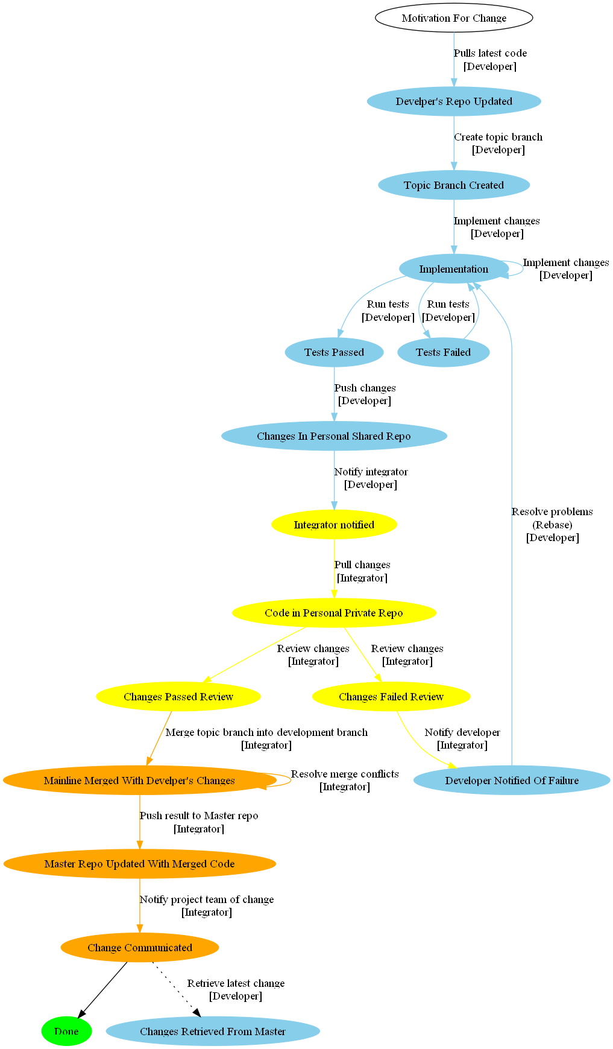Illustration 2: Change process

Purpose
This process applies whenever a change should be made. This includes features, documentation, cleanup, bug fixes, etc

Activities

Pull latest code
Description | The latest code from the master branch is pulled into the developer's repository. Developer is working on up-to-date code this way.
Actor | Developer
Entry conditions | A Ticket in the tracking system exists, the developer is assignee.
Exit conditions | Developers private repository updated

Create Topic Branch
Description | A topic branch is created of the master branch. All work will happen only on the topic branch
Actor | Developer
Entry conditions | Local master branch updated to latest state.
Exit conditions | Topic branch created

Implement changes
Description | Changes are being implemented.
Actor | Developer
Entry conditions | Switched to the newly created topic branch
Exit conditions | Requested changes are implemented

Run Tests
Description | Test, including Unit tests are run.
Actor | Developer
Entry conditions | Changes are implemented
Exit conditions | Either:  - Tests run correctly. Next step is pushing the changes  - Tests fail. Back to implementation

Push changes
Description | The changes are pushed from the private to the shared repository
Actor | Developer
Entry conditions | Changes are implemented, tests pass.
Exit conditions | Tests are pushed to the shared repository and are available as a branch.

Notify integrator
Description | The integrator is notified that the changes are implemented, pushed and are ready for merging. The ticket in the tracker is updated with a comment, the state set to "resolved". The name of the branch must be part of the notification message.
Actor | Developer
Entry conditions | Changes are pushed.
Exit conditions | Integrator is notified

Pull changes
Description | The integrator pulls the changes into a private repository for review and possible merging.
Actor | Integrator
Entry conditions | Notification from developer received.
Exit conditions | Changes are available in the integrator's local repository.

Review changes
Description | The changes are reviewed for technical correctness, if the rules are followed, etc.
Actor | Integrator
Entry conditions | Changes are available in a branch in the local repository.
Exit conditions | Either:  - Review passes. Next is merging topic branch  - Review fails. Next is notify developer

Merge topic branch into development branch
Description | The changes from the developer's topic branch are merged into the development branch, possible merge conflicts are resolved.
Actor | Integrator
Entry conditions | Changes pass review
Exit conditions | Merge correctly finished.

Push result to Master repository
Description | The changes are pushed to the master repository. The ticket in the tracker is set from "resolved" to "closed".
Actor | Integrator
Entry conditions | Merge correctly finished.
Exit conditions | Changes pushed.

Notify project team of change
Description | The project team is notified about the update of the master repository.
Actor | Integrator
Entry conditions | Changes Pushed
Exit conditions | Notification sent

Notify developer of failed review
Description | The developer is notified about the problems. This notification points out what points need resolving. The ticket in the tracker is updated, set back to "assigned"
Actor | Integrator
Entry conditions | Review failed.
Exit conditions | Developer notified. Ticket updated.

Resolve problems
Description | The developers resolved the problems from the failed review. This possibly results in re-basing the changes in a new topic branch, resolving the problems of the change sets in question.
Actor | Developer
Entry conditions | Review failed, Developer notified.
Exit conditions | Problems resolved.

git Setup
Some points to ensure the "git" environment is set up properly.

Name and e-mail address
Since each commit must contain Name and e-mail address of the author, it is required to set up this correctly in git. To do so, two small git commands are necessary.
Note: The configuration can be done in "git gui" as well.
git config --global --add user.name <name>
git config --global --add user.email <email>

Correct line endings
git supports a feature that is called "autocrlf". This feature checks out files with Windows style line ending (\r\n) on Windows. It is turned on by default on Windows, but unfortunately it just causes problems not described here. It is required to turn it off and track files as they are. To do so, execute the following git command once:
git config --global --add core.autocrlf false

