**SUPPORTING INFORMATION**

**Elevation and leaf litter interact in determining the structure of ant communities on a tropical mountain**

Jimmy Moses\* 1, 2, 3, Tom M. Fayle2, 4, Vojtech Novotny1, 2, 3 and Petr Klimes2

1Faculty of Science, University of South Bohemia, Ceske Budejovice, Czech Republic

2Biology Centre of the Czech Academy of Sciences, Institute of Entomology, Ceske Budejovice, Czech Republic

3New Guinea Binatang Research Center, Madang, Papua New Guinea

4Institute for Tropical Biology and Conservation, Universiti Malaysia Sabah, Kota Kinabalu, Malaysia

\*Correspondence: Jimmy Moses, Biology Centre of the Czech Academy of Sciences, Institute of Entomology, Branisovska 1160/31, 370 05, Ceske Budejovice, Czech Republic. Email: j.moses0131@gmail.com

G:\mtWilhelmmap.tif

**Figure S1** Map of the research camp locations spaced by approximately 500 m a.s.l. elevational bands along the Mt. Wilhelm rainforest elevational gradient, Papua New Guinea. At each of the locations, 10 sites were sampled for the ants along a 560 m long transect (see Methods for details).

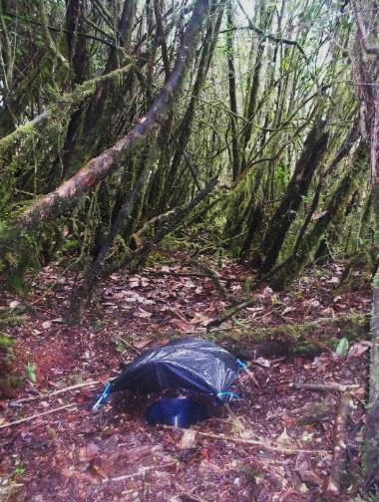

**Figure S2** The pitfall trap design used for this study. The photo shows one of the pitfall traps installed at 3,200 m a.s.l. location.

C:\Users\moses\Documents\WorkSpace\JMoses\PhDWorkfolder\Analyses_Projects\Jimmy\groundAntCom\mtW_groundAnts\doc\mns\Biotropica_Reviewers\Biotropica_Rws_FIGS_TABS\Figure_S3.tif

**Figure S3** Correlations between elevation, leaf litter depth and mean temperature. The first two variables were measured for each of 80 sites, while temperature was measured for each of the main eight locations (note 60 sites are analysed here as the two top locations without ants are excluded, see Methods). Elevation and average temperature were highly correlated with each other (Kendall’s correlation coefficient (Rτ) = 0.80, \*\*\* p < 0.001). However, compared to this relationship, correlation coefficients were low for elevation and litter depth (Rτ = -0.18), and leaf litter depth and mean temperature (Rτ = 0.13). Fitted lines are based on loess smoothing, using linear polynomial fitting (degree = 1).

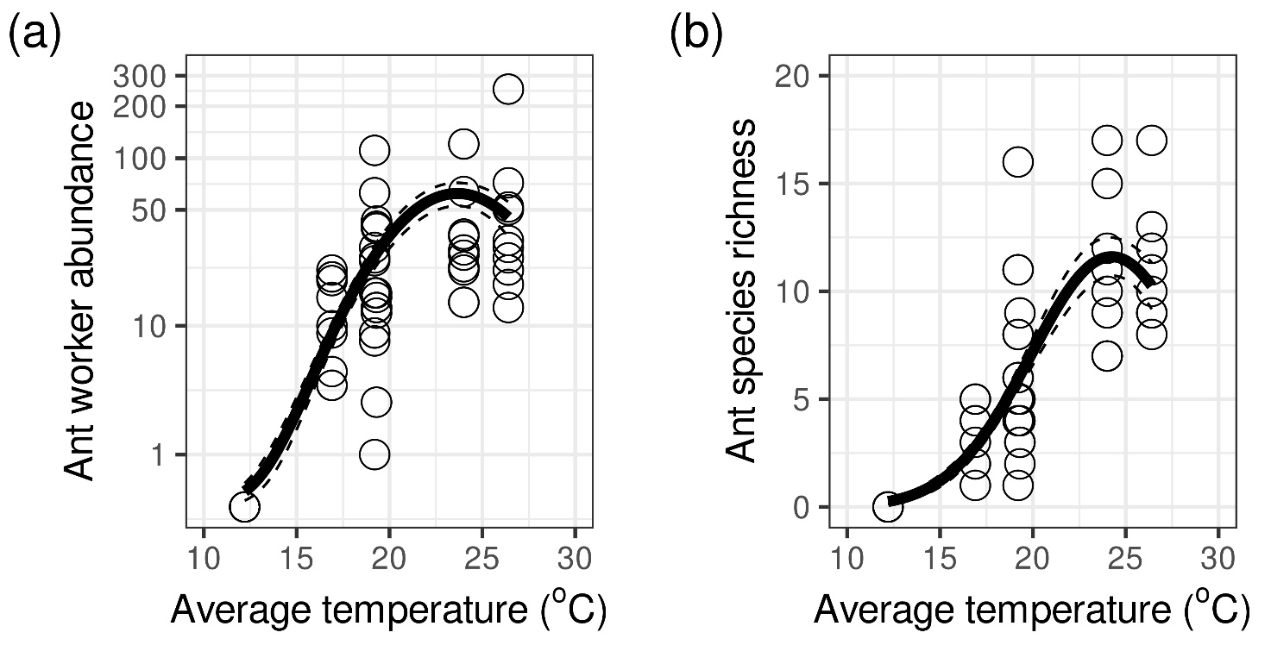

**Figure S4** Relationship between temperature and (a) ant worker abundance and (b) ant species richness. There was a significant effect of temperature on the both variables (abundance, χ2[2, 57], deviance = 98.91, p < 0.001; richness, χ2[2, 57], deviance = 157.73, p < 0.001). Curves were fitted according to GLM predictions (i.e. black lines, see Methods and Table S2) along with standard errors (dashed lines). Note that temperature measures are available only for the main locations from Figure S1. The top two locations without ants are excluded (see methods).

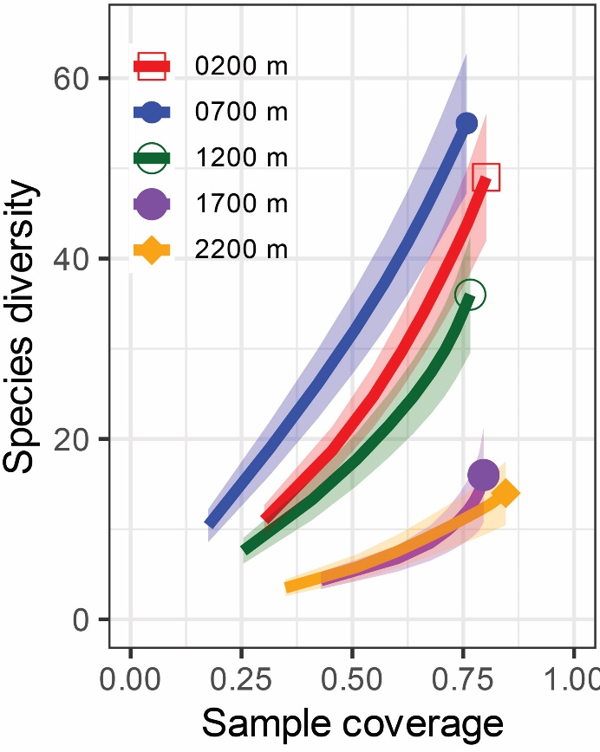

**Figure S5.** Coverage-based rarefaction curves of number of ant species with 95% confidence intervals (shaded areas, see Methods) for the five locations where ants were found on the Mt. Wilhelm elevational gradient.

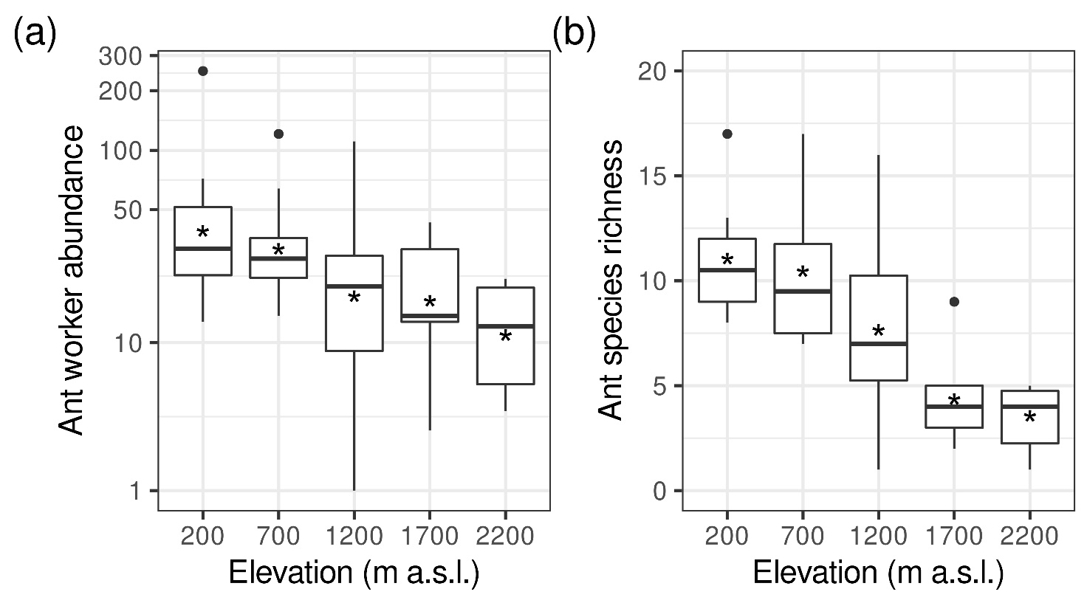

**Figure S6.** Box plots of the variation in ant worker abundance (a) and species richness (b) at the small geographic scale, within each of the main five locations (transects), where the ants occurred, ranked by increasing elevation (from Fig. S1). Horizontal lines represent medians and asterisks the means. Boxes represent the 1st and 3rd quartiles and the whiskers 1.5 times the interquartile range of the observations respectively.

**Table S1** The 118 ant species collected in the study (species codes, species names and total abundance of individuals collected). The species codes are plotted in the constrained ordination (Figure 5, CCA) assessing the simultaneous effects of elevation and leaf litter depth on ant species composition.

|  |  |  |  |
| --- | --- | --- | --- |
| **Code** | **Species Name** | **No workers** | **No sites** |
| ACRO001 | *Acropyga ambigua* Emery, 1922 | 2 | 1 |
| AENI003 | *Aenictus nesiotis* Wheeler & Chapman 1930 | 1 | 1 |
| ANCY001 | *Ancyridris* sp. nov. 1 aff. *polyrhachioides* Wheeler, 1935 | 51 | 9 |
| ANCY002 | *Ancyridris* sp. nov. 2 aff. *polyrhachioides* Wheeler, 1935 | 3 | 2 |
| ANCY003 | *Ancyridris* sp. 3 sp. nov. | 1 | 1 |
| ANON001 | *Anonychomyrma* cf. scrutator (Smith F., 1859) | 1 | 1 |
| ANON002 | *Anonychomyrma minuta* (Donisthorpe, 1943) | 1 | 1 |
| ANON003 | *Anonychomyrma dimorpha* (Viehmeyer, 1912) | 53 | 6 |
| ANON008 | *Anonychomyrma extensa* (Emery, 1887) | 2 | 1 |
| ANON009 | *Anonychomyrma* sp. 9 | 57 | 4 |
| ANON014 | *Anonychomyrma* sp. 14 aff. sp. 1 | 10 | 4 |
| ANOP001 | *Anoplolepis gracilipes* (Smith F., 1857) | 210 | 2 |
| APHA001 | *Aphaenogaster* sp. aff. *dromedaria* (Emery, 1900) | 10 | 6 |
| CAMP001 | *Colobopsis vitrea* (Smith F., 1860) | 3 | 3 |
| CAMP027 | *Camponotus* cf. *aureopilus* Viehmeyer, 1914 | 2 | 2 |
| CAMP030 | *Camponotus* *posteropilus* Shattuck, 2005 | 2 | 1 |
| CAMP034 | *Camponotus* *albocinctus* (Ashmead, 1905) | 2 | 1 |
| CARE007 | *Carebara* *melanocephala* Donisthorpe, 1948 | 121 | 14 |
| CERA003 | *Cerapachys* cf. *marginatus* Emery, 1897 | 1 | 1 |
| CREM003 | *Crematogaster polita* Smith F., 1865 | 27 | 3 |
| CREM005 | *Crematogaster flavitarsis* Emery, 1900 | 2 | 1 |
| CREM010 | *Crematogaster emeryi* Forel, 1907 | 3 | 2 |
| CREM014 | *Crematogaster* cf. *irritabilis* Smith, F., 1860 | 1 | 1 |
| CREM022 | *Crematogaster* sp. 22 aff. *Flavitarsis* | 1 | 1 |
| CRYP001 | *Cryptopone* sp. 1 | 1 | 1 |
| CRYP002 | *Cryptopone* sp. 2 | 4 | 3 |
| EURH001 | *Eurhopalothrix biroi* (Szabó, 1910) | 1 | 1 |
| GNAM001 | *Gnamptogenys* sp. 1 | 2 | 2 |
| HYPO002 | *Hypoponera* cf. *confinis* Roger, 1860 | 2 | 2 |
| HYPO003 | *Hypoponera sabrone* Donisthorpe, 1941 | 35 | 11 |
| HYPO006 | *Hypoponera* sp. 6 aff. *sp*. 3 | 1 | 1 |
| HYPO007 | *Hypoponera* sp. 7 aff. *sp*. 3 | 6 | 5 |
| LEPG002 | *Leptogenys breviceps* Viehmeyer, 1914 | 128 | 3 |
| LEPG003 | *Leptogenys drepanon* Wilson, 1958 | 2 | 2 |
| LEPM001 | *Leptomyrmex fragilis* (Smith F., 1859) | 5 | 4 |
| LEPM002 | *Leptomyrmex flavitarsus* (Smith, F., 1859) | 10 | 5 |
| LORD003 | *Lordomyrma cryptocera* Emery, 1897 | 2 | 1 |
| LORD004 | *Lordomyrma furcifera* Emery, 1897 | 1 | 1 |
| LORD005 | *Lordomyrma* sp. 5 | 5 | 1 |
| MAYR001 | *Mayriella sharpi* Shattuck & Barnett, 2007 | 4 | 1 |
| MERA001 | *Meranoplus* sp. 1 aff. *astericus* Donisthorpe, 1947 | 4 | 2 |
| MERA002 | *Meranoplus astericus* Donisthorpe, 1947 | 5 | 2 |
| MONO002 | *Monomorium intrudens* Smith F., 1894 | 1 | 1 |
| MONO004 | *Monomorium pharaonis* (Linnaeus 1758) | 2 | 2 |
| MYOP002 | *Myopias* sp*.* 2 | 4 | 4 |
| MYRM002 | *Myrmecina* cf. *brevicornis* Emery, 1897 | 1 | 1 |
| ODON001 | *Odontomachus simillimus* Smith F., 1858 | 12 | 9 |
| ODON003 | *Odontomachus* sp. 3 | 6 | 4 |
| ODON004 | *Odontomachus papuanus* Emery, 1887 | 6 | 4 |
| ODON006 | *Odontomachus* sp. 6 | 1 | 1 |
| OECO001 | *Oecophylla smaragdina* (Fabricius, 1775) | 3 | 3 |
| PACH002 | *Ectomomyrmex* cf. *aciculatus* (Emery, 1901) | 18 | 6 |
| PACH006 | *Brachyponera* *croceicornis* (Emery,1900) | 57 | 18 |
| PACH007 | *Mesoponera* *manni* (Viehmeyer, 1924) | 3 | 2 |
| PACH008 | *Mesoponera* *papuana* (Viehmeyer, 1914) | 1 | 1 |
| PARA005 | *Nylanderia* aff. *vaga* (Forel, 1901) | 12 | 7 |
| PARA006 | *Paraparatrechina* sp. 6 | 1 | 1 |
| PARA007 | *Nylanderia nuggeti* Donisthorpe, 1941 | 10 | 3 |
| PARA008 | *Nylanderia* sp. 8 | 2 | 1 |
| PARA011 | *Nylanderia* sp. 11 | 1 | 1 |
| PARA015 | *Nylanderia* sp. 15 | 2 | 1 |
| PHEI003 | *Pheidole fuscula* Emery, 1900 | 8 | 4 |
| PHEI004 | *Pheidole hospes* Smith, F. 1865 | 37 | 10 |
| PHEI005 | *Pheidole cervicornis* Emery, 1900 | 1 | 1 |
| PHEI006 | *Pheidole* sp. 6 | 8 | 1 |
| PHEI013 | *Pheidole* sp. 13 aff. *tricolor*, Donisthorpe, 1949 | 5 | 2 |
| PHEI015 | *Pheidole* sp. 15 "*bifurca* clade" | 3 | 1 |
| PHEI019 | *Pheidole* sp. 19 cf. *amplificata* Viehmeyer, 1914 | 17 | 11 |
| PHEI020 | *Pheidole* sp. 20 | 3 | 3 |
| PHEI025 | *Pheidole* sp. 25 aff. *sexspinosa biroi* Emery, 1900 | 12 | 2 |
| PHEI026 | *Pheidole* sp. 26 | 50 | 2 |
| PHEI028 | *Pheidole* sp. 28 | 5 | 3 |
| PHEI036 | *Pheidole* sp. 36 aff.sp. 31 | 6 | 2 |
| PHEI038 | *Pheidole* sp. 38 | 41 | 4 |
| PHEI042 | *Pheidole* sp. 42 "*bifurca* clade" | 15 | 3 |
| PHEI046 | *Pheidole amber* Donisthorpe, 1941 | 1 | 1 |
| PHEI051 | *Pheidole* sp. 51 aff. *distincta* Donisthorpe, 1943 | 1 | 1 |
| PHEI052 | *Pheidole* sp*.* 52 | 5 | 3 |
| PHEI054 | *Pheidole* sp. 54 aff. sp. 3 group | 1 | 1 |
| PHEI055 | *Pheidole* sp*.* 55 aff. *tricolor* Donisthorpe, 1949 | 2 | 1 |
| PHEI057 | *Pheidole* sp. 57 aff. *elegans* Donisthorpe, 1938 | 8 | 4 |
| PHEI059 | *Pheidole* cf. *hercules* Donisthorpe, 1941 | 2 | 1 |
| PHEI060 | *Pheidole* sp. 60 | 5 | 4 |
| PHIL001 | *Philidris* cf. *cordata* (Smith F., 1859) | 55 | 10 |
| PLAT003 | *Platythyrea* sp. 3 | 2 | 2 |
| PODO003 | *Podomyrma* sp. 3 aff. *laevifrons* Smith F., 1859 | 4 | 3 |
| PODO007 | *Podomyrma* cf. *minor* Donisthorpe, 1949 | 3 | 2 |
| POLY002 | *Polyrhachis* (Myrma) *sericata* (Guérin-Méneville, 1838) (*relucens*-group) | 1 | 1 |
| POLY004 | *Polyrhachis* (Cyrtomyrma) *debilis* Emery, 1887 | 2 | 1 |
| POLY031 | *Polyrhachis* (Chariomyrma) *limbata* Emery, 1897 | 18 | 2 |
| POLY041 | *Polyrhachis* (Polyrhachis) sp. 41 | 3 | 2 |
| PONE005 | *Ponera* sp. 5 aff. sp. 4 | 4 | 3 |
| PONE006 | *Ponera* sp. 6 aff. *tenuis* (Emery, 1900) | 1 | 1 |
| PRIS001 | *Pristomyrmex inermis* Wang, 2003 | 2 | 1 |
| PRIS002 | *Pristomyrmex quadridens* Emery, 1897 | 1 | 1 |
| PROL002 | *Prolasius* sp. 2 aff. sp. 1 | 9 | 3 |
| PSEU001 | *Pseudolasius* cf. *breviceps* Emery, 1887 | 55 | 16 |
| RHYT001 | *Rhytidoponera* *aenescens* Emery, 1900 | 20 | 3 |
| RHYT002 | *Rhytidoponera* *strigosa* (Emery, 1887) | 86 | 17 |
| RHYT003 | *Rhytidoponera* sp. 3 | 14 | 4 |
| RHYT004 | *Rhytidoponera* sp. 4 | 8 | 3 |
| RHYT005 | *Rhytidoponera* sp. 5 | 5 | 2 |
| STRU001 | *Strumigenys* cf. *loriae* Emery, 1897 | 2 | 1 |
| STRU002 | *Strumigenys* *szalayi* Emery, 1897 | 2 | 1 |
| STRU003 | *Strumigenys* cf. *racabura* Bolton, 2000 | 24 | 5 |
| STRU009 | *Strumigenys* *pulchra* Bolton, 2000 | 3 | 2 |
| STRU010 | *Strumigenys* sp. 10 aff. sp.1 | 1 | 1 |
| TECH004 | *Technomyrmex* *albicoxis* Donisthorpe, 1945 | 1 | 1 |
| TETR003 | *Tetramorium* cf. *validisculum* Emery, 1897 | 3 | 3 |
| TETR018 | *Tetramorium* *fulviceps* Emery, 1897 | 4 | 3 |
| TETR022 | *Tetramorium* sp. 22 aff. *politum* Emery, 1897 | 1 | 1 |
| TETR026 | *Tetramorium* sp. 26 aff. 021 | 68 | 14 |
| TETR028 | *Tetramorium* *melleum* Emery, 1897 | 8 | 1 |
| TETR029 | *Tetramorium* sp. 29 aff. 24 | 4 | 1 |
| VOLL001 | *Vollenhovia* *brachycera* Emery, 1897 | 1 | 1 |
| VOLL006 | *Vollenhovia* aff. *rufiventris* Forel, 1901 | 1 | 1 |
| VOLL010 | *Vollenhovia* sp. 10 | 2 | 1 |
| VOLL011 | *Vollenhovia* sp. 11 | 3 | 2 |
|  | **Total** | 1585 | 80 |

**Table S2** GLM models of the effect of temperature on ant abundance and species richness. T1 and T2 = temperature fitted with first and second order polynomial respectively. Note temperature measurements are available only for the main locations (Fig. S4). The most parsimonious based on AICc is in bold; for its significance (p-value) see Results.

|  |  |  |  |  |  |  |
| --- | --- | --- | --- | --- | --- | --- |
| Response | Models | df | AICc | ΔAICc | R2 | Stochastic error distribution |
| Abundance | ~ Null model | 2 | 510.4 | 62.1 | 0.00 | Negative Binomial(link = “log”) |
| ~ T1 | 3 | 477.8 | 29.5 | 0.40 | Negative Binomial(link = “log”) |
| **~ T2** | **4** | **448.3** | **0.0** | **0.63** | **Negative Binomial(link = “log”)** |
| Richness | ~ Null model | 2 | 348.6 | 87.8 | 0.00 | Negative Binomial(link = “log”) |
| ~ T1 | 3 | 290.2 | 29.4 | 0.58 | Negative Binomial(link = “log”) |
| **~ T2** | **4** | **260.8** | **0.0** | **0.74** | **Negative Binomial(link = “log”)** |

**Table S3** GLM models of the effect of main elevation on ant abundance and species richness (i.e. locations; *n* = 6, spaced by ~ 500 m elevational intervals, see Figures S1 and 2ac). Elevation 1/2 = Elevation fitted with first and second order polynomial respectively. The most parsimonious based on AICc is in bold; for its significance (p-value) see Results.

|  |  |  |  |  |  |  |
| --- | --- | --- | --- | --- | --- | --- |
| Response | Models | df | AICc | ΔAICc | R2 | Stochastic error distribution |
| Abundance | ~ Null model | 1 | 981.9 | 824.8 | 0.00 | Poisson(link = “log”) |
| ~ Elevation1 | 2 | 206.9 | 49.8 | 0.83 | Poisson(link = “log”) |
| **~ Elevation2** | **3** | **157.1** | **0.0** | **0.89** | **Poisson(link = “log”)** |
| Richness | ~ Null model | 1 | 135.0 | 81.2 | 0.00 | Poisson(link = “log”) |
| ~ Elevation1 | 2 | 60.1 | 6.3 | 0.75 | Poisson(link = “log”) |
| **~ Elevation2** | **3** | **53.8** | **0.0** | **0.91** | **Poisson(link = “log”)** |

**Table S4** GLM models of the effects of elevation and leaf litter depth on ant abundance and species richness. The 60 sites of 80 sampled were used in the models (gradient limited to 2,746 m a.s.l., see Methods). The negative binomial error family instead of Poisson was used for ant abundance to account for overdispersion. Numbered superscripts indicate polynomial degrees. The plus (+) represent additive models; the asterisks (\*) the full models including both additive and interaction effects (e.g. Elevation2 \* LD1 = Elevation2 + LD1 + Elevation2 : LD1). The most parsimonious models based on AICc including only elevation (Figure 2bd), only leaf litter depth (LD) (Figure 3), and those including both elevation and leaf litter depth (Figure 4ab and Table 1), are in bold; for their significance (p-value) and fitted predictions see Results. In case of sole effects of litter depth on ant abundance, null model has performed better (there is no effect). In case of sole effects of litter depth on ant species richness, LD1 and LD2 performed similarly based on ∆AICc (\*), but the one with the lower value and higher R2 is used in Figure 3.

|  |  |  |  |  |  |  |
| --- | --- | --- | --- | --- | --- | --- |
| **Response** | **Model predictors** | **AICc** | **∆AICc** | ***df*** | ***R2*** | **Stochastic error distribution** |
| Abundance | ~ Null model | 510.4 | 36.7 | 2 | 0.00 | Negative Binomial(link = “log”) |
| ~ Elevation1 | 486.0 | 12.3 | 3 | 0.32 | Negative Binomial(link = “log”) |
| **~ Elevation2** | **478.2** | **4.4** | 4 | **0.41** | **Negative Binomial(link = “log”)** |
| ~ LD1 | 512.2 | 38.5 | 3 | 0.01 | Negative Binomial(link = “log”) |
| ~ LD2 | 513.8 | 40.1 | 4 | 0.02 | Negative Binomial(link = “log”) |
| ~ Elevation1 + LD1 | 485.1 | 11.4 | 4 | 0.35 | Negative Binomial(link = “log”) |
| ~ Elevation1 + LD2 | 487.2 | 13.5 | 5 | 0.35 | Negative Binomial(link = “log”) |
| **~ Elevation2 + LD1** | **473.7** | **0.0** | 5 | **0.47** | **Negative Binomial(link = “log”)** |
| ~ Elevation2 + LD2 | 475.9 | 2.2 | 6 | 0.47 | Negative Binomial(link = “log”) |
| ~ Elevation1 \* LD1 | 486.5 | 12.8 | 5 | 0.36 | Negative Binomial(link = “log”) |
| ~ Elevation1 \* LD2 | 490.7 | 17.0 | 7 | 0.37 | Negative Binomial(link = “log”) |
| ~ Elevation2 \* LD1 | 476.8 | 3.1 | 7 | 0.48 | Negative Binomial(link = “log”) |
| ~ Elevation2 \* LD2 | 484.1 | 10.4 | 10 | 0.49 | Negative Binomial(link = “log”) |
| Richness | ~ Null model | 438.2 | 176.8 | 1 | 0.00 | Poisson(link = “log”) |
| ~ Elevation1 | 290.2 | 28.9 | 2 | 0.60 | Poisson(link = “log”) |
| **~ Elevation2** | **265.2** | **3.8** | 3 | **0.70** | **Poisson(link = “log”)** |
| **~ LD1** | **426.0** | **164.7\*** | **2** | **0.06** | **Poisson(link = “log”)** |
| **~ LD2** | **425.7** | **164.4\*** | **3** | **0.07** | **Poisson(link = “log”)** |
| ~ Elevation1 + LD1 | 292.4 | 31.1 | 3 | 0.60 | Poisson(link = “log”) |
| ~ Elevation1 + LD2 | 294.6 | 33.3 | 4 | 0.60 | Poisson(link = “log”) |
| ~ Elevation2 + LD1 | 267.0 | 5.7 | 4 | 0.71 | Poisson(link = “log”) |
| ~ Elevation2 + LD2 | 269.4 | 8.1 | 5 | 0.71 | Poisson(link = “log”) |
| ~ Elevation1 \* LD1 | 291.4 | 30.1 | 4 | 0.61 | Poisson(link = “log”) |
| ~ Elevation1 \* LD2 | 293.5 | 32.2 | 6 | 0.62 | Poisson(link = “log”) |
| **~ Elevation2 \* LD1** | **261.3** | **0.0** | 6 | **0.75** | **Poisson(link = “log”)** |
| ~ Elevation2 \* LD2 | 263.5 | 2.2 | 9 | 0.77 | Poisson(link = “log”) |