Insect Conservation & Diversity

Supplementary material for

**Effect of forest disturbance on ant (Hymenoptera: Formicidae) diversity in a Mexican tropical dry forest canopy**

Running title: Disturbance and canopy ant diversity

Jaime Hernández-Flores1, Alejandro Flores-Palacios1,Miguel Vásquez-Bolaños2,Víctor Hugo Toledo-Hernández1, Ofelia Sotelo-Caro3, Michelle Ramos-Robles4*

Table S1. Main characteristics of the mature, disturbed and secondary habitat in a tropical dry forest in Central of Mexico (Sotelo-Caro *et al*., 2015).

|  |  |  |  |  |  |
| --- | --- | --- | --- | --- | --- |
| Characteristics | Mature |  | Disturbed |  | Secondary |
| Physiognomy | Tall, close canopy, thorny bushes are infrequent |  | Tall open canopy, thorny bushes are frequent |  | Short open canopy, high abundance of thorny bushes |
| Canopy | Vines and epiphytes are frequent |  | Vines and epiphytes are frequent |  | No vines, few epiphytes |
| Most abundant plants | *Conzattia*, *Bursera*, *Lysiloma* |  | *Bursera*, *Lysiloma, Acacia, Ipomoea* |  | *Acacia*, *Ipomoea*, *Guazuma,* |
| Human signs | Roads for cattle and cattle manure are rare, signs of wood extraction are infrequent |  | Roads for cattle and cattle manure are frequent and also signs of wood extraction |  | Cattle and cattle manure is common, few signs of wood extraction |

Table S2. Percentage of occurrence of the ant species found in 15 fragments of mature, disturbed, and secondary tropical dry forest fragments in Central Mexico. Percentage of occurrence was calculated as the number of ant occurrence in the transects of each forest type in two seasons. Nesting habits: A: arboreal; G: ground; B: both. Nesting habits were determined using specialized literature (Adams *et al*., 2019b, AntWeb, 2020, AntWiki, 2020).

| Subfamily/Species | Forest type | | | Nesting habits |
| --- | --- | --- | --- | --- |
| Mature (n=10) | Disturbed (n=10) | Secondary (n=10) |
| **Dolichoderinae** |  |  |  |  |
| *Azteca beltii*  Emery, 1893 | 20 | 0 | 0 | A |
| *Forelius pruinosus* (Roger, 1863) | 30 | 0 | 0 | G |
| *Tapinoma melanocephalum* (Fabricius, 1793) | 40 | 10 | 0 | B |
| *Tapinoma ramulorum*  Emery, 1896 | 50 | 70 | 60 | A |
| **Dorylinae** |  |  |  |  |
| *Nomamyrmex esenbeckii* (Westwood, 1842) | 0 | 0 | 10 | G |
| **Ectatomminae** |  |  |  |  |
| *Ectatomma tuberculatum* (Olivier, 1792) | 0 | 20 | 0 | G |
| **Formicinae** |  |  |  |  |
| *Brachymyrmex musculus*  Forel, 1899 | 60 | 70 | 80 | B |
| *Brachymyrmex minutus* Forel, 1893 | 60 | 30 | 0 | B |
| *Camponotus atriceps* (Smith, 1858) | 100 | 100 | 100 | B |
| *Camponotus salvini* Forel, 1899 | 30 | 20 | 0 | A |
| *Camponotus planatus* Roger, 1863 | 40 | 0 | 0 | A |
| *Camponotus rectangularis* Emery, 1890 | 90 | 100 | 80 | A |
| *Camponotus conspicuus zonatus*  Emery, 1894 | 90 | 100 | 70 | B |
| *Camponotus picipes guatemalensis*  Forel, 1885 | 40 | 40 | 60 | B |
| *Camponotus rubrithorax* Forel, 1899 | 10 | 0 | 30 | B |
| *Cardiocondyla emeryi*  Forel, 1881 | 10 | 10 | 0 | G |
| *Myrmelachista mexicana*  Wheeler, 1934 | 50 | 0 | 0 | A |
| *Nylanderia austroccidua* (Trager, 1984) | 10 | 0 | 0 | B |
| *Paratrechina longicornis* (Latreille, 1802) | 20 | 0 | 10 | G |
| ***Myrmicinae*** |  |  |  |  |
| *Acromyrmex octospinosus* (Reich, 1793) | 20 | 0 | 0 | G |
| *Atta mexicana* (Smith, 1858) | 10 | 20 | 0 | G |
| *Cephalotes insularis* (Wheeler, 1934) | 50 | 50 | 40 | A |
| *Crematogaster crinosa*  Mayr, 1862 | 50 | 20 | 30 | A |
| *Monomorium ebeninum*  Forel, 1891 | 0 | 20 | 30 | B |
| *Monomorium floricola* (Jerdon, 1851) | 30 | 20 | 10 | B |
| *Nesomyrmex echinatinodis* (Forel, 1886) | 30 | 50 | 0 | A |
| *Nesomyrmex wilda* (Smith, 1943) | 80 | 80 | 40 | A |
| *Pheidole bilimeki*  Mayr, 1870 | 90 | 20 | 20 | B |
| *Pheidole centeotl* Wheeler, 1914 | 40 | 60 | 40 | B |
| *Pheidole erethizon*  Wilson, 2003 | 0 | 20 | 20 | G |
| *Pheidole hirtula*  Forel, 1899 | 50 | 20 | 30 | G |
| *Pheidole obtusospinosa*  Pergande, 1896 | 30 | 20 | 20 | B |
| *Pheidole tepicana* Pergande, 1896 | 10 | 0 | 0 | G |
| *Pheidole tolteca*  Forel, 1901 | 20 | 0 | 0 | G |
| *Pheidole sp. 1* | 0 | 10 | 0 | G |
| *Pheidole sp. 2* | 20 | 0 | 0 | G |
| *Pheidole sp. 3* | 10 | 20 | 10 | G |
| *Solenopsis sp. 1* | 10 | 30 | 20 | G |
| *Solenopsis geminata* (Fabricius, 1804) | 0 | 10 | 20 | G |
| *Temnothorax salvini* (Forel, 1899) | 20 | 0 | 0 | A |
| *Temnothorax morongo* Snelling *et al*., 2014 | 30 | 50 | 20 | A |
| *Temnothorax subditivus* (Wheeler, 1903) | 10 | 20 | 10 | A |
| *Xenomyrmex stollii*  Forel, 1885 | 0 | 20 | 0 | A |
| **Ponerinae** |  |  |  |  |
| *Platythyrea punctata* (Smith, 1858) | 10 | 0 | 0 | A |
| **Pseudomyrmicinae** |  |  |  |  |
| *Pseudomyrmex cubaensis* (Forel, 1901) | 10 | 0 | 0 | A |
| *Pseudomyrmex elongatus* (Mayr, 1870) | 30 | 50 | 10 | A |
| *Pseudomyrmex gracilis* (Fabricius, 1804) | 80 | 90 | 50 | A |
| *Pseudomyrmex janzeni*  Ward, 1993 | 0 | 0 | 10 | A |
| *Pseudomyrmex kuenckeli* (Emery, 1890) | 10 | 0 | 10 | A |
| *Pseudomyrmex major* (Forel, 1899) | 70 | 90 | 80 | A |
| *Pseudomyrmex pallidus* (Smith, 1855) | 90 | 70 | 80 | A |
| *Pseudomyrmex veneficus* (Wheeler, 1942) | 20 | 0 | 0 | A |

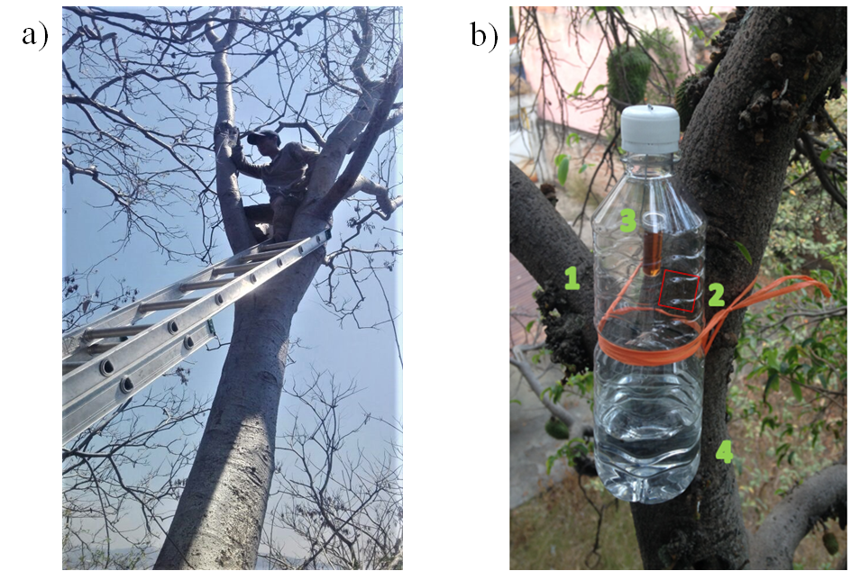

**Fig. S1.** a)Pitfall trap being attached in the crown of a *Conzattia multiflora* tree individual;b)Baited pitfall trap to capture canopy ants. (1) 500 ml PET bottle, (2) opening to allow the ants to enter the trap. (3) bait (honey or sardine) inside the trap, and (4) propylene glycol to preserve the ants.