Supplementary material: Ants as indicators of environmental change and ecosystem processes

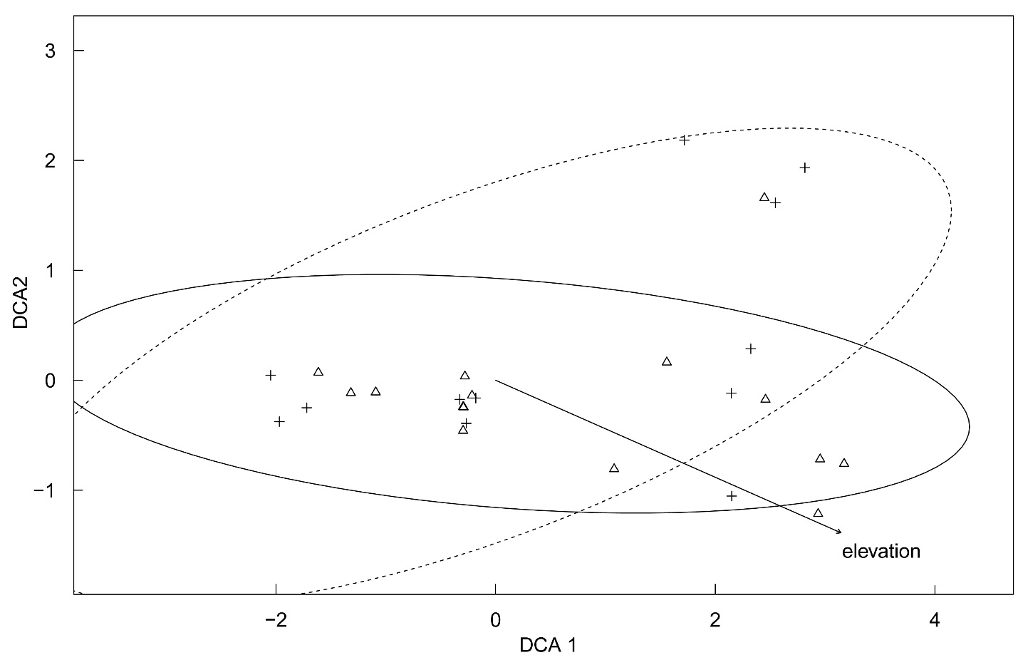

**A.1.** Changes of ant species composition in relation to elevation and forest degradation. Shown are the results of the site scores of a detrended correspondence analysis (decorana; triangles, natural forest plots; crosses, degraded forest plots) and the fitted environmental variables elevation (arrow) and forest degradation [centroids represent 95% interval for natural plots (solid line) and degraded plots (dotted line)]. The decorana (DCA) axes scale is in units of species standard deviations, which is a measure of beta-diversity. Elevation was strongly and positively correlated with the first axis (DCA 1; r² = 0.92, p < 0.001; Pearson product-moment correlation coefficients), but not with forest degradation (r² = 0.0089, p = 0.72; Pearson product-moment correlation coefficients).

**A.2.** Changes in ant species richness (model 1), (raw) functional richness of ant assemblages (model 2), and predation of artificial caterpillars (model 3) with elevation, drier vs. wetter season, and forest degradation. Linear mixed effect models were used for models 1, and 2, and a generalized linear mixed effect model was used for model 3. Study plots were included as random effect in models 1–3 to correct for pseudoreplication; model 3 included each observation as a random effect to remove overdispersion. Boldface indicates significant values.

|  |  |  |  |
| --- | --- | --- | --- |
| Source of variation | Estimate | *z-value* | *p-value* |
| Model 1: Ant species richness | |  |  |
| Elevation | −8.4 * 10−1 | −10.7 | **< 0.001** |
| Season | 1.8 * 10−1 | 2.5 | **< 0.1** |
| Degradation | 2.1 * 10−2 | 0.27 | 0.78 |
| Model 2: Functional richness | |  |  |
| Elevation | 3.8 * 10−2 | 0.25 | 0.80 |
| Season | 6.5 * 10−2 | 0.85 | 0.40 |
| Degradation | −6.0 * 10−2 | −0.74 | 0.46 |
| Ant species richness | 9.1 * 10−1 | 6.5 | **< 0.001** |
| Model 3: Predation of artificial caterpillars | |  |  |
| Elevation | 1.7 * 10−2 | 0.068 | 0.95 |
| Season | −4.8 * 10−1 | −3.4 | **< 0.001** |
| Degradation | 9.1 * 10−2 | 0.68 | 0.50 |
| Ant species richness | 6.7 * 10−1 | 2.0 | **< 0.1** |
| Functional richness | 6.1 * 10−4 | −0.002 | 1.0 |

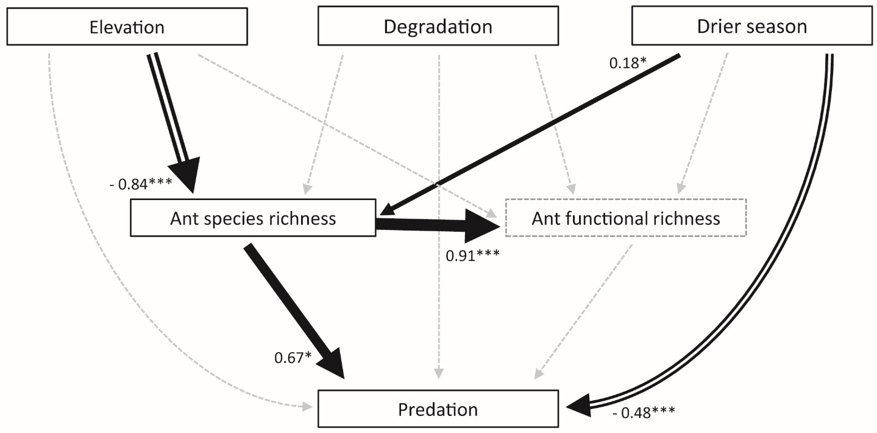

**A.3.** Path model for relationships between elevation (a proxy for temperature), season, forest degradation, species richness, and functional richness of ants, and predation of artificial caterpillars. The thickness of the solid arrows depict the values of the estimated effect sizes next to arrows; values in black and solid arrows indicate significant positive effects, framed arrows indicate significant negative effects with asterisks demarking the significance level (0.050 < * > 0.010 < ** > 0.001 < *** > 0.000). Note that ant functional richness does not differ for ant assemblages with randomly distributed sets of traits across species (indicated by dashed frame; cf. Figure 1B; for details, see Methods and Results section).