Supplementary material for Solar et al. How pervasive is biotic homogenization in human-modified tropical forests?

*Biodiversity sampling*

We sampled five taxa: dung beetles, orchid bees, ants, birds and plants.

*Large and small stems*

All trees and palms (alive or dead) ≥ 10 cm of diameter at 1.3 m height were identified in 10 x 250 m plots. Smaller individuals (2 to 10 cm diameter) were sampled in five subplots of 5 x 20 m. Lianas (woody vines) were also sampled in the same manner with the exception that the diameter was measured at 1.3 m from its main root, if this was located inside the plot (for large individuals) or inside the subplots (for smaller individuals).

*Birds*

Birds were surveyed with 15-min point counts collected at three sampling points (0, 150 and 300 m); there were two repeat surveys. Sampling was conducted between 15 min before dawn up until 09:30 at the latest (but usually finishing by 08:30) and all point counts were sound-recorded to facilitate error-checking. For a full description of the avian sampling protocol and lists of voucher sound-recordings and images see Lees *et al.* (2012, 2013).

*Dung beetles:*

We sampled dung beetles using pitfall traps (1 litre plastic containers, 14 cm radius, 9 cm height) baited with 50 g of dung (80% pig and 20% human, according to Marsh et al. 2013) and half filled with a killing solution (5% detergent and 2% salt). Three traps were dug at the corners of a 3-m side triangle and sampled at three point along the transect (0, 150 and 300 m) and left for 48 hours prior to collection and removal.

*Ants*

We sampled ants only in PGM using six epigaeic pitfall traps. Traps were all baited with sardine and honey (15 g of each), located along each transect, separated by 50 m. We left traps in the field for 48 hours prior to collection and removal. The traps consisted of 12 cm height and 8 cm diameter plastic pots, half filled with a mixture of water, salt (2%) and detergent (5%) to kill the ants.

*Orchid bees*

To sample orchid bees, which were only sampled in PGM, we used plastic bottles with scent baits (2L, 10cm diameter, 35cm height) as traps. Each bottle had three radial holes (2 cm diameter) at the height of 20 cm, where a flower-like structure was inserted (the tips of three other bottles). These flower-like structures were impregnated with coarse sand on the inner side to give support to the bees. Male orchid bees were attracted to four class of scent baits distributed along the transect (eugenol, methyl salicylate, vanilla or eucalyptol), separated by 50 m from each other. We tied the traps to a tree trunk, 1.5 m above the ground and remained in the field for 48h.

References for the Supplementary Material.

1.

Lees, A.C., de Moura, N.G., Andretti, C.B., Davis, B.J.W., Lopes, E.V., Pinto Henriques, L.M. *et al.* (2013). One hundred and thirty-five years of avifaunal surveys around Santarem, central Brazilian Amazon. *Revista Brasileira De Ornitologia*, 21, 16-57.

2.

Lees, A.C., de Moura, N.G., Santana, A., Aleixo, A., Barlow, J., Berenguer, E. *et al.* (2012). Paragominas: a quantitative baseline inventory of an eastern Amazonian avifauna. *Revista Brasileira De Ornitologia*, 20, 93-118.

3.

Marsh, C.J., Louzada, J., Beiroz, W. & Ewers, R.M. (2013). Optimising Bait for Pitfall Trapping of Amazonian Dung Beetles (Coleoptera: Scarabaeinae). *Plos One*, 8.

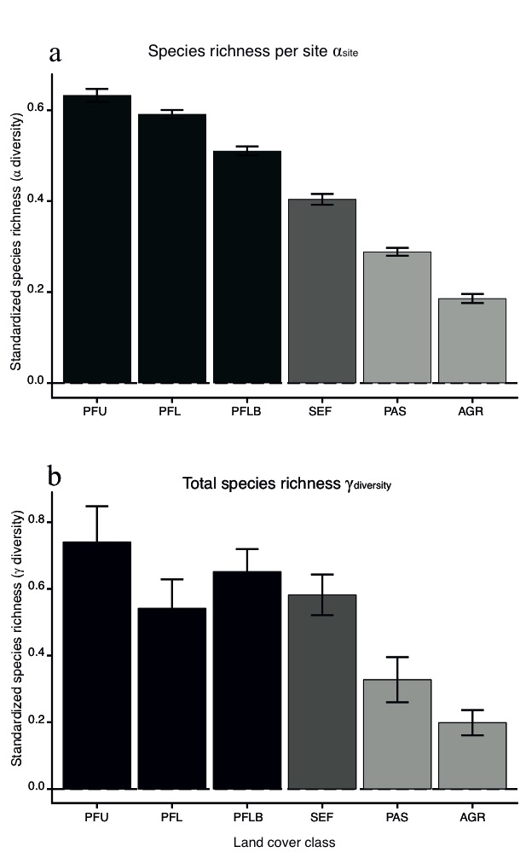

Figure S1 α and γ diversities accounting for proxies of species abundance (Hill numbers of order 1). In (a), α-diversity is calculated based on the species found per site and in (b), γ-diversity is calculated based on the total number of species observed per taxon in each region. Both metrics were standardized by the maximum value per taxon (range 0-1). Different colours illustrate forest (black and dark grey) and non-forest land-covers (light grey), we used P<0.05 to determine significance and errors bars are standard errors. Codes for land-cover classes are as Table 1.



Figure S2 β-diversity among sites and landscapes accounting for proxies of species abundance (Hill numbers of order 1). β-diversity was calculated as the multiplicative Whittaker’s β and sampling effort is standardized by resampling all land-cover classes to the same sample size. Data is presented as average β-diversity per taxon and per land-cover class for both among sites within landscapes (a) and among landscapes within regions (b). Different colours illustrate forest (black and dark grey) and non-forest land-covers (light grey), we used P<0.05 to determine significance and errors bars are standard errors. Codes for land-cover classes are as Table 1.



Figure S3 Percentage contribution of the nestedness component to the total β-diversity observed among sites and among landscapes for each individual taxon. β-diversity components were computed following Baselga (2010) procedure (βNES= βSOR- βSIM) and standardized by resampling all land use classes to the same sample size. Data is presented as the average percentage contribution of the nestedness component per land-cover class for both the decomposition of β-diversity among sites in a landscape (β1 – row a) and the decomposition of β-diversity among landscapes in a region (β2 –row b). Different colours express forest (black and dark grey) and non-forest land-covers (light grey), we used *P*<0.05 to determine significance and errors bars are standard errors.

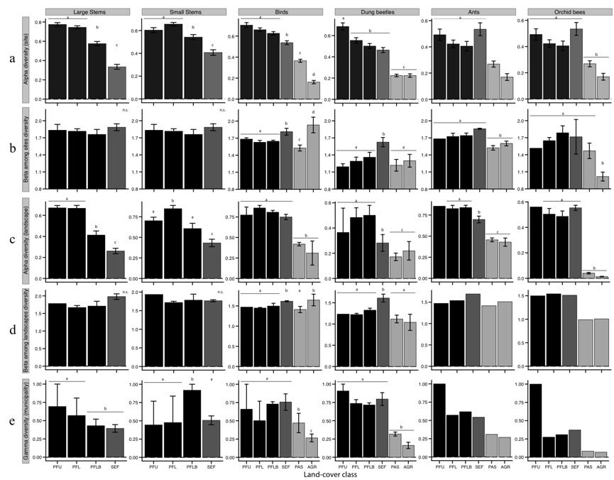

Figure S4 Components of diversity for all taxa across all land-cover classes accounting for proxies of species abundance (Hill numbers of order 1). Row (a), shows αsite diversity (i.e. average number of species per site), rows (b) and (d) show β-diversity among-sites and among-landscapes, row (c) shows αlandscape diversity (i.e. average number of species per landscape) and row (3) shows is γ-diversity (for each region). Different colours illustrate forest (black and dark grey) and non-forest land-covers (light grey), we used P<0.05 to determine significance levels and error bars represent standard errors (bars are absent where we could only calculate a single value). Codes for land-cover classes are as Table 1.