Hospital Operational Efficiency Improvement
  - Business Requirements Document
Version 2.0 • Final academic submission • Prepared for hospital leadership and the project assessment team

Executive summary
This hypothetical medium-sized hospital seeks to reduce administrative processing time per admission by 20% within six months of project initiation. The proposed scope covers admissions, patient records and interdepartmental communication. Duplicate entry, delayed access to admission records and manual handoffs define the case for change.
The preferred strategy is Option B: targeted integration through existing clinical and admissions interfaces. Reuse verified patient data, make successfully submitted records available to authorized staff and notify the receiving ward. Retaining familiar interfaces may limit disruption, but interoperability, vendor support, lifecycle cost and operational safety require validation before investment approval.
Leadership should authorize a time-boxed discovery and integration proof of concept, followed by a controlled pilot only if technical, security and financial gates pass. Full EHR replacement remains a fallback if integration cannot meet requirements at an acceptable lifecycle cost.

Evidence and status
This is an academic scenario, not a report of a live hospital engagement. No stakeholder interviews, infrastructure audit, measured baseline, vendor quotation or pilot results are claimed. All numerical targets and planning periods are illustrative. Requirements and acceptance criteria below are proposed for validation. The document provides a complete proposed requirements baseline and an explicit acceptance framework for the academic case.
Document control | Status
Source basis | User case decisions, Coursera instructions and Project Worksheet; two supplied Lucidchart screenshots
Decision requested | Conditional approval of discovery and pilot planning
Business owner | Hospital administration sponsor
Clinical and technical approvers | Clinical lead, admissions lead, IT owner and privacy/security representative

Source and course alignment
Sources: Case Studies conversation supplied by the user; Coursera project instructions and Project Worksheet; original Lucidchart screenshots dated 13 November 2026. No external clinical or financial evidence is claimed. Sections 1–10 cover initiation, elicitation, requirements, gaps, prioritization, workflows, technology, optional change/risk planning and evaluation, and closure.

1 Business context and scope
The scenario describes outdated record handling and inefficient communication. Specific bottlenecks are hypotheses derived from the case and illustrative workflows; observation and timing studies must confirm their size and causes.
In scope | Out of scope
Admission registration and identity verification | Full EHR replacement in the initial proposal
Reuse and update of admission-related patient data | Clinical diagnosis, treatment algorithms and AI alerts
Availability of records in existing clinical interfaces | Hospital-wide data migration and billing redesign
Admission completion and planned-transfer communication | Patient scheduling portal and bed capacity optimization

Business objectives
ID | Objective and measurement
BO1 | Reduce mean active administrative processing minutes per completed admission by 20% versus a validated baseline by month 6.
BO2 | Reduce mean record availability delay by 50% versus a validated baseline by month 6. Illustrative secondary target, measured against the same baseline cohort.
BO3 | Improve handoff reliability through traceable notifications without introducing unsafe access or unresolved record mismatches.

Assumptions and constraints
Assume existing admissions and clinical systems remain in service, supported interfaces may be available, and a limited pilot ward can participate. These assumptions require confirmation. The scenario does not establish a hospital budget, volume or staffing level. The financial model below uses separately disclosed synthetic inputs, with no claim that they describe a real institution.
Changes must fit existing workflows and preserve continuity of admission services. Confirm interface licensing, vendor release schedules, identity matching, data ownership, downtime procedures and applicable privacy obligations before detailed design. The six-month objective is a planning constraint, not a delivery guarantee.

Dependencies
The sponsor must allocate staff time. IT and vendors must provide interface documentation and test environments. Clinical and admissions leads must agree a minimum admission dataset, completion event, receiving team and exception ownership. Financial approval depends on a credible lifecycle business case.

2 Stakeholder analysis and elicitation
Stakeholder | Role | Interest | Influence | Planned involvement
Hospital administration | Sponsor | High | High | Decision gates, benefits and cost review
Physicians | Clinical record users | High | Medium | Workflow review and access testing
Nurses | Receiving ward users | High | Medium | Handoff design, pilot and training
IT department | Technical delivery owner | Medium | High | Architecture, security, support and testing
Patients | Service beneficiaries | Medium | Low | Accessible feedback and privacy expectations
Admissions staff | Primary registration users | High | Medium | Data entry observation, design and UAT

Interest and influence ratings retain the user’s case assumptions. Admissions staff complete the stakeholder map. IT involvement should increase during delivery. A privacy/security representative and clinical safety owner support approval where applicable.

Planned interview and validation questions
Group | Questions to validate
Administration | Which operational benefit matters most? What investment ceiling, payback criteria and recurring costs are acceptable?
Admissions | Where is information entered twice? Which fields require verification? How are uncertain identity matches resolved?
Physicians and nurses | Which admission fields are essential? When is a record usable? Who receives and acknowledges handoff messages?
IT and security | Which interfaces and authentication methods exist? What are capacity limits, failure modes, audit capabilities and vendor constraints?
Patients | Where does repeated information collection create burden? What access, communication or privacy concerns arise?

Proposed method: interview role representatives, observe admissions across relevant shifts, review data definitions and examine system timestamps. Record actual participants, dates, consent arrangements and findings only after activities occur. Use a joint playback workshop to resolve conflicting needs and approve revisions.

3 Functional requirements

FR01 Patient data reuse
After identity verification and a confirmed match, retrieve agreed existing patient fields for review and reuse. Staff shall edit outdated values and create a new record only when no confirmed match exists.
Acceptance criteria: Returning-patient test reuses mapped fields without duplicate entry. New-patient test creates one record. Ambiguous match enters a manual resolution queue.

FR02 Timely record access
After successful admission submission, publish the agreed admission dataset to authorized clinical staff through the existing clinical interface. Show synchronization status and actionable failure information.
Acceptance criteria: Proposed threshold: 95% of pilot records accessible within 60 seconds. Reconcile source and receiving fields and test denied access. This is an illustrative design threshold for the case.

FR03 Admission notifications
After successful submission and confirmed record availability, notify the designated receiving ward of admission completion and planned transfer status. Track delivery and acknowledgement.
Acceptance criteria: Test correct routing, event timestamps and acknowledgement. Retry failed delivery, prevent duplicate messages and escalate an unacknowledged handoff after five minutes without acknowledgement. Proposed pilot service level: 95% of notifications delivered within 60 seconds and 95% acknowledged within five minutes. All thresholds are illustrative.

Business rules and exception handling
Verify identity before reuse. Record the source and last update time of imported fields. Staff confirm mandatory fields before submission. Do not imply that a notification authorizes a physical transfer: the receiving team must confirm readiness under the hospital’s approved protocol.
Keep failed synchronizations visible and assign an owner. Use controlled retries and reconciliation to avoid duplicate records or messages. Provide a documented manual downtime process, then reconcile queued work after recovery. Do not silently overwrite conflicting patient data.

Data and interface requirements
Agree patient and encounter identifiers, required demographic and admission fields, destination ward, completion status, timestamps and record version. Designate the authoritative source per field. Confirm whether supported APIs or messaging interfaces can meet this contract; no specific standard or vendor capability is assumed.

4 Non functional requirements and acceptance
ID | Requirement | Verification and qualification
NFR01 | Role based access control | Only authorized roles may view or modify the agreed data. Verify permitted and denied actions for admissions, clinical and support roles. Admissions staff may create and update admission data; physicians and nurses may read assigned patient records; IT support may inspect technical metadata without routine clinical-content access. Test each allowed and denied action.
NFR02 | Auditability | Log user or service identity, patient/encounter reference, action, timestamp and outcome for access, updates and integration events. Test traceability and restricted log access. Retain logs for an illustrative 12 months in protected storage; flag deletion attempts and export failures. The final deployment must align retention with applicable local obligations.
NFR03 | Availability and continuity | Illustrative target: 99.9% availability during agreed service hours. Measure over a 24/7 monthly service window including unplanned outages. Illustrative recovery objectives: restore service within 60 minutes and recover transactions to within 15 minutes. Reconcile all downtime admissions after recovery.
NFR04 | Secure and reliable integration | Protect data in transit and at rest according to approved security design. Test identity matching, data mapping, retries, duplicate suppression and failed-message recovery.
NFR05 | Usability and performance | Complete agreed admission scenarios within existing interfaces with no unresolved critical usability issue. Illustrative test workload: 20 concurrent users, with 95% of routine screen requests responding within two seconds. At least 90% of trained pilot users shall complete the returning-patient scenario without assistance.

Compliance and operational safeguards
Determine the hospital jurisdiction and applicable privacy, healthcare data and retention obligations with qualified local stakeholders. The course mentions HIPAA as an example; this case does not assume a US setting or assert compliance. Security and privacy review must precede any use of live patient data.

Approval and change control
Business owner and clinical, admissions and IT leads review each requirement and its test evidence. The security/privacy representative signs off access and data controls. Maintain a requirements log with ID, owner, rationale, version, priority and test result. Assess scope, cost, risk and timeline impact before sponsor approval of changes.

5 Gap analysis and prioritization
Current state hypothesis | Desired state | Gap | Response
Duplicate manual entry | Verified data reused across interfaces | No validated mapping or reuse mechanism | FR01 plus NFR04
Delayed record access | Usable records after submission | No verified cross-department availability | FR02 plus NFR01–03
Manual handoff | Traceable ward notification | No validated completion and delivery event | FR03 plus NFR02–04

The gaps form the scenario baseline. The discovery protocol tests each hypothesis using observation, timestamps and technical inspection before deployment.
ID | Capability | Impact | Feasibility | Cost | Priority
NFR01–04 | Security, audit, continuity, integration | High | Medium | High | Must / release gate
FR01 | Patient data reuse | High | Medium | Medium | Must / pilot core
FR02 | Timely access | High | Medium | Medium | Must / pilot core
FR03 | Ward notifications | High | Medium | Medium | Must / pilot core
NFR05 | Usability and performance | High | High | Low–medium | Must / acceptance

Ratings are qualitative assumptions, not estimates or vendor assessments. All listed requirements form the minimum safe pilot. Sequence controls and interface proof first, then reuse and access, then notifications because notification depends on reliable availability. Advanced analytics and mobile push are Could Have enhancements outside the initial baseline.

Traceability
Business need | Gap | Requirement | Evidence for acceptance
BO1 less administrative effort | Duplicate entry | FR01, NFR05 | Timed comparable admission tasks and reuse tests
BO2 faster record availability | Access delay | FR02, NFR03–04 | Submission and first accessible timestamp
BO3 reliable handoff | Communication delay | FR03, NFR01–02 | Delivery, acknowledgement and access tests

6 Current and future workflows
AS-IS • User-supplied Lucidchart screenshot • Illustrative unvalidated workflow
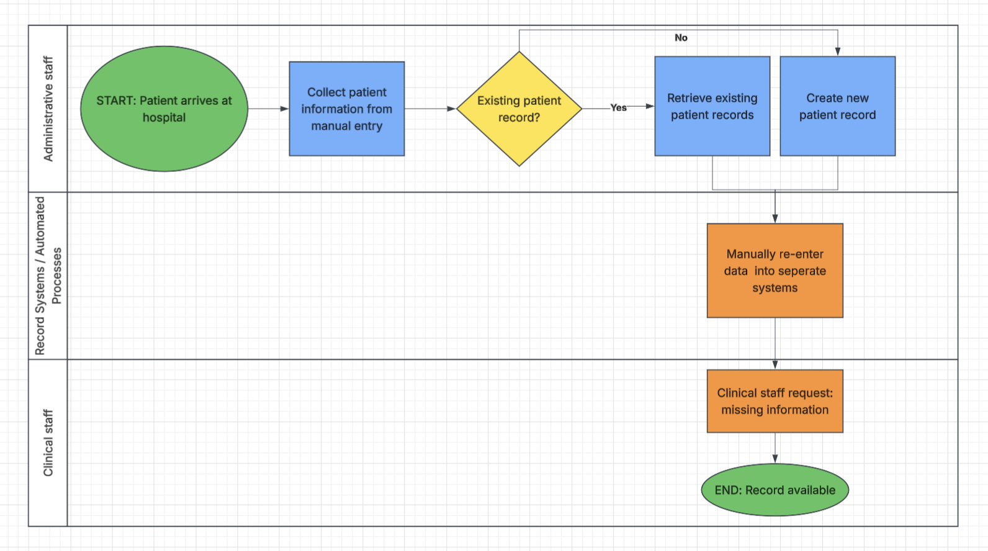
Bottlenecks: manual collection precedes the existing-record check, staff re-enter data in separate systems and clinical staff request missing information. These are illustrative steps, not observed hospital performance.
TO-BE • User-supplied Lucidchart screenshot • Illustrative unvalidated workflow
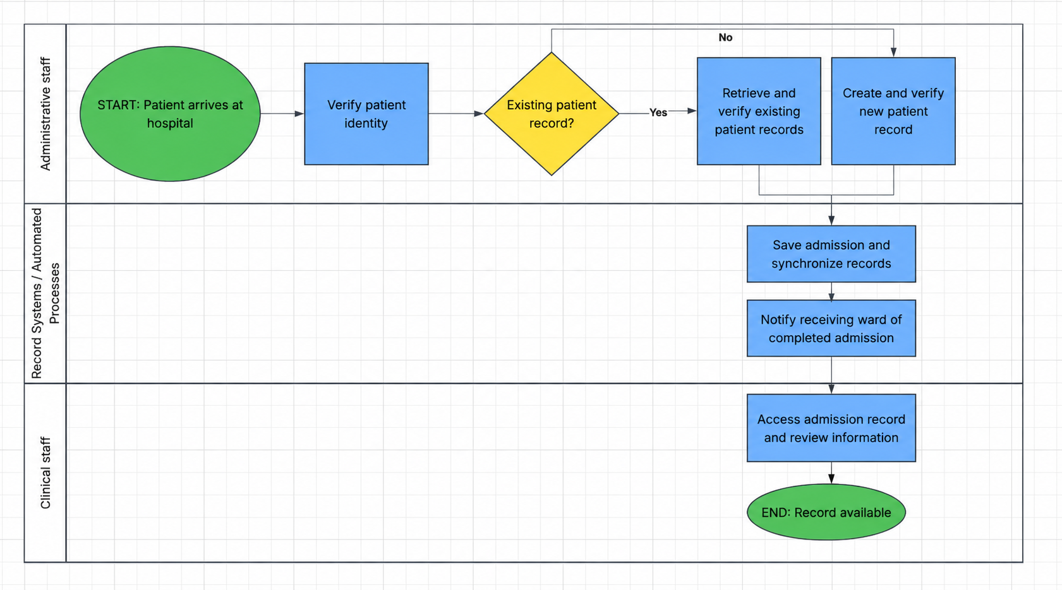
Proposed improvement: verify identity, retrieve or create a verified record, save and synchronize, notify the receiving ward and enable clinical review.
The TO-BE reproduction removes the unused placeholder connector and stray line from the supplied screenshot. The AS-IS retains the original spelling “seperate” and places manual re-entry in the systems lane. Both diagrams illustrate the main path only; FR01–03 and the exception rules specify identity resolution, failed synchronization, retries and handoff escalation. These are illustrative unvalidated workflows, not approved operating procedures.

7 Technology assessment and investment gates
Current technology is unspecified. The scenario assumes fragmented record handling, separate systems and manual communication. Inventory applications, versions, interfaces, identity services, hosting, support contracts and capacity before choosing a product.
Option | Potential value | Main limitations | Assessment
A Full EHR replacement | Opportunity to standardize the platform | Broad migration, training and continuity exposure and extensive procurement | Reserve for a strategic review if integration fails
B Targeted integration | Retains familiar interfaces and targets admission gaps | Depends on vendor interfaces, data quality and sustainable support | Preferred conditionally
C Process changes only | Potentially low initial disruption | May leave duplicate entry and access gaps unresolved | Interim fallback and downtime support

Option B is a direction, not a proven lowest-cost solution. Maintaining legacy systems and interfaces can increase recurring support costs. Compare multi-year costs and benefits against replacement and process-only alternatives before commitment.

Technical gate
IT and vendors demonstrate a representative end-to-end admission in a non-production environment: identity match, field reuse, record availability, notification, access control, audit and failure recovery. Confirm interface support and performance. Stop or redesign if critical mappings, safety or reliability cannot pass.

Financial gate
Obtain comparable estimates for integration, licensing, vendor services, internal staff, testing, training, support, hosting and contingency. Value capacity released separately from cash savings. Annual capacity hours = annual admissions × minutes saved per admission ÷ 60. The illustrative financial model below demonstrates the decision logic without claiming a real quotation or return.

Pilot and scale gates
Clinical, admissions and IT leads approve UAT, security, downtime rehearsal and support coverage before pilot launch. Scale only after reconciliation and operational review show reliable workflows. Reassess Option A or a smaller scope if lifecycle cost or integration feasibility fails the gate.

8 Illustrative financial assessment
This completed planning model uses synthetic assumptions to test affordability. It is not a vendor quotation, hospital forecast or measured financial result. The model assumes steady-state benefits from a full year of operation; implementation-year benefits would be lower.
Planning input | Illustrative assumption | Rationale
Annual admissions | 24,000 | Demonstration volume for a medium-sized hospital scenario
Administrative time | 10 minutes baseline and 8 minutes target | 20% reduction in active administrative effort
Loaded staff cost | EUR 35 per hour | Assumed economic value of staff capacity
One-time implementation cost | EUR 45,000 | EUR 25,000 integration, EUR 10,000 testing, EUR 5,000 training, EUR 5,000 contingency
Annual recurring cost | EUR 10,000 | Assumed licensing, monitoring and support

Benefit calculation and interpretation
Annual capacity released = 24,000 admissions × 2 minutes ÷ 60 = 800 hours. Gross annual capacity value = 800 × EUR 35 = EUR 28,000. After EUR 10,000 recurring cost, annual net economic value is EUR 18,000. Simple steady-state payback is EUR 45,000 ÷ EUR 18,000 = 2.5 years. Over three full operating years, net economic value after implementation is EUR 9,000 before discounting and tax.
Released staff time is capacity, not automatic cash savings. The business case produces cash savings only where management can reduce paid overtime, agency work or an otherwise required cost. Patient experience and safer handoffs are potential nonfinancial benefits and are not monetized here.
Sensitivity | Annual net capacity value | Simple payback
10% time reduction | EUR 4,000 | 11.25 years
20% time reduction | EUR 18,000 | 2.50 years
30% time reduction | EUR 32,000 | 1.41 years

The sensitivity holds volume, hourly cost and all project costs constant. Investment rule for this illustrative case: proceed only if the technical pilot passes and the updated base case supports payback within three steady-state years. The sponsor must explicitly accept the downside case. Avoid presenting a favorable capacity calculation as guaranteed budget savings.

9 Implementation change and risk management
Illustrative timing | Activity | Accountable role and exit
Month 1 | Validate baseline, requirements and system inventory | Sponsor / approved scope and measurement plan
Month 2 | Integration proof and cost comparison | IT / technical and financial gates
Months 3–4 | Build, test and prepare users | IT and clinical leads / UAT and readiness
Month 5 | Controlled pilot with fallback | Admissions lead / resolved critical issues
Month 6 | Evaluate against baseline and decide scale | Sponsor / benefits review and decision

The plan assumes discovery supports the six-month objective. Rebaseline openly if procurement, interface access or safety testing requires more time. Do not compress critical testing to preserve an illustrative date.

Change management
Admissions and ward champions review the design and co-lead scenario-based training. Cover verified reuse, uncertain matches, failed synchronization, notifications and downtime. Use a test environment and practical competency checks. Provide shift-based support, quick guides and an issue log during pilot. Communicate purpose, scope, planned disruptions and escalation ownership before launch.
Risk | Impact | Mitigation | Owner
Integration incompatibility | High | Interface proof, vendor commitment and staged testing | IT lead
Wrong match or conflicting data | High | Identity verification, manual resolution and reconciliation | Admissions lead
Unauthorized access or data exposure | High | Access matrix, security tests and restricted logs | Security owner
Outage or lost notification | High | Monitoring, retries, escalation and rehearsed fallback | IT operations
Staff resistance or added effort | Medium | Co-design, training and pilot feedback | Change lead
Cost or timetable overrun | High | Lifecycle cost gate, contingency and scope control | Sponsor

Risk impact ratings are illustrative. Likelihood, residual exposure, thresholds and named owners require local assessment. Critical unresolved access, identity or synchronization failures block release.

10 Evaluation closure and recommendation
Metric | Definition | Baseline | Illustrative target | Owner
Administrative time per admission | Mean active administrative minutes per completed admission | 10 min illustrative | 8 min by month 6 | Admissions lead
Record availability delay | Mean time from successful submission to first authorized availability | 20 min illustrative | 10 min by month 6 | IT lead
Admission to transfer time | Time from admission completion to physical transfer | 30 min illustrative | 24 min by month 6 | Clinical lead
Notification reliability | Delivered and acknowledged events / eligible events | 80% illustrative | 95% within service intervals | Ward lead
Safety and quality | Wrong matches, missing fields and unresolved sync failures | Release gate | Zero unresolved critical issues | Clinical / IT leads

All baseline values in the table are synthetic planning assumptions, not measured hospital data. No post-implementation result exists in this case. Proposed FR02 60-second/95% service criterion and NFR03 99.9% availability are illustrative design thresholds, separate from baseline-relative outcome targets.

Measurement and review plan
Measurement protocol: collect two weeks of pre-change observations with at least 100 completed admissions covering shifts, new and returning patients and relevant admission types. These sampling choices are illustrative. Replace the synthetic planning baseline with the observed cohort before judging improvement. Define active work separately from elapsed waiting. Use consistent timestamps and denominators. Exclude or report downtime and exceptional cases transparently. Collect a comparable two-week follow-up cohort in month 6. Report the mean, median, 90th percentile and sample size, stratified by admission type. IT reviews system metrics daily during pilot; admissions reviews processing time weekly; the sponsor reviews benefits monthly.
Improvement percentage = (baseline mean − follow-up mean) ÷ baseline mean × 100. A purely illustrative example is 10 minutes becoming 8 minutes for a 20% reduction; these values are not observed data. Transfer time is a secondary measure because bed readiness, transport and clinical decisions also affect it.

Closure and executive decision
At the final review, present actual test results, KPI evidence, staff and patient feedback, open risks and operational ownership. Update the BRD and workflows, obtain role-based sign-off and transfer support documentation to operations. No review or approval is claimed in this submission.
Recommendation: approve discovery and a gated Option B pilot, subject to technical feasibility, affordable lifecycle cost and safe operation. The expected benefit is reduced duplicate work and faster usable records. The 20% administrative-time and 50% record-delay improvements remain illustrative targets until measured.

