This article was published in the “ITB Journal”. Please cite is as follows:
Smith (2002) Matt Smith. “Pitch Circles – from music theory to computer-based learning tool”. ITB Journal (Spring 2002 issue), Published by the Institute of Technology Blanchardstown, Dublin, Ireland.

Pitch Circles
– from music theory to computer-based learning tool

Matt Smith
School of Informatics and Engineering
Institute of Technology Blanchardstown

Abstract

This paper describes how a music theory with explanatory power for expression of relationships between pitch classes, chords and tonal regions can be exploited as the foundations for a computer-based tool, called ‘Pitch Circles’, to support musical novices learn about and manipulate such musical concepts and relationships . The paper introduces this research with a brief review of the ‘direct manipulation’ principles for computer interaction design on which the computer-based learning tool has been based, and of the features of tonal theories which led to our choice of a particular theory, ‘Pitch Spaces’, as the basis for this work.

Introduction
Lerdahl and Jackendoff’s (1983) Generative Theory of Tonal Music (GTTM) was, and remains, an important and ambitious grammatical approach to modelling the structure of Western Tonal Music. In part to address the lack of detail for the ‘stability conditions’ of the GTTM, another of Lerdahl’s contributions to music theory was his proposal for a model of ‘Pitch Spaces’ (Lerdahl 1988). The Pitch Space model treats pitches, chords and regions in a single framework, overcoming limitations of previous theories. In this paper we will both summarise Lerdahl's arguments for the relative strengths of the model over previous cognitive models of harmonic knowledge, and we will present an extension to the model facilitating the design and implementation of a computer-based tool, called ‘Pitch Circles’, for harmonic analysis and composition for musical novices. We then describe the current implementation of the computer music tool and make suggestions about how it may be used to support learning of aspects of tonal harmony by musical novices.

Effective tools for learning with computers
‘Direct Manipulation’ (Shneiderman, 1982) is an approach to computer interface design so users feel as through they are directly performing a task – i.e. they effectively do not notice they are using a computer but have an experience whereby the artefacts presented by the computer (for example through the monitor or virtual reality headset) respond to their controls as if they were real world objects. Important aspects of direct manipulation interfaces are real-time response, and continual visual/audio communication of the ‘state’ of the system. Just as when driving a motor car the current state of the car is communicated through the angle of the steering wheel, the position of the gear lever, the pressure and position of the break pedal, and what the driver sees through the windows, direct manipulation computer interfaces likewise present continuous presentation of the state of the virtual device and ways to change that state. Direct manipulation computer systems are appropriate for novice learners (novices to computers or to the domain) since they are easier to learn, and to understand – generally there are no complex ‘hidden’ aspects to the state of the interactive tool or simulation, and there are no complex symbolic languages to learn to communicate with the system. The ‘drag-and-drop’ desktop metaphor of modern graphical user interfaces is based on direct manipulation principles, so for example when a folder has been dragged and dropped into the wastebasket the folder disappears and the wastebasket shows that it is no longer empty with a bulging icon, all without the user having to learn or remember commands such as ‘delete’ or the path to the item being deleted.

When designing tools to aid musical novices learn and manipulate core concepts of pitch classes, scales (regions) and chords, we have taken the approach of searching for a sound theoretical basis on which to design and develop a direct manipulation tool. Thus the relationship between two chords, or a chord and a region, or a pitch class and a chord are to be presented visually (and with audio) in a form that can be manipulated through actions that make sense to the presented representation (concentric circles that can be rotated – as shall be presented later ni this paper).

A computer tool to support learning built upon sound and sufficiently rich theoretical foundations can offer the following benefits:
- easy to use
- easy to learn to use
- a consistent framework for the progressive introduction from simple to more sophisticated concepts and manipulations (i.e. start with few components / controls and add they as needed)

Tonal framework models and motivation for Lerdahl’s model

Models and pitch space frameworks
Models are an attempt to present the important characteristics of a concept or class of objects, while ignoring the unnecessary details. Those engaged in modelling attempt to simplify to the point where superfluous details have been removed, and where any further simplification would render the model too simple to be useful. Modelling takes place in the analysis and design activities of many disciplines, for example scale models of proposed building or conceptual models of the relationships between data for database design. Tonal frameworks attempt to present a model of a tonal system – so these tonal models attempt to present simple yet powerful framework for the analysis and modelling of musical concepts. Models arranging concepts in multi-dimensional spaces attempt to create a model to aid explanations of the proximity and distance of pitch classes and tonal regions – pitches and tonal regions arranged a multi-dimensional way so that distance in the space means something. For example, if two items are nearby in the space then the two items are perceptually proximate. Since many musical space models can be presented visually they can form the basis for interactive computer tools for analysis and composition of music. Figure 1 illustrates a screen shot of Holland’s (1989) Harmony Space – it is a good example of a direct manipulation tool for learning about music based on Longuet-Higgins' (1962) topological model.
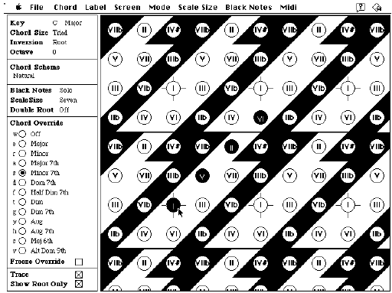

Figure 1: Holland’s ‘Harmony Space’ direct manipulation learning tool.

Several different tonal framework models have been proposed, some over 100 years ago, including different models of pitch classes by Balzano (1982) and Shepard (1982), and models of tonal regions such as Weber (1830/1851) and Schoenberg (1911/1978). For example Shepard proposes a three-dimensional model in the form of a double helix, where a chromatic circle forms the X-Z dimensions. The circle is arranged so that pitches on opposite sides of the circle are perfect fifths, and vertically above any pitch is an intersection with the double helix of a pitch one or more octaves higher. Many of these frameworks have the weakness that each only models a single level of pitch description (e.g. pitch classes or tonal regions). One tonal framework that does model multiple levels of pitch description is Longuet-Higgins (1962) – a framework that derives tonal regions from pitch classes. However, Lerdahl cites as a weakness of Longuet-Higgins’ model that it cannot be straightforwardly used to describe pitch proximity.

In addition to the number of levels of pitch description, another important feature of a tonal framework model is whether the model is symmetrical or asymmetrical. While symmetrical models can be simpler and more general for multiple tonal systems, those models that are symmetric can be viewed as misrepresenting the non-symmetrical aspects of any particular tonal system, such as the non-symmetrical aspects of the diatonic system of Western Tonal Music.

Taking as an example the Diatonic scale for the region C major:
C (C#) D (D#) E F (F#) G (G#) A (Bb) B
clearly there is asymmetry since some intervals between scale members are 2 semitones (e.g. from C to C# to D) and between others only a semitone (from E to F). Listeners of many pieces of music from a particular tonal culture will 'overlearn' (Deutsch & Feroe, 1981) pitch, chord and region relationships. Such overlearning is one of the ways the human brain manages to process and make sense of complex perceptual input from the senses. To take a computing science example, in the same way a simulated neural network for voice recognition is trained with representative sets of data (e.g. samples of a person speaking known words) all the Western Tonal Music a person has heard through their life has been tonal training for their perception of diatonic tonal music. Lerdahl makes use of the particular hierarchical overlearning of chromatic, diatonic and triadic spaces identified by Deutsch & Feroe to form the basis for his proposed pitch space levels.

Motivation and background to the Pitch Space framework
Lerdahl’s Pitch Space framework was constructed to combine the strengths and overcome the weaknesses of earlier tonal frameworks. Most importantly the Pitch Spaces framework is able to model, in a single framework, the same asymmetry as the chords and keys (regions) it is modelling in the diatonic system at multiple levels of pitch description. Lerdahl cites several key studies as the background to the development of his model, including descriptions of pitch classes, chord spaces and tonal regions from Krumhansl (1979 & 1983), Krumhansl, Bharucha & Kessler (1982) and Krumhansl & Kessler (1982). Lerdahl’s Pitch Spaces have been successfully used to predict phrase structures in a empirical investigation of listener’s perceptions of tension in music (Smith & Cuddy, 1997).

Description of Lerdahl's pitch space framework
Building upon the chromatic, diatonic and triadic overlearning ideas previously mentioned, Lerdahl's framework is a hierarchy of five spaces. The hierarchy is such that each level is made up of a strict subset of those pitch classes from the level immediately below. The five spaces are shown in Table 1.
Level | Name
a | Octave space
b | Open fifth space
c | Triadic space
d | Diatonic space
e | Chromatic space

Table 1: Names of pitch spaces

Important points Lerdahl makes about the spaces are as follows:
- except for the chromatic space, the spaces describe the asymmetric patterns appropriate for diatonic music
- the diatonic space is directly represented in the framework (unlike the symmetrical frameworks mentioned earlier)
- the pitch space framework allows unified treatment of pitch class, chord and regional proximity

Lerdahl uses the Roman-numeral notation of chord / region – in this paper we shall further clarify the references to chords and regions by presenting the region numeral in parentheses. For example. I/(I) is the pitch space for the tonic chord (say C major), in the region of the tonic (the C major diatonic region). The choice of the tonic as C is arbitrary, and could be any other pitch class. A general numeric form of reference to pitch classes is adopted for many of the tables of pitch spaces in this paper, the numbers are calculated from semitone intervals from the root. So for a root pitch class of C, the numerals are:
C = 0 C# = 1 D = 2 … G# = 8 A = 9 B = a B = b
Both the numeric and alphabetic forms for the pitch space I/(I) are shown in Table 2.

Space | Pitch Class  when C/(C) is chosen as I/(I) |  |  |  |  |  |  |  |  |  |  |  |  | Space | Pitch Class
a | C |  |  |  |  |  |  |  |  |  |  |  |  | a | 0
b | C |  |  |  |  |  |  | G |  |  |  |  |  | b | 0 |  |  |  |  |  |  | 7
c | C |  |  |  | E |  |  | G |  |  |  |  |  | c | 0 |  |  |  | 4 |  |  | 7
d | C |  | D |  | E | F |  | G |  | A |  | B |  | d | 0 |  | 2 |  | 4 | 5 |  | 7 |  | 9 |  | b
e | C | C# | D | D# | E | F | F# | G | G# | A | Bb | B |  | e | 0 | 1 | 2 | 3 | 4 | 5 | 6 | 7 | 8 | 9 | a | b
ed | 0 | 4 | 3 | 4 | 2 | 3 | 4 | 1 | 4 | 3 | 4 | 3 |  | ed | 0 | 4 | 3 | 4 | 2 | 3 | 4 | 1 | 4 | 3 | 4 | 3

Table 2: Pitch space for I/(I) in numeric and alphabetic formats.

The pitch spaces can be thought of as being repeated in both directions, or alternatively thought as wrapped around by a modulus arithmetic. So, for example, travelling along level d to the right (0 2 4 5 7 9 b), having reached b one would go back to meet 0 2 4 5 and so on.

The bottom (shaded) row in Table 2, ‘ed’, is the 'embedding distance' – this is a measure of how far from the octave space a given pitch class is for a given pitch space. This distance shifts for a given chord and region. The shallower the embedding (the closer a pitch class is to space ‘a’ at the top) the more important the pitch class harmonically for a given space. In the space for I/(I) pitch classes 0 and 7 have the shallowest embedding distances, and are therefore the two most important pitch classes for this space (see Table 2).

Lerdahl explains this vertical embedding distance measure in terms of 'skip' and 'step':
"In traditional usage a step occurs between adjacent members of the chromatic or diatonic scales (a chromatic or diatonic step), and an arpeggiation takes place between adjacent members of a triad. It is more illuminating, however, to thing of an arpeggiation as stepwise motion in triadic space [space c]. A leap of two octaves, on the other hand, is a skip in octave space [space a]. In sum, a step is adjacent motion along any level of the hierarchy, and a skip is non-adjacent motion – two or more steps – along any level."
[underline emphasis has been added to the quotation] (Lerdahl, 1988, pp. 321-322)

Pitch-class proximity
Using Lerdahl's definition of step and skip, the proximity of two pitches in a given pitch space (e.g. I/(I)) can be measured as a 'step distance' by the number of steps left or right at a given level to get from one pitch to another – e.g. in I/(I) from p0 to p4 is one step in triadic space, two steps in diatonic space and four steps in chromatic space.

Chord proximity
Triadic chords are found in space c (triadic space), with the root defined by the pitch class in space a (octave space) – for example we can see the Cmaj chord in Table 2 constructed from the root C plus pitch classes E and G (also as 0 4 7 in the more general numeric form). Chord proximity can be calculated using two factors: the diatonic circle of fifths and the number of common tones between the two chords. Lerdahl describes how each of these factors can be modelled via his pitch spaces. He presents the 'chord circle rule', defined as instruction to "move the pcs [pitch classes] at levels a-c four diatonic steps to the right or left (mod 12) on level d" (p. 322). Thus there is no change to the diatonic or chromatic spaces when modelling the chord circle. The circle of fifths (See Figure 2) appears as a sequence of pitch spaces when the chord circle rule is successively applied as shown from V/(I) to ii/(I) in Tables 3 and 4.
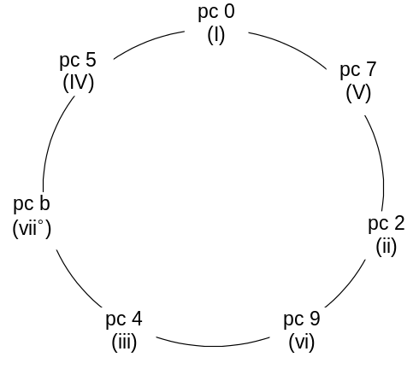

Figure 2: The circle of fifths

Note how movement of levels a-c as steps along level d (the diatonic level) naturally results in the major and minor (and diminished) triadic chords for the key (assuming I/(I) is chord Cmaj in region Cmaj):
- in Table 1 we start with a major chord – I/(I) – chord Cmaj / (region Cmaj)
- after one application (to the right) of the chord circle rule we see in Table 3 – V/(I) – chord Gmaj / (region Cmaj)
- after a second application of the chord circle rule we see in Table 4 – ii/(I) – chord Dmin / (region Cmaj)
- and so on, until:
- after a sixth application of the chord circle rule we arrive at vii°/(I) – chord Bdim / (region Cmaj)
Space | Pitch Class
a |  |  |  |  |  |  |  |  | 7
b |  |  | 2 |  |  |  |  |  | 7
c | 0 |  | 2 |  |  |  |  |  | 7 |  |  |  | b
d | 0 |  | 2 |  |  | 4 | 5 |  | 7 |  | 9 |  | b
e | 0 | 1 | 2 |  | 3 | 4 | 5 | 6 | 7 | 8 | 9 | a | b

Table 3: Pitch space for V/(I)

Space | Pitch Class
a |  |  | 2
b |  |  | 2 |  |  |  |  |  |  |  | 9
c |  |  | 2 |  |  |  | 5 |  |  |  | 9
d | 0 |  | 2 |  |  | 4 | 5 |  | 7 |  | 9 |  | b
e | 0 | 1 | 2 |  | 3 | 4 | 5 | 6 | 7 | 8 | 9 | a | b

Table 4: Pitch space for ii/(I)

Lerdahl proposes a straightforward metric for the chord proximity of two chords in the same region – a combination of the shortest number of steps between the chords on the circle of fifths and the number of common/different tones between the chords. The chord circle rule can be used to find the shortest number of steps (in either direction) between chords on the circle of fifths, calculations of this measured for chords from I/(I) are:
- 1 step to V / (I)
- 2 steps to ii / (I)
- 3 steps to vi / (I)
- 3 steps to iii / (I)
- 2 steps to vii° / (I)
- 1 steps to IV / (I)

When measuring the number of common/different tones Lerdahl proposes a measure of the number of different tones in the second chord at all hierarchical levels. For measures of chord proximity in the same region there will be no difference in the chromatic or diatonic levels (levels d and e), therefore the number of different tones in levels a, b and c are counted. Chord I/(I) can be though of as: 0 0 0 4 7 7, a 0 from level a, 0 and 7 from level b and 0 4 7 from level c.

We can therefore calculate the number of distinctively different tones in chords from I/(I) as follows:
- chord V/(I) has 2 2 7 7 7 b so distinctive new pitch classes are 2 2 7 b = 4
- chord ii/(I) has 2 2 2 5 9 9 so all 6 pitch classes are new = 6
- chord vi/(I) has 9 9 9 0 4 4 so distinctive new pitch classes are 9 9 9 4 = 4
- chord iii/(I) has 4 4 4 7 b b so distinctive new pitch classes are 4 4 b b = 4
- chord vii°/(I) has b b b 2 5 5 so all 6 pitch classes are new = 6
- chord IV/(I) has 5 5 5 9 0 0 so distinctive new pitch classes are 5 5 5 9 = 4

A single measure for the proximity (chord distance ‘d’) of two chords in the same region can be calculated by adding the two values (Lerdahl, p324):
d (chord) = shortest number of steps on circle of fifths + number of distinctive pitch classes

Applying this formula for each chord with a root in region (I) we get the following:
- chord V/(I) = 1 step + 4 distinct pitch classes = proximity distance of 5
- chord ii/(I) = 2 steps + 6 distinct pitch classes = proximity distance of 8
- chord vi/(I) = 3 steps + 4 distinct pitch classes = proximity distance of 7
- chord iii/(I) = 3 steps + 4 distinct pitch classes = proximity distance of 7
- chord vii°/(I) = 2 steps + 6 distinct pitch classes = proximity distance of 8
- chord IV/(I) = 1 steps + 4 distinct pitch classes = proximity distance of 5

The addition of these two values have been carefully chosen to correspond to cognitive importance, so that proximity on the circle of fifths is not enough, nor just the number of common pitch classes but their hierarchical importance. Thus while vii° is closed than iii on the circle of fifths, their chord proximity calculations (8 and 7 respectively) show than Lerdahl’s metric calculates iii as closer to I – this corresponds to our musical perceptions in tonal music. Likewise, while vi shares two common pitch classes with the root (0 4) and V only shares a single pitch class (7) their measure of distinct pitch classes at all hierarchical levels is the same (since 7 is the root of V and reduces the overall number of different pitch classes with the root) therefore, overall, V is found to be perceptually closer to the root than vi due to Vs proximity on the circle of fifths (1 step against vi’s 3 steps).

Lerdahl goes further, and defines a measure of chord proximity across regions using a rule that gives a chromatic circle of fifths, and a measure of region proximity. Likewise he suggests how other chord levels could be introduced for modelling particular styles of music for which such chords form a fundamental base. Lerdahl (p320) suggests the introduction of a seventh-chord level for modelling such musical styles as jazz, Debussy and Ravel, and proposes how seventh and minor chords can be modelled in the framework. One of the claimed strengths for the Pitch Space model is how a single tonal framework can support metrics for pitch-class, chord and region proximity. In this section we have summarised how Pitch Spaces can be used to measure Pitch proximity and Chord proximity with a region. Further details of the Pitch Space theory, including measure of Chord Proximity across Regions and Region Proximity, can be found in Lerdahl’s publications, and we plan to demonstration their reification in the tool in our own publications in the future.

The hierarchical and numerical nature of the pitch spaces, and the simplicity of the measurement of pitch, chord and region proximity suggest the use of this framework for computational modelling. The pitch space formalism has strong explanatory power, and as Lerdahl goes on to discuss, appears to correlate with experimental results investigating pitch class stability (see Krumhansl 1979, and Krumhansl & Shepard 1979), multi-dimensional scaling of diatonic triads (Krumhansl, Bharucha & Kessler, 1982) and abstract region spaces (Krumhansl & Kessler, 1982).

Our extended pitch space model – pitch circles
The contribution we make to Lerdahl's pitch spaces is to make the model a circular model, rather than a tabular, linear arrangement. This new model is a non-repeating, two-dimensional model in the form of concentric circles – with chromatic space as the innermost circle, and octave space as the outer one. The result is that steps and skips are seen as motions around the circles to move from one space to another, and rules such as the circle-space rule are seen as rotations of the circles themselves.

An example of the model for I/(I) is presented in Figure 3 (See Figures 11 and 12 for clearer versions of this screen in numeric (0..b) and note-letter (C..B) notations).

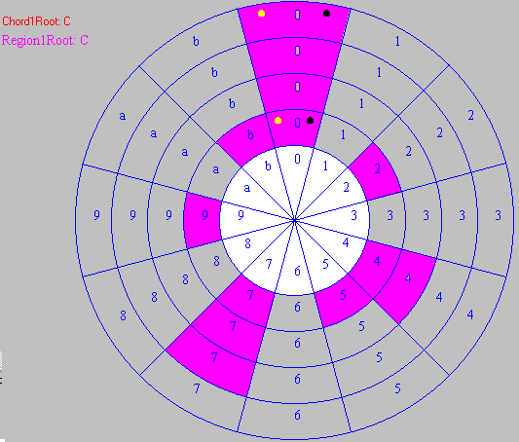
Figure 3: I/(I)

The modulus arithmetic required for calculating pitch classes now becomes natural and intuitive with the circular organisation — if it is necessary to go beyond pitch class zero (e.g. C) or pitch class 11 (e.g. B) one just continues to count around the circle in the appropriate direction. This straightforward extension to Lerdahl’s original work makes the model much more suitable for computer-based implementation as a tool for music analysis and generation by musical novices.

The current prototype
A direct manipulation implementation of our interactive, circular model of Lerdahl's pitch spaces has been developed (as a Java application). Figures 2 and 3 show the current prototype running with I/(I) and V/(I) (shown as chords Cmaj and Gmaj in region Cmaj).

Note that at the time of implementation a flat symbol was not straightforward to display, so that all notes are presented in sharp notation (e.g. A# instead of B b) – the author is aware of this notational inaccuracy and it will be addressed in the next version of the computer tool.

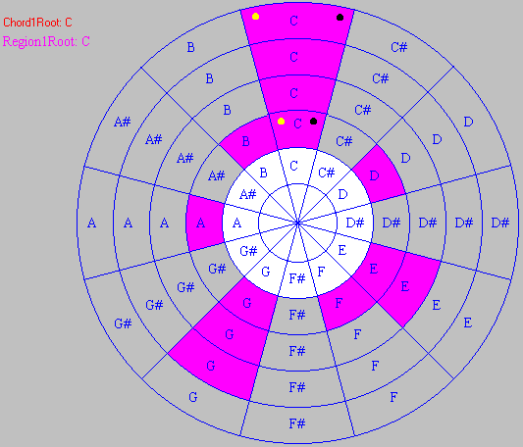
Figure 4: I/(I) as C/(C)

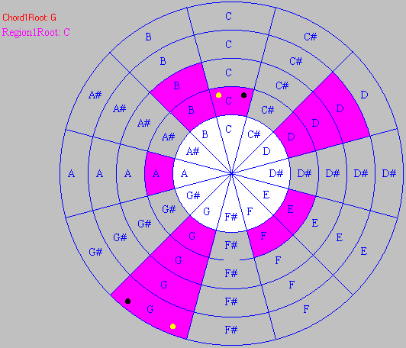
Figure 5: V/(I) as G/(C)

As can be seen from the difference between Figure 3 and Figure 4 (and full versions in the web browser in Figures 11 and 12) the prototype allows the user to choose whether to see pitch class numbers (0..b or 0..11) or the note letters assuming pitch class 0 is C.

The user currently has simply facilities such as stepping (rotating) the major chord circles (levels a, b and c) chromatically, and/or stepping the diatonic region circle (level d) chromatically. The chromatic circle is left unchanged. With each move the three notes at triadic level are played as a MIDI chord (in root inversion).

Proposed extensions to the implementation
We are in the process of extending our prototype for use in experiments with novice musicians for the support of simple harmonic analysis and composition tasks. If Lerdahl's claims are correct, and the asymmetry of his model provides a good cognitive fit with human harmonic problem solving, we expect to find positive results from our trials, in comparisons with alternatives such as Holland's (1989) ‘Harmony Space’ computer tool.

In the next few sections we shall present some examples of the kinds of questions musical novices might be asked, and how they might be able to answer them using the tool. A key feature of the tool being direct manipulation is that a student can be set tasks that are straightforward to understand and undertake, but through which they can discover concepts and rules of the subject domain, i.e. about pitch classes, chords and regions, since tasks on this tool are actions to change the state of a theoretically grounded representation of the relationships of pitch classes, chords and regions.

Chord shapes in a region
The musical novice might be presented with the system set up with Cmaj chord in the region Cmaj (as in Figure 4). In the current implementation any rotations of chord will be in chromatic steps (i.e. the chord shape is fixed as a major chord). A task that could be set to a student with the system constrained this way is:
In addition to Cmaj what are the other major chords likely to sound nice in this region of Cmaj?

The student could then rotate the chord circles (‘a’, ‘b’ and ‘c’) to discover major chords which have all three common pitch classes with the current diatonic region. Rotating clockwise from Cmaj, the student would first come to C#/(C) (see Figure 6). Clearly this chord does not share all notes with the region Cmaj, since neither C# nor G# as in Cmaj. Continuing to step the major chord shape (rotate the outer three circles) around the chromatic or diatonic circles the student would first come to chord Fmaj (see Figure 7) then Gmaj (see Figure 5) and find that these two chords, in addition to Cmaj, are the only three major chords that have all notes common with the Cmaj region.

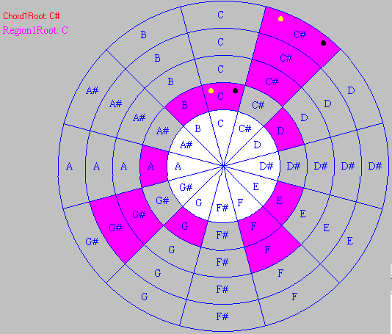
Figure 6: C#/(C)

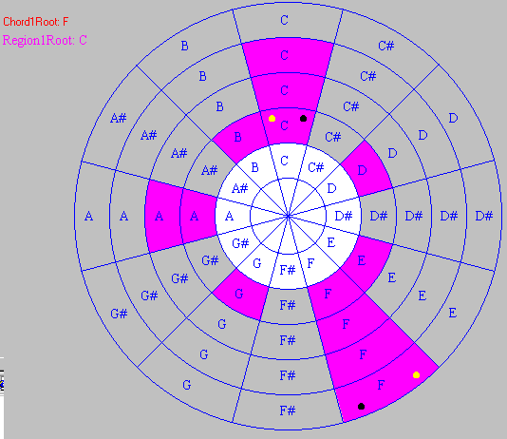
Figure 7: IV/(I) as F/(C)

Regions for which a particular chord will fit
Again, working within the current (chromatic) constraints of the current implementation, another question we might ask a student is to find in which other regions a particular chord would share all three notes. For example if, once again, the musical novice is presented with the system set up with Cmaj chord in the region Cmaj they could be asked the following question:
In addition to the region Cmaj what are the other regions in which the chord Cmaj is likely to sound nice (i.e. fit all three pitch classes)?

Rotating the diatonic region circle clockwise from Cmaj, the student would first come to C#maj (see Figure 6). Clearly the chord Cmaj only shares one note with the region C#maj (note C, see Figure 8).
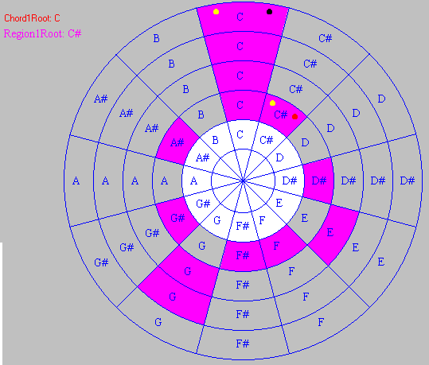
Figure 8: C/(C#)

Continuing to step the region around this way the student will come across the 2 diatonic regions in which chord Cmaj does share all notes — region Fmaj (see Figure 9) and region Gmaj (see Figure 10).
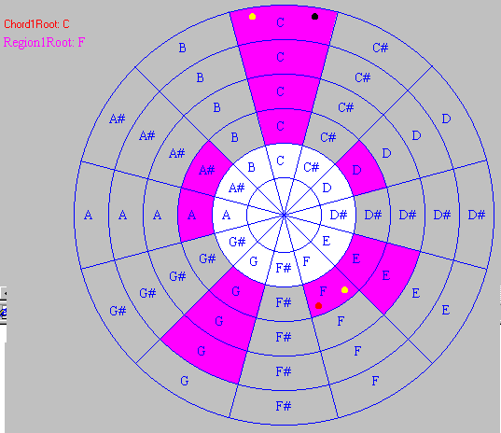
Figure 9: C/(F)

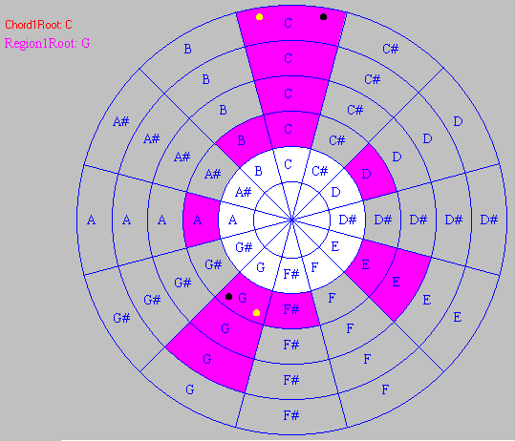
Figure 10: C/(G)

Tasks possible with extensions to the current implementation
If the system has added features to allow straightforward comparison of two regions (perhaps two overlapping pitch circles with different colours/shading), we could ask the student to derive the cycle of fifths as progressions to the most similar regions:
Which are the closest regions to Cmaj — i.e. which regions shall all but one pitch class.

If the system could properly apply the chord circle rule, so that the chord shapes will change between major, minor and diminished as spaces a, b and c are stepped along the diatonic space, then a student could be asked to derive which chords are major, minor and diminished for each region. Both aspects of chord proximity (circle of fifths distance and number of distinct pitch classes) could easily be understood by students using the tool with such facilities.

Conclusions & Further work
Initial, informal experiments with musical novices have been encouraging. Clearly the extended circular model maintains the features and strengths of Lerdahl’s original, tabular pitch space model. Once the prototype implementation is complete stand alone and comparative experiments as suggested above will be conducted. The fact that the model and computer program represent the asymmetry of the diatonic system may be important to help students move more easily from theory to practice on physical instruments where such asymmetry is unavoidable. We hope we have illustrated the advantages of building direct manipulation interactive computer-based learning tools on sound and rich theoretical foundations – it becomes straightforward to set simple tasks that enable a student to engage with the domain theory and relationships directly. With appropriate actions and constraints, actions with the tool are always meaningful in the domain. The challenge now is to add direct manipulation interface components to allow users to perform a range of meaningful actions on the state of one or more pitch circles.

Oversize screen shot figures
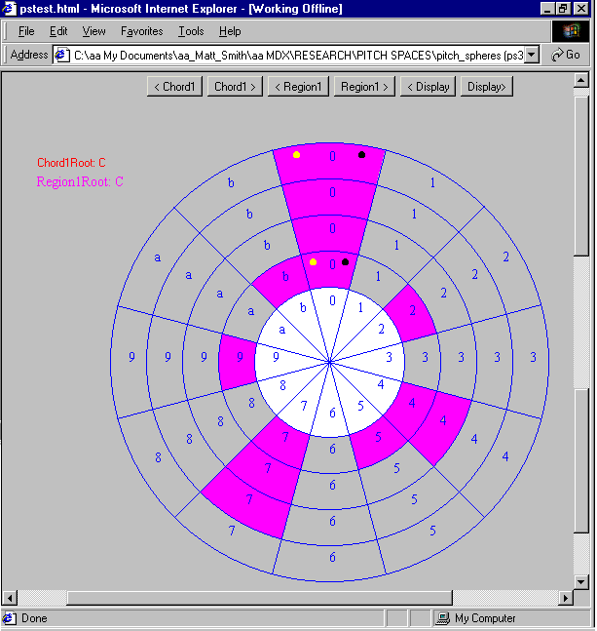

Figure 11: Pitch Circles tool in web browser window, numeric notation mode I/(I)

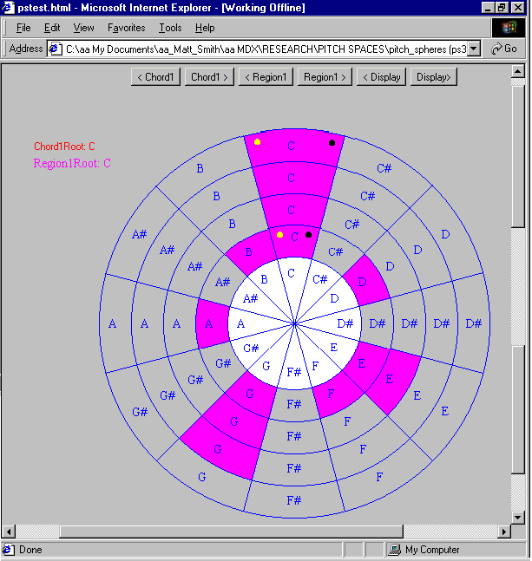

Figure 12: Pitch Circles tool in note letter mode I/(I) as C/(C)

Related publications
This paper is an updated and extended version of a publication at the Symposium on Creative & Cultural Aspects and Applications of AI & Cognitive Science, part of AISB-2000, Birmingham, UK, April 2000.

References
Balzano (1982) G. J. Balzano, The pitch set as a level of description for studying musical pitch perception, In Music, Mind and Brain: the neuropsychology of music, M. Clynes (Ed.), Plenum, New York, USA.
Deutsch (1982) D. Deutsch, The processing of pitch combinations, in D. Deutsch (Ed.): The Psychology of Music, Academic Press, NY, USA.
Deutsch & Feroe (1984) D. Deutsch & J. Feroe, The internal representation of pitch sequences in tonal music, Psychological Review, 88:503-522.
Holland (1989) S. Holland, Artificial Intelligence, Education and Music, Unpublished PhD thesis, IET, Open University, UK, 1989. , Perceptual structures for tonal music, In Perception, 1(1):28-62.
Krumhansl et al. (1982) C. Krumhansl, J. J. Bharucha & E. Kessler, Perceived harmonic structure of chords in three related musical keys, In Journal of Experimental Psychology: Human Perception and Performance, 8:24-36.
Krumhansl & Kessler (1982) C. Krumhansl & E. Kessler, Tracing the dynamic changes in perceived tonal organisation in a spatial representation of musical keys, In Psychological Review, 89:334-368.
Krumhansl & Shepard (1979) C. Krumhansl & R. Shepard, Quantification of the hierarchy of tonal functions within a diatonic context, Presented at the Conference on Music and the Cognitive Sciences, 17-21 September, Cambridge, UK.
Lerdahl (1988) Fred Lerdahl, Tonal Pitch Space, Music Perception, 5 (3):351-350.
Lerdahl and Jackendoff (1983) Fred Lerdahl & Ray Jackendoff, A generative theory of tonal music. Cambridge, MA: The MIT Press, 1983.
Longuet-Higgins (1962) H. Christopher Longuet-Higgins, Two letters to a musical friend, In The Music Review, November 1962, 23: 244-228 & 271-280.
Schoenberg (1911/1978) Arnold Schoenberg, Theory of Harmony, originally published 1911. Translated by R. Carter, University of California Press, Berkley, CA, USA.
Shepard (1982) R. N. Shepard, Mental images and their transformations, The MIT Press, Cambridge, MA, USA.
Shneiderman (1982) Ben Shneiderman, The future of interact systems and the emergence of direct manipulation, In Behaviour and Information Technology, 1:237-256.
Smith & Cuddy (1997) Nicolas A. Smith & Lola L. Cuddy. Patterns of tension/relaxation in music: A consideration of psychoacoustic and cognitive influences. Canadian Acoustics, 25(3):38.
Weber (1830/1851) G. Weber, The theory of musical composition, Mainz: B. Schotts Sohne. (originally published as Versuch einer Geordneten Theorie der Tonsetzkunst, 1830).

