

**Web Framework Development**

**LAB TEST 2**

**SAMPLE for March 2017**

**This is a 2-hour-30-minute lab test**

**Students arriving more than 10 minutes after the start of their lab test will not be permitted entry.**

**The test is fully open book**

PLEASE **SAVE** YOUR WORK FREQUENTLY …

**Instructions for preparation and submission of work**

This test will be marked out of 100 marks

Answer ALL questions

Unless asked otherwise use the PHP namespace: **Itb**

You may either submit a single project (implementing all questions), or separate folders, one per question. It is recommended that you answer the questions in the order presented.

Do NOT submit more than one folder per question – multiple attempts at the same question will not be graded.

NOTE:

* At the end of the test:
  + Save all your work
  + Close all your applications
  + ZIP up your web root folder and submit the single ZIP file   
    (the lecturer will indicate how the file is to be submitted)
  + Submit only a ZIP file (i.e. 7zip or Rar etc. will not be accepted)

Do not leave the test room until the lecturer has confirmed your files have been submitted – if you leave before doing so then you risk the chance that your files have not been received for marking and you would score zero.

Class Book (and documentation web pages) are provided in the files for this test.

Data items used in this exam

id **1239**

title **brown**

image **father_brown.jpg**

total pages **320**

index pages **25**

id **8761**

title **marple**

image **miss_marple.jpg**

total pages **201**

index pages **11**

id **3003**

title **holmes**

image **sherlock_holmes.jpg**

total pages **432**

index pages **30**

You have been provided with a non-MVC site, which retrieves all Book objects from a BookRepository object and displays them as an HTML table.

You are to refactor the provided site into an MVC web application, demonstrating:

* a single front controller, Silex routing and Twig templating
* a WebApplication class (extending Silex Application)
* aborting and/or forwarding requests
* controllers as classes

Note  
the provided folder has already had the Twig and Silex vendor packages installed via Composer.

**Question 1 – basic routes 25 marks**

Implement the following routes:

/

* + a welcome message
  + a link to the list page

/list

* + an HTML table listing all books
  + make the first column of the home page a link to the ‘show’ page passing the book’s id

/show/<id>

* + show details of one book record as headings and paragraphs
  + where <id> represents the numeric id of the record to be displayed

**Question 2 – database driven 25 marks**

Refactor class BookRepository to work with book details in a MySQL database.

**Question 3 – improved structure 25 marks**

(if you have not already done so …) Please refactor your code to have the following:

* Twig template inheritance has been used
  + so all child pages extend a base template, that declares HTML head, title, etc.
* separate the MCV components into their own directories, with their own namespace subsnamespaces (and update code / composer correspondingly)
  + model classes in /src/model, with namespace Itb\Model
  + controller classes in /src/controllers, with namespace Itb\Controller

**Question 4 – error handling 25 marks**

Refactor your answer to cope elegantly with the following error situations:

* if the id for a non-existent book is received by the show route (404 error with message)
* if route /show is requested with NO id at all (400 error with message)
* if a route is requested which does not match any that have been defined
  + i.e. cope with 404 – not found errors

**Screenshot – home page**

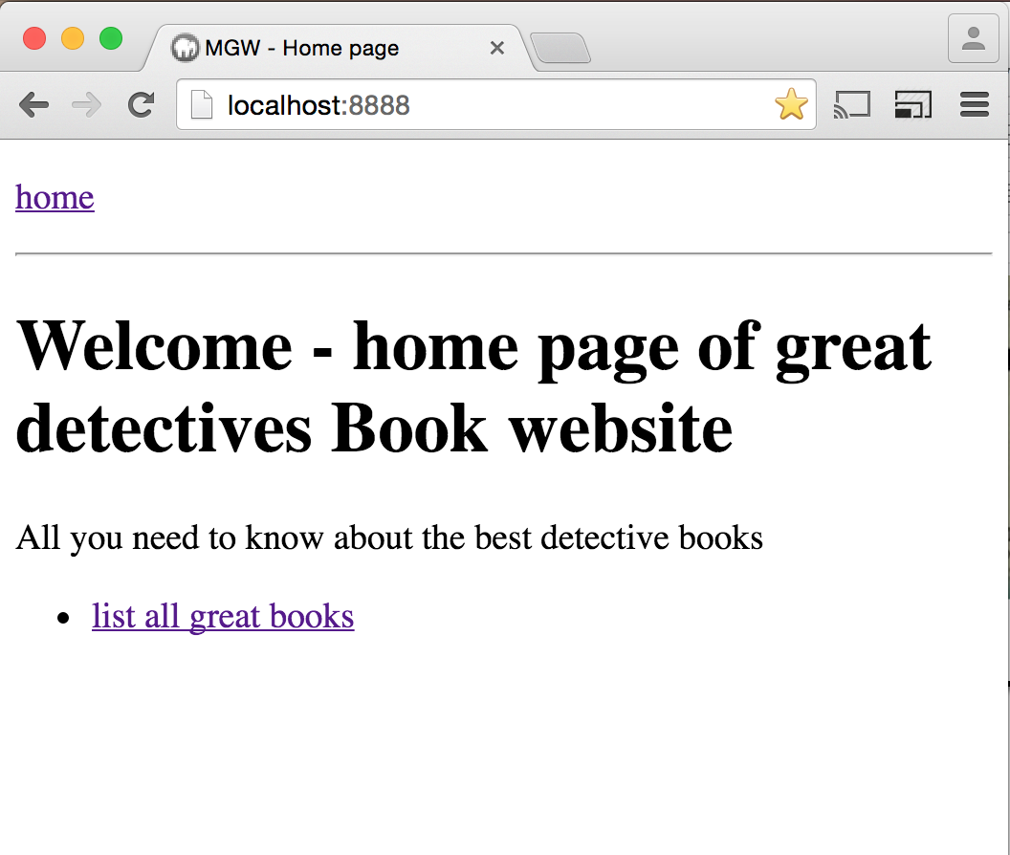

**Screenshot – list all books**

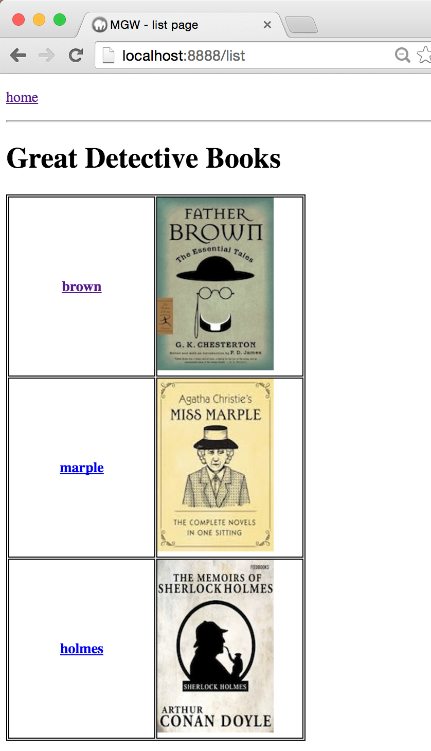

**Screenshot – show book for a given ID (book exists)**

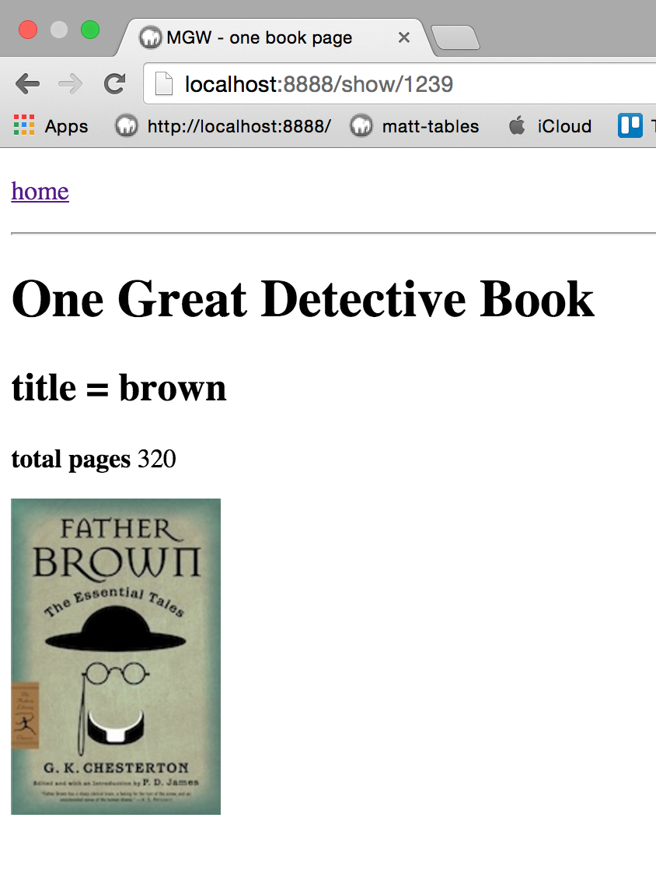

**Screenshot – show book for given ID, BUT no book for that ID**

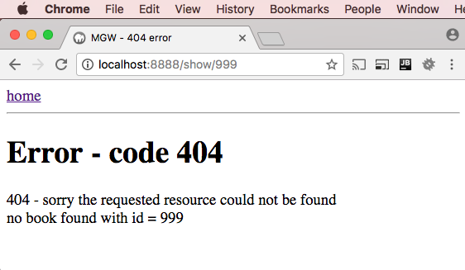

**Screenshot – show book for given ID, BUT no id provided**

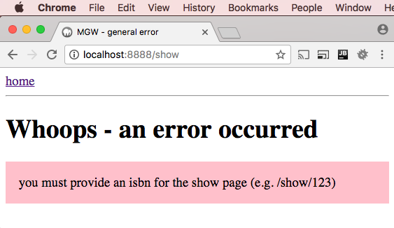

**Screenshot – bad route (no such page)**

