Web Development 1 – Lab Session 5
HTML page level blocks

In this lab you’ll first create a simple page, and apply styles to some DIVs and SPANs, using element and class selectors.
Next you’ll organise a page into header, footer and three columns of content. First download the ‘red_queen’ files and unzip into your lab05 folder. NOTE: You are advised to improve code readability with HTML comments before each page level block element.

NOTE: For the second half of this lab sheet you’ll be editing the mona.html text file provided (and its associated CSS and image assets).
PART A
Exercise A1: Class selector and anonymous class selector
- Create a new HTML file containing the following heading and 3 paragraphs:
<h1>Classes are great</h1>
<p>
I am paragraph 1
</p>
<p>
I am paragraph 2
</p>
<p>
I am paragraph 3
</p>

- Write a CSS file to style all paragraphs to have green text (and add an appropriate import statement in the HTML to read in this styesheet).

- We now want to make only the second paragraph have yellow background color. Add a class attribute to the opening <p> tag of paragraph 2, giving it the class “special”:
<p class="special">
I am paragraph 2
</p>

- Now add a CSS rule so that paragraphs of class “special” have a yellow background:
p.special {
background-color: yellow;
}

- Next edit the opening tag of the level 1 heading, and make that heading also belong to class “special.
<h1 class="special">

- Let’s change the CSS rule so that it is an anonymous class – i.e. ANY element of class special will have the rule applied; so we remove the ‘p’ before the full stop:
.special {
background-color: yellow;
}
Exercise A2: Span
- Let us apply some style to the word “great” in the level 1 heading. Since strong and em might be used in some other way in out imaginary website, lets use the generic inline element “span” and a class, to be able to target a style rule to be applied only to the word “great”. First add the span tags around the word, with a class of “stand_out”:
<h1>Classes are <span class=”stand_out”>great</span></h1>

- Now add a CSS rule so that elements of anonymous class “stand_out” are in small-caps:
.stand_out {
font-variant: small-caps;
}
Exercise A3: Div
- Write a new HTML file about songs – there will be a band as a level 1 heading and one of their songs in a paragraph.
<h1>Blondie</h1>
<p>Hanging on the telephone</p>
<h1>Sex Pistols</h1>
<p>God save the Queen</p>
<h1>Maklemore & Ryan Lewis</h1>
<p>Same Love</p>

- We can group each heading and paragraph together with the generic <div> element. (We could also use section – but let’s use div this time). Finally write your own style rule to blocks of class “song” (next week try adding a border-top to each DIV …).
<div class=”song”>
<h1>Blondie</h1>
<p>Hanging on the telephone</p>
</div>
...
PART B: Mona museum
Exercise B1: Headers and footer
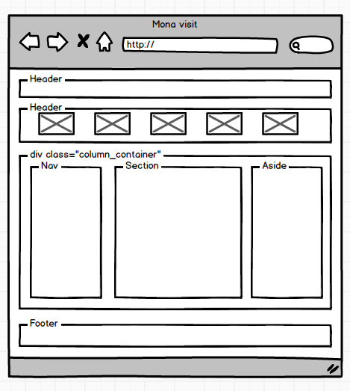
Before you start – look at this diagram – this is the high level ‘page layout’ you are to create using HTML blocks in this part of the exercise.

- Unzip the provided Mona resoures into a sub-folder of your lab05 folder. Do all your work in this folder.
Note: Use 7zip – extract to here (right mouse button menu) to Unzip folders when working on ITB Windows computers. Avoid the use of the build-in Windows.
Do NOT double left-mouse-click a ZIP folder - you’ll just be ‘looking inside’ the ZIP folder, but have not actually extracted the contents.
Extract the folder then DELETE the ZIP – don’t leave ZIP files hanging around your computer hard disk.
- Add a parent ‘header’ element around the level 1 heading.
<!-- *********** HEADER *********** -->
<header>
<h1>Mona - Museum of Old and New Art</h1>
</header>

- Add another parent ‘header’ element around the 4 images images just after the level 1 heading, AND add a <section> around each image:
<header>
<section><img src="images/logo.png" alt="red queen exhibit"></section>
<section><img src="images/red_queen1.png" alt="red queen exhibit"></section>
<section><img src="images/red_queen2.png" alt="red queen exhibit"></section>
<section><img src="images/red_queen4.png" alt="red queen exhibit"></section>
<section><img src="images/red_queen5.png" alt="red queen exhibit"></section>
</header>

- Markup the final line in the body as a ‘footer’ element:
<footer>
2013 Tasmania visit report &copy; Matt Smith
</footer>

- When you view the page in a browser you should see how some of the styles for header and footer have been applied...
Exercise B2: Navigation links into a ‘nav’ element
- Markup the level 2 heading ‘links’ and its unordered list of links as being inside a ‘nav’ element:
<!-- *********** NAV *********** -->
<nav>
<h2>links</h2>
<ul>
<li>
<a href="http://www.mona.net.au/">Main museum website
...
...
<li>
<a href="http://www.canberratimes.com.au/photogallery/entertainment/art-and-design/the-red-queen-exhibit-at-mona-20130618-2oh6m.html">
Canberra Times Mona review web page
</a>
</li>
</ul>
</nav>
Exercise B3: List of exhibitions into an ‘aside’ element
- Markup the level 2 heading ‘July 2013...’ and its definition list of exhibits as being inside an ‘aside’ element:
<!-- *********** ASIDE *********** -->
<aside>
<h2>
July 2013 Mona exhibition highlights
</h2>
<h3>
Chen Zhen (installation) "Danser la musique"
</h3>
<p>
trampoline with bells attached - make music as you bounce
...
...
a room full of TVs and arm chairs, each TV show a different person's life story
</p>
</aside>
Exercise B4: Main content elements into a ‘section’ element
- Markup all the content between the ‘nav’ and ‘aside’ elements as bring inside a ‘section’ element:
<!-- *********** main section *********** -->
<section>
<h1>Museum Of New and Old art (Mona)</h1>
<h2>Background</h2>
<p>
Hobart hosts an internationally renowned new
...
...
<li>
Visitors paths through the museum are recorded, allowing visitors to retrieve they routes from the web at a later date (if they provided an email address), and also providing useful traffic date for museum staff, in terms of visitor behaviour while in the museum
</li>
</ul>
</section>

<aside>
<h2>July 2013 Mona exhibition highlights</h2>
Exercise B5: Column container for nav, section and aside
- We want a 3-column page layout, this is achieved by placing the ‘nav’, ‘section’ and ‘aside’ elements inside a containing DIV, which we will give the class ‘column_container’. The CSS file ‘layout.css’ contains rules that will arrange these elements into a neat 3-column page, sandwiched between the page-wide header and footer:
<!-- *********** MAIN DIV - column container *********** -->
<div class="column_container">

<!-- *********** NAV *********** -->
<nav>
<h2>
links
</h2>

HINT:
Don’t forget to add the </div> closing tag BEFORE the footer block …

Step by step you have marked-up page level rectangular blocks to have CSS applied to create the following 3-column page layout:
