Web Development 1 - Lab Session 3

**Text and list mark-ups & styling with CSS**

You will practice your web skills by creating a web page for a recipe. You will also be trying out what you learned about CSS and simple text formatting and colours.

**Exercise 3-A: Gathering The Assets**

Create a folder called **lab03** in your **web_dev_1** folder and place into this folder these 2 files: pepper.jpg (an image of a red pepper), and recipe.txt (text content for this page).

Look at Screenshot 1. Your task is to make the web page based on this. It should contain the textual content, the pepper image, and be as close to the print version as possible.

**Exercise 3-B: Add document structure**

1. Make a copy of recipe.txt naming the copy recipe.html
2. Add to recipe.html the basic HTML document structure: DOCTYPE and head and body elements. All the text content should be inside the body element.
3. In the head declare the title of the web page as “Rice and Pepper pilaf – home page”

HINT:

**<!DOCTYPE html>**

**<html>**

**<head>**

**<meta charset="utf-8">**

**<title>Rice and Pepper pilaf - home page</title>**

**Exercise 3-C: Further steps**

Use element **<strong>** to embolden text where necessary and **<br>** elements for line breaks.

1. Make the first line inside the body an image element, displaying the red pepper image
2. Make the text “red rice and pepper pilaf” be declared as a level 1 heading, with a line break after the word “and”
3. After the heading, the three lines of text starting “preparation time…” should be a single paragraph **<p>** element.

HINT:  
Use line breaks to force the sentences starting “cooking” and “total time” onto a new line

1. Use **<hr>** when you want a horizontal line (rule – HR – Horizontal Rule) across the page.

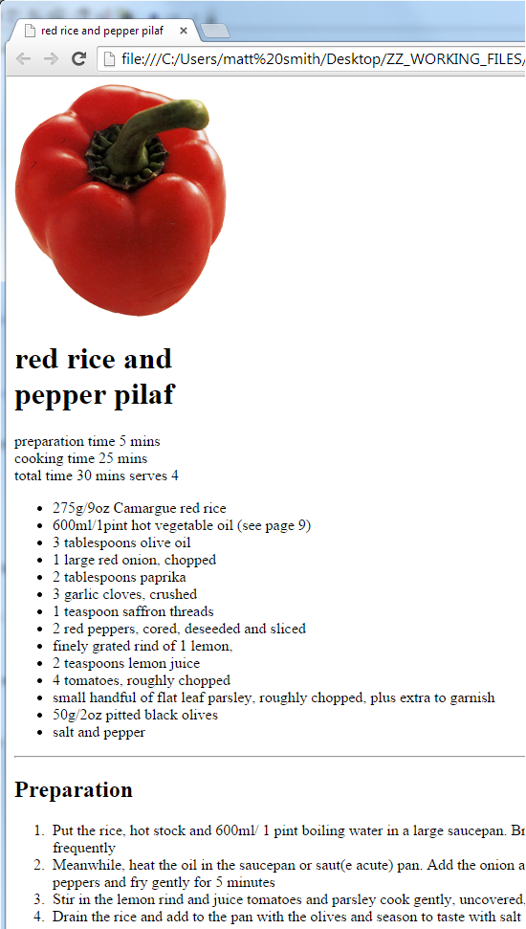

**Exercise 3-D: Further hints…**

1. Use an unordered list for the ingredients, and an ordered list for the Preparation:

HINT:

**<ul>**

**<li>275g/9oz Camargue red rice </li>**

**<li>600ml/1pint hot vegetable oil (see page 9)</li>**

1. Add a horizontal rule before the level 2 heading “Preparation”

(**Summer menu at the restaurant – CSS exercises …**)

**Exercise 3-E:** Gathering The Assets

Download the following files from the module website/moodle:

* menu_summer.html

**Exercise 3-F: Create a simple external style sheet**

1. Create a new, empty text file menu.css
2. Add the following body CSS style rule to this new style sheet text file.

**body {**

**font-family: Verdana, sans-serif;**

**}**

1. Validate your code, and fix any errors before moving on.

**Exercise 3-G: Make HTML page import style sheet**

1. Modify HTML file menu_summer.html file so that it imports your new CSS stylesheet menu.css
2. Validate your code, and fix any errors before moving on.
3. View the webpage in a browser - all text should be in a sans serif typeface

Your page should look as follows:

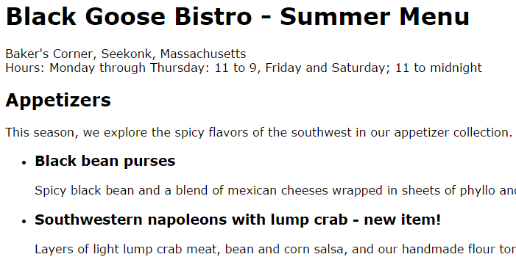

**Exercise 3-H: Italicise the strong Elements**

Now that the menu items are in bold, some of the text marked up as strong in the document is not standing out very well. We are going to add extra emphasis to these by making them italicised as well as bold. To do this we add a font-style property to the strong element.

strong {

font-style: italic;

}

**Exercise 3-I: Try out the Small Caps**

Let’s set the h1 heading to be in small caps to see if it works. Add a new CSS style rule to apply to all h1 elements.

h1 {

font-variant: small-caps;

}

**Exercise 3-J: Add some text (foreground) colour**

Add colour to the “new item!” elements next to certain menu item names. They are marked up as strong, so we can add the color property to the strong element.

**strong {**

***font-style: italic;***

**color: maroon;**

}

**Exercise 3-K: Add some background colour**

Set the background colour for the h1 headings to be yellow.

**Exercise 3L: Further HTML work - Winter Menu**

Using the summer as a guide, complete the HTML mark-up for winter.html.

Once the HTML for this file is complete, add the @import statement for it to use the same stylesheet as for menu_summer.html – i.e. menu.css