Web Development 1 – Lab Session 4

**Images, links and CSS styling text**

**Exercise 4-A: A list of external links**

1. Create a new webpage that offers links to some useful websites:

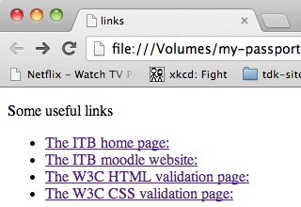

The ITB home page:

**www.itb.ie**

The ITB moodle website:

**moodle.itb.ie**

The W3C HTML validation page:

**validator.w3.org**

The W3C CSS validation page:

**jigsaw.w3.org/css-validator**

HINTS: External links need absolute URLs – including the http protocol etc.

**<ul>**

**<li>**

**<a href**

**Exercise 4-B: Page 1 of a simple 2-page website**

1. Create a webpage (named page1.html) that looks as follows, and links to page2.html

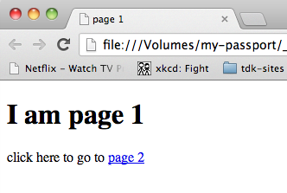

HINT: Internal links just need the HTML filename   
(since the linked page should be in the same website folder)

**Exercise 4-C: Page 1 of a simple 2-page website**

1. Create the second webpage, named page2.html, that looks as follows and links back to page1.html

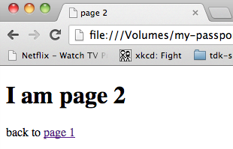

**Exercise 4-D: Images**

Provided with this lab sheet should be the following 4 images: dog.png, cat.png, dog_button.png, cat_button.png.

1. Copy all images provided into a folder “images”
2. 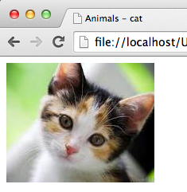Create a file cat.html that displays the cat image, and a page dog.html that displays the dog image.
3. Create a new HTML file animals.html that displays the two button images.

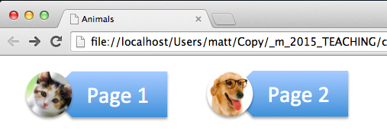

**Exercise 4-E: Images as links**

1. In animals.html mark-up the page 1 cat image button as a link to cat.html
2. Likewise mark-up the page 1 dog image button as a link to dog.html

**Exercise 4-F: CSS styling text**

1. Create a complete HTML file (i.e. a validating page with DOCTYPE and head etc.) named fox.html with where the body contains simply a single paragraph with the text: **The quick brown fox jumps over the lazy dog.**

HINT:

<p>The quick brown ...

1. Create CSS file root.css to style the root **html** element with a font size of 17 pixels.

This sets the base font size from which all other fonts and borders/spacing will be based.

1. Create CSS file style1.css to style paragraph elements with the following properties:

* Font family is sans serif
* Font size is 80% of the root font size (i.e. **0.8rem**)

Modify HTML file fox.html to import CSS files root.css and style1.css

Web page fox.html should look as follows is the browser:

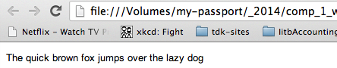

**Exercise 4-G: CSS styling text – fantasy 30pt**

1. Create CSS file style2.css to style paragraph elements with the following properties:

* Font family is fantasy
* Font size is twice the size of the root font size (i.e **2rem**)

1. Modify HTML file fox.html to now import CSS file style2.css
2. Re-open fox.html in a web browser to see the changes to the text styling

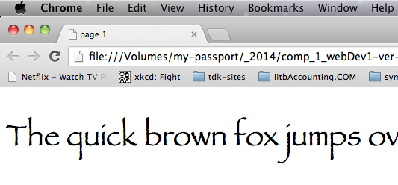

**Exercise 4-H: CSS styling text – order of preference**

1. Create CSS file style3.css to style paragraph elements with the following properties:

* Typeface chosen will be Courier New if available, otherwise Courier if available, otherwise the generic monospace
* Font size is 1.5 times the root font size (i.e. **1.5rem**)

1. Modify HTML file fox.html to now import CSS file style3.css
2. Re-open fox.html in a web browser to see the changes to the text styling:

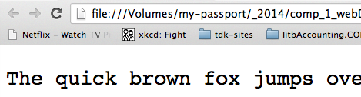

1. Edit style3.css to change the first preference font to Arial (rather than Courier New), and see the difference
   1. NOTE: If the computer you are testing on does not have Arial, then choose some other named font that is on your computer – you can get a list of fonts in any word processor document:

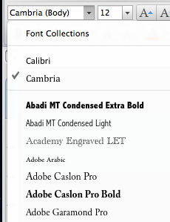

HINT:

font-family: "Courier New",