Web Development 1 – Lab Session 6

**Practice with the Box Model**

Today you will be implementing CSS concepts CSS box model & descendent selectors.

**Exercise 1: Unzip and look at page in browser**

1. Download the folder of assets for this exercise, then open file jenware.html in the Google Chrome browser. This is a page for fictional shopping site.
2. Look at the page to get a ‘feel’ for the different items of content in the page.

How the page looks before the lab session:

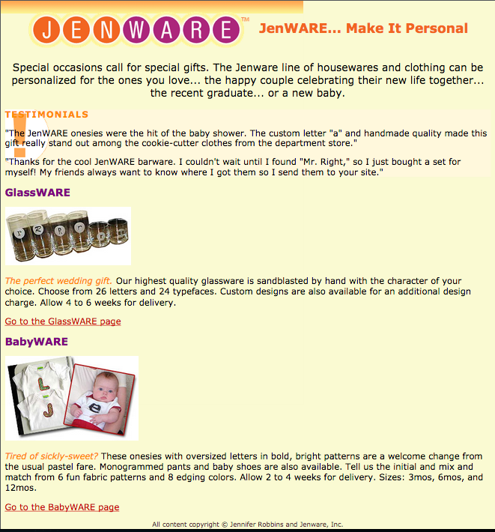

**Exercise 2: Open in text editor and get to know the code**

1. Now open jenware.html in TextPad. Look over the HTML to get a better idea of the structure of the document, in terms of the BLOCK-level elements making up the different parts of the page.
2. Finally open box_model.css in your text editor. You will do all your work in this file for these lab exercises.

Note that the document has been divided into **three section elements** (“intro”, “testimonials” and “products”). If you look in the other CSS files you can see rules for background colours have been added to the body, testimonials, and products sections. There are other rules for formatting text and a horizontally repeating background image along the top of the body

**Add all your CSS rules for this lab session into file:  
box_model.css**

Notice the SEQUENCE of CSS imports – because **box_model.css** is last in the sequence then CSS rules in this file will **override** any in the previously loaded CSS file.

As always, BEFORE you look the page in Chrome:

1. Validate your HTML and CSS code before looking at it in the browser
2. PREDICT what change you will see when you reload the web page in the browser  
   (also refer to the CSS properties, and check line has had the affect your expected it to)

**Exercise 3: Edit code - add Some Padding**

Add a white background and some padding to the “products” div. Two rems of padding all around should be fine. In box_model.css in write a new rule for the **.products** class selector:

.products {

padding: 2rem;

background-color: white;

line-height: 2rem;

}

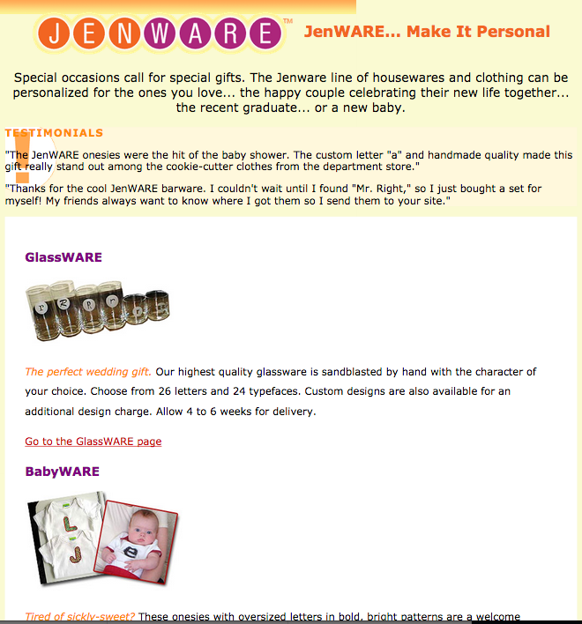

**Exercise 4: Clear Some Space**

We will now clear some text from the left side of the testimonials **section** so that the exclamation point background image is visible. Do this by adding some **padding**. Remember padding is spacing INSIDE the border of a block.

The rule below firstly adds 1 rem of **padding** to all sides of the **section** and then a second declaration adds 3 rem’s of **padding** to the left side. The second one will override the first one, meaning that the left side will have 3 rem’s of **padding**, the other 3 sides will have 1 rem.

.testimonials {

padding: 1rem;

padding-left: 3rem;

}

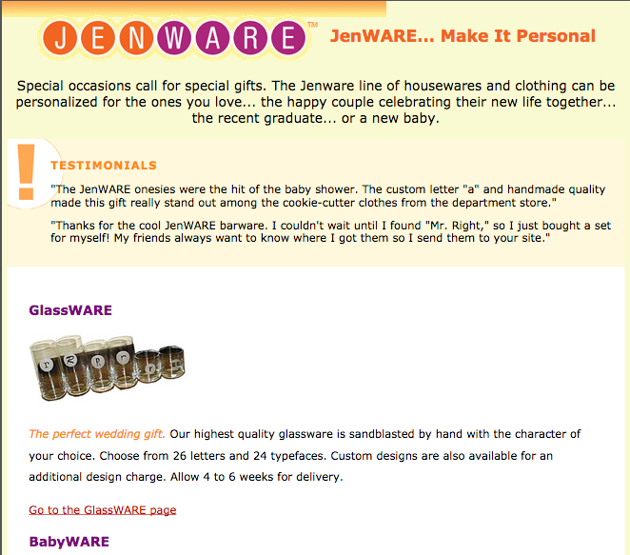

**Exercise 5: Fun With Borders**

Use the shorthand border property to add an orange dashed **border** around the testimonials section. Do this by adding the following declaration to the rule for the testimonials **section**.

border: 0.1rem dashed orange;

Now add a double rule around the “products” area that is a lighter shade (try the colour ‘coral’). Do this by adding the following declaration to the rule for the products **section**.

border: double coral;

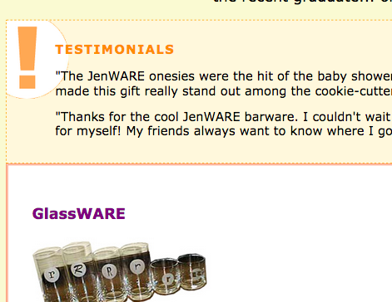

**Exercise 6: More Fun With Borders**

Now we’ll add decorative borders on two sides of the **headlines** in the **products** section. We will make the borders the same colour as the text by simply not setting a border-color.

Create a new rule targeting **h2** headings inside the products section:

1. Add a declaration that adds a 0.1rem solid border on the top of the level 2 heading.
2. Add another declaration that adds a thicker, 0.4rem solid rule on the left side.
3. Finally, to prevent the test from bumping into that left border, we can add a little bit of padding (1 rem) to the left of the headline content.

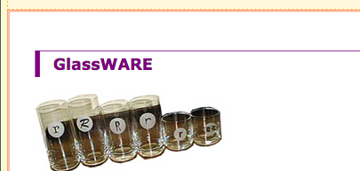

**Exercise 7: Fixing Up The Links**

Now replace the standard text underline under links with a decorative bottom border.

1. First, turning off the underline for all links, by setting the text-decoration to none

text-decoration: none;

1. Next, add a 0.1 rem dotted border to the bottom edge of every link:

border-bottom: 0.1rem dotted;

1. Finally, when a **border** is added it is usually a good idea to add some padding so the text isn’t too close to the border. So add the following to your rule for links:

padding-bottom: 0.25rem;

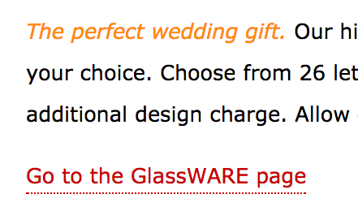

**Exercise 8: Adding Margin Space to the Body**

Firstly, add some space between the browser window and the sides of the content. Making the margins 10rem of the browser window should give it plenty of space. Create a rule for the **body** element.

margin-left: 10rem;

margin-right: 10rem;

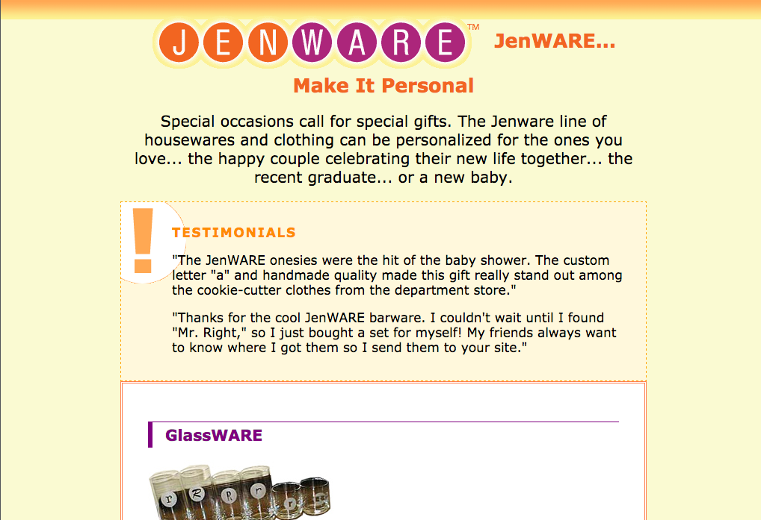

**Exercise 9: Centring the Testimonials Box**

Suppose we want to centre to the testimonials box horizontally on the page. A good way to do this is to set a fixed width for the box and then set the left and right margins to auto. This means that the browser will apply as much **margin** as is necessary to fill the available space and keep the element centred in the browser window. Add the following to declarations to the rule for the testimonials **section** in order to achieve this:

width: 30rem;

margin: 2rem; /* make all 4 sides have 2rem margin */

margin-left: auto; /* override left margin to be auto */

margin-right: auto; /* ditto for right margin */

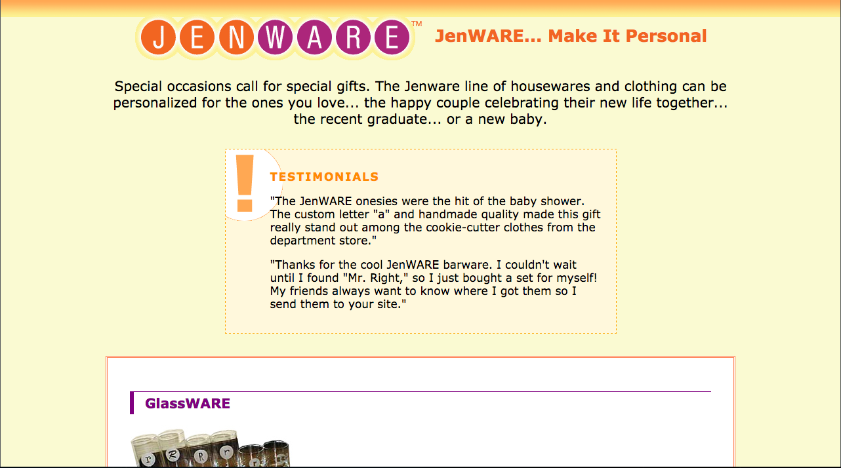

**Exercise 10: Margin Space Above Headings**

Now add a 3 rems of space above the product category **h2** elements by adding a declaration using the **margin-top** property.

So add a declaration to add this spacing in your **.products h2** rule.

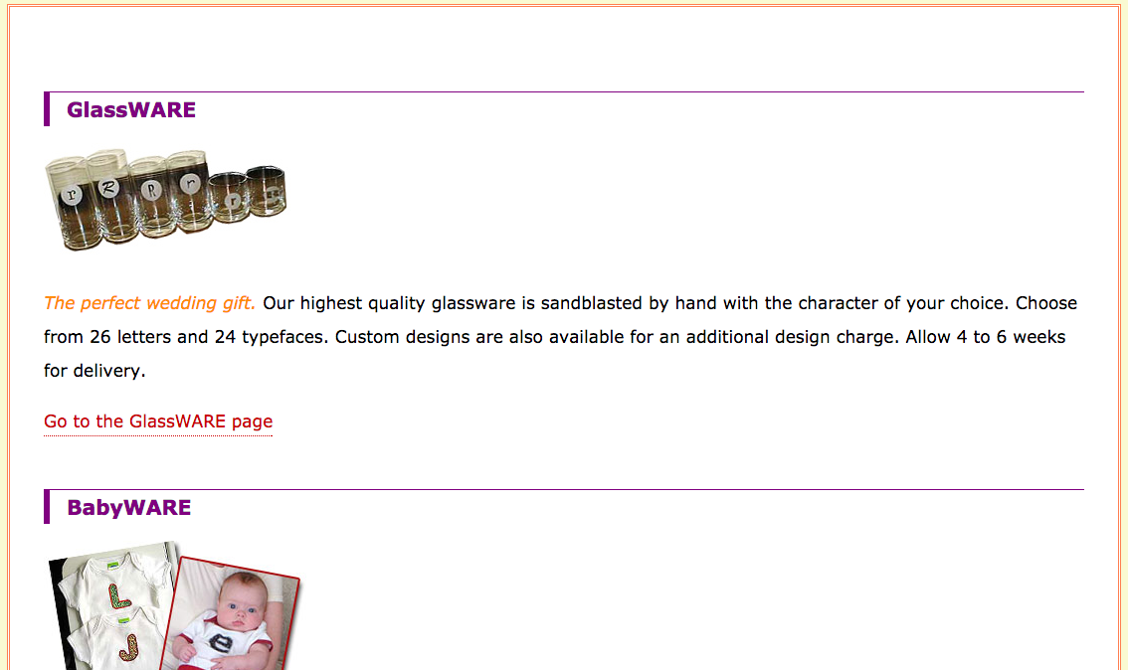

**Exercise 11: Finally …**

Finally, let’s get rid of the 3 ems of space above the first **h2** heading as we don’t really need it. How can we pick out this heading? Well, it belongs to the class “first” so the following rule will achieve this:

.products h2.first {

margin-top: 0;

}

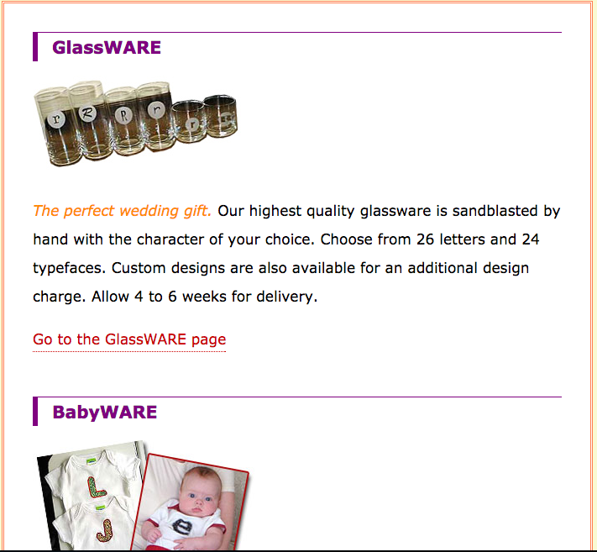

Having completed all exercises, your page should now look as follows:

