# Web Development 1 – Lab Session 7

**Styling lists of links as navigation bars**

Today you will be using CSS styling to create navigation bars from simple lists of links.   
You’ll build a professional looking vertical navigation bar from scratch, step-by-step.

**Exercise 1: Create an unorderd list of page names that link to respective HTML files**

Create an unordered list of pages for a personal website (name your file **index.html**. Each word/phrases should be marked up as a link to the corresponding page:

* Home (index.html) About Me (about.html),
* Gallery (gallery.html) Contact Me (contact.html)

Put the whole unordered list inside a ‘nav’ element, since these links are the main navigation links on the page.

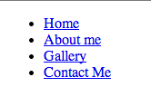**Hint:**

<nav>

<ul>

<li><a href="index.html">Home</a></li>

<li><a href="about.html">About Me</a></li>

etc.

**Exercise 2: Remove the spacing and bullets from the parent ‘ul’ element**

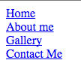Add to your CSS a rule to remove all padding, margins, and list style bullets from the <ul> list element in nav

nav ul {

padding: 0;

etc.

**Exercise 3: Style the links, and add a hover (rollover) effect**

Create a sub-folder named ‘**css/**’, and in that folder create file **nav.css**. Write rules in this CSS file to do the following:

* All ‘a’ elements should have foreground colour red, and no underline
* When the mouse is hovering over ‘a’ elements, the underline should be seen

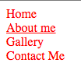nav a {

color: red;

 etc.

nav a:hover {

etc.

**Exercise 4: Make ‘a’ elements display as blocks, so they ‘fill up’ parent ‘li’ elements**

Each link element <a> is inside a parent <li> element. If we tell the browser to make ‘a’ elements inside ‘li’ elements display as BLOCKS, then each ‘a’ element will expand to fill the full width of the ‘li’ parent. We’ll also make the background of ‘a’ elements yellow.

**Hints:**

* Don’t forget you must use Google CHROME browser to test our advanced CSS rules...

nav a {

...

**display: block;**

**text-align: center; /* let’s also center content in each ‘a’ block */**

**Exercise 5: Add some background colour and padding to ‘a’ elements**

So we can see the ‘rectangle’ box forming each link <a> element, let’s add more CSS for ‘a’ elements adding **background color yellow**, and **padding of 0.5 ems**.

Let’s also make the link rollover effect to **swap the background and foreground colors**.

**Hints:**

nav a {

...

**background-color: yellow;**

nav a:hover {

text-decoration: underline;

**color: yellow;**

**etc.**

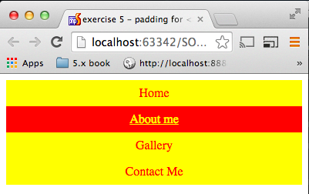

**Exercise 6: Highlight the current page to user via navbar**

Since the user is viewing the Home (index.html) page, we should indicate this to the user by highlighting this in the navigation bar somehow. Edit your HTML so that the <a> element for the home page is marked up as the class “current_page”. Then write a CSS rule so that ‘a’ elements in a ‘nav’ element of the class “current_page” have a grey background.

**Hints:**

<a href="..." class="current_page” ...

nav a.current_page {

color: yellow;

etc.

****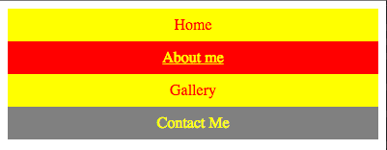

**WELL DONE!**

You now have a working (vertical) navigation list, with rollover effects, and full control of width, padding etc. since the <a> elements are now displayed as blocks